
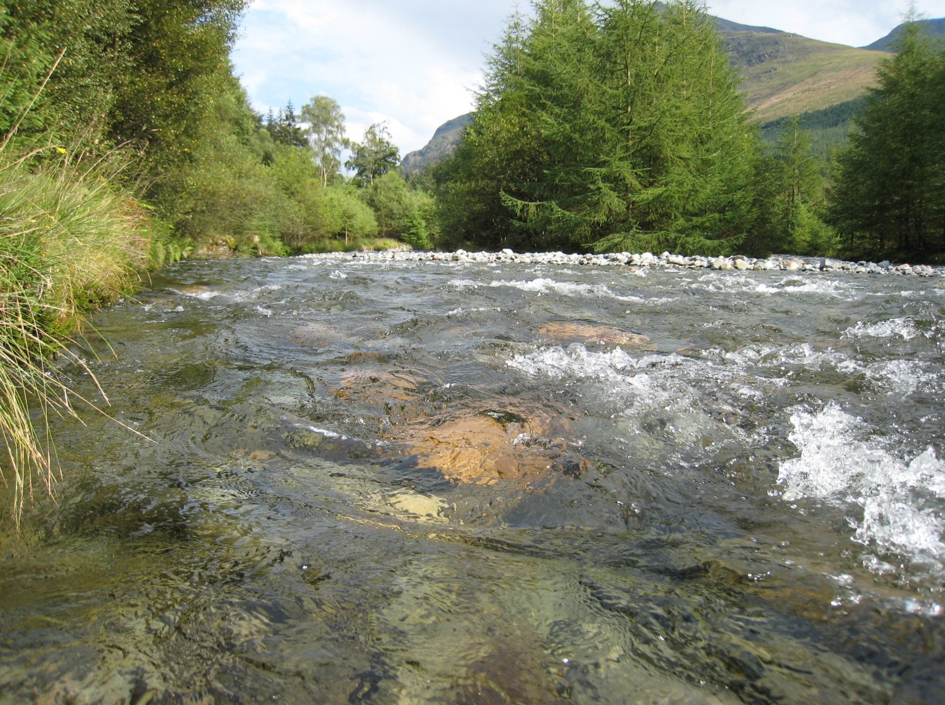

A comparison of European freshwater nutrient boundaries:
A report to ECOSTAT, October 2015

Geoff Phillips, Jo-Anne Pitt

2015

A comparison of European freshwater nutrient boundaries used for the Water Framework Directive:
A report to ECOSTAT, October 2015

Geoff Phillips, Jo-Anne Pitt*

Ensis Ltd.
Environmental Change Research Centre
University College London
Pearson Building, Gower St.
London, WC1E 6BT

*Environment Agency, UK

Cover photo: © G Phillips
Contents
1 Summary and key observations 1
1.1 Lake total phosphorus boundaries 2
1.2 River phosphorus boundaries 2
1.3 Lake nitrogen boundaries 3
1.4 River nitrogen boundaries 3
2 Introduction 3
2.1 Background 3
2.2 Boundary setting methods 4
3 Comparison of Phosphorus boundary values 9
3.1 Range of metrics and boundary values used 9
3.2 Comparison of total phosphorus boundaries for lakes 15
3.2.1 Introduction 15
3.2.2 Comparison of boundaries by lake type 17
3.2.3 Comparison by country 26
3.2.4 Comparison by method used to set boundaries 28
3.3 Comparison of phosphorus boundaries for rivers 30
3.3.1 Introduction 30
3.3.2 Comparison of boundaries by river type 32
3.3.3 Comparison by country 41
3.3.4 Comparison by methods used to set boundaries 43
4 Comparison of Nitrogen boundary values 45
4.1 Range of metrics and boundary values used 45
4.2 Comparison of nitrogen boundaries for lakes 50
4.2.1 Introduction 50
4.2.2 Comparison of boundaries by lake type 53
4.2.3 Comparison by country 57
4.2.4 Comparison by method used to set boundaries 59
4.3 Comparison of nitrogen boundaries for rivers 60
4.3.1 Introduction 60
4.3.2 Comparison of boundaries by river type 63
4.3.3 Comparison by country 72
4.3.4 Comparison by method used to set boundaries 72
5 References 75
6 Appendices 76
6.1 Detailed comparison of lake boundaries 76
6.1.1 Lake boundaries by intercalibration type and country 76
6.1.2 Lake total phosphorus boundaries by broad type and country 83
6.2 Detailed comparison of river boundaries 107
6.2.1 River boundaries by intercalibration type and country 107
6.2.2 River phosphorus and nitrogen boundaries by broad type and country 134

List of Tables
Table 2.1-1 Number of countries (BE W and BE Fl counted separately) reporting different nutrient related supporting elements for rivers and lakes (NH3-N free ammonia, NH₄-N total ammonium as nitrogen, NO₂-N nitrite as nitrogen, NO₃ nitrate as nitrogen, Org N organic nitrogen, SRP soluble reactive phosphorus, TN total nitrogen, TP total phosphorus, TRP total reactive P) 4
Table 2.2-1 Categories of methods used to set lake and river boundaries 5
Table 2.2-2 Summary of methods used to set lake boundary values 6
Table 2.2-3 Summary of methods used to set river boundary values 8
Table 3.1-1 Summary metrics used to specify lake and river phosphorus boundary values 10
Table 3.1-2 Parameters used to specify phosphorus boundaries for lakes (SRP soluble reactive phosphorus, TP total phosphorus, TRP total reactive phosphorus) 11
Table 3.1-3 Parameters used to specify phosphorus boundaries for rivers (SRP soluble reactive phosphorus, TP total phosphorus, TRP total reactive phosphorus) 12
Table 3.2-1 Number of national lake types, good/moderate boundary values and broad types with boundaries reported by each Member State. (FR SE & UK have site specific boundary values, mean for national types used in above table, values for ES are 75th percentiles) 16
Table 3.2-2 Number of national type specific good/moderate boundary values for TP reported for each lake intercalibration type 19
Table 3.2-3 Number of national lake types allocated to each broad type by country 21
Table 3.2-4 Number of national lake types that could be linked to intercalibration and broad types. 22
Table 3.3-1 Number of national types, good/moderate boundary values reported by each Member State for rivers and number of broad types that have been linked to the national types. 31
Table 3.3-2 Number of national river types allocated to each intercalibration type with good/moderate boundary values for phosphorus. 35
Table 3.3-3 Number of national river types with reported good/moderate phosphorus boundaries allocated to each broad type by country 37
Table 3.3-4 Number of national river types allocated to each broad type by country (continued) 38
Table 4.1-1 Number of countries using different summary metrics and parameters to specify lake and river nitrogen boundary values 45
Table 4.1-2b Summary metrics and parameters used to specify lake and river nitrogen boundary values by country 46
Table 4.2-1 Number of national types, good/moderate boundary values for nitrogen (total nitrogen and nitrate) reported by Member States for lakes and number of broad types that have been linked to national types. 52
Table 4.2-2 Number of national lake types with reported nitrogen good/moderate boundary values (total nitrogen or nitrate) by intercalibration type. 53
Table 4.2-3 Number of national lake types with reported nitrogen good/moderate boundary values (total nitrogen or nitrate) by broad type. 55
Table 4.3-1 Number of national types, good/moderate boundary values for nitrogen (total N and nitrate) reported by Member States for rivers and number of broad types that have been linked to the national types. 62
Table 4.3-2 Number of national river types allocated to each intercalibration type with good/moderate boundary values for nitrogen (total nitrogen or nitrate nitrogen). 66
Table 4.3-3 Number of national river types allocated to each broad type with good/moderate boundary values for nitrogen (total nitrogen or nitrate nitrogen). 71
Table 6.1-1 National & broad types for Alpine GIG countries reporting lake intercalibration type L-AL3 76
Table 6.1-2 National & broad types for Alpine GIG countries reporting lake intercalibration type L-AL4 77
Table 6.1-3 National & broad types for Central Baltic GIG countries reporting lake intercalibration type L-CB1 78
Table 6.1-4 National & broad types for Central Baltic GIG countries reporting lake intercalibration type L-CB2 81
Table 6.1-5 National & broad types for Northern GIG countries reporting lake intercalibration type L-N2a 82
Table 6.1-6 National & intercalibration types for countries reporting Broad Type 1 Very large and deep (stratified) (all Europe Lakes) 83
Table 6.1-7 National & intercalibration types for countries reporting Broad Type 2 Lowland, siliceous lakes. 86
Table 6.1-8 National & intercalibration types for countries reporting Broad Type 3 Lowland, stratified, calcareous/mixed lakes. 88
Table 6.1-9 National & intercalibration types for countries reporting Broad Type 4 Lowland, calcareous/mixed, very shallow (unstratified) lakes. 91
Table 6.1-10 National & intercalibration types for countries reporting Broad Type 5, lowland, organic siliceous lakes. 93
Table 6.1-11 National & intercalibration types for countries reporting Broad Type 6, lowland, organic calcareous/mixed lakes. 95
Table 6.1-12 National & intercalibration types for countries reporting Broad Type 7, Mid-altitude, siliceous lakes 97
Table 6.1-13 National & intercalibration types for countries reporting Broad Type 8, mid-altitude, calcareous/mixed 99
Table 6.1-14 National & intercalibration types for countries reporting Broad Type 9 mid-altitude, organic and siliceous lakes. 101
Table 6.1-15 National & intercalibration types for countries reporting Broad Type 11, highland, siliceous (all Europe) 102
Table 6.1-16 National & intercalibration types for countries reporting Broad Type 12, highland, calcareous/mixed (all Europe) 104
Table 6.1-17 National & intercalibration types for countries reporting Broad Type 13 Mediterranean, small-large, siliceous (including reservoirs) 104
Table 6.1-18 National & intercalibration types for countries reporting Broad Type 14, Mediterranean, small-large, calcareous/mixed (including reservoirs) 105
Table 6.2-1 National & broad types for Alpine GIG countries reporting river intercalibration type R-A2 107
Table 6.2-2 National & broad types for Central Baltic GIG countries reporting river intercalibration type R-C1 109
Table 6.2-3 National & broad types for Central Baltic GIG countries reporting river intercalibration type R-C3 111
Table 6.2-4 National & broad types for Central Baltic GIG countries reporting river intercalibration type R-C4 114
Table 6.2-5 National & broad types for Central Baltic GIG countries reporting river intercalibration type R-C5 117
Table 6.2-6 National & broad types for Central Baltic GIG countries reporting river intercalibration type R-C6 119
Table 6.2-7 National & broad types for Eastern Continental GIG countries reporting river intercalibration type R-E1 121
Table 6.2-8 National & broad types for Eastern Continental GIG countries reporting river intercalibration type R-E2 122
Table 6.2-9 National & broad types for Eastern Continental GIG countries reporting river intercalibration type R-E3 124
Table 6.2-10 National & broad types for Eastern Continental GIG countries reporting river intercalibration type R-E4 125
Table 6.2-11 National & broad types for Mediterranean GIG countries reporting river intercalibration type R-M1 127
Table 6.2-12 National & broad types for Mediterranean GIG countries reporting river intercalibration type R-M2 129
Table 6.2-13 National & broad types for Mediterranean GIG countries reporting river intercalibration type R-M4 130
Table 6.2-14 National & broad types for Mediterranean GIG countries reporting river intercalibration type R-M5 132
Table 6.2-15 National & intercalibration types for countries reporting Broad Type 1, very large rivers all Europe 134
Table 6.2-16 National & intercalibration types for countries reporting Broad Type 2, lowland, siliceous, medium large rivers 136
Table 6.2-17 National & intercalibration types for countries reporting Broad Type3, lowland, siliceous, very small-small rivers 138
Table 6.2-18 National & intercalibration types for countries reporting Broad Type 4, lowland, calcareous/mixed, medium-large rivers 143
Table 6.2-19 National & intercalibration types for countries reporting Broad Type 5, lowland, calcareous/mixed, very small-small rivers 147
Table 6.2-20 National & intercalibration types for countries reporting Broad Type 6, lowland, organic & siliceous rivers 150
Table 6.2-21 National & intercalibration types for countries reporting Broad Type 7 lowland, organic and calcareous/mixed rivers 151
Table 6.2-22 National & intercalibration types for countries reporting Broad Type 8, mid-altitude, siliceous, medium large rivers 152
Table 6.2-23 National & intercalibration types for countries reporting Broad Type 9, mid-altitude, siliceous, very small-small rivers 155
Table 6.2-24 National & intercalibration types for countries reporting Broad Type 10, mid-altitude, calcareous/mixed, medium-large rivers (90th percentile values halved) 158
Table 6.2-25 National & intercalibration types for countries reporting Broad Type 11, mid-altitude, calcareous/mixed, very small-small rivers (90th percentile values halved) 162
Table 6.2-26 National & intercalibration types for countries reporting Broad Type 12 163
Table 6.2-27 National & intercalibration types for countries reporting Broad Type 13 mid-altitude calcareous/mixed 164
Table 6.2-28 National & intercalibration types for countries reporting Broad Type 14, highland, siliceous, all Europe rivers 165
Table 6.2-29 National & intercalibration types for countries reporting Broad Type15, highland, calcareous/mixed, all Europe rivers 167
Table 6.2-30 National & intercalibration types for countries reporting Broad Type16 169
Table 6.2-31 National & intercalibration types for countries reporting Broad Type 17, Mediterranean, lowland, medium-large rivers 170
Table 6.2-32 National & intercalibration types for countries reporting Broad Type 18 Mediterranean, mid-altitude, medium-large, perennial rivers 172
Table 6.2-33 National & intercalibration types for countries reporting Broad Type 19, Mediterranean, very small perennial rivers 173
Table 6.2-34 National & intercalibration types for countries reporting Broad Type 20, Mediterranean, temporary/intermittent streams 175

List of Figures
Figure 3.1-1 Comparison of Total P boundaries in lakes (L) and rivers (R) by country (UK and IE river P boundaries are Total Reactive P rather than Total P. River values for ES and AT are Soluble Reactive P, values for AT rivers and ES lakes are halved as they are 90th percentiles, river values for IE exclude 95th percentile, lake values for DE exclude 75th percentile values) 13
Figure 3.1-2 Range of good/moderate phosphorus boundary values in lakes (L) and rivers (R). Width of bar proportional to number of countries with boundary values (75th and 90th percentile values are halved). 14
Figure 3.1-3 Range of a) ratio between high/good and good/moderate type specific phosphorus boundary values and b) the resulting width of the good class for lakes (TP) and rivers (TP and TRP/SRP if TP not measured). Arranged by country in ascending order of median value for all types reported by country. The ratio of 0.5 represents a doubling of phosphorus concentration from the high/good boundary. 14
Figure 3.2-1 Range of a) high/good and b) good/moderate boundaries for lakes, arranged by median value of boundaries for each country. Lines mark 25th, 50th and 75th percentile values for all countries. (Range for DE includes only median, range for ES is for 75th percentile values) 17
Figure 3.2-2 Range of a) good/moderate and b) high/good total phosphorus boundaries for lake intercalibration types 18
Figure 3.2-3 Range of reported high/good boundary values for lakes grouped by broad types. Numbers show the number of national types allocated to each broad type. Types ordered by median value of reported boundary. 23
Figure 3.2-4 Range of reported good/moderate boundary values for lakes grouped by broad types. Numbers show the number of national types allocated to each broad type. Types ordered by median value of reported boundary 24
Figure 3.2-5 Range of ratio between high/good and good/moderate type specific phosphorus boundary values for each broad lake type. Numbers show the number of national types allocated to each broad type. Types ordered by median value of reported boundary 25
Figure 3.2-6 Average of the discrepancies (µgl⁻¹) between the national and average broad lake type total phosphorus good/moderate boundary value, for all types by country. 27
Figure 3.2-7 Average of the discrepancies (µgl⁻¹) between the national and average broad lake type total phosphorus high/good boundary value, for all types by country. 27
Figure 3.2-8 Range of good/moderate TP boundary values for lakes by category of method used to establish boundaries by different Member States 28
Figure 3.2-9 Range of values of the ratio of high/good to good/moderate TP boundary values for lakes by category of method used to establish boundaries by different Member States 29
Figure 3.3-1 Range of a) high/good and b) good/moderate boundaries for rivers by country, arranged by median values of boundaries for each country. Lines mark 25th, 50th and 75th percentile values for all countries. (90th percentile metrics were halved and are identified by *) 32
Figure 3.3-2 Range of a) good/moderate and b) high/good river phosphorus boundaries for intercalibration types, (90th percentile values halved) 33
Figure 3.3-3 Range of a) good/moderate and b) high/good river phosphorus boundaries by geographic intercalibration group (90th percentile values halved) 36
Figure 3.3-4 Range of reported high/good phosphorus boundary values for rivers grouped by broad types, (90th percentile values halved). Numbers show the number of national types allocated to each broad type. Types ordered by median value of reported boundary, dotted lines show interquartile range for all broad types. 40
Figure 3.3-5 Range of reported good/moderate phosphorus boundary values for rivers grouped by broad types (90th percentile values halved). Numbers show the number of national types allocated to each broad type. Types ordered by median value of reported boundary, dotted lines show interquartile range for all broad types. 41
Figure 3.3-6 Average of the discrepancies (µgl⁻¹) between the national and average broad type river phosphorus good/moderate boundary value for all types by country. (90th percentile values halved AT, BE (W), FR, RO, SK) 42
Figure 3.3-7 Average of the discrepancies (µgl⁻¹) between the national and average broad type river phosphorus high/good boundary value for all types by country. (90th percentile values halved AT, BE (W), FR, RO, SK) 42
Figure 3.3-8 Range of good/moderate river phosphorus boundary values grouped by category of method used to determine the value. (90th percentile values halved) 43
Figure 3.3-9 Range of high/good river phosphorus boundary values grouped by category of method used to determine the value. (90th percentile values halved) 44
Figure 4.1-1 Comparison of total nitrogen good/moderate boundaries in lakes (L) and rivers (R) by country (river 90th percentile values halved RO, SK) 47
Figure 4.1-2 Comparison of nitrate nitrogen good/moderate boundaries in lakes (L) and rivers (R) by country (maximum (FR lakes) and 90th percentiles rivers AT, BE, FR, RO, SK halved) 48
Figure 4.1-3 Range of good/moderate nitrogen boundary values in lakes (L) and rivers (R). Width of bar proportional to number of countries with boundary values. 49
Figure 4.2-1 Range of a) high/good and b) good/moderate total nitrogen boundaries for lakes by country, arranged by median value of boundaries for each country. Lines mark 25th, 50th and 75th percentile values for countries. 50
Figure 4.2-2 Range of a) high/good and b) good/moderate nitrate nitrogen boundaries for lakes by country (reservoirs for PT), arranged by median value of boundaries for each country. Lines mark 25th, 50th and 75th percentile values for countries (maximum value for FR was halved for comparison) 51
Figure 4.2-3 Range of reported lake total nitrogen boundary values for each intercalibration type, arranged by median national boundary value for the type. Width of bar is proportional to the number of national types linked to intercalibration type. 54
Figure 4.2-4 Range of reported total nitrogen good/moderate boundary values for lakes grouped by broad types. Numbers show the number of national types contributing to the broad type with boundary values. Types ordered by median boundary for broad type. Lines show 25th 50th and 75th percentiles of all reported good/moderate total nitrogen boundary values. 56
Figure 4.2-5 Range of reported nitrate nitrogen good/moderate boundary values for lakes grouped by broad types. Numbers show the number of national types contributing to the broad type with boundary values. Types ordered by median boundary for broad type. Lines show 25th 50th and 75th percentiles of all reported good/moderate nitrate nitrogen boundary values (maximum value FR halved). 57
Figure 4.2-6 Average of the discrepancies (mgl⁻¹) between the national and average broad type lake nitrogen (total nitrogen or nitrate nitrogen where total nitrogen not reported) good/moderate boundary values for all types by country. (For FR, only a maximum nitrate value is reported and these values were halved for comparison with other country mean values) 58
Figure 4.2-7 Range of total nitrogen good/moderate boundary values for lakes by category of method used to establish boundary by different Member States 59
Figure 4.3-1 Range of a) high/good and b)good/moderate total nitrogen boundaries for rivers by country, arranged by median values of boundaries for each country. Lines mark 25th, 50th and 75th percentile values for all countries, numbers are national types with boundary values. (90th percentiles identified by * and orange shading RO, SK) 60
Figure 4.3-2 Range of a) high/good and b)good/moderate nitrate nitrogen boundaries for rivers by country, arranged by median values of boundaries for each country. Lines mark 25th, 50th and 75th percentile values for all countries, numbers are national types with boundary values. (90th percentiles identified by * and orange shading AT, BE, FR, RO, SK) 61
Figure 4.3-3 Range of a)good/moderate, b)high/good boundaries for river total nitrogen by intercalibration type, arranged by median value of intercalibration type, numbers are national types with boundary values in the intercalibration type. (90th percentile values halved RO, SK) 63
Figure 4.3-4 Range of a)good/moderate, b)high/good boundaries for river nitrate nitrogen by intercalibration type, arranged by median value of intercalibration type, numbers are national types with boundary values in the intercalibration type (90th percentiles halved AT, BE, FR, RO, SK) 64
Figure 4.3-5 Range of good/moderate and high/good river total nitrogen and nitrate nitrogen boundaries by geographic intercalibration group. . (90th percentile values halved for total nitrogen RO, SK and for nitrate AT, BE, FR, RO, SK) 65
Figure 4.3-6 Range of reported good/moderate total nitrogen boundary values for rivers grouped by broad type. Numbers show the number of national types allocated to each broad type. Types ordered by median value of reported boundary, dotted lines show interquartile range for all broad types. (Values for 90th percentiles (RO, SK) were halved) 68
Figure 4.3-7 Range of reported good/moderate nitrate nitrogen boundary values for rivers grouped by broad type. Numbers show the number of national types allocated to each broad type. Types ordered by median value of reported boundary, dotted lines show interquartile range for all broad types. Values for 90th percentiles (AT BE-FL BE-W FR RO SK) were halved 69
Figure 4.3-8 Average of the discrepancies (mgl⁻¹) between the national and average broad type river nitrogen (total nitrogen or nitrate nitrogen where total nitrogen not reported) good/moderate boundary value for all types by country. 90th percentile values adjusted to match measures of mean and median 72
Figure 4.3-9 Range of total nitrogen good/moderate boundary values for rivers by category of method used to establish boundary by different Member States. 90th percentile values adjusted to match measures of mean and median. 73
Figure 4.3-10 Range of nitrate nitrogen good/moderate boundary values for rivers by category of method used to establish boundary by different Member States 74
Figure 6.1-1 Range of a) good/moderate, b) high/good, c) ratio of good/moderate to high/good total phosphorus boundary values for intercalibration types L-AL3 77
Figure 6.1-2 Range of a) good/moderate, b) high/good, c) ratio of good/moderate to high/good total phosphorus boundary values for intercalibration types AL4 77
Figure 6.1-3 Range of a) good/moderate, b) high/good, c) ratio of good/moderate to high/good total phosphorus boundary values for intercalibration type L-CB1, high alkalinity shallow stratified lake types by country (values for DE are median and 75th percentile) 78
Figure 6.1-4 Range of a) good/moderate, b) high/good, c) ratio of good/moderate to high/good total nitrogen boundary values for intercalibration type L-CB1, high alkalinity shallow stratified lake types by country 79
Figure 6.1-5 Range of a) good/moderate, b) high/good, c) ratio of good/moderate to high/good total phosphorus boundary values for intercalibration type L-CB2, high alkalinity very shallow lakes 81
Figure 6.1-6 Range of a) good/moderate, b) high/good, c) ratio of good/moderate to high/good total nitrogen boundary values for intercalibration type L-CB2, high alkalinity very shallow lakes 81
Figure 6.1-7 Range of a) good/moderate, b) high/good, c) ratio of good/moderate to high/good total phosphorus boundary values for intercalibration type L-N2a lakes 82
Figure 6.1-8 Range of a) good/moderate, b) high/good, c) ratio of good/moderate to high/good total nitrogen boundary values for intercalibration type L-N2a lakes 83
Figure 6.1-9 Range of a) good/moderate, b) high/good, c) ratio of good/moderate to high/good total phosphorus boundary values for broad type 1, Very large and deep (stratified) (all Europe) lake types by country. 83
Figure 6.1-10 Range of a) good/moderate, b) high/good, c) ratio of good/moderate to high/good total nitrogen boundary values for broad type 1, Very large and deep (stratified) (all Europe) lake types by country 84
Figure 6.1-11 Range of a) good/moderate, b) high/good, c) ratio of good/moderate to high/good total phosphorus boundary values for broad type 2, lowland siliceous lake types by country. 86
Figure 6.1-12 Range of a) good/moderate, b) high/good, c) ratio of good/moderate to high/good total nitrogen boundary values for broad type 2, lowland siliceous lake types by country. 86
Figure 6.1-13 Range of a) good/moderate, b) high/good, c) ratio of good/moderate to high/good total phosphorus boundary values for broad type 3, lowland stratified calcareous/mixed lake types by country (values for DE include both median and 75th percentile standards). 89
Figure 6.1-14 Range of a) good/moderate, b) high/good, c) ratio of good/moderate to high/good total nitrogen boundary values for broad type 3, lowland stratified calcareous/mixed lake types by country. 89
Figure 6.1-15 Range of a) good/moderate, b) high/good, c) ratio of good/moderate to high/good nitrate nitrogen boundary values for broad type 3, lowland stratified calcareous/mixed lake types by country. 89
Figure 6.1-16 Range of a) good/moderate, b) high/good, c) ratio of good/moderate to high/good total phosphorus boundary values for broad type 4, lowland, calcareous/mixed, very shallow (un-stratified) lakes. 91
Figure 6.1-17 Range of a) good/moderate, b) high/good, c) ratio of good/moderate to high/good total nitrogen boundary values for broad type 4, lowland, calcareous/mixed, very shallow (un-stratified) lakes. 92
Figure 6.1-18 Range of a) good/moderate, b) high/good, c) ratio of good/moderate to high/good nitrate nitrogen boundary values for broad type 3, lowland stratified calcareous/mixed lake types by country. 92
Figure 6.1-19 Range of a) good/moderate, b) high/good, c) ratio of good/moderate to high/good total phosphorus boundary values for broad type 5, lowland, organic siliceous lakes. 94
Figure 6.1-20 Range of a) good/moderate, b) high/good, c) ratio of good/moderate to high/good total nitrogen boundary values for broad type 5, lowland, organic siliceous lakes. 94
Figure 6.1-21 Range of a) good/moderate, b) high/good, c) ratio of good/moderate to high/good total phosphorus boundary values for broad Broad Type 6, lowland, organic calcareous/mixed lakes. 95
Figure 6.1-22 Range of a) good/moderate, b) high/good, c) ratio of good/moderate to high/good total nitrogen boundary values for broad Broad Type 6, lowland, organic calcareous/mixed lakes. 96
Figure 6.1-23 Range of a) good/moderate, b) high/good, c) ratio of good/moderate to high/good total phosphorus boundary values for Broad Type Type 7 Mid-altitude, siliceous lakes (values for DE include both median and 75th percentile metrics) 98
Figure 6.1-24 Range of a) good/moderate, b) high/good, c) ratio of good/moderate to high/good total phosphorus boundary values for Broad Type Type 7 Mid-altitude, siliceous lakes 98
Figure 6.1-25 Range of a) good/moderate, b) high/good, c) ratio of good/moderate to high/good nitrate phosphorus boundary values for Broad Type Type 7 Mid-altitude, siliceous lakes 98
Figure 6.1-26 Range of a) good/moderate, b) high/good, c) ratio of good/moderate to high/good total phosphorus boundary values for broad type 8, mid-altitude, calcareous/mixed (values for DE include median and 75th percentiles). 100
Figure 6.1-27 Range of a) good/moderate, b) high/good, c) ratio of good/moderate to high/good nitrate nitrogen boundary values for broad type 8, mid-altitude, calcareous/mixed. 100
Figure 6.1-28 Range of a) good/moderate, b) high/good, c) ratio of good/moderate to high/good nitrate nitrogen boundary values for broad type 9 mid-altitude, organic and siliceous lakes. 101
Figure 6.1-29 Range of a) good/moderate, b) high/good, c) ratio of good/moderate to high/good total phosphorus boundary values for broad type11, highland, siliceous (all Europe) 103
Figure 6.1-30 Range of a) good/moderate, b) high/good, c) ratio of good/moderate to high/good total nitrogen boundary values for broad type11, highland, siliceous (all Europe) 103
Figure 6.1-31 Range of a) good/moderate, b) high/good, c) ratio of good/moderate to high/good nitrate nitrogen boundary values for broad type11, highland, siliceous (all Europe) 103
Figure 6.1-32 Range of a) good/moderate, b) high/good, c) ratio of good/moderate to high/good boundary values for broad type12, highland, calcareous/mixed (all Europe) 104
Figure 6.1-33 Range of a) good/moderate, b) high/good, c) ratio of good/moderate to high/good total phosphorus boundary values for broad type 13 Mediterranean, small-large, siliceous (including reservoirs) 105
Figure 6.1-34 Range of a) good/moderate, b) high/good, c) ratio of good/moderate to high/good total phosphorus boundary values for broad type 14, Mediterranean, small-large, calcareous/mixed (including reservoirs) 106
Figure 6.1-35 Range of a) good/moderate, b) high/good, c) ratio of good/moderate to high/good nitrate nitrogen boundary values for broad type 14, Mediterranean, small-large, calcareous/mixed (including reservoirs) 106
Figure 6.2-1 Range of a)good/moderate, b)high/good, c)ratio of good/moderate to high/good phosphorus boundary values for intercalibration type R-A2 108
Figure 6.2-2 Range of a)good/moderate, b)high/good, c)ratio of good/moderate to high/good nitrate nitrogen boundary values for intercalibration type R-A2 108
Figure 6.2-3 Range of a)good/moderate, b)high/good, c)ratio of good/moderate to high/good phosphorus boundary values for intercalibration type R-C1 109
Figure 6.2-4 Range of a)good/moderate, b)high/good, c)ratio of good/moderate to high/good total nitrogen boundary values for intercalibration type R-C1 110
Figure 6.2-5 Range of a)good/moderate, b)high/good, c)ratio of good/moderate to high/good nitrate nitrogen boundary values for intercalibration type R-C1 110
Figure 6.2-6 Range of a)good/moderate, b)high/good, c)ratio of good/moderate to high/good phosphorus boundary values for intercalibration type R-C3 112
Figure 6.2-7 Range of a)good/moderate, b)high/good, c)ratio of good/moderate to high/good nitrate nitrogen boundary values for intercalibration type R-C3 112
Figure 6.2-8 Range of a)good/moderate, b)high/good, c)ratio of good/moderate to high/good phosphorus boundary values for intercalibration type R-C4 114
Figure 6.2-9 Range of a)good/moderate, b)high/good, c)ratio of good/moderate to high/good total nitrogen boundary values for intercalibration type R-C4 115
Figure 6.2-10 Range of a)good/moderate, b)high/good, c)ratio of good/moderate to high/good nitrate nitrogen boundary values for intercalibration type R-C4 115
Figure 6.2-11 Range of a)good/moderate, b)high/good, c)ratio of good/moderate to high/good phosphorus boundary values for intercalibration type R-C5 117
Figure 6.2-12 Range of a)good/moderate, b)high/good, c)ratio of good/moderate to high/good total nitrogen boundary values for intercalibration type R-C5 117
Figure 6.2-13 Range of a)good/moderate, b)high/good, c)ratio of good/moderate to high/good nitrate nitrogen boundary values for intercalibration type R-C5 118
Figure 6.2-14 Range of a)good/moderate, b)high/good, c)ratio of good/moderate to high/good phosphorus boundary values for intercalibration type R-C6 120
Figure 6.2-15 Range of a)good/moderate, b)high/good, c)ratio of good/moderate to high/good total nitrogen boundary values for intercalibration type R-C6 120
Figure 6.2-16 Range of a)good/moderate, b)high/good, c)ratio of good/moderate to high/good nitrate nitrogen boundary values for intercalibration type R-C6 120
Figure 6.2-17 Range of a)good/moderate, b)high/good, c)ratio of good/moderate to high/good phosphorus boundary values for intercalibration type R-E1 121
Figure 6.2-18 Range of a)good/moderate, b)high/good, c)ratio of good/moderate to high/good total nitrogen boundary values for intercalibration type R-E1 122
Figure 6.2-19 Range of a)good/moderate, b)high/good, c)ratio of good/moderate to high/good nitrate nitrogen boundary values for intercalibration type R-E1 122
Figure 6.2-20 Range of a)good/moderate, b)high/good, c)ratio of good/moderate to high/good phosphorus boundary values for intercalibration type R-E2 123
Figure 6.2-21 Range of a)good/moderate, b)high/good, c)ratio of good/moderate to high/good total nitrogen boundary values for intercalibration type R-E2 123
Figure 6.2-22 Range of a)good/moderate, b)high/good, c)ratio of good/moderate to high/good nitrate nitrogen boundary values for intercalibration type R-E2 123
Figure 6.2-23 Range of a)good/moderate, b)high/good, c)ratio of good/moderate to high/good phosphorus boundary values for intercalibration type R-E3 124
Figure 6.2-24 Range of a)good/moderate, b)high/good, c)ratio of good/moderate to high/good total nitrogen boundary values for intercalibration type R-E3 125
Figure 6.2-25 Range of a)good/moderate, b)high/good, c)ratio of good/moderate to high/good nitrate nitrogen boundary values for intercalibration type R-E3 125
Figure 6.2-26 Range of a)good/moderate, b)high/good, c)ratio of good/moderate to high/good phosphorus boundary values for intercalibration type R-E4 126
Figure 6.2-27 Range of a)good/moderate, b)high/good, c)ratio of good/moderate to high/good total nitrogen boundary values for intercalibration type R-E4 126
Figure 6.2-28 Range of a)good/moderate, b)high/good, c)ratio of good/moderate to high/good nitrate nitrogen boundary values for intercalibration type R-E4 126
Figure 6.2-29 Range of a)good/moderate, b)high/good, c)ratio of good/moderate to high/good phosphorus boundary values for intercalibration type R-M1 128
Figure 6.2-30 Range of a)good/moderate, b)high/good, c)ratio of good/moderate to high/good nitrate nitrogen boundary values for intercalibration type R-M1 128
Figure 6.2-31 Range of a)good/moderate, b)high/good, c)ratio of good/moderate to high/good phosphorus boundary values for intercalibration type R-M2 129
Figure 6.2-32 Range of a)good/moderate, b)high/good, c)ratio of good/moderate to high/good nitrate nitrogen boundary values for intercalibration type R-M2 130
Figure 6.2-33 Range of a)good/moderate, b)high/good, c)ratio of good/moderate to high/good boundary values for intercalibration type R-M4 131
Figure 6.2-34 Range of a)good/moderate, b)high/good, c)ratio of good/moderate to high/good nitrate nitrogen boundary values for intercalibration type R-M4 131
Figure 6.2-35 Range of a)good/moderate, b)high/good, c)ratio of good/moderate to high/good phosphorus boundary values for intercalibration type R-M5 133
Figure 6.2-36 Range of a)good/moderate, b)high/good, c)ratio of good/moderate to high/good nitrate nitrogen boundary values for intercalibration type R-M5 133
Figure 6.2-37 Range of a) good/moderate, b)high/good, c) ratio of good/moderate to high/good national phosphorus boundary values for rivers in broad type 1, very large rivers all Europe. (90th percentile values halved) 135
Figure 6.2-38 Range of a) good/moderate, b)high/good, c) ratio of good/moderate to high/good national total nitrogen boundary values for rivers in broad type 1, very large rivers all Europe. 135
Figure 6.2-39 Range of a) good/moderate, b)high/good, c) ratio of good/moderate to high/good national nitrate nitrogen boundary values for rivers in broad type 1, very large rivers all Europe. 135
Figure 6.2-40 Range of a) good/moderate, b)high/good, c) ratio of good/moderate to high/good national phosphorus boundary values for rivers in broad type 2, lowland, siliceous, medium large rivers (90th percentile values halved) 136
Figure 6.2-41 Range of a) good/moderate, b)high/good, c) ratio of good/moderate to high/good national total nitrogen boundary values for rivers in broad type 2, lowland, siliceous, medium large rivers 137
Figure 6.2-42 Range of a) good/moderate, b)high/good, c) ratio of good/moderate to high/good national nitrate nitrogen boundary values for rivers in broad type 2, lowland, siliceous, medium large rivers 137
Figure 6.2-43 Range of a) good/moderate, b)high/good, c) ratio of good/moderate to high/good national phosphorus boundary values for rivers in broad type 3, lowland, siliceous, very small-small rivers (90th percentile values halved) 139
Figure 6.2-44 Range of a) good/moderate, b)high/good, c) ratio of good/moderate to high/good national total nitrogen boundary values for rivers in broad type 3, lowland, siliceous, very small-small rivers 139
Figure 6.2-45 Range of a) good/moderate, b)high/good, c) ratio of good/moderate to high/good national nitrate nitrogen boundary values for rivers in broad type 3, lowland, siliceous, very small-small rivers 140
Figure 6.2-46 Range of a) good/moderate, b)high/good, c) ratio of good/moderate to high/good national phosphorus boundary values for rivers in broad type 4, lowland, calcareous/mixed, medium-large rivers (90th percentile values halved) 144
Figure 6.2-47 Range of a) good/moderate, b)high/good, c) ratio of good/moderate to high/good national total nitrogen boundary values for rivers in broad type 4, lowland, calcareous/mixed, medium-large rivers 144
Figure 6.2-48 Range of a) good/moderate, b)high/good, c) ratio of good/moderate to high/good national nitrate nitrogen boundary values for rivers in broad type 4, lowland, calcareous/mixed, medium-large rivers 145
Figure 6.2-49 Range of a) good/moderate, b)high/good, c) ratio of good/moderate to high/good national phosphorus boundary values for rivers in broad type 5, lowland, calcareous/mixed, very small-small rivers (90th percentile values halved) 148
Figure 6.2-50 Range of a) good/moderate, b)high/good, c) ratio of good/moderate to high/good national total nitrogen boundary values for rivers in broad type 5, lowland, calcareous/mixed, very small-small rivers 148
Figure 6.2-51 Range of a) good/moderate, b)high/good, c) ratio of good/moderate to high/good nitrate nitrogen boundary values for rivers in broad type 5, lowland, calcareous/mixed, very small-small rivers 149
Figure 6.2-52 Range of a) good/moderate, b)high/good, c) ratio of good/moderate to high/good national phosphorus boundary values for rivers in broad type 6, lowland, organic & siliceous rivers 150
Figure 6.2-53 Range of a) good/moderate, b)high/good, c) ratio of good/moderate to high/good national total nitrogen boundary values for rivers in broad type 6, lowland, organic & siliceous rivers 151
Figure 6.2-54 Range of a) good/moderate, b)high/good, c) ratio of good/moderate to high/good national phosphorus boundary values for rivers in broad type 7, lowland, organic & calcareous/mixed rivers. 151
Figure 6.2-55 Range of a) good/moderate, b)high/good, c) ratio of good/moderate to high/good national phosphorus boundary values for rivers in broad type 8, mid-altitude, siliceous, medium large rivers (90th percentile values halved) 152
Figure 6.2-56 Range of a) good/moderate, b)high/good, c) ratio of good/moderate to high/good national total nitrogen boundary values for rivers in broad type 8, mid-altitude, siliceous, medium large rivers 153
Figure 6.2-57 Range of a) good/moderate, b)high/good, c) ratio of good/moderate to high/good national nitrate nitrogen boundary values for rivers in broad type 8, mid-altitude, siliceous, medium large rivers 153
Figure 6.2-58 Range of a) good/moderate, b)high/good, c) ratio of good/moderate to high/good national phosphorus boundary values for rivers in broad type 9, mid-altitude, siliceous, very small-small rivers (90th percentile values halved) 155
Figure 6.2-59 Range of a) good/moderate, b)high/good, c) ratio of good/moderate to high/good national total nitrogen boundary values for rivers in broad type 9, mid-altitude, siliceous, very small-small rivers 155
Figure 6.2-60 Range of a) good/moderate, b)high/good, c) ratio of good/moderate to high/good national nitrate nitrogen boundary values for rivers in broad type 9, mid-altitude, siliceous, very small-small rivers 156
Figure 6.2-61 Range of a) good/moderate, b)high/good, c) ratio of good/moderate to high/good national phosphorus boundary values for rivers in broad type 10, mid-altitude, calcareous/mixed, medium-large rivers (90th percentile values halved) 159
Figure 6.2-62 Range of a) good/moderate, b)high/good, c) ratio of good/moderate to high/good national total nitrogen boundary values for rivers in broad type 10, mid-altitude, calcareous/mixed, medium-large rivers 159
Figure 6.2-63 Range of a) good/moderate, b)high/good, c) ratio of good/moderate to high/good national nitrate nitrogen boundary values for rivers in broad type 10, mid-altitude, calcareous/mixed, medium-large rivers 160
Figure 6.2-64 Range of a) good/moderate, b)high/good, c) ratio of good/moderate to high/good national phosphorus boundary values for rivers in broad type 11, mid-altitude, calcareous/mixed, very small-small rivers 162
Figure 6.2-65 Range of a) good/moderate, b)high/good, c) ratio of good/moderate to high/good national total nitrogen boundary values for rivers in broad type 11, mid-altitude, calcareous/mixed, very small-small rivers 163
Figure 6.2-66 Range of a) good/moderate, b)high/good, c) ratio of good/moderate to high/good national nitrate nitrogen boundary values for rivers in broad type 11, mid-altitude, calcareous/mixed, very small-small rivers 163
Figure 6.2-67 Range of a) good/moderate, b)high/good, c) ratio of good/moderate to high/good national phosphorus boundary values for rivers in broad type 12 mid-altitude organic and siliceous (90th percentile values halved) 164
Figure 6.2-68 Range of a) good/moderate, b)high/good, c) ratio of good/moderate to high/good national phosphorus boundary values for rivers in broad type 13 mid-altitude calcareous/mixed 164
Figure 6.2-69 Range of a) good/moderate, b)high/good, c) ratio of good/moderate to high/good national phosphorus boundary values for rivers in broad type 14, highland, siliceous, all Europe rivers (90th percentile values halved) 166
Figure 6.2-70 Range of a) good/moderate, b)high/good, c) ratio of good/moderate to high/good national total nitrogen boundary values for rivers in broad type 14, highland, siliceous, all Europe rivers 166
Figure 6.2-71 Range of a) good/moderate, b)high/good, c) ratio of good/moderate to high/good national nitrate nitrogen boundary values for rivers in broad type 14, highland, siliceous, all Europe rivers 166
Figure 6.2-72 Range of a) good/moderate, b)high/good, c) ratio of good/moderate to high/good national phosphorus boundary values for rivers in broad type 15, highland, calcareous/mixed, all Europe rivers (90th percentile values halved) 167
Figure 6.2-73 Range of a) good/moderate, b)high/good, c) ratio of good/moderate to high/good national total nitrogen boundary values for rivers in broad type 15, highland, calcareous/mixed, all Europe rivers 168
Figure 6.2-74 Range of a) good/moderate, b)high/good, c) ratio of good/moderate to high/good national nitrate nitrogen boundary values for rivers in broad type 15, highland, calcareous/mixed, all Europe rivers 168
Figure 6.2-75 Range of a) good/moderate, b)high/good, c) ratio of good/moderate to high/good national phosphorus boundary values for rivers in broad type 16, glacial rivers, all Europe (90th percentile values halved) 169
Figure 6.2-76 Range of a) good/moderate, b)high/good, c) ratio of good/moderate to high/good national nitrate nitrogen boundary values for rivers in broad type 16, glacial rivers, all Europe 170
Figure 6.2-77 Range of a) good/moderate, b)high/good, c) ratio of good/moderate to high/good national phosphorus boundary values for rivers in broad type 17, Mediterranean, lowland, medium-large rivers (90th percentile values halved) 171
Figure 6.2-78 Range of a) good/moderate, b)high/good, c) ratio of good/moderate to high/good national nitrate nitrogen boundary values for rivers in broad type 17, Mediterranean, lowland, medium-large rivers 171
Figure 6.2-79 Range of a) good/moderate, b)high/good, c) ratio of good/moderate to high/good national phosphorus boundary values for rivers in broad type 18 mid-altitude medium large perennial rivers (90th percentile values halved) 172
Figure 6.2-80 Range of a) good/moderate, b)high/good, c) ratio of good/moderate to high/good national nitrate boundary values for rivers in broad type 18 mid-altitude medium large perennial rivers, 173
Figure 6.2-81 Range of a) good/moderate, b)high/good, c) ratio of good/moderate to high/good national phosphorus boundary values for rivers in broad type 19, Mediterranean, very small perennial rivers (90th percentile values halved) 174
Figure 6.2-82 Range of a) good/moderate, b)high/good, c) ratio of good/moderate to high/good national nitrate nitrogen boundary values for rivers in broad type 19, Mediterranean, very small perennial rivers 174
Figure 6.2-83 Range of a) good/moderate, b)high/good, c) ratio of good/moderate to high/good national phosphorus boundary values for rivers in broad type 20, Mediterranean, temporary/intermittent streams (90th percentile values halved) 176
Figure 6.2-84 Range of a) good/moderate, b)high/good, c) ratio of good/moderate to high/good national total nitrogen boundary values for rivers in broad type 20, Mediterranean, temporary/intermittent streams 176
Figure 6.2-85 Range of a) good/moderate, b)high/good, c) ratio of good/moderate to high/good national nitrate nitrogen boundary values for rivers in broad type 20, Mediterranean, temporary/intermittent streams 176

Background and organisation of the work.

The Water Framework Directive requires Member States to follow an intercalibration process to ensure comparability of status class boundaries (specifically the Good/Moderate boundary) for biological quality elements. This process is well established, and has been successfully followed by many MS for a range of BQEs. However, concerns have been raised that an apparently wide range of nutrient boundary values have been established by MS to support good ecological status. ECOSTAT has initiated a project to investigate this issue. The work is being led by UK (Freshwaters), Germany (Saline waters) and JRC. The aim of the work is to investigate and establish the reasons for any differences between MS in the development and application of nutrient boundaries, leading to the production of best practice guidance.

This work is beng co-ordinated by the steering group members listed below:
Ulrich Claussen (Germany – Federal Environment Agency)
Wera Leujak (Germany - Federal Environment Agency)
Geoff Phillips (UK – University of Stirling & University College London)
Jo-Anne Pitt (UK – Environment Agency)
Sandra Poikane (Joint Research Centre, JRC)
Anne Lyche Solheim (Norway – Norwegian Institute for Water Research, NIVA)
Marcel van den Berg (Netherlands - Rijkswaterstaat, Ministry of Transport and the Environment)

Summary and key observations
The purpose of this report is to provide a comparison of the nutrient boundary values used by Member States to support good ecological status for freshwaters (rivers and lakes) under the Water Framework Directive (WFD). Data, provided in 2014 by 28 countries on WFD boundary values for nitrogen and phosphorus, and methods used in deriving the values, were collated and analysed. The results presented here represent the authors’ interpretation of the information provided by experts from the Member States updated following a previous draft circulated to member state experts.
There are a number of factors that make direct comparison of nutrient boundaries between Member States difficult – these include the distribution of different river and lake types, the use of different summary statistics, different laboratory analytical techniques and determinands, and different methodological approaches to establishing boundary values. In addition, some MS have set site-specific boundaries, some type-specific, and in some cases some have used generic boundary values for all types. It should also be noted that MS may not have provided information for all of their national types, as the questionnaire only asked for the most important types. We have taken a pragmatic approach to the data, and used a variety of comparison methods in order to try to minimise the influence of these factors and to provide possible explanations for observed differences.
It is very difficult to reliably allow for type-specific differences when comparing nutrient boundary values. However, the overall impression gained from the information provided for both nitrogen and phosphorus in rivers and lakes is that the boundary values in use for lakes are more comparable than for rivers, and the values for phosphorus are more comparable than those for nitrogen. Comparisons have been made using a combination of National, Intercalibration and European Broad types.
For lakes there is a strong scientific literature relating phosphorus concentrations to the eutrophication response, and it is not surprising that boundary values for phosphorus are less variable than for rivers. The understanding of the eutrophication response in rivers is less well developed, and it is suggested that this is reflected in the wider variation between Member States in the boundary values used.
The least comparable boundaries were for nitrogen, particularly in rivers. Several Member States reported values for nitrate nitrogen that appear to be linked to guideline values from the repealed Drinking Water Directive (80/778/EC) and Surface Water Abstraction Directive (75/440/EC), These are unlikely to be linked to supporting ecological status. Other Member States reported lower values for nitrate, or values for total nitrogen, although these still covered a relatively large range of concentrations.
In general, for both rivers and lakes, lower values were reported where modelling or regression methods were used to establish boundary values. The highest values were reported when statistical distributions of the nutrient concentrations from all water bodies were used to set the boundary values or they were set by expert judgement.
For lakes, the majority of Member States use a mean or median as a summary metric, but for rivers and particularly for nitrogen, upper percentile values are used. In most cases there is no clear explanation, although France report that a maximum is used to detect the most unvavourable situation. For soluble nutrients such as nitrate an upper percentile may reflect winter concentration when applied to annual data, and thus be a better indication of annual available nitrogen load. However, upper percentiles have much higher uncertainty and are thus likely to be less appropriate as a metric to support ecological status. To facilitate comparison between differing summary statistics we have halved values for upper percentiles, based on general relationships between means and these percentiles.
When considering the variation in reported boundary values, we have made direct comparison between Member States, but we have also made comparisons with calculated average values within types or across all types, with the aim of identifying whether Member States have tended to set tighter or lower boundaries than the average. Further refinement of this approach, to exclude outlying values, should be considered.
It is recommended that the reported boundary values should be compared with pressure-response relationships developed during the intercalibration process, taking into account the uncertainty of relationships and thus deriving a range of boundary values that could support ecological status for specific water body types.

Lake total phosphorus boundaries
Almost all Member States have reported boundary values for lake total phosphorus (TP). Those that did not report values either had no lakes or were in the process of revising their approach. The results show that there is a large range of boundary values in use, with the majority in the range of 5-100 µgl⁻¹. Almost all countries use similar summary metrics (mean, median or geometric mean), with ES using only a 75th percentile value, and DE using a combination of a median and 75th percentile value. This simplifies comparisons of boundaries, as differences caused by the summary metric are likely to be small in comparison to differences due to other reasons.
Comparison of national boundary values using the intercalibration and European broad typology (Lyche-Solheim et al. 2015) demonstrates that differences in boundary values are partly a result of different lake types. Siliceous and upland lakes have lower boundaries than lowland and calcareous/mixed or organic lake types. This is a reflection of well-established differences in natural (reference) phosphorus loadings to these lake types. However, it is difficult to make robust comparisons of boundary values through the use of type specific comparisons as the types used are either narrowly defined (intercalibration types), and thus contain boundaries from few countries, or they are more widely defined (European broad types), contain more countries but a wider range of national lake types. However, the analysis suggests that while there are country specific differences these are, for most countries, on average less than ±20 µgl⁻¹ differences in the good/moderate boundary. A few countries tend to set boundaries that are lower (-30 µgl⁻¹) and a few higher (+ 30 µgl⁻¹), only one country (HU) set much higher boundary values.
Member states use different methods to set boundaries and there is evidence that the use of expert judgement or the distribution of TP concentrations across a range of values within a Member State results in higher good/moderate boundary values than the values that result from regression relationships with biological quality elements.
With a few exceptions the good/moderate boundary values used by Member States for lakes are broadly comparable and reflect differences in the sensitivity of lake types and uncertainty in the relationships between TP and biological quality elements. Further work comparing pressure response relationships developed between phytoplankton and TP in lakes during the intercalibration process may provide a more confident assessment of the appropriate range of boundary values for different lake types.

River phosphorus boundaries
Although the majority (22) of Member States reported TP boundary values for rivers, four only reported soluble or total reactive phosphorus (AT,ES, IE, UK). More countries used upper percentile summary metrics, such as 90th percentiles, for rivers than were reported for lakes. This was perhaps a surprising result, as upper percentile values are likely to have greater uncertainty and are most often used as a water quality standard where there is evidence that short term higher concentrations have a significant impact on ecological status.
Most Member States have established fewer type specific phosphorus boundaries for rivers than for lakes, despite usually having more river types. Nine countries reported a single national good/moderate boundary value covering all of their river types, and a further five countries only reported two boundary values. Thus there was much less evidence of type specific discrimination for river phosphorus boundary values, and the majority fall within a range of 10-500 ugl⁻¹. This lack of type specific difference was clear when boundary values were compared using both the intercalibration and broad typologies. In both cases, for the majority of the types, ranges of boundaries within the type were relatively high and showed much smaller type specific differences than for lakes. For the high/good boundary there was slightly better evidence of a gradation between siliceous and calcareous river type boundary values, but again this was less clear than it was for lakes.
As for lakes, there was evidence that the use of the distribution of phosphorus concentration values from all river water bodies produced higher boundary values than those based on relationships between phosphorus and biological status, both regression and categorical techniques.
The overall impression gained from the comparison of river boundaries was of a greater range of values and much less widespread or effective use of type specific boundaries than was the case for lakes. This has resulted in greater country differences and in some Member States much higher phosphorus concentrations for boundaries. In some cases these values are upper percentiles, but even after making allowance for this (e.g by halving the value for comparison) the values remain higher than for other countries.
Rivers are more dynamic than lakes and this heterogeneity is likely to be reducing the ability to establish nutrient thresholds. However, it is suggested that these results reveal a less clearly developed view of the impact of phosphorus in rivers than in lakes, and that further work to produce pressure response relationships for a variety of biological quality elements or metrics is needed before realistic ranges of phosphorus boundaries can be established from European rivers.

Lake nitrogen boundaries
Only sixteen countries reported boundary values for nitrogen in lakes, fewer than for phosphorus. The majority use total nitrogen, with two using only nitrate, one a mean value the other a maximum summary statistic value. Total nitrogen good/moderate boundary values range from 0.3 – 4.0 mgl⁻¹, although in one country nitrate nitrogen standards are also set for reservoirs at a higher values than for total nitrogen (5.65 mgl⁻¹) linked to guideline standards for drinking water and thus not applicable to supporting ecological quality.
In comparison to boundaries for lake phosphorus most Member States have established fewer type specific boundary values, suggesting less understanding of the impact of nitrogen on lake. There is also a greater range of country specific differences for nitrogen boundaries, than there were for phosphorus, with most countries showing differences, after allowing for different lake types, of ±0.5 mgl⁻¹.
As for phosphorus, there is also evidence that Good/moderate boundary values for nitrogen are dependent on the method used to derive the boundary. The lowest values being used where regression techniques are applied, and the highest when distribution of all water bodies are used.

River nitrogen boundaries
Twenty two countries reported boundary values for nitrogen in rivers, although the majority of these are for nitrate rather than for total nitrogen. At least five of these report values which are likely to be taken from drinking water standards and may not be intended as a value supporting good ecological status. As for lakes, most countries have reported relatively few good/moderate boundary values for nitrogen in comparison to the number of river types, suggesting little evidence of type specific sensitivity or background nitrogen concentrations.
There are a wide range of good/moderate total nitrogen boundary values, ranging from 0.25 mgl⁻¹ to 35 mgl⁻¹. The lowest values are found in countries from the Northern GIG and the highest from the Eastern Continental GIG. While there are differences in the range of boundary values used when rivers are grouped by the European broad types, several of these types contained substantial ranges of boundary values. Comparing boundary values after making allowance for type specific differences demonstrated that river nitrogen (total nitrogen, or where not used nitrate nitrogen) boundary values show substantial country variation, typically ± 1.5 mgl⁻¹, much higher than for lakes (±0.5mgl⁻¹).

Introduction

Background
This report provides an initial comparison of the nutrient boundary values used by EU Member States as supporting quality elements for the Water Framework Directive (WFD). National experts in each country were asked to provide data concerning the metrics and summary statistics used to define supporting element nutrient (phosphorus and nitrogen) boundary values. This information was supplemented by a questionnaire requesting descriptions of the approaches used and how the boundary values were applied. Data provided by each member state for the metrics and type specific boundary values used to define WFD supporting element status for nutrients were compiled into a single data set. The data set contained 2772 records with one or more good/moderate boundary values for the parameters shown in Table 2.1-1. 26 Member States reported values for Lakes and 25 for rivers. To compare boundary values it is important to compare similar lake and river types, so the reported national typologies were matched to the recently developed Broad typology. For lakes 73% of records were matched, for rivers 78%. An alternative approach would be to use the intercalibration types: the data set had 64% of lake and 44% of river national types allocated to one or more intercalibration types.
Comparisons are reported here for the nutrient parameters where sufficient numbers of boundary values were reported: total phosphorus and total nitrogen for lakes, and total phosphorus, total nitrogen and nitrate nitrogen for rivers. Comparisons were not made for ammonium or nitrite nitrogen as they were not considered to be substances which contribute significantly to eutrophication, their mode of action being via toxicity to fish and invertebrates.

Category | NH₃-N | NH₄-N | NO₂-N | NO₃-N | Org N | SRP | TN | TP | TRP
Lake |  | 6 | 2 | 6 |  | 3 | 14 | 26
River | 1 | 17 | 7 | 19 | 2 | 14 | 13 | 24 | 2

Table 2.1-1 Number of countries (BE W and BE Fl counted separately) reporting different nutrient related supporting elements for rivers and lakes (NH3-N free ammonia, NH₄-N total ammonium as nitrogen, NO₂-N nitrite as nitrogen, NO₃ nitrate as nitrogen, Org N organic nitrogen, SRP soluble reactive phosphorus, TN total nitrogen, TP total phosphorus, TRP total reactive P)

Boundary setting methods
Each country was asked to summarise information about the way that the good/moderate boundary was set and where appropriate to provide similar information relating to reference conditions. Few countries provided information about reference conditions, as the WFD does not require reference conditions to be established for supporting elements. However, several countries interpreted this question as the method used to establish the high/good boundary, which provided useful additional information and a view of supporting element concentrations which were close to reference conditions. The responses have been summarised (Table 2.2-3) and can be grouped into five main approaches and an additional category of “insufficient information” (Table 2.2-2).
For rivers the most commonly stated method could be categorised as “expert judgement” and included values taken from the literature. For lakes the most common approach is the use of regression modelling where nutrient concentration is related to a BQE or part of a BQE such as chlorophyll a concentration. This approach is less common for rivers, probably due to weaker relationships between river BQEs and nutrients (Davies 2012).
For rivers, and to a lesser extent lakes, another common method was based on the distribution of nutrient concentrations in water bodies assigned a WFD status, typically from biological classifications. Various approaches were described, for example the 90th percentile of water bodies classified as Good. This approach is relatively objective, although as for all methods there is an element of expert judgement in the selection of the percentile used (see below).
Another approach, was to define boundaries from a percentile of the distribution of supporting element concentrations from all water bodies. This approach introduces a high degree of expert judgement, as there is no explicit link between ecological status and the chosen percentile of the supporting element and the boundaries are likely to be influenced by the range of current conditions present in any particular country.
For lake phosphorus two countries predicted reference TP values from models of alkalinity and depth, from which high/good and good/moderate boundaries were then derived using expert views on the relative degree of change from reference (an EQR approach).
For nitrate, the common use of the value 5.65 mgl⁻¹ as N is likely to be derived from the guideline value of 25 mgl⁻¹ as NO₃ in the Drinking Water Directive (80/778/EC) although this has now been repealed. However the standards used for protection of drinking water supplies do not have any relationship with ecological reponse, so it is difficult to understand how they might be perceived to support good ecological status.
Method used to determine GM boundary | Lakes | Rivers
Insufficient information | DE, GR, IE, LV, Sl | BE(W), DE², GR, LU, LV, PL
Expert Judgement | BE(Fl), BG, CZ, HU | BE(FL), BG, ES, FR, IT, PT, SK, CZ (Nitrate)
Distribution of all water bodies | CY, RO, FR (NO₃) | EE, HU, RO
Distribution of High/Good/Moderate water bodies | AT, HR, LT, PL, ES | AT, CY, CZ, FI, HR, IE, LT
Regression with biology | DK, FI, FR(TP), IT, NL, NO, PT | CZ(3rd cycle), NL, NO, UK
Modelling and expert judgement | EE, SE, UK | SE
Table 2.2-2 Categories of methods used to set lake and river boundaries

 |  | Summary of method used to derive boundary values for lakes
Country | Ref. provided | Reference | High/Good | Good / Moderate
AT | Y | mean of reference lakes or expert judgement | Mean concentration-range at boundary H/G of BQE Phytoplankton assessment | Mean concentration-range at boundary G/M of BQE Phytoplankton
BE_FL |  |  | Expert Judgement | Expert judgement
BE_WL | no lakes
BG |  | 75th percentile of Good | Expert Judgement |  | Expert judgement
CY | Y | 25th percentile of all sites |  |  | EQR 0.8
CZ |  |  |  |  | Derived from river boundary
DK |  |  |  |  | Empirical Models
DE |  |  |  |  | insufficient detail (reports in Gernan)
EE | Y | Model using Morpho Edaphic Index |  |  | EQR 0.3-0.6
ES |  |  | Expert judgement |  | 75th percentile of reference sites
FI | Y | Mean of Reference | 75th percentile Reference |  | 95th percentile of Reference +0.5xReference
FR |  | Maximum of Reference (Defined by phytoplankton) | Regression with Phytoplankton metric. For NO₃ 90th percentile of reference |  | Regression with Phytoplankton metric. For NO₃ geometric method 10^(1/4*max(log10(NO3_N))-P90(log10(NO3_N))) )
GR
HR |  |  | 25th percentile of Good |  | 90th percentile of Good
HU |  | unspecified stat of Ref sites | Expert judgement, statistical analysis |  | Expert judgement, statistical analysis
IE |  |  |  |  | insufficient detail
IT | Y | From GIG |  |  | Regression from literature
LT | Y | 25th percentile of Reference | Average of 75th & 25th percentiles of High & Good |  | Average of 75th & 25th percentiles of Good & Moderate
LU | no lakes
LV |  | Median of Reference | 90th percentile of Reference |  | No information provided
NL |  | Alkalinity/Depth model |  |  | 90th percentile of upper residuals of regression with Biology
NO | Y | Predicted from regression with Chlorophyll, using value of Reference sites |  |  | Clear low alkalinity lakes, 25th percentile of residuals of regression with chlorophyll, Moderate alkalinity lakes, regression with whole phytoplankton EQR
PL |  |  |  |  | 90th percentile of High & Good
PT |  |  |  |  | Regression with Chlorophyll
RO |  |  | 90th percentile Reference or Best Available |  | Double HG boundary
SE | Y | Modelling & Expert Judgement | Modelling and Expert Judgement |  | Modelling and Expert Judgement
Sl |  |  | Use AT boundary values |  | Use AT boundary values
SK | no lakes
UK | Y | Model using Morpho Edaphic Index | 0.80 EQR |  | 0.5 EQR
Table 2.2-3 Summary of methods used to set lake boundary values
Country | Ref. provided | Method used to derive value
Country | Ref. provided | Reference | High/Good | Good / Moderate
AT |  |  | Mean concentration at boundary H/G of BQE Phytobenthos-assessment (for PO4-P) and Macroinvertebrate (for NO3-N) | Mean concentration-range at boundary G/M of BQE Phytobenthos (for PO4-P)
BE_FL |  |  | Expert Judgement | Expert Judgement
BE_WL |  |  | Expert Judgement | Expert Judgement
BE_WL |  |  | based on SEQ-eau Method (V.2 –alterations and biological potentialities) and Directive 78/659/EEC for fishes
BG |  | 75th percentile Good | Expert Judgement | Expert judgement
HR |  |  | 10th or 25th percentile of Good | 75th or 90th percentile ofGood
CY |  |  | 25th percentile of all, 75th percentile of Reference | 50th percentile of Good + Moderate
CZ |  | Mean of Reference water bodies | 90th percentile of Reference water bodies (Nitrate with reference to Nitrates Directive) | 90th percentile of Good water bodies (moderate anthropogenic pressure)
DK
DE |  | Under revision | under revision | Unspecified statistic
EE | Y | Mean of Reference |  | 75th percentile of all
ES |  |  | 90th percentile of Reference | Expert judgement
FI |  | No reference value defined. | 75th-90th percentile Reference or best available | Combination of statistics and review panel work/expert judgement
FR |  | Expert Judgement | Expert Judgement | Expert Judgement
GR
HU |  | modelled using altitude | 10-30th percentile of all + regression with Phytobenthos | 30-50th percentile of all + regression with Phytobenthos
IE |  | Mean of Reference | 95th percentile of High | Compare interquartile ranges of Good & Moderate
IT |  | 90th percentile Reference (TP) 75th percentile (NO3) | Expert judgement | Expert Judgement
LT |  | 25th percentile Reference | Average of 75th & 25th percentiles of High & Good | Average of 75th & 25th percentiles of Good & Moderate
LU |  |  |  | German method
LV |  | 50th percentile Reference | 90th percentile of Reference
NL |  |  |  | regression with Biology
NO |  | Lake Reference x 1.5 confirmed by river BQE ref.values and regressions against TP, For turbid rivers: regression model for TP vs. catchment clay-cover in ref.sites | Lake Ref x 1.5, confirmed by river BQE HG values and regressions against TP: Clear riv EQR: 0,5-0,6 | Lake Ref x 1.5, confirmed by river BQE GM values and regressions against TP: Clear riv EQR 0.3-0,4, Turb riv 0.5
PL
PT |  |  |  | Historic value
RO |  |  | 90th percentile best available | Double High/Good
SE | Y |  |  | Expert Judgement
SK |  | Expert Judgement |  | Expert Judgement
UK | Y | Modelled using alkalinity and altitude | Regression with EQR for Macrophytes and Phytobenthos | Regression with EQR for Macrophytes and Phytobenthos
Table 2.2-4 Summary of methods used to set river boundary values

Comparison of Phosphorus boundary values

Range of metrics and boundary values used
A variety of statistical summary metrics are used to specify phosphorus boundary values, the most common was a mean, usually calculated for the growing season for lakes and annually for rivers (Table 3.1-5). Five countries (AT, BE (W), FR, RO, SK) use 90th percentile values in rivers and ES uses a 75th percentile for lakes. Two countries use a combination of mean and percentile values: DE use a mean and 75th percentile in lakes and IE a mean and 95th percentile for rivers.
The use of upper percentiles as the summary metric needs to be taken into account when comparing the boundary values as they would typically have higher numeric values than a mean or median value. To allow for this upper 90th and 95th percentile values have been halved for comparisons (see 3.3.1 for details). The growing season is defined in various ways, but typically covered the period from March to October, (May to October in Scandinavian countries). In comparison to differences in the use of percentiles and means it is assumed that differences between annual and growing season means would be negligible in the context of comparing national values.
For lakes, all countries that reported boundaries use total phosphorus (TP) and three (BG, HU, RO) additionally report soluble phosphorus (SRP) (Table 3.1-6). For rivers the majority report TP, although two only reported SRP (AT, ES) and two only total reactive phosphorus (TRP) (IE, UK) (Table 3.1-7).
Phosphorus concentrations for the good/moderate boundary varied substantially between countries with values in rivers generally higher than those in lakes (Figure 3.1-1) which would be expected as phosphorus is retained in lake sediments and average concentration should thus be lower than that found in inflowing rivers. Some of the variation in boundary values is likely to be due to differences in typology and thus the following sections will compare phosphorus boundary values for similar lake and river types using the intercalibration and recently developed European broad typology (see 3.2.2 & 3.3.2).
When comparing boundary values it would be instructive to compare Member States views of reference phosphorus concentration, as although Annex V makes it clear that the good/moderate boundary for nutrients should be at a level “so as to ensure the functioning of the ecosystem ..”, at the high/good nutrient boundary “concentrations remain within the range normally associated with undisturbed conditions”. Only 9 Member States (AT, CY, EE, FI, IT, LT, NO, SE, UK) reported reference values for phosphorus, although the majority reported values for the high/good boundary. The exceptions were DK, GR, IE, PL for lakes and DE, GR, IT, PT, SK for rivers.
If it is assumed that the high/good boundary value reflects a member state’s view of reference, then the ratio of the high/good to good/moderate boundary can be used to measure the relative degree of change of phosphorus that each member state assumes will still support good ecological status. The difference can also be expressed as an absolute change in TP, by subtracting the good/moderate boundary value from the high/good value, to provide the TP good class width. Both are potentially useful measures, although the ratio approach is very similar to that used to define chlorophyll boundary values for lakes and represents a relative change from reference rather than an absolute value, both are shown in Figure 3.1-3.
For both lakes and rivers there was a substantial range in this ratio. For lakes the majority of countries had values above 0.5, a doubling of phosphorus concentration across the good status class. However, for rivers the range of values was greater, with approximately as many countries with values below 0.5 as above 0.5. These results suggests that there is a more uniform view of the impact of phosphorus in lakes than in rivers, and implies that rivers are less sensitive to phosphorus as greater changes will still support good status in rivers. This difference in apparent sensitivity between rivers and lakes also illustrates that while the ratio may reflect different national approaches to boundary setting it may also reflect the sensitivities of different lake or river types and emphasises the importance of comparing boundary values in common types.

Category | Parameter Code | Period | Not specified | Percentiles |  |  | geometric mean | mean | median
 |  |  |  | 75th | 90th | 95th | geometric mean | mean | median
Lakes | SRP | Annual |  |  |  |  |  | 2
Lakes | SRP | Growth Season |  |  |  |  |  | 1
Lakes | TP | Annual |  | 1 |  |  | 2 | 8
Lakes | TP | Growth Season |  | 1 |  |  |  | 13 | 2
Rivers | SRP | Annual | 1 |  | 4 |  |  | 6 | 1
Rivers | SRP | Growth Season |  |  |  |  |  | 2
Rivers | TP | Annual |  |  | 4 |  |  | 14 | 3
Rivers | TP | Growth Season |  |  |  |  |  | 3
Rivers | TRP | Annual |  |  |  | 1 |  | 2

Table 3.1-5 Summary metrics used to specify lake and river phosphorus boundary values

Category | Country | Period | SRP | TP
Lakes | AT | Annual |  | mean
Lakes | BE (Fl) | Growth Season |  | mean
Lakes | BG | Annual | mean | mean
Lakes | CY | Annual |  | mean
Lakes | CZ | Growth Season |  | mean
Lakes | DE | Growth Season |  | median
 |  |  |  | 75th percentile
Lakes | EE | Growth Season |  | mean
Lakes | ES | Annual |  | 75th percentile
Lakes | FI | Growth Season |  | mean
Lakes | FR | Growth Season |  | median
Lakes | GR | Annual |  | mean
Lakes | HR | Growth Season |  | mean
Lakes | HU | Annual | mean | mean
Lakes | IE | Annual |  | mean
Lakes | IT | Annual |  | geometric mean
Lakes | LT | Growth Season |  | mean
Lakes | LV | Annual |  | mean
Lakes | NL | Growth Season |  | mean
Lakes | NO | Growth Season |  | mean
Lakes | PL | Growth Season |  | mean
Lakes | PT | Annual |  | mean
Lakes | RO | Growth Season | mean | mean
Lakes | SE | Growth Season |  | mean
Lakes | Sl | Growth Season |  | mean
Lakes | UK | Annual |  | geometric mean

Table 3.1-6 Parameters used to specify phosphorus boundaries for lakes (SRP soluble reactive phosphorus, TP total phosphorus, TRP total reactive phosphorus)

Category | Country | Period | SRP | TP | TRP
Rivers | AT | Annual | 90th percentile
Rivers | BE (Fl) | Growth Season | mean | mean
Rivers | BE (W) | Annual |  | 90th percentile
Rivers | BG | Annual | mean | mean
Rivers | CY | Annual | mean | mean
Rivers | CZ | Annual |  | median
Rivers | CZ_3rd | Annual | median | median
Rivers | DE | Annual | mean | mean
Rivers | EE | Annual |  | mean
Rivers | ES | Annual | metric not reported
Rivers | FI | Annual |  | mean
Rivers | FR | Annual | 90th percentile | 90th percentile
Rivers | GR | Annual |  | mean
Rivers | HR | Annual |  | median
Rivers | HU | Annual | mean | mean
Rivers | IE | Annual |  |  | mean
 |  |  |  |  | 95th percentile
Rivers | IT | Annual |  | mean
Rivers | LT | Annual | mean | mean
Rivers | LU | Annual | mean | mean
Rivers | LV | Annual |  | mean
Rivers | NL | Growth Season |  | mean
Rivers | NO | Annual |  | mean
Rivers | PL | Growth Season | mean | mean
Rivers | PT | Annual |  | mean
Rivers | RO | Annual | 90th percentile | 90th percentile
Rivers | SE | Annual |  | mean
Rivers | SK | Annual | 90th percentile | 90th percentile
Rivers | UK | Annual |  |  | mean

Table 3.1-7 Parameters used to specify phosphorus boundaries for rivers (SRP soluble reactive phosphorus, TP total phosphorus, TRP total reactive phosphorus)
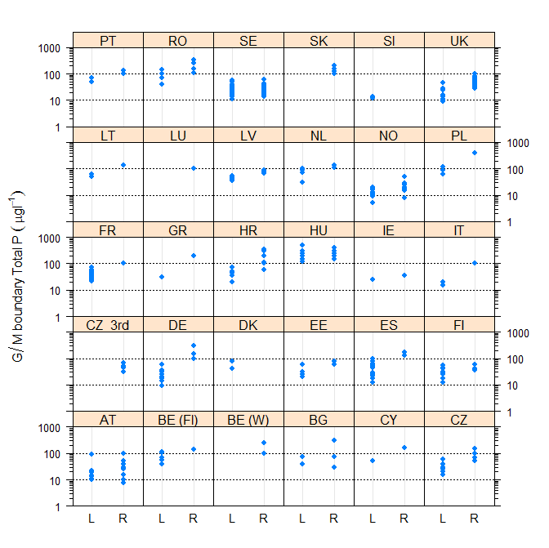
Figure 3.1-1 Comparison of Total P boundaries in lakes (L) and rivers (R) by country (UK and IE river P boundaries are Total Reactive P rather than Total P. River values for ES and AT are Soluble Reactive P, values for AT rivers and ES lakes are halved as they are 90th percentiles, river values for IE exclude 95th percentile, lake values for DE exclude 75th percentile values)
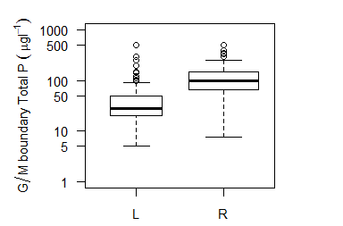
Figure 3.1-2 Range of good/moderate phosphorus boundary values in lakes (L) and rivers (R). Width of bar proportional to number of countries with boundary values (75th and 90th percentile values are halved).
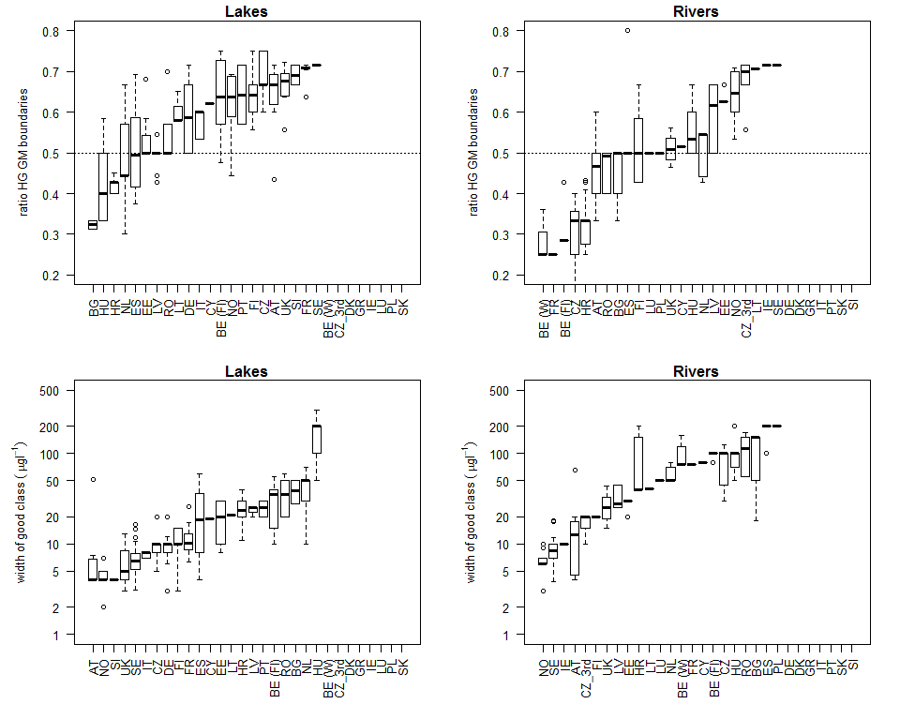
Figure 3.1-3 Range of a) ratio between high/good and good/moderate type specific phosphorus boundary values and b) the resulting width of the good class for lakes (TP) and rivers (TP and TRP/SRP if TP not measured). Arranged by country in ascending order of median value for all types reported by country. The ratio of 0.5 represents a doubling of phosphorus concentration from the high/good boundary.

Comparison of total phosphorus boundaries for lakes

Introduction
For lakes the comparison of TP boundaries is straightforward as only one country (ES) uses an upper percentile standard. There was a relatively wide range of national type specific good/moderate boundary TP values (Figure 3.2-4 & Table 3.2-8). The lowest good/moderate boundary values were reported by AT, IT, NO, Sl and UK (all with a median value less than the 25th percentile of all countries boundaries) and the highest by BE(FL), BG, DK, HU, NL, PL, PT and RO, all with a median value greater than the 75th percentile of all countries boundaries (Figure 3.2-4). Thus across Europe good/moderate phosphorus boundary values vary from <10 µgl⁻¹ to > 200 ugl⁻¹.
Within each country the range of total phosphorus boundary values is smaller than it is across Europe. This is to be expected as no single country is likely to have lakes exhibiting the full range of European conditions. The majority of Member States reported fewer good/moderate boundary values than national lake types, as often a boundary value was applied to several lake types. However typically at least 5 different values were used. Notable exceptions were BG, DK and IT, with 12, 11 and 18 national lake types respectively, but only two boundary values. It is assumed that within each Member State the range of values used reflects the different sensitivities to phosphorus of their lake types. The lowest range of good/moderate boundary values was reported by IT (15-20 µgl⁻¹), despite having 18 different lake types, and the highest by HU (120-500 µgl⁻¹), although the majority typically have boundary values spanning a range of <100 µgl⁻¹ with a median value for all countries of 46 µgl⁻¹.
There is a similar range of high/good boundary values across Europe (Figure 3.2-4). The lowest values are below 10 µgl⁻¹ and the highest above 50 µgl⁻¹(with some above 100 µgl⁻¹) which must at least partly be a reflection of different natural TP concentrations in different European lake types. It is thus important to make comparisons of boundary values within similar types of lake, using either the intercalibration (IC) typology or the recently developed European broad typology. The IC typology has the advantage that the lake types were relatively narrowly defined and thus contain the most similar lakes, although few countries are then represented in each type. In addition the intercalibration process was carried out within geographic regions and thus cannot be used for a pan-European comparison. The broad typology was designed to overcome these problems, but potentially compares lakes that are less similar, as the types are relatively widely defined. In particular alkalinity, a factor likely to reflect background phosphorus concentrations (Cardoso et al. 2007) is not explicity included, although it is reflected by broad categories of geology. Both approaches have been used, see section 3.2.2.

Country | Number of |  |  |  | Range good/moderate boundary values (µgl⁻¹)
Country | National types | National types with boundary | Unique good/moderate boundary values | Broad types | Min | Max | Range
AT | 8 | 8 | 7 | 4 | 10 | 92 | 82
BE (Fl) | 6 | 6 | 5 | 2 | 40 | 110 | 70
BE (W) | No lakes
BG | 13 | 12 | 2 | 5 | 40 | 75 | 35
CY | 1 | 1 | 1 | 1 | 50 | 50 | 0
CZ | 9 | 9 | 6 | 0 | 15 | 60 | 45
DE | 16 | 14 | 8 | 3 | 9 | 60 | 51
DK | 11 | 11 | 2 | 2 | 42 | 80 | 38
EE | 8 | 8 | 4 | 4 | 20 | 60 | 40
ES | 39 | 28 | 12 |  | 12 | 100 | 88
FI | 13 | 13 | 8 | 3 | 12 | 55 | 43
FR | 33 | 29 | 29 | 11 | 21 | 71 | 49
GR | 1 | 1 | 1 | 0 | 30 | 30 | 0
HR | 6 | 6 | 5 | 2 | 20 | 70 | 50
HU | 16 | 14 | 6 | 4 | 120 | 500 | 380
IE | 13 | 13 | 1 | 4 | 25 | 25 | 0
IT | 18 | 20 | 2 | 9 | 15 | 20 | 5
LT | 3 | 3 | 2 | 2 | 50 | 60 | 10
LU | No lakes
LV | 9 | 9 | 5 | 4 | 35 | 55 | 20
NL | 19 | 6 | 4 | 3 | 30 | 100 | 70
NO | 21 | 21 | 8 | 5 | 5 | 20 | 15
PL | 13 | 4 | 3 | 2 | 60 | 120 | 60
PT | 5 | 4 | 2 | 2 | 50 | 70 | 20
RO | 17 | 13 | 4 | 6 | 40 | 140 | 100
SE | 64 | 64 | 63 | 10 | 11 | 58 | 47
SK | No lakes
Sl | 2 | 2 | 2 | 1 | 12 | 14 | 2
UK | 8 | 8 | 8 | 3 | 9 | 47 | 38

Table 3.2-8 Number of national lake types, good/moderate boundary values and broad types with boundaries reported by each Member State. (FR SE & UK have site specific boundary values, mean for national types used in above table, values for ES are 75th percentiles)
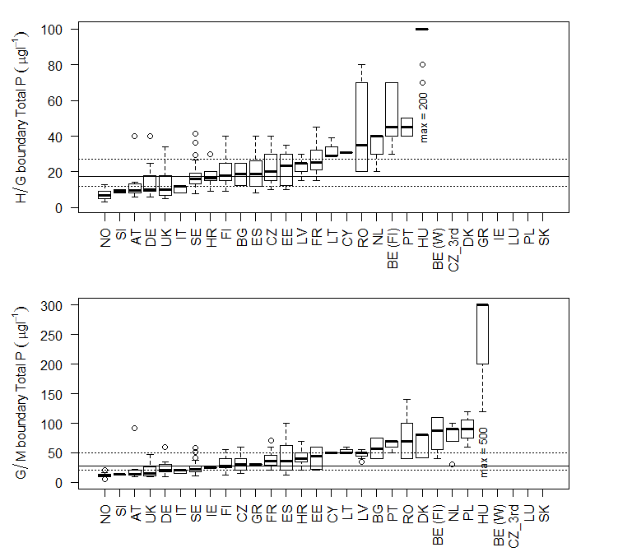
Figure 3.2-4 Range of a) high/good and b) good/moderate boundaries for lakes, arranged by median value of boundaries for each country. Lines mark 25th, 50th and 75th percentile values for all countries. (Range for DE includes only median, range for ES is for 75th percentile values)

Comparison of boundaries by lake type

Comparison of boundaries by intercalibration type
Five Member States did not report links to the intercalibration typology and are thus not represented in this comparison. The number of reported good moderate boundary values for total phosphorus in each intercalibration type is shown in Table 3.2-9. Only five types have more than 3 countries represented in the type. National boundaries for these types are shown in Appendix section 6.1.1 and all values are based on a mean or median summary statistic.
There is a clear transition in both good/moderate and high/good boundary values across the intercalibration typology (Figure 3.2-5). The lowest values were found in the low alkalinity lakes intercalibrated by the Northern GIG (NGIG). Slightly higher values were reported from moderate alkalinity and humic NGIG lakes (L-N1 L-N6a, L-N8a & L-N3a), Mediterranean reservoirs (L-M5/7, L-M8) and high alkalinity Alpine lakes (L-AL3 & L-AL4). The highest values were reported for the Eastern Continental GIG (L-EC1), the next highest in the Central Baltic GIG (CBGIG) high alkalinity lakes (L-CB1 & L-CB2), with moderate alkalinity types in the CBGIG (L-CB3) having slightly lower values, but still higher than those for what might be a similar lake type in NGIG (L-N1).
As expected the range of good/moderate boundary values within each of these intercalibration types was smaller than the range for each country, clearly demonstrating the importance of lake type when making boundary comparisons. The smallest ranges (10-20 µgl⁻¹) were reported for the NGIG and ALGIG lake types, perhaps reflecting that these types were represented by only four or less countries, but probably also reflecting the smaller range of actual TP concentrations in these lakes. In contrast the CBGIG lake types had from 6-7 countries reporting boundary values for the type with ranges of 70-80 µgl⁻¹ (Figure 3.2-5). For example the lowest values in the high alkalinity CBGIG lakes were reported by IE (25µgl⁻¹) and the highest by PL (L-CB1 90 µgl⁻¹) and BE(Fl) (L-CB2 105 µgl⁻¹) (see Figure 6.1-44 & Figure 6.1-45). The highest range of good moderate values were found in the Eastern Continental GIG (L-EC1), although only two MS (BG, HU) were represented.
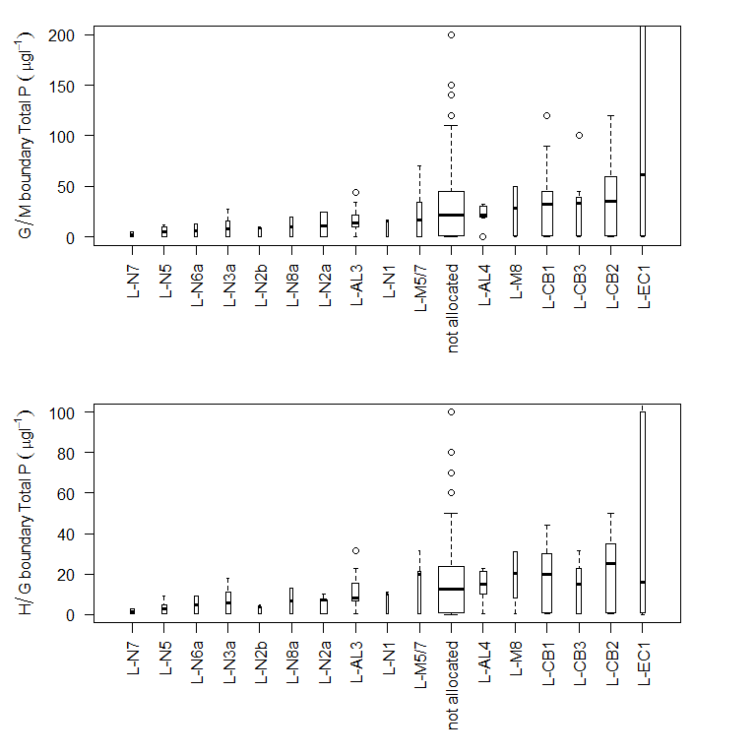
Figure 3.2-5 Range of a) good/moderate and b) high/good total phosphorus boundaries for lake intercalibration types

Intercalibration type | Number of countries | Total National Types | AT | BE (Fl) | BG | CY | CZ | DE | DK | EE | ES | FI | FR | GR | HR | HU | IE | IT | LT | LV | NL | NO | PL | PT | RO | SE | Sl | UK
not allocated |  | 201 | 1 | 2 | 12 |  | 9 | 8 | 9 | 6 | 28 | 7 | 4 | 1 | 6 | 9 | 5 | 11 |  | 2 |  |  |  | 2 | 13 | 64 |  | 3
L-AL3 | 5 | 20 | 5 |  |  |  |  | 1 |  |  |  |  | 8 |  |  |  |  | 4 |  |  |  |  |  |  |  |  | 2
L-AL4 | 4 | 15 | 2 |  |  |  |  | 2 |  |  |  |  | 8 |  |  |  |  | 3
L-CB1 | 11 | 32 |  | 2 |  |  |  | 3 | 1 | 1 |  |  | 11 |  |  |  | 2 |  | 2 | 3 | 2 |  | 4 |  |  |  |  | 1
L-CB2 | 11 | 36 |  | 2 |  |  |  | 3 | 1 | 1 |  |  | 16 |  |  |  | 2 |  | 1 | 2 | 3 |  | 4
L-CB3 | 3 | 8 |  |  |  |  |  |  |  |  |  |  | 5 |  |  |  |  |  |  | 2 | 1 |  |  |  |  |  |  | 1
L-EC1 | 1 | 5 |  |  |  |  |  |  |  |  |  |  |  |  |  | 5
L-M5/7 | 3 | 7 |  |  |  |  |  |  |  |  |  |  | 4 | 1 |  |  |  |  |  |  |  |  |  | 2
L-M8 | 4 | 6 |  |  |  | 1 |  |  |  |  |  |  | 2 | 1 |  |  |  | 2
L-N1 | 2 | 2 |  |  |  |  |  |  |  |  |  |  |  |  |  |  |  |  |  |  |  | 1 |  |  |  |  |  | 1
L-N2a | 4 | 11 |  |  |  |  |  |  |  |  |  | 2 |  |  |  |  | 4 |  |  |  |  | 4 |  |  |  |  |  | 1
L-N2b | 2 | 2 |  |  |  |  |  |  |  |  |  |  |  |  |  |  |  |  |  |  |  | 1 |  |  |  |  |  | 1
L-N3a | 2 | 5 |  |  |  |  |  |  |  |  |  | 3 |  |  |  |  |  |  |  |  |  | 2
L-N5 | 2 | 5 |  |  |  |  |  |  |  |  |  | 1 |  |  |  |  |  |  |  |  |  | 4
L-N6a | 2 | 5 |  |  |  |  |  |  |  |  |  | 1 |  |  |  |  |  |  |  |  |  | 4
L-N7 | 1 | 4 |  |  |  |  |  |  |  |  |  |  |  |  |  |  |  |  |  |  |  | 4
L-N8a | 1 | 1 |  |  |  |  |  |  |  |  |  |  |  |  |  |  |  |  |  |  |  | 1

Table 3.2-9 Number of national type specific good/moderate boundary values for TP reported for each lake intercalibration type

Comparison of boundaries by broad type
The European broad typology combines lakes into 15 different broad types and the reported national types were linked to broad types using information in Lyche-Solheim et al. (2015). A comparison between the national types allocated to each of these broad types and to the intercalibration type, as defined by each Member State in their questionnaire responses was made. In general there was a good correspondence between the intercalibration types included within each broad type and those identified by Lyche-Solheim et al. (2015), but several revisions were made where lake types and TP boundaries suggested inappropriate type matches,and the resulting correspondence is shown in Table 3.2-11. Some IC types are still split between broad types, which may reflect further inappropriate matches but the current data set contains the best currently available match between national and broad types (see tables in Appendix section 6.1.2 for details).
The majority of broad types are represented by four or more countries and some (the lowland calcareous lake types) by 14-16 countries, (Table 3.2-10). Typically the variation in high/good boundary values in each broad lake type is < 20 µgl⁻¹, although larger values do occur in some of the types (Figure 3.2-5). The greatest variation occurred in type 6 (lowland, organic & calcareous/mixed) and was the result of very high values reported by one member state (HU), see Figure 6.1-62, other countries having relatively similar values. The lowest values were found in highland lakes (broad type 12), large deep lakes and siliceous lakes (broad types 13,1, 7, 11, 2, 9), slightly higher values in the Mediterranean and lowland organic siliceous lakes (broad types 9,10,5,14). The highest values, mostly < 40 µgl⁻¹, were found in the lowland calcareous lake types (broad types 3, 4, 6). This is a pattern that would be expected from our current understanding of lake ecology and reflects the greater natural fertility of lakes found in soft rock systems. It also suggests that for the majority of countries there is a relatively uniform view of reference phosphorus conditions that matches current understanding of lake ecology.
Good moderate boundary values show a similar trend, with higher values associated with the calcareous/mixed lakes and the lowest with the siliceous lakes (Figure 3.2-7). The majority of siliceous lakes had values below 50 µgl⁻¹ and the calcareous lakes below 100 µgl⁻¹. However, there was generally a wider range of values within each of the broad types than was reported for the high/good boundary. This is either a reflection of the wider range of conditions in what is by definition a “broad” typology or it reveals differences in Member States perception of the relative sensitivity of ecology to phosphorus. In general the range of values was greater when more countries and national type boundaries were included in the broad type. As an example the highland siliceous lakes (broad type 11) had a particularly high range of national good/moderate boundaries with two countries (BG, RO) having similar higher boundary values, three countries (NO, IT, SE) with similar lower values, while on country (FR) has an intermediate value (Figure 6.1-70). This may reflect different lake types or different views of the TP concentrations required to support good status.
The range of the ratio of high/good to good/moderate boundaries shows few differences between the broad types, with the majority having ratios less than 0.5, i.e. less than a doubling of TP concentration from high/good to good/moderate (Figure 3.2-8)..
A more detailed comparison of TP lake boundary values within intercalibration and broad typologies are given in sections (6.1.1 & 6.1.2). However, from these comparisons it is suggested that while typology is a major factor accounting for differences in TP lake boundary values, country specific differences are also likely to be significant. It is very difficult to separate the effect of country and typology due to the limitations of the use of a sufficiently broad typology in the comparison across Member States. One approach to achieving this comparison is to compare the average difference between Member State boundaries and the average boundary value (of all countries contributing to the type) for each broad type (see 3.2.3)

Broad Type |  | Number countries | Total national types | AT | BE (Fl) | BG | CY | CZ | DE | DK | EE | ES | FI | FR | GR | HR | HU | IE | IT | LT | LV | NL | NO | PL | PT | RO | SE | Sl | UK
 | Not allocated |  | 129 |  | 2 | 2 |  | 9 | 7 | 7 | 1 | 39 | 8 | 17 | 1 |  | 7 |  | 1 |  | 1 | 13 |  | 9 | 1 | 2 |  |  | 2
1 | Very large & deep (stratified) (all Europe) | 4 | 5 |  |  | 1 |  |  |  |  |  |  | 2 | 1 |  |  |  |  | 1
2 | Lowland, siliceous | 7 | 32 |  |  |  |  |  |  |  | 1 |  | 1 |  |  |  |  | 4 |  |  |  |  | 6 |  |  | 1 | 15 |  | 4
3 | Lowland, stratified, calcareous/mixed | 16 | 44 |  | 2 | 4 |  |  | 2 | 1 | 4 |  |  | 2 |  |  | 4 | 4 | 2 | 2 | 3 | 3 |  | 3 |  | 3 | 5 |  | 1
4 | Lowland, calcareous/mixed, very shallow (unstratified) | 14 | 33 | 1 | 2 | 1 |  |  |  | 3 | 1 |  |  |  |  |  | 2 | 4 | 1 | 1 | 2 | 2 |  | 1 |  | 3 | 10 |  | 1
5 | Lowland, organic & siliceous | 5 | 25 |  |  |  |  |  |  |  |  |  | 2 |  |  |  |  |  |  |  | 2 |  | 3 |  |  |  | 15
6 | Lowland, organic & calcareous/mixed | 6 | 13 |  |  |  |  |  |  |  | 1 |  |  |  |  |  | 3 |  |  |  | 1 | 1 |  |  |  | 4 | 3
7 | Mid altitude, siliceous | 9 | 21 | 1 |  |  |  |  | 2 |  |  |  |  | 1 |  |  |  | 1 | 2 |  |  |  | 4 |  | 2 | 2 | 6
8 | Mid altitude, calcareous/mixed | 8 | 26 | 5 |  | 2 |  |  | 5 |  |  |  |  | 6 |  | 2 |  |  | 2 |  |  |  |  |  |  |  | 2 | 2
9 | Mid altitude, organic & siliceous | 22 | 8 |  |  |  |  |  |  |  |  |  |  |  |  |  |  |  |  |  |  |  | 2 |  |  |  | 6
10 | Mid altitude, organic & calcareous/mixed | 1 | 1 |  |  |  |  |  |  |  |  |  |  |  |  |  |  |  |  |  |  |  |  |  |  |  | 1
11 | Highland, siliceous (all Europe) | 6 | 15 |  |  | 3 |  |  |  |  |  |  |  | 2 |  |  |  |  | 1 |  |  |  | 6 |  |  | 2 | 1
12 | Higland, calcareous/mixed (all Europe) | 2 | 2 | 1 |  |  |  |  |  |  |  |  |  |  |  |  |  |  | 1
13 | Mediterranean, small-large, siliceous (including reservoirs) | 3 | 6 |  |  |  |  |  |  |  |  |  |  | 2 |  |  |  |  | 2 |  |  |  |  |  | 2
14 | Mediterranean, small-large, calcareous/mixed (including reservoirs | 4 | 11 |  |  |  | 1 |  |  |  |  |  |  | 1 |  | 4 |  |  | 5
15 | Mediterranean, very small | 1 | 1 |  |  |  |  |  |  |  |  |  |  | 1

Table 3.2-10 Number of national lake types allocated to each broad type by country

Broad Type |  | National Types | L-AL3 | L-AL4 | L-CB1 | L-CB2 | L-CB3 | L-EC1 | L-M5/7 | L-M8 | L-N1 | L-N2a | L-N2b | L-N3a | L-N5 | L-N6a | L-N7 | L-N8a | not allocated
Not allocated |  | 145 | 2 | 3 | 10 | 11 | 5 | 1 | 5 | 5 |  |  |  |  | 1 | 1 |  |  | 101
1 | Very large & deep (stratified) (all Europe) | 5 | 1 |  |  |  |  |  |  |  |  | 1 |  | 1 |  |  |  |  | 2
2 | Lowland, siliceous | 35 | 1 |  |  |  | 1 |  | 1 |  | 2 | 10 | 2 |  |  |  |  |  | 18
3 | Lowland, stratified, calcareous/mixed | 57 | 1 | 1 | 22 | 8 | 4 | 2 |  |  |  |  |  |  |  |  |  |  | 19
4 | Lowland, calcareous/mixed, very shallow (unstratif | 44 |  | 1 | 3 | 18 |  | 1 |  |  |  |  |  |  |  |  |  |  | 21
5 | Lowland, organic & siliceous | 26 |  |  |  |  | 1 |  |  |  |  |  |  | 4 |  |  |  | 1 | 18
6 | Lowland, organic & calcareous/mixed | 13 |  |  | 1 | 1 |  | 2 |  |  |  |  |  |  |  |  |  |  | 9
7 | Mid altitude, siliceous | 28 | 3 | 1 | 2 | 2 | 1 |  | 1 |  |  |  |  |  | 4 |  |  |  | 14
8 | Mid altitude, calcareous/mixed | 35 | 9 | 9 | 2 | 3 | 2 |  | 1 |  |  |  |  |  |  |  |  |  | 9
9 | Mid altitude, organic & siliceous | 8 |  |  |  |  |  |  |  |  |  |  |  |  |  | 2 |  |  | 6
10 | Mid altitude, organic & calcareous/mixed | 1 |  |  |  |  |  |  |  |  |  |  |  |  |  |  |  |  | 1
11 | Highland, siliceous (all Europe) | 20 | 1 |  |  |  |  |  | 1 |  |  |  |  |  |  | 2 | 4 |  | 12
12 | Higland, calcareous/mixed (all Europe) | 2 | 1 |  |  |  |  |  |  |  |  |  |  |  |  |  |  |  | 1
13 | Mediterranean, small-large, siliceous (including r | 6 |  |  |  |  |  |  | 2 | 1 |  |  |  |  |  |  |  |  | 3
14 | Mediterranean, small-large, calcareous/mixed (incl | 16 | 1 | 1 |  |  |  |  | 1 | 4 |  |  |  |  |  |  |  |  | 9
15 | Mediterranean, very small | 1 |  |  |  |  |  |  |  |  |  |  |  |  |  |  |  |  | 1

Table 3.2-11 Number of national lake types that could be linked to intercalibration and broad types.

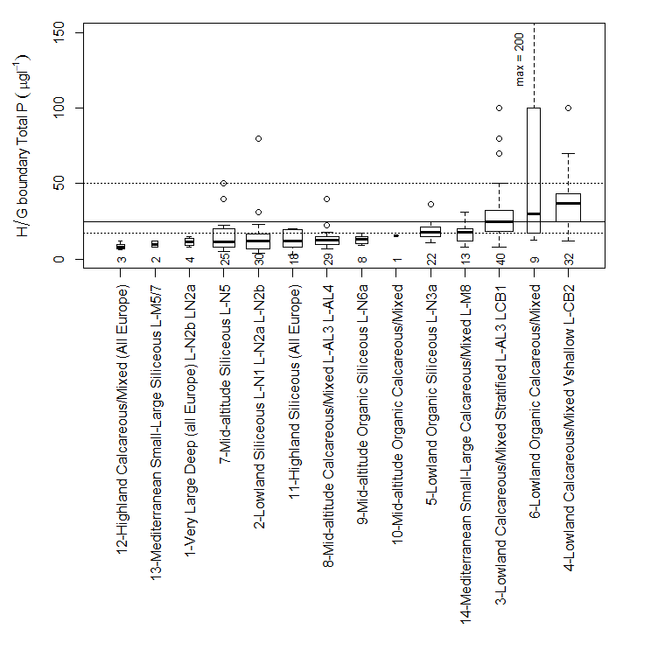
Figure 3.2-6 Range of reported high/good boundary values for lakes grouped by broad types. Numbers show the number of national types allocated to each broad type. Types ordered by median value of reported boundary.
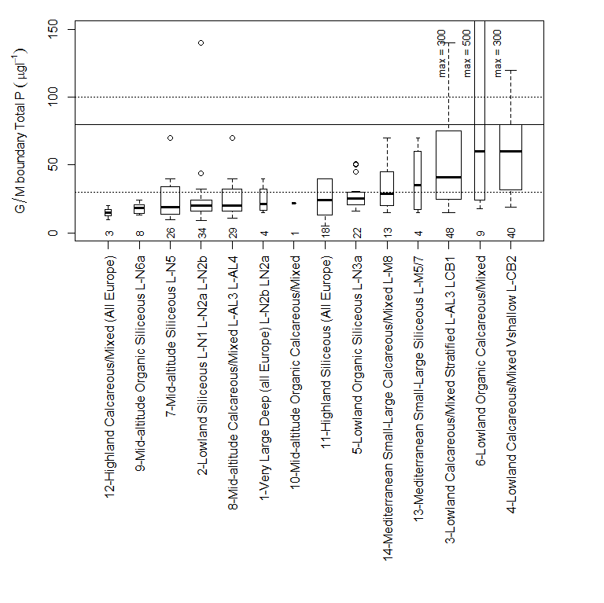
Figure 3.2-7 Range of reported good/moderate boundary values for lakes grouped by broad types. Numbers show the number of national types allocated to each broad type. Types ordered by median value of reported boundary
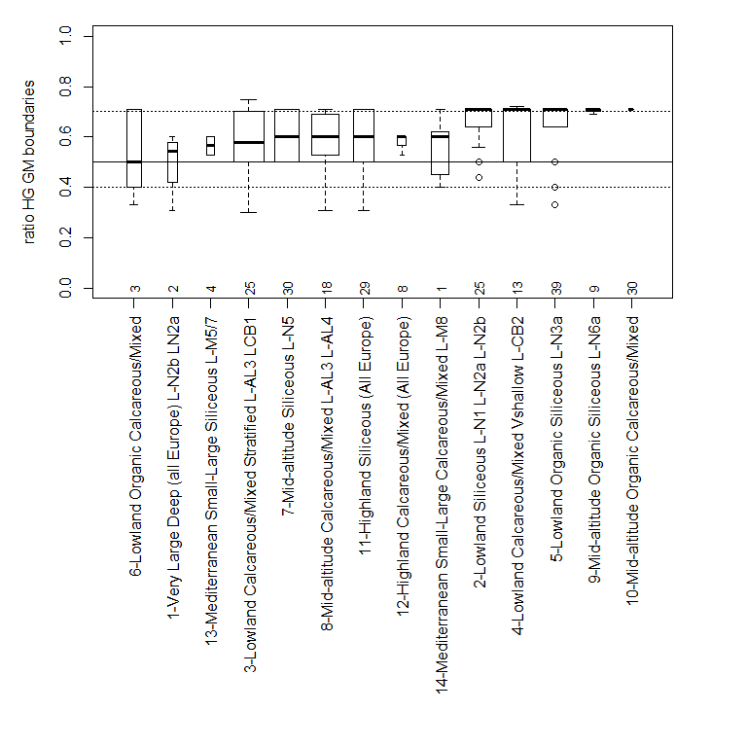
Figure 3.2-8 Range of ratio between high/good and good/moderate type specific phosphorus boundary values for each broad lake type. Numbers show the number of national types allocated to each broad type. Types ordered by median value of reported boundary

Comparison by country
The nutrient boundary values that are used to support WFD ecological status are likely to result not only from differences in background nutrient concentration and sensitivity caused by different lake morphological features such as depth and water retention, but also to the interpretation of these differences by Member States. It is very difficult to separate out these differences, but one approach is to compare the national boundary value of each country that contributes a value to a broad type with the average of all national boundary values for the type. This provides a value for each Member State that is the relative difference in concentration from the average, and thus minimises the influence of typological differences. This approach is similar to the process of comparing biological EQR values during intercalibration, with the average of all Member States boundary values forming the common view of a boundary value. By averaging the results by Member State across all broad types a value is obtained that will show on average if Member States tend to set tighter or lower boundaries.
In summary the following approach was used. After allocating national lake types to each broad type, the average national type boundary value was calculated for each broad lake type, providing a view of the boundary each country applies within a common European type. Then for each broad lake type the average boundary value for all countries included in the type was calculated, to give a type boundary, in effect a common view of all countries with lakes in the common type. The discrepancy between this common type boundary value and the national value for the type was then determined by subtracting the type average from each national value. Finally the average of these broad type specific differences was determined for each country, across all of the broad types. These values will reflect the average relative boundary value allocated by each country with respect to other countries, having removed type specific differences.
It is important to remember that this approach averages across types and thus identifies relative levels of precaution for different countries (i.e. does country A always set values that are lower/higher than country B?). A country with some very high and some very low boundary values would average out to show a low level of average difference. It should also be remembered that the averages are influenced by outlier boundary values. However, given the difficulty of making comparisons it is suggested that this is a useful approach.
The results show that on average the majority of Member States have set high/good boundary values which have differences of less than ±15µgl⁻¹ once type differences are removed (Figure 3.2-10). The exceptions are PT, RO and HU which have much higher high/good boundary values. This suggests that the majority of Member States have similar views of reference conditions for lakes.
For the good/moderate boundary the differences are higher, but the majority of Member States have a difference of less than ±30µgl⁻¹ (Figure 3.2-9). Three (PT, PL, RO) are slightly higher (< +30µgl⁻¹), while one (HU) has a much greater discrepancy (+200 µgl⁻¹).

Figure 3.2-9 Average of the discrepancies (µgl⁻¹) between the national and average broad lake type total phosphorus good/moderate boundary value, for all types by country.

Figure 3.2-10 Average of the discrepancies (µgl⁻¹) between the national and average broad lake type total phosphorus high/good boundary value, for all types by country.

Comparison by method used to set boundaries
Countries used a wide variety of methods to establish boundary values (see 2.2) and it is likely that this may influence the resulting boundary values. There is evidence that this is the case, as boundary values set using statistical distributions of all water bodies and expert judgement tend to result in higher values (Figure 3.2-11). The highest values are associated with “expert judgement”, the next highest where Member States use statistical distributions of all water bodies with data, followed by statistical distributions based on classified water bodies. Approaches using modelling and regression tend to have lower values, although note that the results for modelling are only taken from three countries. There is also a difference in the ratio of good/moderate to high/good boundaries, with larger multiples of high/good resulting from boundaries set using expert judgement and the distribution of all water bodies (Figure 3.2-12).
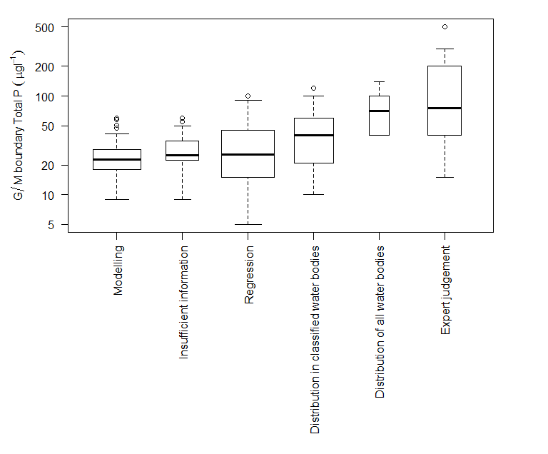
Figure 3.2-11 Range of good/moderate TP boundary values for lakes by category of method used to establish boundaries by different Member States

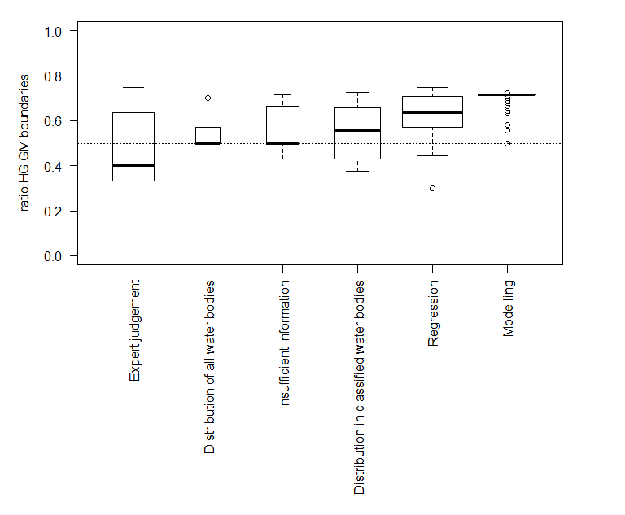
Figure 3.2-12 Range of values of the ratio of high/good to good/moderate TP boundary values for lakes by category of method used to establish boundaries by different Member States

Comparison of phosphorus boundaries for rivers

Introduction
Member States use a wider range of metrics and parameters to assess phosphorus status in rivers than they do for lakes. The majority use total phosphorus (TP), but two (AT, ES) only report soluble phosphorus (SRP) and two (UK, IE) only total reactive phosphorus (TRP). For the comparison of standards TP has been used, except for the above countries where SRP or TRP values have also been used. In addition five Member States (AT, BE(W), FR, RO, SK), report that they use a 90th percentile summary metric rather than a mean or median value. It is not always clear why these upper statistical summary values are used, they are most useful when high concentrations of a chemical have a particularly strong impact, for example low oxygen levels that result in fish deaths. In some cases (AT) it was because this summary statistic provided the best statistical fit with biological data. However, it is important to make allowances for the use of these upper percentiles as boundaries, as they would have higher values in comparison to a measure of central tendency such as a mean or median. Based on a large UK data set for both TP and TRP it is estimated that on average a 90th percentile would be approximately double the value of a mean, thus the values which use these percentiles could be approximately halved for comparative purposes.
The number of national types and corresponding number of phosphorus boundary values and the range of these boundaries is shown in Table 3.3-12. In comparison to the situation in lakes, the majority of Member States reported fewer phosphorus boundary values, despite having as many or more river types. Nine Member States (BE(Fl), CY, FR, GR, IE, IT, LT, LU, PL) have only a single (national) boundary value applicable to all river types, and 5 (BE(W), EE, ES, NL, PT) only 2 boundary values, but many river types. This lack of variability in boundary values suggests either that rivers do not vary as much in their sensitivity to phosphorus, or that there is insufficient information from which to derive boundary values, as there are fewer published pressure response relationships for rivers than there are for lakes.
The reported boundary values, in addition to being higher than those reported for lakes (see section 3.2 & Figure 3.1-2) were more variable across Europe. The lowest good/moderate boundary values were set by NO (8-50 µgl⁻¹) and the highest by PL, RO and SK (200 – 660 µgl⁻¹), although as RO and SK use 90th percentile metrics the highest equivalent mean boundary value would be more like 400 µgl⁻¹(the 660 µgl⁻¹ being equivalent to a mean of c330 µgl⁻¹). It was also noted that the majority of countries that had the smallest national range of good/moderate boundary values set boundaries that were lower than the average for all countries (Figure 3.3-13).
The high/good boundary values, which reflect Member State views of background phosphorus, showed a similarly large range of values across Europe. The lowest were reported by NO, AT, FI and the highest by CY, HU, BG, RO, LT, ES and PL. Many of these high values were also a single value, for example 100 or 200 µgl⁻¹.
These findings suggest that there may be a much less well developed understanding of both natural phosphorus levels in rivers and of the potential impact that this nutrient has on ecological status. Type specific boundary values appear to be less well developed for rivers than for lakes. However, comparisons of reported boundary values have been made using both the intercalibration and broad river typologies.
Country | Number of |  |  | Range good/moderate boundary values (µgl⁻¹)
Country | National types | Unique Good/moderate boundary values | Broad Types | Min | Max | Range
AT | 12 | 8 | 4 | 15 | 200 | 185
BE (Fl) | 8 | 1 | 3 | 140 | 140 | 0
BE (W) | 24 | 2 | 8 | 200 | 500 | 300
BG | 14 | 3 | 7 | 30 | 300 | 270
CY | 3 | 1 | 2 | 165 | 165 | 0
CZ | 21 | 4 | 5 | 50 | 150 | 100
CZ_3rd | 21 | 4 | 5 | 30 | 70 | 40
DE | 28 | 3 | 10 | 100 | 300 | 200
DK |  |  |  | No values reported
EE | 7 | 2 | 3 | 60 | 80 | 20
ES | 31 | 2 | Not linked | 133 | 167 | 33
FI | 11 | 3 | 4 | 35 | 60 | 25
FR | 88 | 1 | 14 | 200 | 200 | 0
GR | 1 | 1 |  | 200 | 200 | 0
HR | 28 | 6 | 9 | 60 | 350 | 290
HU | 25 | 5 | 6 | 150 | 400 | 250
IE | 12 | 1 | 2 | 35 | 35 | 0
IT | 59 | 1 | 11 | 100 | 100 | 0
LT | 5 | 1 | 2 | 140 | 140 | 0
LU | 6 | 1 | 4 | 100 | 100 | 0
LV | 6 | 3 | 2 | 65 | 90 | 25
NL | 12 | 2 | 4 | 110 | 140 | 30
NO | 22 | 8 | 7 | 8 | 50 | 42
PL | 25 | 1 | 12 | 400 | 400 | 0
PT | 13 | 2 | 3 | 100 | 130 | 30
RO | 19 | 4 | 6 | 220 | 660 | 440
SE | 40 | 40 | 10 | 14 | 63 | 50
SK | 36 | 4 | 6 | 200 | 400 | 200
Sl |  |  |  | No values reported
UK | 21 | 19 | 10 | 28 | 100 | 72

Table 3.3-12 Number of national types, good/moderate boundary values reported by each Member State for rivers and number of broad types that have been linked to the national types.
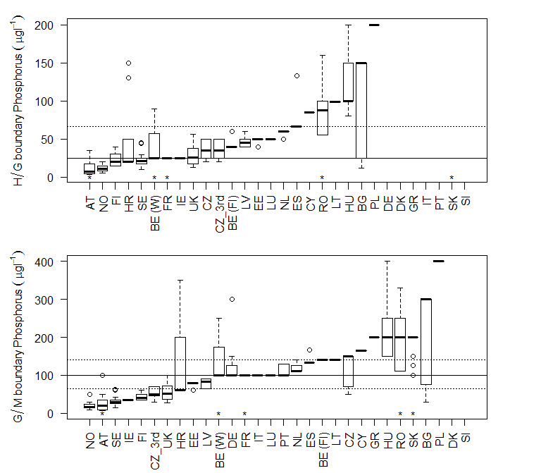
Figure 3.3-13 Range of a) high/good and b) good/moderate boundaries for rivers by country, arranged by median values of boundaries for each country. Lines mark 25th, 50th and 75th percentile values for all countries. (90th percentile metrics were halved and are identified by *)

Comparison of boundaries by river type

Comparison by intercalibration type
Seventeen intercalibration types had national boundary values for four or more countries, a higher proportion than for lakes, although these did not include types from the NGIG (Table 3.3-13). Detailed comparisons of national boundaries within those IC types are provided in section 6.2.1 with general observations below.
The lowest boundary values were found in the NGIG types, although too few countries linked national types to the NGIG types to allow useful comparisons to be made (Figure 3.3-14). For the Alpine, large river, Eastern and Central GIG types, good/moderate boundary values typically ranged over at least 100 µgl⁻¹ with several examples of boundary values with conveniently round numbers of 100 µgl⁻¹. The highest values reported were from some of the Mediterranean types, and all types from the Eastern Continental GIG.
There was a similar range of values for the high/good boundary, with the numeric value of 50 µgl⁻¹ commonly being used in the Alpine and Central river types. As for the good/moderate boundary, the highest values for high/good were found in some of the Mediterranean and Eastern Continental types, with 200 µgl⁻¹ being a relatively common value. Thus the boundary values used fall into three groups, most clearly seen when the ranges are shown by GIG (Figure 3.3-15). Low values in northern GIG, high values in Mediterranean with the other GIGs reporting boundaries between 100 and 200 µgl⁻¹.

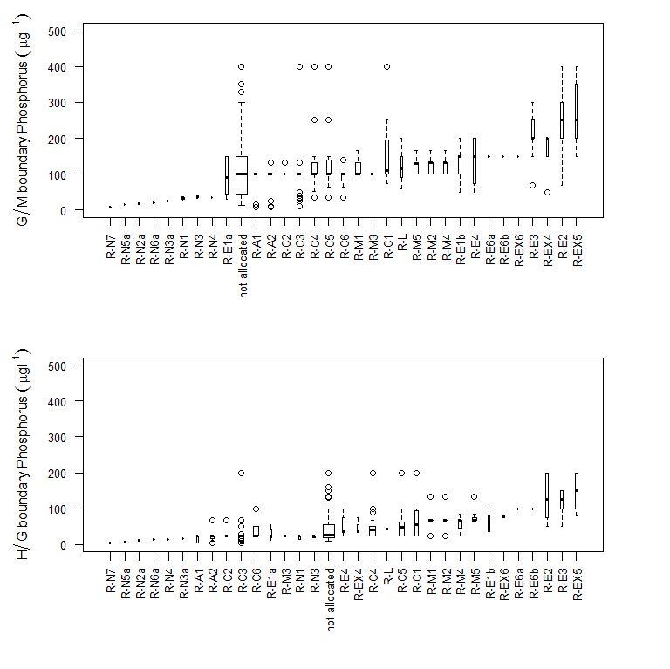
Figure 3.3-14 Range of a) good/moderate and b) high/good river phosphorus boundaries for intercalibration types, (90th percentile values halved)

Type | Countries | National Types | AT | BE (Fl) | BE (W) | BG | CY | CZ | CZ_3rd | DE | EE | ES | FI | FR | GR | HR | HU | IE | IT | LT | LU | LV | NL | NO | PL | PT | RO | SE | SK | UK
not allocated | 17 | 231 |  | 3 |  | 10 |  | 13 | 12 | 36 |  | 8 | 7 |  | 1 | 28 |  |  | 9 |  |  |  |  | 3 | 16 | 1 | 12 | 40 | 16 | 16
R-A1 | 3 | 16 | 2 |  |  |  |  |  |  |  |  |  |  | 3 |  |  |  |  | 11
R-A2 | 4 | 25 | 4 |  |  |  |  |  |  |  |  | 1 |  | 10 |  |  |  |  | 10
R-C1 | 6 | 16 |  |  | 1 |  |  |  |  |  |  |  |  | 5 |  |  |  |  |  | 1 |  |  | 5 |  | 3 |  |  |  |  | 1
R-C2 | 2 | 5 |  |  |  |  |  |  |  |  |  | 1 |  | 4
R-C3 | 7 | 32 | 5 |  | 5 |  |  |  |  |  |  | 2 |  | 14 |  |  |  |  |  |  | 2 |  |  |  | 2 |  |  |  |  | 2
R-C4 | 14 | 49 |  | 4 | 6 |  |  | 1 | 1 |  | 3 | 1 |  | 17 |  |  |  | 2 |  | 2 | 2 | 2 | 3 |  | 3 |  |  |  |  | 2
R-C5 | 12 | 36 |  |  | 6 |  |  | 1 | 1 |  | 2 | 1 |  | 10 |  |  |  | 2 |  | 2 | 1 | 3 | 4 |  | 3
R-C6 | 7 | 26 |  |  | 6 |  |  |  |  |  | 4 |  |  | 6 |  |  |  | 4 |  | 3 | 1 | 2
R-E1a | 5 | 6 |  |  |  | 1 |  | 1 | 1 |  |  |  |  |  |  |  |  |  |  |  |  |  |  |  |  |  | 1 |  | 2
R-E1b | 6 | 9 |  |  |  | 1 |  | 1 | 1 |  |  |  |  |  |  |  | 3 |  |  |  |  |  |  |  |  |  | 1 |  | 2
R-E2 | 6 | 9 |  |  |  | 1 |  | 1 | 1 |  |  |  |  |  |  |  | 4 |  |  |  |  |  |  |  |  |  | 1 |  | 1
R-E3 | 5 | 15 |  |  |  | 1 |  | 1 | 1 |  |  |  |  |  |  |  | 7 |  |  |  |  |  |  |  |  |  |  |  | 5
R-E4 | 7 | 10 | 1 |  |  | 1 |  | 2 | 2 |  |  |  |  |  |  |  | 2 |  |  |  |  |  |  |  |  |  | 1 |  | 1
R-E6a | 1 | 2 |  |  |  |  |  |  |  |  |  |  |  |  |  |  | 2
R-E6b | 1 | 1 |  |  |  |  |  |  |  |  |  |  |  |  |  |  | 1
R-EX4 | 4 | 7 |  |  |  |  |  | 1 | 1 |  |  |  |  |  |  |  |  |  |  |  |  |  |  |  |  |  | 1 |  | 4
R-EX5 | 3 | 7 |  |  |  |  |  |  |  |  |  |  |  |  |  |  | 5 |  |  |  |  |  |  |  |  |  | 1 |  | 1
R-EX6 | 2 | 2 |  |  |  |  |  |  |  |  |  |  |  |  |  |  | 1 |  |  |  |  |  |  |  |  |  | 1
R-L | 4 | 6 |  | 1 |  |  |  |  |  |  | 1 |  |  |  |  |  |  |  |  |  |  | 2 |  |  |  |  |  |  | 2
R-M1 | 4 | 40 |  |  |  |  |  |  |  |  |  | 15 |  | 4 |  |  |  |  | 14 |  |  |  |  |  |  | 7
R-M2 | 4 | 29 |  |  |  |  |  |  |  |  |  | 17 |  | 3 |  |  |  |  | 2 |  |  |  |  |  |  | 7
R-M3 | 1 | 8 |  |  |  |  |  |  |  |  |  |  |  | 8
R-M4 | 4 | 20 |  |  |  |  | 1 |  |  |  |  | 11 |  | 4 |  |  |  |  | 4
R-M5 | 4 | 41 |  |  |  |  | 2 |  |  |  |  | 18 |  |  |  |  |  |  | 14 |  |  |  |  |  |  | 7
R-N1 | 3 | 7 |  |  |  |  |  |  |  |  |  |  | 1 |  |  |  |  | 4 |  |  |  |  |  | 2
R-N2a | 1 | 4 |  |  |  |  |  |  |  |  |  |  |  |  |  |  |  |  |  |  |  |  |  | 4
R-N3 | 2 | 6 |  |  |  |  |  |  |  |  |  |  | 2 |  |  |  |  | 4
R-N3a | 1 | 2 |  |  |  |  |  |  |  |  |  |  |  |  |  |  |  |  |  |  |  |  |  | 2
R-N4 | 1 | 1 |  |  |  |  |  |  |  |  |  |  | 1
R-N5a | 1 | 4 |  |  |  |  |  |  |  |  |  |  |  |  |  |  |  |  |  |  |  |  |  | 4
R-N6a | 1 | 4 |  |  |  |  |  |  |  |  |  |  |  |  |  |  |  |  |  |  |  |  |  | 4
R-N7 | 1 | 4 |  |  |  |  |  |  |  |  |  |  |  |  |  |  |  |  |  |  |  |  |  | 4

Table 3.3-13 Number of national river types allocated to each intercalibration type with good/moderate boundary values for phosphorus.

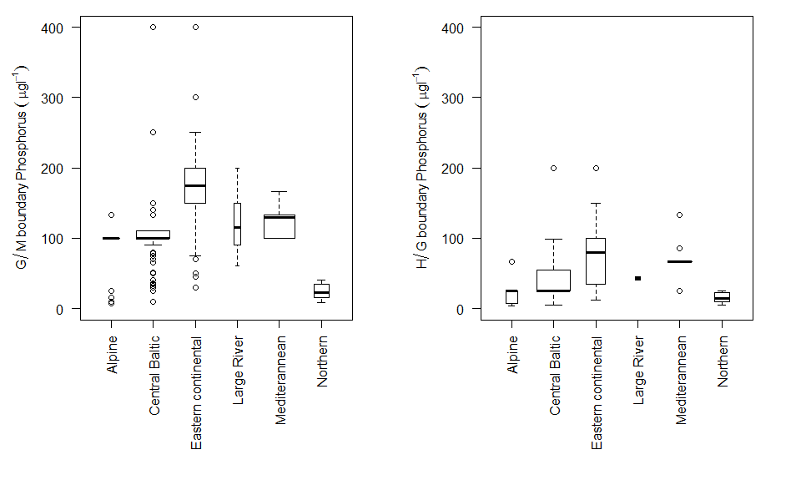
Figure 3.3-15 Range of a) good/moderate and b) high/good river phosphorus boundaries by geographic intercalibration group (90th percentile values halved)

Comparison of boundaries by broad type
A summary of the number of countries and good/moderate boundary values in each of the broad river types is given in Table 3.3-14. As for lakes, the majority of broad types have more than four countries in each type and thus provide a reasonable opportunity to make comparisons across Europe.
With a few exceptions the majority of high/good boundary values in each of the broad river types are below 50 µgl⁻¹ and the range of values is relatively small (Figure 3.3-16). However many of the types have outlier values, typically at 200 µgl⁻¹ which can be attributed to specific countries (ES, HU, RO, PL). In general there is a much less clear gradation of high/good boundary values across the broad types than was noted for lakes, although the calcareous river types had higher values. Mediterranean temporary/intermittent streams (type 20) had particularly high boundary values suggesting that even at reference condition these river types were considered to have high phosphorus concentrations.
The range of good/moderate boundary values for the broad river types is much more variable (Figure 3.3-17). Although the lowest range of boundary values were found in some of the siliceous river types there was a less clear separation between the broad types. The median boundary value was 100 µgl⁻¹, a commonly used value particularly for lowland rivers (types 3, 4, 5).
The overall impression from comparison of broad types is similar to that reached by comparing the intercalibration types: country differences are greater than type differences and the understanding of both background phosphorus concentration and potential different type sensitivity is poor, leading to a wide range of national type specific phosphorus boundaries for rivers.
Broad Type |  |  | Number Countries | AT | BE (Fl) | BE (W) | BG | CY | CZ | CZ_3rd | DE | EE | ES | FI | FR | GR | HR | HU | IE | IT | LT | LU | LV | NL | NO | PL | PT | RO | SE | SK | UK
 |  |  | 14 |  | 3 |  | 2 |  |  | 3 | 6 |  | 75 | 5 |  | 1 | 5 |  |  |  |  |  | 2 |  |  | 6 | 10 | 2 |  | 12 | 2
1 | Very large rivers (all Europe) |  | 12 |  | 1 | 1 |  |  |  |  | 2 | 1 |  | 2 | 1 |  | 4 | 6 |  |  |  |  |  | 1 |  | 1 |  | 1 |  | 2
2 | Lowland, siliceous, medium-large |  | 6 |  | 2 |  | 1 |  |  |  |  |  |  | 1 | 6 |  |  |  |  |  |  |  |  |  |  |  |  |  | 4 |  | 2
3 | Lowland, siliceous, very small-small |  | 11 |  | 2 |  |  |  |  |  | 1 |  |  | 1 | 8 |  | 1 |  | 4 |  |  |  |  | 3 | 5 | 3 |  |  | 4 |  | 2
4 | Lowland, calcareous/mixed, medium-large |  | 19 |  |  | 3 | 5 |  | 4 | 4 | 5 | 6 |  |  | 22 |  | 2 | 5 |  | 1 | 6 | 2 | 5 | 5 |  | 5 |  | 4 | 3 | 6 | 2
5 | Lowland, calcareous/mixed, very small-small |  | 20 |  |  | 1 |  |  | 2 | 2 | 7 | 3 |  |  | 5 |  | 2 | 5 | 12 | 4 | 2 | 1 | 2 | 3 | 1 | 1 |  | 2 | 4 | 1 | 2
6 | Lowland, organic & siliceous |  | 6 |  |  |  |  |  |  |  | 2 |  |  | 2 |  |  |  |  |  |  |  |  |  |  | 3 | 1 |  |  | 8 |  | 3
7 | Lowland, organic & calcareous/mixed |  | 3 |  |  |  |  |  |  |  | 2 |  |  |  |  |  |  |  |  |  |  |  |  |  | 2 |  |  |  | 7
8 | Mid altitude, siliceous, medium-large |  | 9 |  |  | 3 | 1 |  |  |  | 1 |  |  |  | 6 |  |  |  |  | 2 |  | 1 |  |  |  | 1 |  |  | 2 |  | 2
9 | Mid altitude, siliceous, very small-small |  | 12 | 5 |  | 2 | 2 |  |  |  | 2 |  |  |  | 11 |  |  | 1 |  | 7 |  | 2 |  |  | 4 | 3 |  |  | 2 |  | 2
10 | Mid altitude, calcareous/mixed, medium-large |  | 12 | 1 |  | 7 |  |  | 6 | 5 | 5 |  |  |  | 2 |  | 3 | 4 |  |  |  |  |  |  |  | 1 |  | 3 |  | 9 | 2
11 | Mid altitude, calcareous/mixed, very small-small |  | 11 |  |  | 6 |  |  | 6 | 6 | 3 |  |  |  |  |  | 3 | 4 |  | 9 |  |  |  |  |  | 2 |  | 3 |  | 2 | 1
12 | Mid altitude, organic & siliceous |  | 3 |  |  | 1 |  |  |  |  |  |  |  |  |  |  |  |  |  |  |  |  |  |  | 2 |  |  |  | 4
13 | Mid altitude, organic & calcareous/mixed |  | 2 |  |  |  |  |  |  |  |  |  |  |  |  |  |  |  |  |  |  |  |  |  |  | 1 |  |  | 2
14 | Highland (all Europe), siliceous |  | 7 | 4 |  |  | 2 |  |  |  |  |  |  |  | 4 |  |  |  |  | 2 |  |  |  |  | 6 | 1 |  |  |  |  | 1
15 | Highland (all Europe), calcareous/mixed |  | 8 | 2 |  |  | 1 | 1 | 4 | 1 |  |  |  |  | 5 |  |  |  |  |  |  |  |  |  |  | 1 |  |  |  | 2
16 | Glacial rivers (all Europe) |  | 2 |  |  |  |  |  |  |  |  |  |  |  | 7 |  |  |  |  | 5
17 | Mediterranean, lowland, medium-large, perennial |  | 4 |  |  |  |  |  |  |  |  |  |  |  | 3 |  | 3 |  |  | 3 |  |  |  |  |  |  | 8
18 | Mediterranean, mid altitude, medium-large, perenni |  | 3 |  |  |  |  |  |  |  |  |  |  |  | 5 |  | 1 |  |  | 4
19 | Mediterranean, very small-small, perennial |  | 4 |  |  |  |  |  |  |  |  |  |  |  | 3 |  | 4 |  |  | 11 |  |  |  |  |  |  | 2
20 | Mediterranean, temporary/intermittent streams |  | 5 |  |  |  | 1 | 2 |  |  |  |  |  |  |  |  |  |  |  | 16 |  |  |  |  |  |  | 2 | 4

Table 3.3-14 Number of national river types with reported good/moderate phosphorus boundaries allocated to each broad type by country

Broad Type |  | National types | R-A1 | R-A2 | R-C1 | R-C2 | R-C3 | R-C4 | R-C5 | R-C6 | R-E1a | R-E1b | R-E2 | R-E3 | R-E4 | R-E6a | R-E6b | R-EX4
Not allocated |  | 7 |  | 1 |  | 1 | 2 | 1 | 2
1 | Very large rivers (all Europe) | 9 |  |  |  |  |  |  | 3 |  |  |  |  | 3 |  | 2 | 1
2 | Lowland, siliceous, medium-large | 7 |  |  |  | 2 |  | 2 | 3
3 | Lowland, siliceous, very small-small | 15 |  |  | 11 | 2 |  | 2
4 | Lowland, calcareous/mixed, medium-large | 75 |  |  |  |  |  | 33 | 20 | 5 |  |  | 7 | 10
5 | Lowland, calcareous/mixed, very small-small | 28 |  |  | 5 |  |  | 4 | 2 | 15 |  |  | 2
6 | Lowland, organic & siliceous | 0
7 | Lowland, organic & calcareous/mixed | 0
8 | Mid altitude, siliceous, medium-large | 10 | 1 | 1 |  |  | 5 | 1 | 2
9 | Mid altitude, siliceous, very small-small | 32 | 3 | 3 |  |  | 23 |  |  |  |  | 2 |  |  | 1
10 | Mid altitude, calcareous/mixed, medium-large | 28 |  | 1 |  |  |  | 5 | 4 |  | 1 | 1 |  | 2 | 7 |  |  | 7
11 | Mid altitude, calcareous/mixed, very small-small | 21 | 4 |  |  |  |  |  |  | 6 | 3 | 6 |  |  | 2
12 | Mid altitude, organic & siliceous | 1 |  |  |  |  | 1
13 | Mid altitude, organic & calcareous/mixed | 1 |  |  |  |  |  | 1
14 | Highland (all Europe), siliceous | 10 | 1 | 7 |  |  | 1 |  |  |  | 1
15 | Highland (all Europe), calcareous/mixed | 6 | 5 |  |  |  |  |  |  |  | 1
16 | Glacial rivers (all Europe) | 12 |  | 12
17 | Mediterranean, lowland, medium-large, perennial | 0
18 | Mediterranean, mid altitude, medium-large, perenni | 0
19 | Mediterranean, very small-small, perennial | 0
20 | Mediterranean, temporary/intermittent streams | 2 | 2

Table 3.3-15 Number of national river types allocated to each broad type by country (continued)

Broad Type |  | R-EX5 | R-EX6 | R-L | R-M1 | R-M2 | R-M3 | R-M4 | R-M5 | R-N1 | R-N2a | R-N3 | R-N3a | R-N4 | R-N5a | R-N6a | R-N7 | not allocated
Not allocated |  |  |  | 1 | 12 | 15 | 1 | 5 | 10 |  |  |  |  |  |  |  |  | 88
1 | Very large rivers (all Europe) |  |  | 8 |  |  |  |  |  |  |  |  |  |  |  |  |  | 21
2 | Lowland, siliceous, medium-large |  |  |  |  | 1 |  |  |  |  |  |  |  | 1 |  |  |  | 7
3 | Lowland, siliceous, very small-small |  |  |  | 1 |  |  |  |  | 2 | 3 | 4 |  |  |  |  |  | 8
4 | Lowland, calcareous/mixed, medium-large |  |  | 1 |  |  |  |  |  |  |  |  |  |  |  |  |  | 24
5 | Lowland, calcareous/mixed, very small-small | 6 |  |  |  |  |  |  |  | 5 |  |  |  |  |  |  |  | 22
6 | Lowland, organic & siliceous |  |  |  |  |  |  |  |  |  |  | 2 | 2 |  |  |  |  | 15
7 | Lowland, organic & calcareous/mixed |  |  |  |  |  |  |  |  |  |  |  |  |  |  |  |  | 11
8 | Mid altitude, siliceous, medium-large |  |  |  |  | 2 | 1 |  |  |  |  |  |  |  |  |  |  | 10
9 | Mid altitude, siliceous, very small-small |  |  |  |  |  |  |  |  |  |  |  |  |  | 4 |  |  | 7
10 | Mid altitude, calcareous/mixed, medium-large |  | 1 |  |  |  |  |  |  |  |  |  |  |  |  |  |  | 31
11 | Mid altitude, calcareous/mixed, very small-small | 1 | 1 |  | 2 |  |  |  |  |  |  |  |  |  |  |  |  | 22
12 | Mid altitude, organic & siliceous |  |  |  |  |  |  |  |  |  |  |  |  |  |  | 2 |  | 4
13 | Mid altitude, organic & calcareous/mixed |  |  |  |  |  |  |  |  |  |  |  |  |  |  |  |  | 3
14 | Highland (all Europe), siliceous |  |  |  | 1 |  |  |  |  |  |  |  |  |  |  | 2 | 4 | 3
15 | Highland (all Europe), calcareous/mixed |  |  |  |  |  |  | 3 |  |  |  |  |  |  |  |  |  | 13
16 | Glacial rivers (all Europe) |  |  |  |  |  |  |  |  |  |  |  |  |  |  |  |  | 1
17 | Mediterranean, lowland, medium-large, perennial |  |  |  | 2 | 5 | 3 | 1 | 3 |  |  |  |  |  |  |  |  | 3
18 | Mediterranean, mid altitude, medium-large, perenni |  |  |  | 1 |  | 4 | 4 |  |  |  |  |  |  |  |  |  | 1
19 | Mediterranean, very small-small, perennial |  |  |  | 15 |  |  | 1 |  |  |  |  |  |  |  |  |  | 4
20 | Mediterranean, temporary/intermittent streams |  |  |  |  |  |  |  | 18 |  |  |  |  |  |  |  |  | 5

Table 3.3.4 continued. Number of national river types allocated to each broad type by country

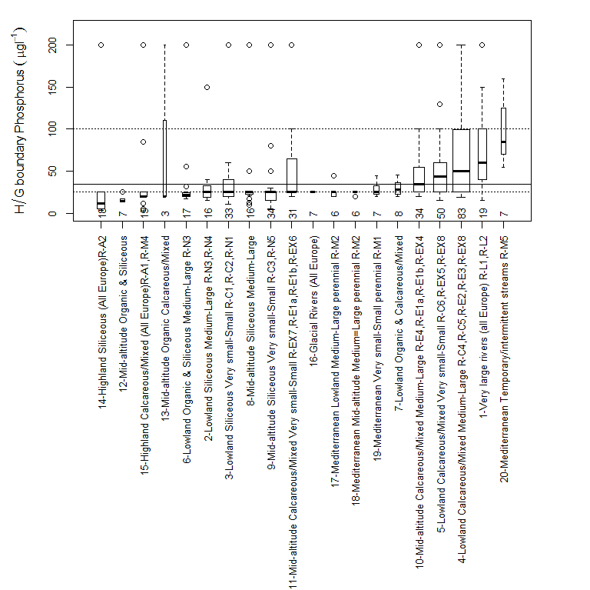
Figure 3.3-16 Range of reported high/good phosphorus boundary values for rivers grouped by broad types, (90th percentile values halved). Numbers show the number of national types allocated to each broad type. Types ordered by median value of reported boundary, dotted lines show interquartile range for all broad types.

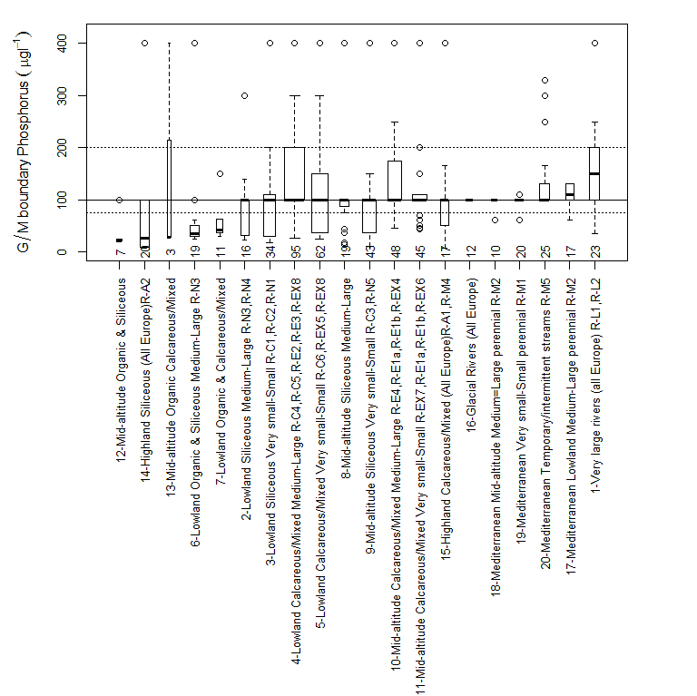
Figure 3.3-17 Range of reported good/moderate phosphorus boundary values for rivers grouped by broad types (90th percentile values halved). Numbers show the number of national types allocated to each broad type. Types ordered by median value of reported boundary, dotted lines show interquartile range for all broad types.

Comparison by country
To compare whether Member States on average tend to set tighter or lower boundaries the same approach as that described for lakes was used (see section 3.2.3). This involved calculating the difference between national and average broad type specific boundary values, and then combining these values as a national average discrepancy.
In comparison to lakes the range of discrepancies was much greater. The majority of Member States set good/moderate boundary values that were >30 µgl⁻¹ lower than the average of all countries, and several (IE, SE, FI, CZ EE. NO, AT, LV, UK) >50 µgl⁻¹ tighter (Figure 3.3-18). Two countries (HU and PL) set boundaries that were >50 µgl⁻¹ lower, in the case of PL 250 µgl⁻¹ lower. It should also be noted that the low values for AT are for SRP and were derived by halving the 90th percentile and so may be less comparable. Similar, although smaller discrepancies were seen for the high/good boundary, although again these were much greater than those for lakes (Figure 3.3-19).

Figure 3.3-18 Average of the discrepancies (µgl⁻¹) between the national and average broad type river phosphorus good/moderate boundary value for all types by country. (90th percentile values halved AT, BE (W), FR, RO, SK)

Figure 3.3-19 Average of the discrepancies (µgl⁻¹) between the national and average broad type river phosphorus high/good boundary value for all types by country. (90th percentile values halved AT, BE (W), FR, RO, SK)

Comparison by methods used to set boundaries
Differences in boundary values were also apparent when grouped by the method used to establish the boundary. The lowest good/moderate boundaries were found where countries used modelling and regression methods, slightly higher values when categorical methods of classified water bodies were used and the highest when the distribution of all water bodies were used (Figure 3.3-20). Differences were less clear for the high/good boundary, but again the highest values occurred when the distribution of all water bodies was used (Figure 3.3-21)
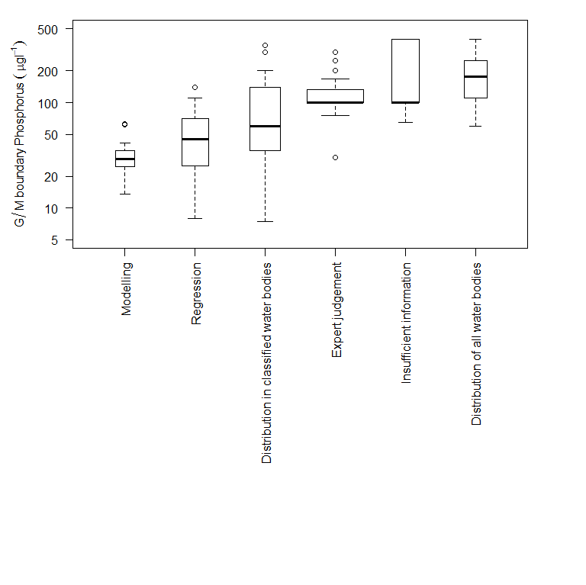
Figure 3.3-20 Range of good/moderate river phosphorus boundary values grouped by category of method used to determine the value. (90th percentile values halved)

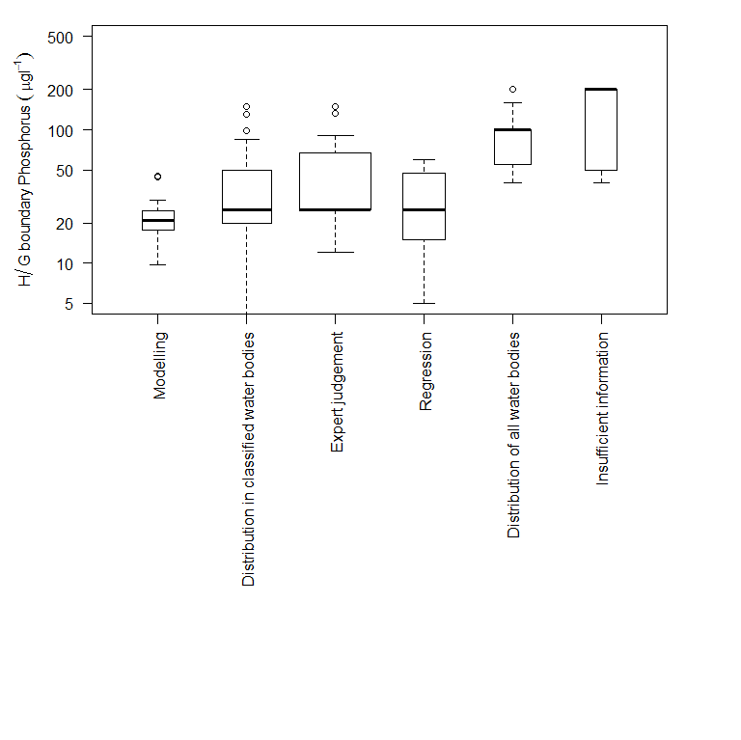
Figure 3.3-21 Range of high/good river phosphorus boundary values grouped by category of method used to determine the value. (90th percentile values halved)

Comparison of Nitrogen boundary values

Range of metrics and boundary values used
Fewer Member States reported nitrogen boundary values than for phosphorus (compare Table 4.1-16 & Table 3.1-5). For lakes, the majority reported total nitrogen (TN), with a few (FR, HR) only reporting nitrate nitrogen (Table 4.1-17). All except FR use a mean value as a summary statistic, FR uses a maximum value. For rivers there is a wider range of summary metrics, and the majority of Member States use nitrate rather than total nitrogen as a quality element. Several Member States use 90th percentile values (AT, BE(Fl & W), FR, RO, SK) rather than mean or median values and CZ (3rd cycle) uses both a median and a maximum value,.
The majority of countries use annual summary statistics for rivers, and growing season summary statistics for lakes. This may reflect the greater ease of sampling rivers throughout the year, and where the 90th percentile summary statistic of nitrate is used on annual data, the value may reflect the winter concentration, which is least influenced by biological uptake, and thus a better indicator of nitrogen load.
Category | Parameter | Period | Not specified | 90th percentile | maximum | mean | median
Lakes | Nitrate N | Annual |  |  |  | 3
Lakes | Nitrate N | Growth Season |  |  | 1 | 2
Lakes | Total N | Annual |  |  |  | 5
Lakes | Total N | Growth Season | 1 |  |  | 9
Rivers | Nitrate N | Annual | 1 | 6 | 1 | 8 | 3
Rivers | Nitrate N | Growth Season |  |  |  | 1
Rivers | Total N | Annual |  | 2 |  | 7 | 1
Rivers | Total N | Growth Season |  |  |  | 3

Table 4.1-16 Number of countries using different summary metrics and parameters to specify lake and river nitrogen boundary values

Category | Country | Period | Nitrate N | Total N
Lakes | BE (Fl) | Growth Season |  | mean
Lakes | BG | Annual | mean | mean
Lakes | DK | Growth Season |  | mean
Lakes | EE | Growth Season |  | mean
Lakes | FI | Growth Season |  | mean
Lakes | FR | Growth Season | maximum
Lakes | GR | Annual |  | mean
Lakes | HR | Growth Season | mean
Lakes | HU | Annual | mean | mean
Lakes | LT | Growth Season |  | mean
Lakes | LV | Annual |  | mean
Lakes | NL | Growth Season |  | mean
Lakes | NO | Growth Season |  | mean
Lakes | PL | Growth Season |  | mean
Lakes | PT | Annual | mean | mean
Lakes | RO | Growth Season | mean | mean
Table 4.1-2a Summary metrics and parameters used to specify lake boundary values by country
Category | Country | Period | Nitrate N | Total N
Rivers | AT | Annual | 90th percentile
Rivers | BE (Fl) | Annual | 90th percentile
Rivers | BE (Fl) | Growth Season |  | mean
Rivers | BE (W) | Annual | 90th percentile
Rivers | BG | Annual | mean | mean
Rivers | CY | Annual | mean
Rivers | CZ | Annual | median
Rivers | CZ_3rd | Annual | median & maximum
Rivers | EE | Annual |  | mean
Rivers | ES | Annual
Rivers | FI | Annual |  | mean
Rivers | FR | Annual | 90th percentile
Rivers | GR | Annual | mean
Rivers | HR | Annual | median | median
Rivers | HU | Annual | mean | mean
Rivers | IT | Annual | mean
Rivers | LT | Annual
Rivers | LU | Annual | mean
Rivers | LV | Annual |  | mean
Rivers | NL | Growth Season |  | mean
Rivers | NO | Annual |  | mean
Rivers | PL | Growth Season | mean | mean
Rivers | PT | Annual | mean
Rivers | RO | Annual | 90th percentile | 90th percentile
Rivers | SK | Annual | 90th percentile | 90th percentile

Table 4.1-17b Summary metrics and parameters used to specify lake and river nitrogen boundary values by country

As was the case for phosphorus, river nitrogen boundary values were higher than those for lakes (Figure 4.1-22, Figure 4.1-23,). For lakes the good/moderate boundary values typically range from 0.7 - 2.0 mgl⁻¹ and for nitrate nitrogen 0.5 – 1.0 mgl⁻¹. For rivers total nitrogen values range from 1.5 - 5.0 mgl⁻¹ and nitrate nitrogen from 2.0 – 6.0 mgl⁻¹ (Figure 4.1-24), however it is important to remember that several Member States use 90th percentile values for rivers which will be higher than a mean or median value. Based on a large UK data set for nitrate it is estimated that on average a 90th percentile would be approximately double the value of a mean, thus when comparing boundaries the values which use these percentiles could be approximately halved for comparative purposes.

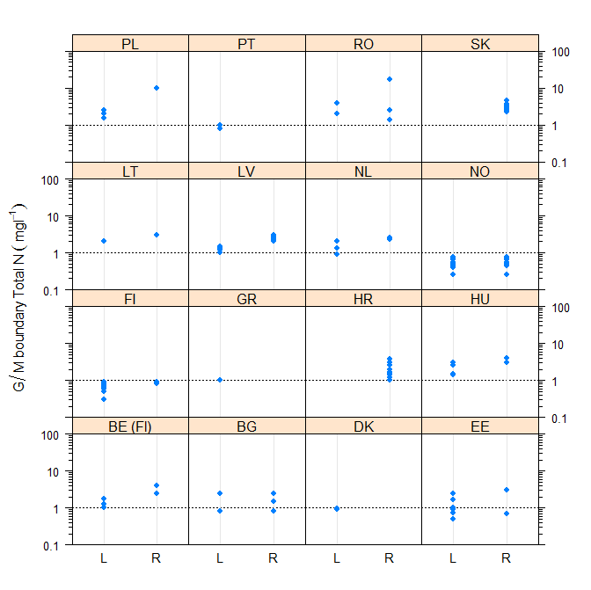
Figure 4.1-22 Comparison of total nitrogen good/moderate boundaries in lakes (L) and rivers (R) by country (river 90th percentile values halved RO, SK)
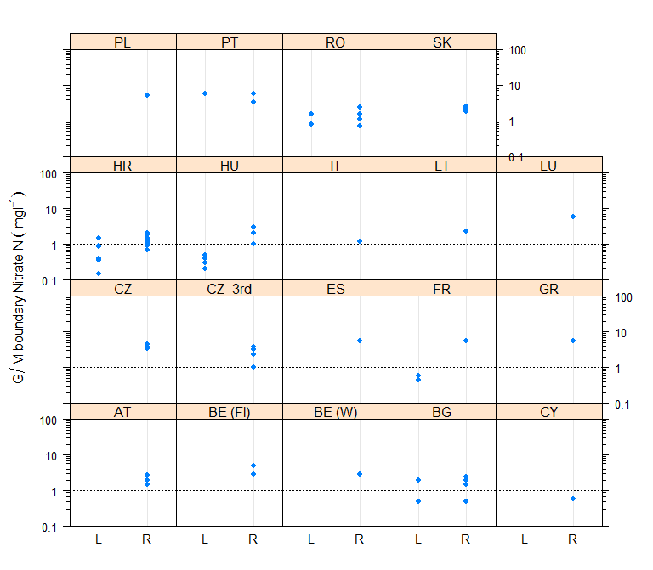
Figure 4.1-23 Comparison of nitrate nitrogen good/moderate boundaries in lakes (L) and rivers (R) by country (maximum (FR lakes) and 90th percentiles rivers AT, BE, FR, RO, SK halved)
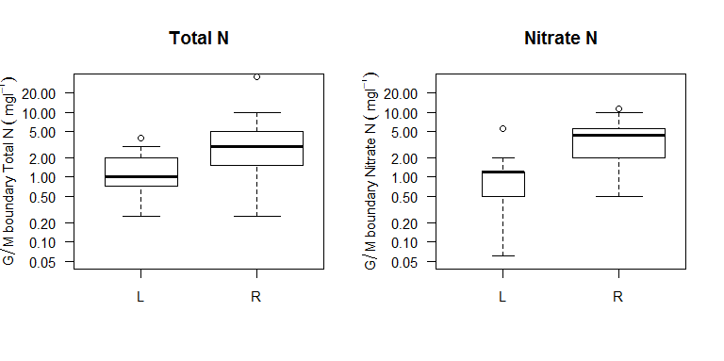
Figure 4.1-24 Range of good/moderate nitrogen boundary values in lakes (L) and rivers (R). Width of bar proportional to number of countries with boundary values.

Comparison of nitrogen boundaries for lakes

Introduction
Sixteen Member States report boundary values for total nitrogen or nitrate nitrogen (). There were a wide range of values reported, but in comparison to phosphorus there were fewer different national type values, with many Member States having three or fewer different values covering all of their lake types. Hungary and Romania report values higher than the upper quartile of all Member States, and Norway and Finland lower than the lower quartile (Figure 4.2-25). Fewer countries report nitrate nitrogen boundary values, but the range of values is much smaller than for total nitrogen, although Portugal report a higher value of 5.65 mgl⁻¹ which was based on the now repealed Drinking Water Directive (80/778/EC) and only applies to reservoirs. (Figure 4.2-26).
There is a similar range of values for the high/good boundary as there is for the good/moderate boundary suggesting that Member States views of reference condition for nitrogen are relatively variable, or that they reflect the different lake types found in each country.
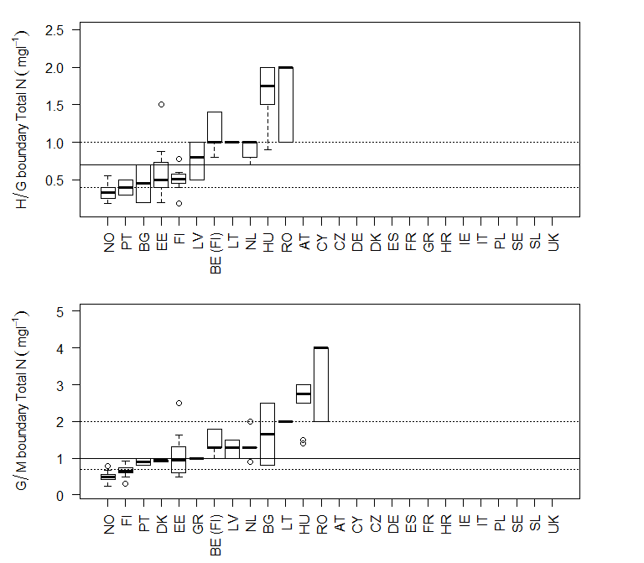
Figure 4.2-25 Range of a) high/good and b) good/moderate total nitrogen boundaries for lakes by country, arranged by median value of boundaries for each country. Lines mark 25th, 50th and 75th percentile values for countries.
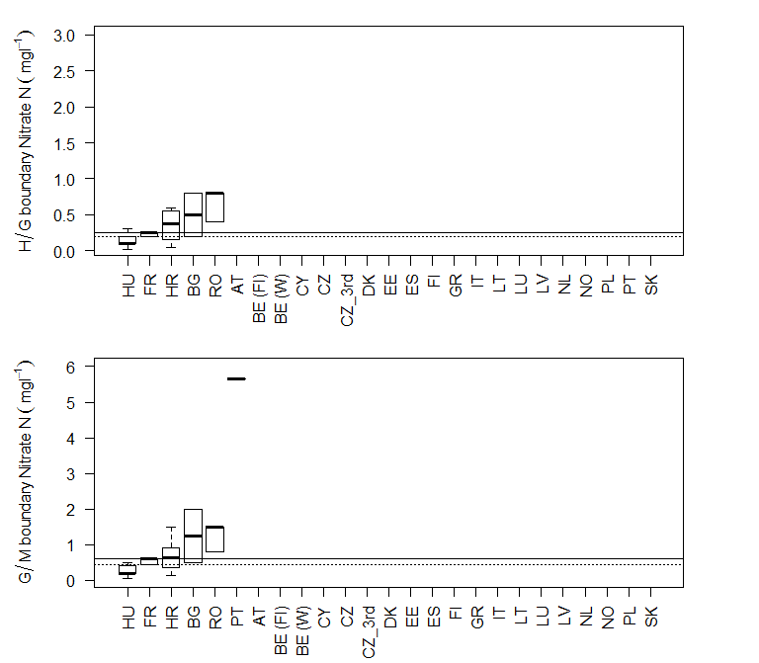
Figure 4.2-26 Range of a) high/good and b) good/moderate nitrate nitrogen boundaries for lakes by country (reservoirs for PT), arranged by median value of boundaries for each country. Lines mark 25th, 50th and 75th percentile values for countries (maximum value for FR was halved for comparison)

Country |  | Number of |  |  | Range good/moderate boundary values (mgl⁻¹) |  |  | Form of nitrogen
 |  | National types | Broad type | Good/moderate boundary values | Min | Max | Range | Form of nitrogen
Austria | AT | 8 | 4
Belgium (Flanders) | BE (Fl) | 6 | 2 | 3 | 1 | 1.8 | 0.8 | TN
Belgium (Wallonia) | BE (W) | No lakes
Bulgaria | BG | 13 | 5 | 2 | 0.5 | 2 | 1.5 | NO3 N
 |  |  |  | 2 | 0.8 | 2.5 | 1.7 | TN
Cyprus | CY | 1 | 1
Czech Republic | CZ | 9
Germany | DE | 16 | 3
Denmark | DK | 11 | 2 | 2 | 0.9 | 0.95 | 0.05 | TN
Estonia | EE | 8 | 4 | 7 | 0.5 | 2.5 | 2 | TN
Spain | ES | 39
Finland | FI | 13 | 3 | 9 | 0.3 | 0.93 | 0.63 | TN
France | FR | 33 | 11 | 3 | 0.9 | 1.2 | 0.3 | NO3 N
Greece | GR | 1 |  | 1 | 1 | 1 | 0 | TN
Croatia (Hravtska) | HR | 6 | 2 | 6 | 0.15 | 1.5 | 1.35 | NO3 N
Hungary | HU | 16 | 4 | 5 | 0.06 | 0.5 | 0.44 | NO3 N
 |  |  |  | 4 | 1.4 | 3 | 1.6 | TN
Ireland | IE | 13 | 4
Italy | IT | 18 | 9
Lithuania | LT | 3 | 2 | 1 | 2 | 2 | 0 | TN
Latvia | LV | 9 | 4 | 4 | 1 | 1.5 | 0.5 | TN
Netherlands | NL | 19 | 3 | 3 | 0.9 | 2 | 1.1 | TN
Norway | NO | 21 | 5 | 8 | 0.25 | 0.78 | 0.53 | TN
Poland | PL | 13 | 2 | 3 | 1.5 | 2.5 | 1 | TN
Portugal | PT | 5 | 2 | 1 | 5.65 | 5.65 | 0 | NO3 N
 |  |  |  | 2 | 0.8 | 1 | 0.2 | TN
Romania | RO | 17 | 6 | 2 | 0.8 | 1.5 | 0.7 | NO3 N
 |  |  |  | 2 | 2 | 4 | 2 | TN
Sweden | SE | 64 | 10
Slovenia | Sl | 2 | 1
United Kingdom | UK | 8 | 3

Table 4.2-18 Number of national types, good/moderate boundary values for nitrogen (total nitrogen and nitrate) reported by Member States for lakes and number of broad types that have been linked to national types.

Comparison of boundaries by lake type
To account for differences due to typology lake nitrogen boundary values have been compared by both intercalibration and broad types. The intercalibration typology is likely to provide the most similar lake types, but has fewer countries per type than the broad typology. A full comparison of boundary values is shown in section 6 Appendices and a summary is set out below.

Comparison of boundaries by intercalibration type
There were only two intercalibration types (L-CB1 and L-CB2) where more than 3 countries reported boundary values (Table 4.2-19). These showed a relatively narrow range of total nitrogen boundary values (1.0 - 2.0 mgl⁻¹) (Figure 4.2-27 and for detail see Figure 6.1-45 & Figure 6.1-47).

IC Type | Number Countries contributing to type | BE (Fl) | BG | DK | EE | FI | FR | GR | HR | HU | LT | LV | NL | NO | PL | PT | RO
L-AL3 | 1 |  |  |  |  |  | 5
L-AL4 | 1 |  |  |  |  |  | 6
L-CB1 | 8 | 2 |  | 1 | 1 |  | 9 |  |  |  | 2 | 3 | 2 |  | 4
L-CB2 | 8 | 2 |  | 1 | 1 |  | 10 |  |  |  | 1 | 2 | 3 |  | 4
L-CB3 | 3 |  |  |  |  |  | 7 |  |  |  |  | 2 | 1
L-EC1 | 1 |  |  |  |  |  |  |  |  | 10
L-M5/7 | 3 |  |  |  |  |  | 5 | 1 |  |  |  |  |  |  |  | 2
L-M8 | 2 |  |  |  |  |  | 4 | 1
L-N1 | 1 |  |  |  |  |  |  |  |  |  |  |  |  | 1
L-N2a | 2 |  |  |  |  | 2 |  |  |  |  |  |  |  | 4
L-N2b | 1 |  |  |  |  |  |  |  |  |  |  |  |  | 1
L-N3a | 2 |  |  |  |  | 3 |  |  |  |  |  |  |  | 2
L-N5 | 2 |  |  |  |  | 1 |  |  |  |  |  |  |  | 4
L-N6a | 2 |  |  |  |  | 1 |  |  |  |  |  |  |  | 4
L-N7 | 1 |  |  |  |  |  |  |  |  |  |  |  |  | 4
L-N8a | 1 |  |  |  |  |  |  |  |  |  |  |  |  | 1
not allocated |  | 2 | 24 | 9 | 6 | 7 | 15 |  | 6 | 18 |  | 2 |  |  |  | 2 | 22
Total National Types |  | 6 | 13 | 11 | 8 | 13 | 33 | 1 | 6 | 16 | 3 | 9 | 19 | 21 | 13 | 5 | 17

Table 4.2-19 Number of national lake types with reported nitrogen good/moderate boundary values (total nitrogen or nitrate) by intercalibration type.

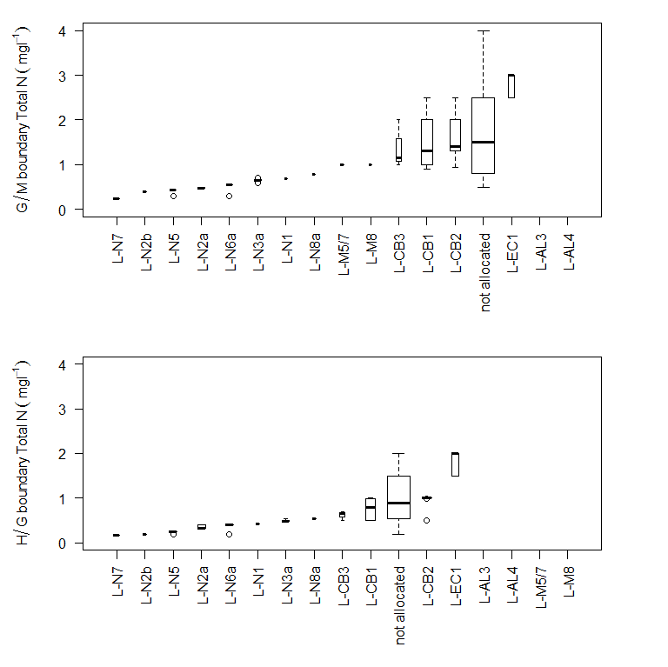
Figure 4.2-27 Range of reported lake total nitrogen boundary values for each intercalibration type, arranged by median national boundary value for the type. Width of bar is proportional to the number of national types linked to intercalibration type.

Comparison of boundaries by broad type
Seven broad types had four or more countries with boundaries linked to the broad type (). The lowest boundary values reported were found in the siliceous lake types, typically with good/moderate boundary values below 2.0mgl⁻¹ and for broad types 2,9 and 11 (lowland, mid-altitude organic and highland siliceous) most below 1.0 mgl⁻¹ (Figure 4.2-28). The highest values were reported for the calcareous lake types, mostly above 1.0 mgl⁻¹ but below 3.0 mgl⁻¹. Several types had total nitrogen boundary values that were outliers, e.g. values of 4.0 for broad type 2 and 2.0 for broad type 11, both reported by RO. For further details of national boundaries in each type see Appendix section 6.1.2.
Typically nitrate nitrogen boundary values had a lower range of values (Figure 4.2-29). Siliceous lake types had the lowest values, calcareous types had higher values, but the highest were found in broad type 13 the Mediterannean siliceous lake type which only included 2 countries (PT, FR).

Broad Type Description |  | Number of countries | Total national types | BE (Fl) | BG | DK  K | EE | FI | FR | GR | HR | HU | LT | LV | NL | NO | PL | PT | RO
 | not allocated | 10 | 41 | 2 | 1 | 7 | 1 | 8 | 14 | 1 |  | 5 |  | 1 |  |  |  |  | 1
1 | Very large & deep (stratified) (all Europe) | 2 | 3 |  | 1 |  |  | 2
2 | Lowland, siliceous | 4 | 9 |  |  |  | 1 | 1 |  |  |  |  |  |  |  | 6 |  |  | 1
3 | Lowland, stratified, calcareous / mixed | 11 | 33 | 2 | 4 | 1 | 4 |  | 5 |  |  | 4 | 2 | 3 | 3 |  | 3 |  | 2
4 | Lowland, calcareous / mixed, very shallow (unstratified) | 11 | 23 | 2 | 1 | 3 | 1 |  | 5 |  |  | 2 | 1 | 2 | 2 |  | 1 |  | 3
5 | Lowland, organic & siliceous | 4 | 8 |  |  |  |  | 2 | 1 |  |  |  |  | 2 |  | 3
6 | Lowland, organic & calcareous / mixed | 4 | 6 |  |  |  | 1 |  |  |  |  | 3 |  | 1 | 1
7 | Mid altitude, siliceous | 4 | 13 |  |  |  |  |  | 5 |  |  |  |  |  |  | 4 |  | 2 | 2
8 | Mid altitude, calcareous / mixed | 3 | 14 |  | 2 |  |  |  | 10 |  | 2
9 | Mid altitude, organic & siliceous | 1 | 2 |  |  |  |  |  |  |  |  |  |  |  |  | 2
11 | Highland, siliceous (all Europe) | 4 | 16 |  | 3 |  |  |  | 5 |  |  |  |  |  |  | 6 |  |  | 2
13 | Mediterranean, small-large, siliceous (including reservoirs) | 2 | 4 |  |  |  |  |  | 2 |  |  |  |  |  |  |  |  | 2
14 | Mediterranean, small-large, calcareous / mixed (including reservoirs) | 2 | 8 |  |  |  |  |  | 4 |  | 4
15 | Mediterranean, very small | 1 | 1 |  |  |  |  |  | 1

Table 4.2-20 Number of national lake types with reported nitrogen good/moderate boundary values (total nitrogen or nitrate) by broad type.

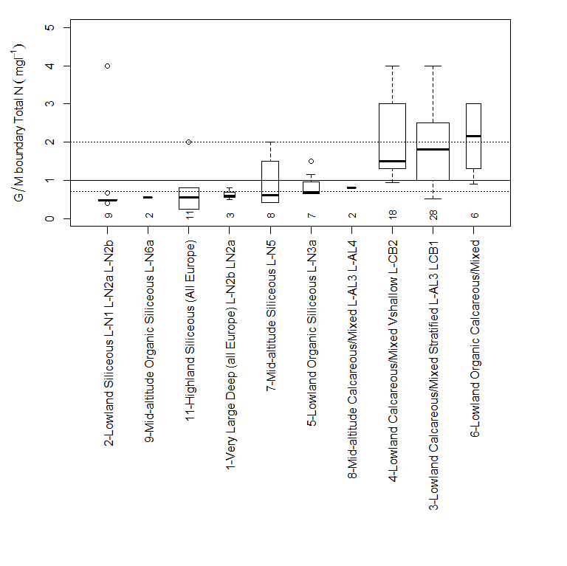
Figure 4.2-28 Range of reported total nitrogen good/moderate boundary values for lakes grouped by broad types. Numbers show the number of national types contributing to the broad type with boundary values. Types ordered by median boundary for broad type. Lines show 25th 50th and 75th percentiles of all reported good/moderate total nitrogen boundary values.
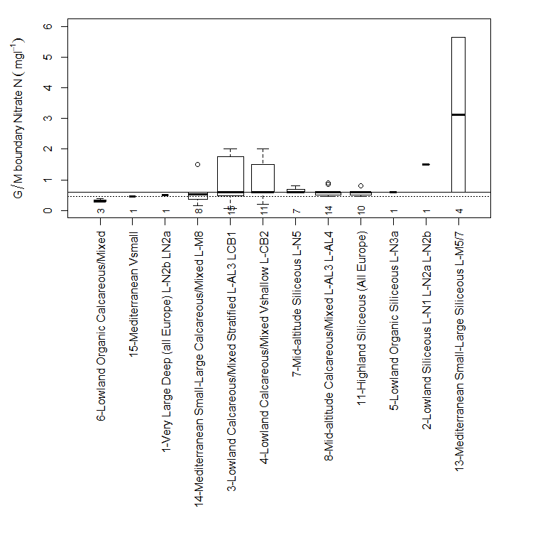
Figure 4.2-29 Range of reported nitrate nitrogen good/moderate boundary values for lakes grouped by broad types. Numbers show the number of national types contributing to the broad type with boundary values. Types ordered by median boundary for broad type. Lines show 25th 50th and 75th percentiles of all reported good/moderate nitrate nitrogen boundary values (maximum value FR halved).

Comparison by country
To compare boundary values by country after taking into account typological differences the same procedure to that described in section 3.2.3 was used. This compares the mean difference between national boundary values and the average for each broad type, for all national types that were linked to broad types. Average differences for nitrogen (total nitrogen or where this was not reported nitrate nitrogen) are shown in Figure 4.2-30. The average difference typically ranges ±0.5mgl⁻¹, the greatest negative differences were found in DK, EE, BE(Fl) and the greatest positive differences in HU and RO. It is however important to note that except for HU these countries contribute to relatively few broad types, and the average comparison is thus derived from relatively few broad lake types and conclusions needed to treated with caution. The difference found for total phosphorus in lakes (± 20µgl⁻¹) was much lower than the average difference for nitrogen and suggests that the relative range of lake nitrogen boundary values is higher than for phosphorus.

Figure 4.2-30 Average of the discrepancies (mgl⁻¹) between the national and average broad type lake nitrogen (total nitrogen or nitrate nitrogen where total nitrogen not reported) good/moderate boundary values for all types by country. (For FR, only a maximum nitrate value is reported and these values were halved for comparison with other country mean values)

Comparison by method used to set boundaries
The range of nitrogen boundary values reported by Member States using different approaches to the boundary setting method are shown in . As shown for lake phosphorus, the highest nitrogen boundary values are found when either expert judgement or the distribution of nitrogen concentration in all water bodies are used.
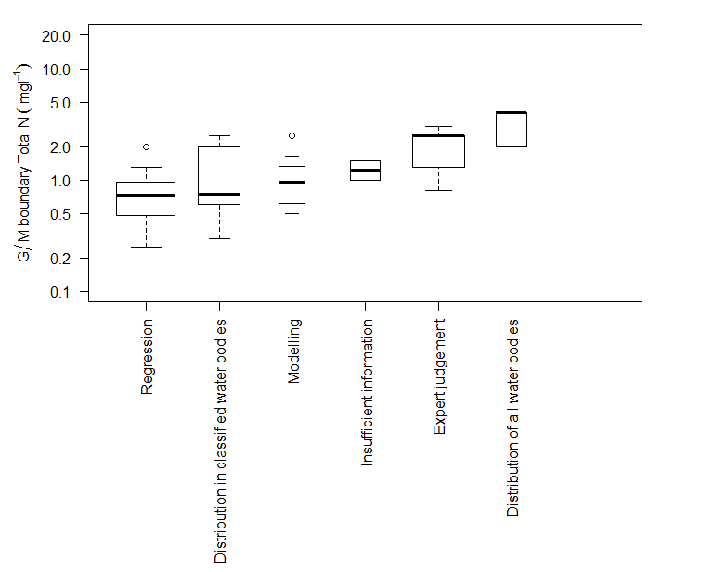

Figure 4.2-31 Range of total nitrogen good/moderate boundary values for lakes by category of method used to establish boundary by different Member States

Comparison of nitrogen boundaries for rivers

Introduction
Twenty two Member States report nitrogen boundaries for rivers, many more than for lakes (). As explained in section 4.1 the majority of these boundary values are nitrate nitrogen rather than total nitrogen and there is a greater use of 90th percentile summary metrics. As for lakes there are far fewer national nitrogen boundary values than there are national types, with the same numeric boundary value applied to several river types.
The lowest total nitrogen boundary values are found in NO and FI, the highest in BE(Fl) and PL (Figure 4.3-32). The range of nitrate nitrogen values is lower than for total nitrogen, with several countries (BE(WL), ES, GR, LU, PT) using a single standard value of 5.65 mgl⁻¹ (25.0 mgl⁻¹ as nitrate, the now repealed Drinking Water Directive guide level 80/778/EC), although with different summary metrics.
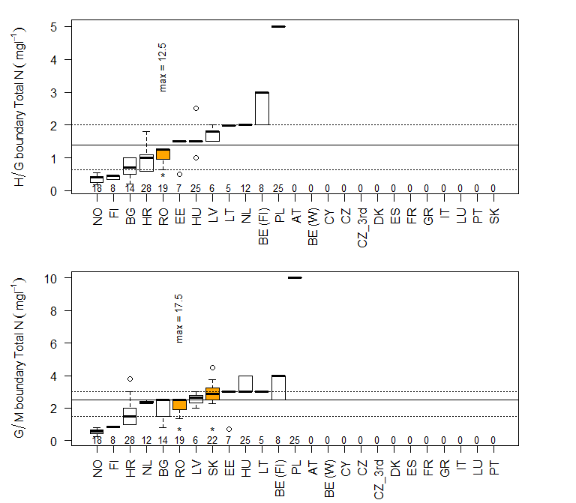
Figure 4.3-32 Range of a) high/good and b)good/moderate total nitrogen boundaries for rivers by country, arranged by median values of boundaries for each country. Lines mark 25th, 50th and 75th percentile values for all countries, numbers are national types with boundary values. (90th percentiles identified by * and orange shading RO, SK)
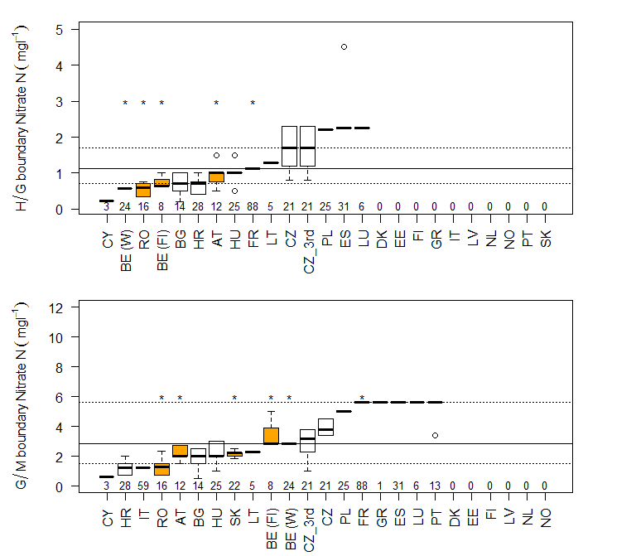
Figure 4.3-33 Range of a) high/good and b)good/moderate nitrate nitrogen boundaries for rivers by country, arranged by median values of boundaries for each country. Lines mark 25th, 50th and 75th percentile values for all countries, numbers are national types with boundary values. (90th percentiles identified by * and orange shading AT, BE, FR, RO, SK)

Country |  | Number of |  |  | Range good/moderate boundary values (mgl⁻¹) |  |  | Form of nitrogen
 |  | National Types | Broad types | Good/moderate boundary values | Min | Max | Range | Form of nitrogen
Austria | AT | 12 | 4 | 3 | 3 | 5.5 | 2.5 | NO3 N
Belgium (Flanders) | BE (Fl) | 8 | 3 | 2 | 5.65 | 10 | 4.35 | NO3 N
 |  |  |  | 2 | 2.5 | 4 | 1.5 | TN
Belgium (Wallonia) | BE (W) | 24 | 8 | 1 | 5.65 | 5.65 | 0 | NO3 N
Bulgaria | BG | 15 | 8 | 4 | 0.5 | 2.5 | 2 | NO3 N
 |  |  |  | 3 | 0.8 | 2.5 | 1.7 | TN
Cyprus | CY | 3 | 2 | 1 | 0.6 | 0.6 | 0 | NO3 N
Czech Republic | CZ | 21 | 5 | 4 | 3.4 | 4.5 | 1.1 | NO3 N
Czech Republic (3rd cycle) | CZ_3rd | 21 | 5 | 7 | 1 | 3.8 | 2.8 | NO3 N
Germany | DE | 31 | 11
Estonia | EE | 7 | 3 | 2 | 0.7 | 3 | 2.3 | TN
Spain | ES | 32 |  | 1 | 5.65 | 5.65 | 0 | NO3 N
Finland | FI | 17 | 6 | 2 | 0.8 | 0.9 | 0.1 | TN
France | FR | 141 | 15 | 1 | 11.29 | 11.29 | 0 | NO3 N
Greece | GR | 1 |  | 1 | 5.645 | 5.645 | 0 | NO3 N
Croatia (Hravtska) | HR | 28 | 9 | 9 | 0.7 | 2 | 1.3 | NO3 N
 |  |  |  | 10 | 1 | 3.8 | 2.8 | TN
Hungary | HU | 25 | 6 | 3 | 1 | 3 | 2 | NO3 N
 |  |  |  | 2 | 3 | 4 | 1 | TN
Ireland | IE | 12 | 2
Italy | IT | 59 | 11 | 1 | 1.2 | 1.2 | 0 | NO3 N
Lithuania | LT | 5 | 2 | 1 | 2.3 | 2.3 | 0 | NO3 N
 |  |  |  | 1 | 3 | 3 | 0 | TN
Luxembourg | LU | 6 | 4 | 1 | 5.65 | 5.65 | 0 | NO3 N
Latvia | LV | 6 | 2 | 5 | 2 | 3 | 1 | TN
Netherlands | NL | 12 | 4 | 2 | 2.3 | 2.5 | 0.2 | TN
Norway | NO | 22 | 7 | 7 | 0.25 | 0.78 | 0.53 | TN
Poland | PL | 25 | 12 | 1 | 5 | 5 | 0 | NO3 N
 |  |  |  | 1 | 10 | 10 | 0 | TN
Portugal | PT | 16 | 4 | 2 | 3.39 | 5.65 | 2.26 | NO3 N
Romania | RO | 21 | 6 | 4 | 1.4 | 4.7 | 3.3 | NO3 N
 |  |  |  | 3 | 2.7 | 35 | 32.3 | TN
Sweden | SE | 40 | 10
Slovak Republic | SK | 36 | 6 | 4 | 3.7 | 5 | 1.3 | NO3 N
 |  |  |  | 7 | 4.5 | 9 | 4.5 | TN
United Kingdom | UK | 21 | 10

Table 4.3-21 Number of national types, good/moderate boundary values for nitrogen (total N and nitrate) reported by Member States for rivers and number of broad types that have been linked to the national types.

Comparison of boundaries by river type
To account for differences due to typology, river nitrogen boundary values have been compared by both intercalibration and broad types. The intercalibration typology is likely to provide the most similar lake types, but has fewer countries per type than the broad typology. A full comparison of boundary values is shown in Section 6 (Appendices), and a summary is set out below.

Comparison of boundaries by intercalibration type
There are 17 river intercalibration types which have four or more national nitrogen good/moderate boundary levels (Table 4.3-22). The majority show a relatively wide range of total nitrogen and nitrate nitrogen boundary values (Figure 4.3-34 Figure 4.3-35), the smallest ranges, all below 1 mgl⁻¹ were found in the Northern GIG for total nitrogen, while the other GIGs had values generally above 2.0 mgl-1 (Figure 4.3-36). For nitrate ranges were much more variable. Further details on national comparisons can be found in the Appendix section 6.2.1.
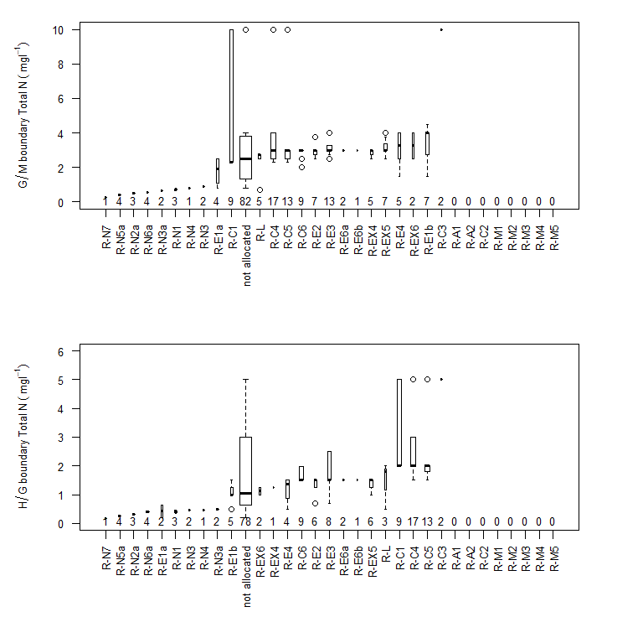
Figure 4.3-34 Range of a)good/moderate, b)high/good boundaries for river total nitrogen by intercalibration type, arranged by median value of intercalibration type, numbers are national types with boundary values in the intercalibration type. (90th percentile values halved RO, SK)
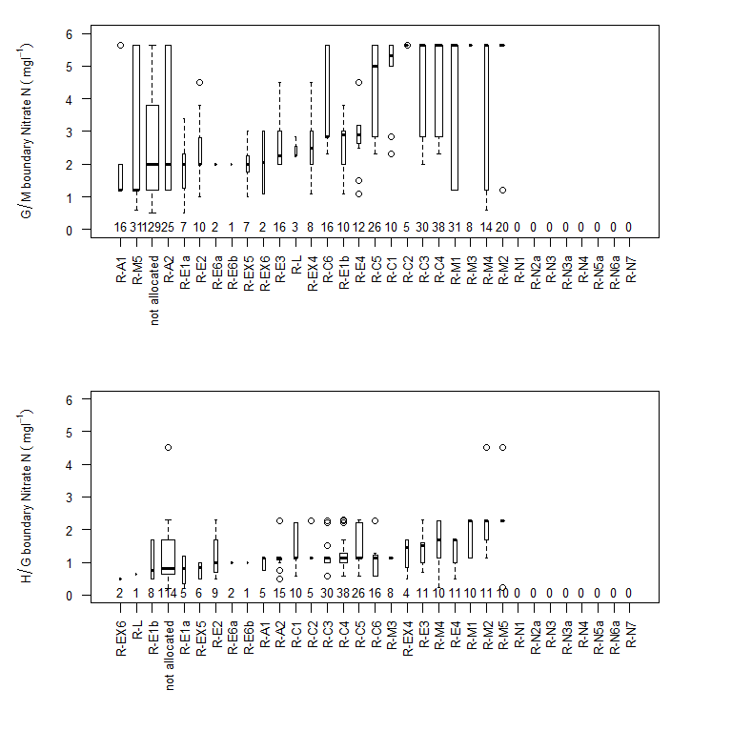
Figure 4.3-35 Range of a)good/moderate, b)high/good boundaries for river nitrate nitrogen by intercalibration type, arranged by median value of intercalibration type, numbers are national types with boundary values in the intercalibration type (90th percentiles halved AT, BE, FR, RO, SK)
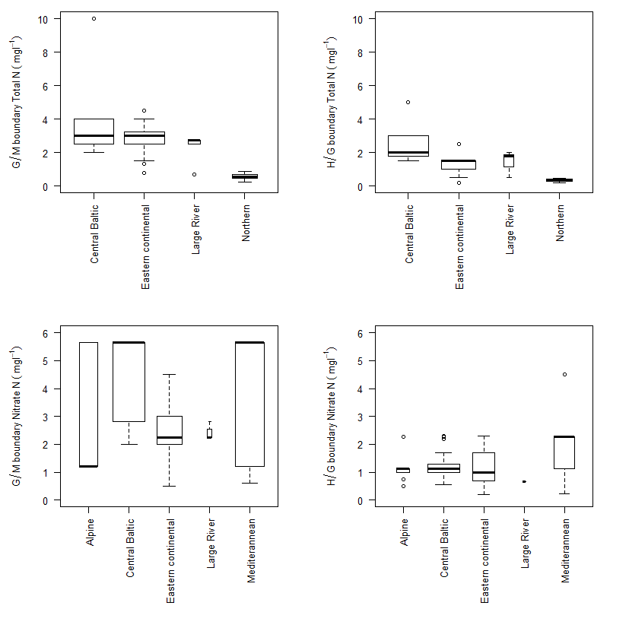
Figure 4.3-36 Range of good/moderate and high/good river total nitrogen and nitrate nitrogen boundaries by geographic intercalibration group. . (90th percentile values halved for total nitrogen RO, SK and for nitrate AT, BE, FR, RO, SK)
Type | Number countries | AT | BE (Fl) | BE (W) | BG | CY | CZ | CZ_3rd | EE | ES | FI | FR | GR | HR | HU | IT | LT | LU | LV | NL | NO | PL | PT | RO | SK
none | 14 |  | 6 |  | 20 |  | 13 | 24 |  | 8 | 4 |  | 1 | 56 |  | 9 |  |  |  |  | 2 | 32 | 1 | 27 | 8
R-A1 | 3 | 2 |  |  |  |  |  |  |  |  |  | 3 |  |  |  | 11
R-A2 | 4 | 4 |  |  |  |  |  |  |  | 1 |  | 10 |  |  |  | 10
R-C1 | 5 |  |  | 1 |  |  |  |  |  |  |  | 5 |  |  |  |  | 2 |  |  | 5 |  | 6
R-C2 | 2 |  |  |  |  |  |  |  |  | 1 |  | 4
R-C3 | 6 | 5 |  | 5 |  |  |  |  |  | 2 |  | 14 |  |  |  |  |  | 2 |  |  |  | 4
R-C4 | 12 |  | 8 | 6 |  |  | 1 | 2 | 3 | 1 |  | 17 |  |  |  |  | 4 | 2 | 2 | 3 |  | 6
R-C5 | 11 |  |  | 6 |  |  | 1 | 2 | 2 | 1 |  | 10 |  |  |  |  | 4 | 1 | 2 | 4 |  | 6
R-C6 | 6 |  |  | 6 |  |  |  |  | 4 |  |  | 6 |  |  |  |  | 6 | 1 | 2
R-E1a | 5 |  |  |  | 2 |  | 1 | 2 |  |  |  |  |  |  |  |  |  |  |  |  |  |  |  | 2 | 4
R-E1b | 6 |  |  |  | 2 |  | 1 | 2 |  |  |  |  |  |  | 6 |  |  |  |  |  |  |  |  | 2 | 4
R-E2 | 6 |  |  |  | 2 |  | 1 | 2 |  |  |  |  |  |  | 8 |  |  |  |  |  |  |  |  | 2 | 2
R-E3 | 5 |  |  |  | 2 |  | 1 | 2 |  |  |  |  |  |  | 14 |  |  |  |  |  |  |  |  |  | 10
R-E4 | 7 | 1 |  |  | 2 |  | 2 | 4 |  |  |  |  |  |  | 4 |  |  |  |  |  |  |  |  | 2 | 2
R-E6a | 1 |  |  |  |  |  |  |  |  |  |  |  |  |  | 4
R-E6b | 1 |  |  |  |  |  |  |  |  |  |  |  |  |  | 2
R-EX4 | 4 |  |  |  |  |  | 1 | 2 |  |  |  |  |  |  |  |  |  |  |  |  |  |  |  | 2 | 8
R-EX5 | 3 |  |  |  |  |  |  |  |  |  |  |  |  |  | 10 |  |  |  |  |  |  |  |  | 2 | 2
R-EX6 | 2 |  |  |  |  |  |  |  |  |  |  |  |  |  | 2 |  |  |  |  |  |  |  |  | 2
R-L | 4 |  | 2 |  |  |  |  |  | 1 |  |  |  |  |  |  |  |  |  | 1 |  |  |  |  |  | 4
R-M1 | 4 |  |  |  |  |  |  |  |  | 6 |  | 4 |  |  |  | 14 |  |  |  |  |  |  | 7
R-M2 | 4 |  |  |  |  |  |  |  |  | 8 |  | 3 |  |  |  | 2 |  |  |  |  |  |  | 7
R-M3 | 1 |  |  |  |  |  |  |  |  |  |  | 8
R-M4 | 4 |  |  |  |  | 1 |  |  |  | 5 |  | 4 |  |  |  | 4
R-M5 | 4 |  |  |  |  | 2 |  |  |  | 8 |  |  |  |  |  | 14 |  |  |  |  |  |  | 7
R-N1 | 2 |  |  |  |  |  |  |  |  |  | 1 |  |  |  |  |  |  |  |  |  | 2
R-N2a | 1 |  |  |  |  |  |  |  |  |  |  |  |  |  |  |  |  |  |  |  | 3
R-N3 | 1 |  |  |  |  |  |  |  |  |  | 2
R-N3a | 1 |  |  |  |  |  |  |  |  |  |  |  |  |  |  |  |  |  |  |  | 2
R-N4 | 1 |  |  |  |  |  |  |  |  |  | 1
R-N5a | 1 |  |  |  |  |  |  |  |  |  |  |  |  |  |  |  |  |  |  |  | 4
R-N6a | 1 |  |  |  |  |  |  |  |  |  |  |  |  |  |  |  |  |  |  |  | 4
R-N7 | 1 |  |  |  |  |  |  |  |  |  |  |  |  |  |  |  |  |  |  |  | 1

Table 4.3-22 Number of national river types allocated to each intercalibration type with good/moderate boundary values for nitrogen (total nitrogen or nitrate nitrogen).

Comparison of boundaries by broad type
A comparison by broad type allows more Member State boundary values to be compared, with the majority of types having 4 or more Member States with boundaries linked to the broad type (Table 4.3-23).
The lowest total nitrogen boundary values (for types with > 4 countries) are found in broad types 14 (the highland siliceous rivers) and 6 (lowland organic & siliceous), with higher values in the calcareous river types (Figure 4.3-37). However, there is more variation than for lakes, with a less clear gradation from upland siliceous to lowland calcareous river types. Several types have outlier values (10mgl⁻¹), which can be attributed to one country (PL) and broad type 9 (mid-altitude siliceous) has a very high range of values, attributable to HU & PL (see Figure 6.2-135 for further detail)
The variation of nitrate nitrogen boundaries is much greater (Figure 4.3-38), and there is little indication of any clear link to the broad types. There is also a clear influence of the relatively widespread use of a boundary value of 5.6mgl⁻¹ by several Member States, which is probably attributable to the guide line value for drinking water. This suggests that for rivers many countries are probably setting nitrate boundary values linked to the use of river water for potable supply rather than as a supporting element for ecological status.
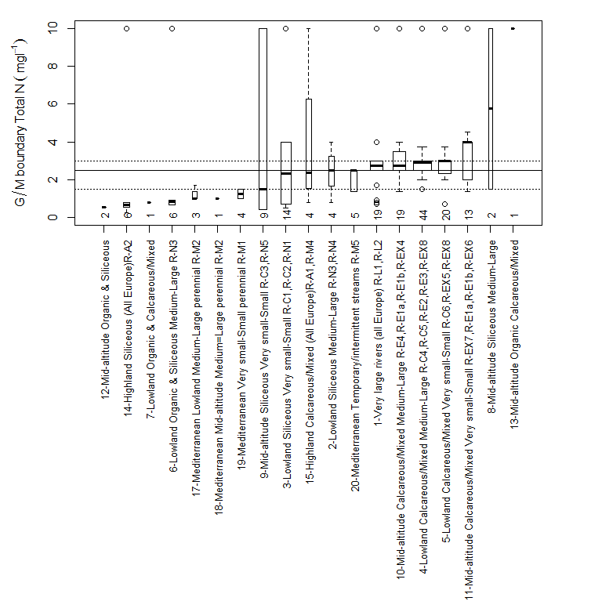
Figure 4.3-37 Range of reported good/moderate total nitrogen boundary values for rivers grouped by broad type. Numbers show the number of national types allocated to each broad type. Types ordered by median value of reported boundary, dotted lines show interquartile range for all broad types. (Values for 90th percentiles (RO, SK) were halved)

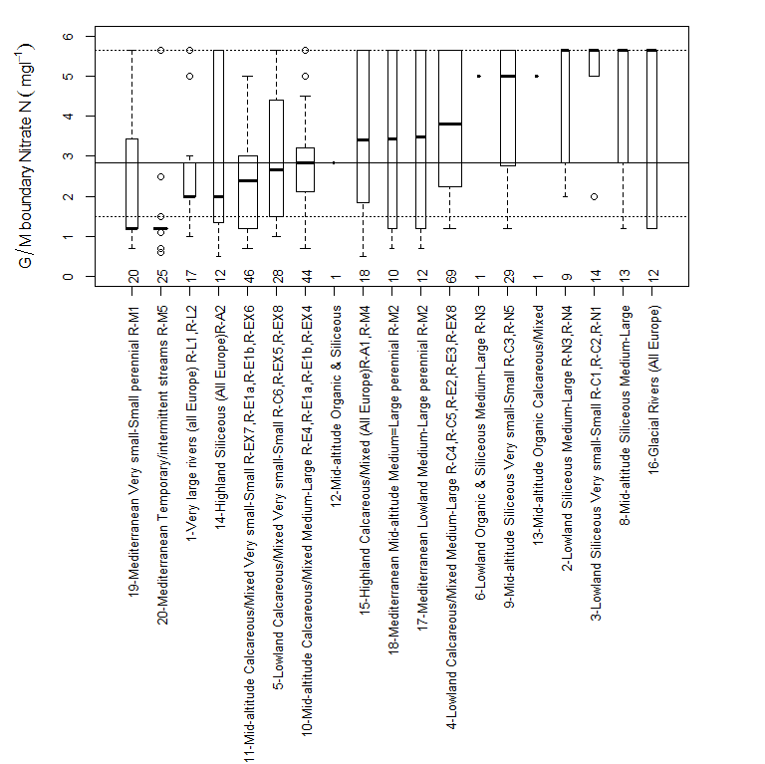
Figure 4.3-38 Range of reported good/moderate nitrate nitrogen boundary values for rivers grouped by broad type. Numbers show the number of national types allocated to each broad type. Types ordered by median value of reported boundary, dotted lines show interquartile range for all broad types. Values for 90th percentiles (AT BE-FL BE-W FR RO SK) were halved

Broad Type |  | Number of countries | Total national types | AT |  | BE (Fl) | BE (W) | BG | CY | CZ | CZ_3rd | EE | ES | FI | FR | GR | HR | HU | IT | LT | LU | LV | NL | NO | PL | PT | RO | SK
Not allocated |  | 10 | 59 |  |  | 3 |  | 2 |  |  |  |  | 31 | 2 |  | 1 | 5 |  |  |  |  | 1 |  |  | 6 | 6 | 2
1 | Very large rivers (all Europe) | 11 | 21 |  |  | 1 | 1 |  |  |  |  | 1 |  | 2 | 1 |  | 4 | 6 |  |  |  |  | 1 |  | 1 |  | 1 | 2
2 | Lowland, siliceous, medium-large | 4 | 10 |  |  | 2 |  | 1 |  |  |  |  |  | 1 | 6
3 | Lowland, siliceous, very small-small | 7 | 22 |  |  | 2 |  |  |  |  |  |  |  | 1 | 8 |  | 1 |  |  |  |  |  | 3 | 4 | 3
4 | Lowland, calcareous/mixed, medium-large | 16 | 80 |  |  |  | 3 | 5 |  | 4 | 4 | 4 |  |  | 22 |  | 2 | 5 | 1 | 4 | 2 | 4 | 5 |  | 3 |  | 6 | 6
5 | Lowland, calcareous/mixed, very small-small | 16 | 35 |  |  |  | 1 |  |  | 2 | 2 | 2 |  |  | 5 |  | 2 | 5 | 4 | 1 | 1 | 2 | 3 | 1 | 1 |  | 2 | 1
6 | Lowland, organic & siliceous | 3 | 6 |  |  |  |  |  |  |  |  |  |  | 2 |  |  |  |  |  |  |  |  |  | 3 | 1
7 | Lowland, organic & calcareous/mixed | 1 | 1 |  |  |  |  |  |  |  |  |  |  |  |  |  |  |  |  |  |  |  |  | 1
8 | Mid altitude, siliceous, medium-large | 6 | 13 |  |  |  | 3 | 1 |  |  |  |  |  |  | 6 |  |  |  | 1 |  | 1 |  |  |  | 1
9 | Mid altitude, siliceous, very small-small | 9 | 33 |  | 5 |  | 2 | 1 |  |  |  |  |  |  | 11 |  |  | 1 | 4 |  | 2 |  |  | 4 | 3
10 | Mid altitude, calcareous/mixed, medium-large | 10 | 39 |  | 1 |  | 7 |  |  | 5 | 5 |  |  |  | 2 |  | 3 | 4 |  |  |  |  |  |  | 1 |  | 2 | 9
11 | Mid altitude, calcareous/mixed, very small-small | 9 | 40 |  |  |  | 6 |  |  | 6 | 6 |  |  |  |  |  | 3 | 4 | 9 |  |  |  |  |  | 2 |  | 2 | 2
12 | Mid altitude, organic & siliceous | 2 | 3 |  |  |  | 1 |  |  |  |  |  |  |  |  |  |  |  |  |  |  |  |  | 2

13 | Mid altitude, organic & calcareous/mixed | 1 | 1 |  |  |  |  |  |  |  |  |  |  |  |  |  |  |  |  |  |  |  |  | 1
14 | Highland (all Europe), siliceous | 6 | 15 | 4 |  |  | 2 |  |  |  |  |  |  | 4 |  |  |  | 1 |  |  |  |  | 3 | 1
15 | Highland (all Europe), calcareous/mixed | 8 | 20 | 2 |  |  | 1 | 1 | 4 | 4 |  |  |  | 5 |  |  |  |  |  |  |  |  |  | 1 |  |  | 2
16 | Glacial rivers (all Europe) | 2 | 12 |  |  |  |  |  |  |  |  |  |  | 7 |  |  |  | 5
17 | Mediterranean, lowland, medium-large, perennial | 4 | 12 |  |  |  |  |  |  |  |  |  |  | 3 |  | 3 |  | 3 |  |  |  |  |  |  | 3
18 | Mediterranean, mid altitude, medium-large, perenni | 3 | 10 |  |  |  |  |  |  |  |  |  |  | 5 |  | 1 |  | 4
19 | Mediterranean, very small-small, perennial | 4 | 20 |  |  |  |  |  |  |  |  |  |  | 3 |  | 4 |  | 11 |  |  |  |  |  |  | 2
20 | Mediterranean, temporary/intermittent streams | 5 | 25 |  |  |  | 1 | 2 |  |  |  |  |  |  |  |  |  | 16 |  |  |  |  |  |  | 2 | 4

Table 4.3-23 Number of national river types allocated to each broad type with good/moderate boundary values for nitrogen (total nitrogen or nitrate nitrogen).

Comparison by country
To compare boundary values by country after taking into account typological differences the same procedure to that described in section 3.2.3 was used. This compares the mean difference between national boundary values and the average for each broad type, for all national types that were linked to broad types. Average differences for river nitrogen (total nitrogen or where this was not reported nitrate nitrogen) good/moderate boundaries are shown in Figure 4.3-39. The differences are greater than for lakes with the majority of countries having values of at least ± 1.5mgl⁻¹ in comparison to the ± 0.5mgl⁻¹ for lakes.

Figure 4.3-39 Average of the discrepancies (mgl⁻¹) between the national and average broad type river nitrogen (total nitrogen or nitrate nitrogen where total nitrogen not reported) good/moderate boundary value for all types by country. 90th percentile values adjusted to match measures of mean and median

Comparison by method used to set boundaries
The range of nitrogen boundary values reported by Member States using different approaches to the boundary setting method are shown in Figure 4.3-40 Figure 4.3-41 . As shown for other metrics, the highest boundary values are found when either expert judgement or the distribution of nitrogen concentration in all water bodies are used, although for nitrogen in rivers the differences due to method were not as significant.
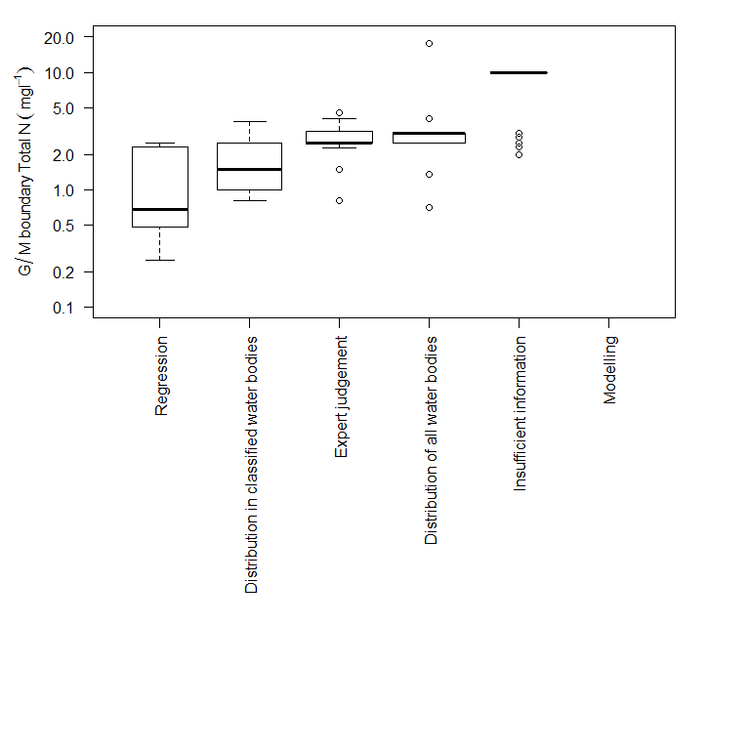
Figure 4.3-40 Range of total nitrogen good/moderate boundary values for rivers by category of method used to establish boundary by different Member States. 90th percentile values adjusted to match measures of mean and median.
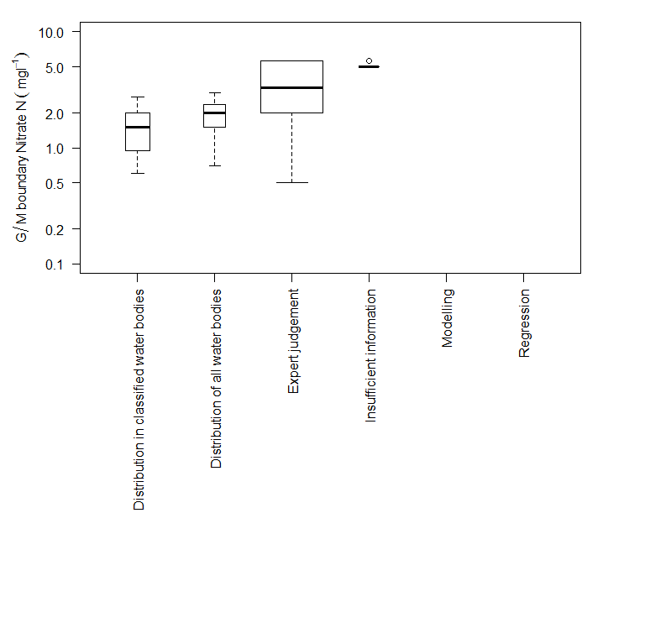
Figure 4.3-41 Range of nitrate nitrogen good/moderate boundary values for rivers by category of method used to establish boundary by different Member States

References

Appendices
Note in the following figures boundary values that use 90th or 95th percentiles have been halved to allow for comparison with other summary metrics.

Detailed comparison of lake boundaries

Lake boundaries by intercalibration type and country

L-AL3 Lowland or mid-altitude, deep, moderate to high alkalinity large lakes in Alpine GIG

Broad Type | Country | National type code | Description of type | IC Type
none | DE | 4 | geschichteter Alpensee | L-AL3
none | FR | A3 | Retenue de moyenne montagne, calcaire, profunde (L-AL3,L-AL4) | L-AL3
none | FR | N4 | Lac de moyenne montagne, calcaire, profond, à zone littorale (L-AL3, L-AL4) | L-AL3
1 | IT | ITAL-3 | Large subalpine lakes | L-AL3
2 | FR | A5 | Retenue de moyenne montagne, non calcaire, profonde | L-AL3
3 | IT | ITAL-6 | Deep subalpine (0-800) lakes/reservoirs | L-AL3
7 | AT | D3 | Large Lakes of the Central Alps 600-600m | L-AL3
7 | FR | A5 | Retenue de moyenne montagne, non calcaire, profonde | L-AL3
7 | IT | ITAL-10 | Deep silceous Alpine (800-2000m) lakes/reservoirs | L-AL3
8 | AT | C1a | Large Carinthian lakes < 600m, Zavg > 15m | L-AL3
8 | AT | D1 | Large, deep lakes of the Northern Limestone Alps 400-600m | L-AL3
8 | AT | D2a+b | Large, shallow to moderately deep lakes of the Limestone Alpine Foothills 600-800 m | L-AL3
8 | FR | A3 | Retenue de moyenne montagne, calcaire, profunde (L-AL3,L-AL4) | L-AL3
8 | IT | ITAL-9 | Deep calcareous Alpine (800-2000) lakes/reservoirs | L-AL3
8 | Sl | A1 | Dep>15m Limestone Area 1-10km2 mid altituded 200-800m >1yr Retention Alps | L-AL3
8 | Sl | A2 | Dep>15m Limestone Area 1-10km2 mid altituded 200-800m <1yr Retention Alps | L-AL3
11 | FR | A5 | Retenue de moyenne montagne, non calcaire, profonde | L-AL3
12 | AT | E1 | Large, deep mountain lakes of the Limestone Alps 800-1200 m | L-AL3

Table 6.1-24 National & broad types for Alpine GIG countries reporting lake intercalibration type L-AL3

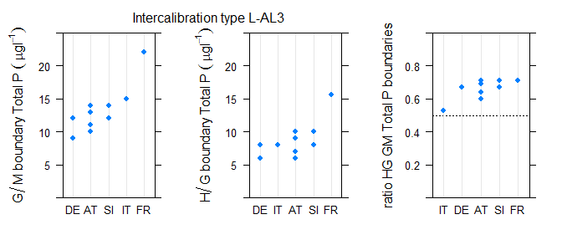
Figure 6.1-42 Range of a) good/moderate, b) high/good, c) ratio of good/moderate to high/good total phosphorus boundary values for intercalibration types L-AL3

L-AL4 Mid-altitude, shallow, moderate to high alkalinity large lakes in Alpine GIG
Broad Type | Country | National type code | Description of type | IC Type
none | FR | A2 | Retenue de moyenne montagne, calcaire, peu profonde (L-AL4) | L-AL4
none | FR | A3 | Retenue de moyenne montagne, calcaire, profunde (L-AL3,L-AL4) | L-AL4
none | FR | N3 | Lac de moyenne montagne, calcaire, peu profunde (L-AL4) | L-AL4
none | FR | N4 | Lac de moyenne montagne, calcaire, profond, à zone littorale (L-AL3, L-AL4) | L-AL4
3 | IT | ITAL-5 | Shallow subalpine lakes/reservoirs | L-AL4
7 | IT | ITAL-8 | Shallow siliceous Alpine (800-2000 m) lakes/reservoirs | L-AL4
8 | AT | B2 | Large Alpine foothill lakes | L-AL4
8 | AT | C1b | Large Carinthian lakes < 600m, Zavg < 15m | L-AL4
8 | DE | 2 | geschichteter Alpenvorlandsee mit relativ großem Einzugsgebiet | L-AL4
8 | DE | 3 | geschichteter Alpenvorlandsee mit relativ kleinem Einzugsgebiet | L-AL4
12 | IT | ITAL-7 | Shallow calcareous Alpine (800-2000 m) lakes/reservoirs | L-AL4

Table 6.1-25 National & broad types for Alpine GIG countries reporting lake intercalibration type L-AL4
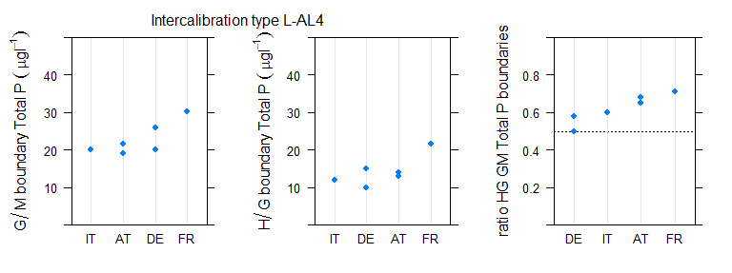
Figure 6.1-43 Range of a) good/moderate, b) high/good, c) ratio of good/moderate to high/good total phosphorus boundary values for intercalibration types AL4

L-CB1 Lowland shallow high alkalinity stratified lakes in Central Baltic GIG

Broad Type | Country | National type code | Description of type | IC Type
3 | BE (Fl) | Awe | Groot, diep, eutroof, alkalisch meer | L-CB1
3 | BE (Fl) | Awom | Groot, diep, oligotroof tot mesotroof, alkalisch meer | L-CB1
3 | DK | 10 | high alkalinity, clear, fresh, deep | L-CB1
3 | EE | 3 | lowland, < 10 km2; medium alkalinity 80-240 HCO3- mg/L, stratified, mean depth 3-15m | L-CB1
3 | IE | 11 | Altitude m<200, Alkalinity meq l-1 >2, Mean depth m>4, Area km2<0.5 | L-CB1
3 | IE | 12 | Altitude m<200, Alkalinity meq l-1 >2, Mean depth m>4, Area km2>0.5 | L-CB1
3 | LT | LWT2 | Medium depth lakes (average depth 3-9 m) | L-CB1
3 | LT | LWT3 | Deep lakes (average depth more than 9m) | L-CB1
3 | LV | L5 | Lowland, size > 50 ha, shallow (2-9 m), hardwater (> 165 mkS/cm), oligohumic (< 80 Pt-Co). | L-CB1
3 | LV | L9 | Lowland, size > 50 ha, deep (> 9 m), hardwater (> 165 mkS/cm), oligohumic (< 80 Pt-Co). | L-CB1
3 | NL | M20 | Matig grote diepe gebufferde meren | L-CB1
3 | NL | M21 | Grote diepe gebufferde meren | L-CB1
3 | PL | 2a | Western Europe Unit (Ni? ?rodkowopolski), stratified, Ca>25 mgCa/l, Schindler's ratio <2 | L-CB1
3 | PL | 4 | Jeziora przymorskie, pod wpływem wód słonych | L-CB1/L-CB2
3 | PL | 5a | Jeziora o wysokiej zawartości wapnia, o małym wypływie zlewni, stratyfikowane | L-CB1/L-CB2
3 | PL | 5b | Jeziora o wysokiej zawartości wapnia, o małym wypływie zlewni, niestratyfikowane | L-CB1/L-CB2
3 | PL | 6a | Eastern Europe Unit (Niziny Wschodnioba?tycko-Bia?oruskie), stratified, Ca>25 mgCa/l, Schindler's ratio >2 | L-CB1/L-CB2
3 | PL | 7a | Jeziora o wysokiej zawartości wapnia, stratyfikowane | L-CB1/L-CB2
3 | UK | HAS | high alkalinity shallow | L-CB1
6 | LV | L6 | Lowland, size > 50 ha, shallow (2-9 m), hardwater (> 165 mkS/cm), polyhumic (> 80 Pt-Co). | L-CB1

Table 6.1-26 National & broad types for Central Baltic GIG countries reporting lake intercalibration type L-CB1
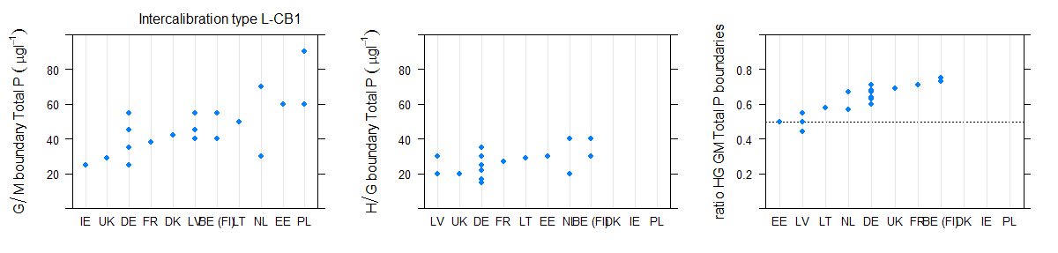
Figure 6.1-44 Range of a) good/moderate, b) high/good, c) ratio of good/moderate to high/good total phosphorus boundary values for intercalibration type L-CB1, high alkalinity shallow stratified lake types by country (values for DE are median and 75th percentile)
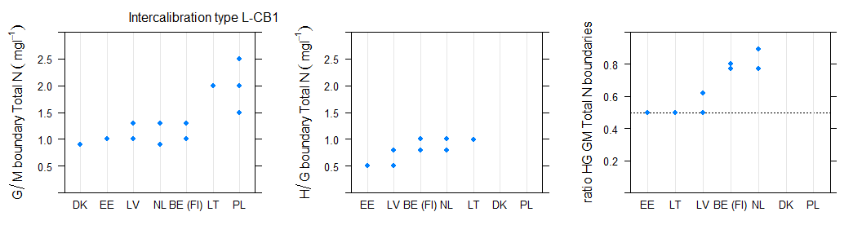
Figure 6.1-45 Range of a) good/moderate, b) high/good, c) ratio of good/moderate to high/good total nitrogen boundary values for intercalibration type L-CB1, high alkalinity shallow stratified lake types by country

L-CB2 Lowland, very shallow, high alkalinity lakes in Central Baltic GIG

Broad Type | Country | National type code | Description of type | IC Type
none | PL | 2b | Jeziora o wysokiej zawartości wapnia, o małym wypływie zlewni, niestratyfikowane | L-CB2
none | PL | 4 | <200m, calcareous, peat, 10-50ha | L-CB2
none | PL | 4 | Jeziora przymorskie, pod wpływem wód słonych | L-CB2
none | PL | 4 | Kalkreicher, geschichteter Alpensee mit relativ kleinem oder großem Einzugsgebiet | L-CB2
none | PL | 4 | Low alkalinity, deep and large | L-CB2
none | PL | 5a | Jeziora o wysokiej zawartości wapnia, o małym wypływie zlewni, stratyfikowane | L-CB2
none | PL | 5b | Jeziora o wysokiej zawartości wapnia, o małym wypływie zlewni, niestratyfikowane | L-CB2
none | PL | 6b | Jeziora o wysokiej zawartości wapnia, o dużym wypływie zlewni, niestratyfikowane | L-CB2
none | PL | 7a | Jeziora o wysokiej zawartości wapnia, stratyfikowane | L-CB2
none | PL | 7b | Jeziora o wysokiej zawartości wapnia, niestratyfikowane | L-CB2
3 | DE | 10 | geschichteter Tieflandsee mit relativ großem Einzugsgebiet | L-CB2
3 | DE | 13 | geschichteter Tieflandsee mit relativ kleinem Einzugsgebiet | L-CB2
3 | FR | A6a | Retenue de basse altitude, peu profonde, non calcaire (L-CB1,L-CB2) | L-CB2
3 | FR | A7a | Retenue de basse altitude, peu profonde, calcaire (L-CB2) | L-CB2
3 | PL | 2a | Western Europe Unit (Niż Środkowopolski), stratified, Ca>25 mgCa/l, Schindler's ratio <2 | L-CB2
3 | PL | 3a | Western Europe Unit (Niż Środkowopolski), stratified, Ca>25 mgCa/l, Schindler's ratio >2 | L-CB2
3 | PL | 6a | Eastern Europe Unit (Niziny Wschodniobałtycko-Białoruskie), stratified, Ca>25 mgCa/l, Schindler's ratio >2 | L-CB2
4 | BE (Fl) | Ai | Ionenrijk, alkalisch meer | L-CB2
4 | BE (Fl) | Ami | Matig ionenrijk, alkalisch meer | L-CB2
4 | DK | 9 | high alkalinity, clear, fresh, shallow | L-CB2
4 | EE | 2 | lowland, < 10 km2; medium alkalinity 80-240 HCO3- mg/L, not stratified mean depth below 3m | L-CB2
4 | FR | A13a | Plan d'eau vidangé à intervalle régulier (L-CB2) | L-CB2
4 | FR | A13b | Plan d'eau généralement non vidangé mais à gestion hydraulique contrôlée (L-CB2) | L-CB2
4 | FR | A16 | Plan d'eau peu profond, obtenu par creusement, en lit majeur d'un cours d'eay, en relation avec la nappe, forme de type L, sand thermocline (L-CB2) | L-CB2
4 | FR | A6a | Retenue de basse altitude, peu profonde, non calcaire (L-CB1,L-CB2) | L-CB2
4 | FR | A7a | Retenue de basse altitude, peu profonde, calcaire (L-CB2) | L-CB2
4 | IE | 10 | Altitude m<200, Alkalinity meq l-1 >2, Mean depth m<4, Area km2>0.5 | L-CB2
4 | IE | 9 | Altitude m<200, Alkalinity meq l-1 >2, Mean depth m<4, Area km2<0.5 | L-CB2
4 | LT | LWT1 | Shallow lakes (average depth less than 3m) | L-CB2
4 | LV | L1 | Lowland, size > 50 ha, very shallow (< 2 m), hardwater (> 165 mkS/cm), oligohumic (< 80 Pt-Co). | L-CB2
4 | LV | L2 | Lowland, size > 50 ha, very shallow (< 2 m), hardwater (> 165 mkS/cm), polyhumic (> 80 Pt-Co). | L-CB2

4 | NL | M14 | Ondiepe gebufferde plassen | L-CB2
4 | NL | M23 | Grote ondiepe kalkrijke plassen | L-CB2
4 | PL | 3b | Western Europe Unit (Niż Środkowopolski),polymictic, Ca>25 mgCa/l, Schindler's ratio >2 | L-CB2
4 | UK | HAVS | high alkalinity very shallow | L-CB2
6 | NL | M27 | Matig grote ondiepe laagveenplassen | L-CB2
7 | FR | A13a | Plan d'eau vidangé à intervalle régulier (L-CB2) | L-CB2
7 | FR | A6a | Retenue de basse altitude, peu profonde, non calcaire (L-CB1,L-CB2) | L-CB2
8 | FR | A13b | Plan d'eau généralement non vidangé mais à gestion hydraulique contrôlée (L-CB2) | L-CB2

Table 6.1-27 National & broad types for Central Baltic GIG countries reporting lake intercalibration type L-CB2

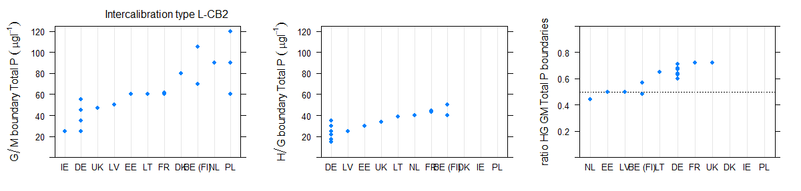
Figure 6.1-46 Range of a) good/moderate, b) high/good, c) ratio of good/moderate to high/good total phosphorus boundary values for intercalibration type L-CB2, high alkalinity very shallow lakes
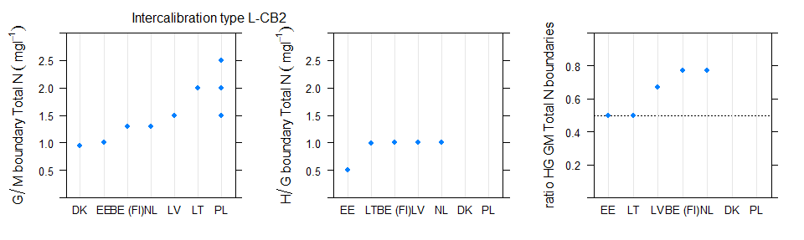
Figure 6.1-47 Range of a) good/moderate, b) high/good, c) ratio of good/moderate to high/good total nitrogen boundary values for intercalibration type L-CB2, high alkalinity very shallow lakes

L-N2a Lowland, siliceous moderate alkalinity shallow lakes in Northern GIG

Broad Type | Country | National type code | Description of type | IC Type
1 | FI | SVh | Large (surface area > 40 km2 ), clear (colour <30 mg/l Pt) | L-N2a
2 | FI | Vh | Medium-size or small (surface area ? 40 km2), clear (colour <30 mg/l Pt), mean depth ?3 m | L-N2a
2 | IE | 1 | Altitude m<200, Alkalinity meq l-1 <0.4, Mean depth m<4, Area km2<0.5 | L-N2a
2 | IE | 2 | Altitude m<200, Alkalinity meq l-1 <0.4, Mean depth m<4, Area km2>0.5 | L-N2a
2 | IE | 3 | Altitude m<200, Alkalinity meq l-1 <0.4, Mean depth m>4, Area km2<0.5 | L-N2a
2 | IE | 4 | Altitude m<200, Alkalinity meq l-1 <0.4, Mean depth m>4, Area km2>0.5 | L-N2a
2 | NO | 1 | lowland, shallow (stratified, mean depth 3-15 m), low alkalinity (<0,2 mekv/l), clear (colour <30 mg Pt/l) | L-N2a
2 | NO | 2 | lowland, shallow (stratified, mean depth 3-15 m), low alkalinity (<0,2 mekv/l), clear (colour <30 mg Pt/l) | L-N2a
2 | NO | 4 | lowland, shallow (stratified, mean depth 3-15 m), low alkalinity (<0,2 mekv/l), clear (colour <30 mg Pt/l) | L-N2a
2 | NO | 5 | lowland, shallow (stratified, mean depth 3-15 m), low alkalinity (<0,2 mekv/l), clear (colour <30 mg Pt/l) | L-N2a
2 | UK | LAS | low alkalinity shallow | L-N2a

Table 6.1-28 National & broad types for Northern GIG countries reporting lake intercalibration type L-N2a

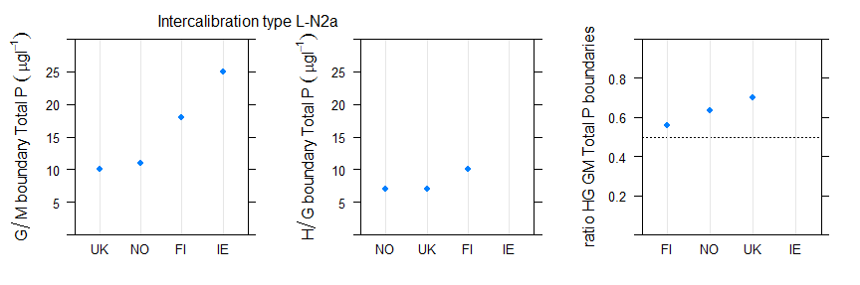
Figure 6.1-48 Range of a) good/moderate, b) high/good, c) ratio of good/moderate to high/good total phosphorus boundary values for intercalibration type L-N2a lakes
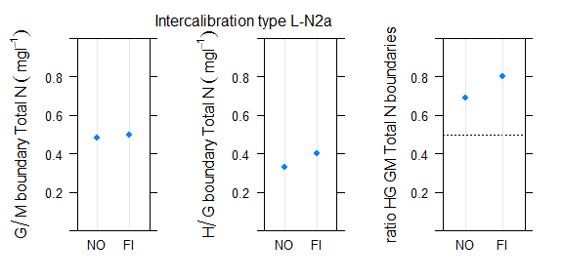
Figure 6.1-49 Range of a) good/moderate, b) high/good, c) ratio of good/moderate to high/good total nitrogen boundary values for intercalibration type L-N2a lakes

Lake total phosphorus boundaries by broad type and country

Type 1 Very large and deep (stratified) (all Europe) lakes.

Broad Type | Country | National type code | Description of type | IC Type
1 | BG | L11 | Large, deep reservoirs/artificial lakes (variable; mixed/silicious/calcareous; >10 km2, large; max. depth <120m profundal zone; salinity < 0.5‰) | NA
1 | FI | Sh | Large (surface area > 40 km2 ), humic (colour 30-90 mg/l Pt) | L-N3a
1 | FI | SVh | Large (surface area > 40 km2 ), clear (colour <30 mg/l Pt) | L-N2a
1 | FR | A52 | Retenue du bouclier guyanais | NA
1 | IT | ITAL-3 | Large subalpine lakes | L-AL3

Table 6.1-29 National & intercalibration types for countries reporting Broad Type 1 Very large and deep (stratified) (all Europe Lakes)

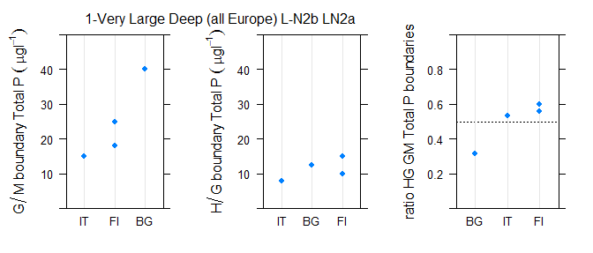
Figure 6.1-50 Range of a) good/moderate, b) high/good, c) ratio of good/moderate to high/good total phosphorus boundary values for broad type 1, Very large and deep (stratified) (all Europe) lake types by country.
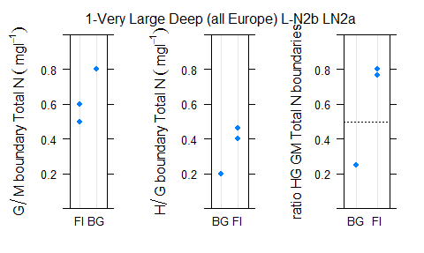
Figure 6.1-51 Range of a) good/moderate, b) high/good, c) ratio of good/moderate to high/good total nitrogen boundary values for broad type 1, Very large and deep (stratified) (all Europe) lake types by country

Type 2 Lowland siliceous lakes

Broad Type | Country | National type code | Description of type | IC Type
2 | EE | 5 | lowland, < 10 km2; low alkalinity < 80 HCO3- mg/L, bright water, not stratified, mean depth 3-5 m
2 | FI | Vh | Medium-size or small (surface area ? 40 km2), clear (colour <30 mg/l Pt), mean depth ?3 m | L-N2a
2 | IE | 1 | Altitude m<200, Alkalinity meq l-1 <0.4, Mean depth m<4, Area km2<0.5 | L-N2a
2 | IE | 2 | Altitude m<200, Alkalinity meq l-1 <0.4, Mean depth m<4, Area km2>0.5 | L-N2a
2 | IE | 3 | Altitude m<200, Alkalinity meq l-1 <0.4, Mean depth m>4, Area km2<0.5 | L-N2a
2 | IE | 4 | Altitude m<200, Alkalinity meq l-1 <0.4, Mean depth m>4, Area km2>0.5 | L-N2a
2 | NO | 1 | lowland, shallow (stratified, mean depth 3-15 m), low alkalinity (<0,2 mekv/l), clear (colour <30 mg Pt/l) | L-N2a
2 | NO | 2 | lowland, shallow (stratified, mean depth 3-15 m), low alkalinity (<0,2 mekv/l), clear (colour <30 mg Pt/l) | L-N2a
2 | NO | 4 | lowland, shallow (stratified, mean depth 3-15 m), low alkalinity (<0,2 mekv/l), clear (colour <30 mg Pt/l) | L-N2a
2 | NO | 5 | lowland, shallow (stratified, mean depth 3-15 m), low alkalinity (<0,2 mekv/l), clear (colour <30 mg Pt/l) | L-N2a
2 | NO | 6 | lowland, deep (mean depth > 15m), low alkalinty (<0,2 mekv/l), clear (< 30 mg Pt/l) | L-N2b
2 | NO | 8 | lowland, shallow (stratified, mean depth 3-15 m), moderate alkalinity (0,2-1,0 mekv/l), clear (colour <30 mg Pt/l) | L-N1
2 | RO | ROLN10 | Lac natural in zona de campie, adancime mica, siliciu, suprafata medie
2 | SE | S3DLNN | Dep>4m Alk<1meqL Col<50mgPtL Area>10km2 S3, Coast of Norrland below marine limit (the highest level the sea reached after the ice age)
2 | SE | S3DSNN | Dep>4m Alk<1meqL Col<50mgPtL Area<10km2 S3, Coast of Norrland below marine limit (the highest level the sea reached after the ice age)
2 | SE | S3SLNN | Dep<4m Alk<1meqL Col<50mgPtL Area>10km2 S3, Coast of Norrland below marine limit (the highest level the sea reached after the ice age)
2 | SE | S3SSNN | Dep<4m Alk<1meqL Col<50mgPtL Area<10km2 S3, Coast of Norrland below marine limit (the highest level the sea reached after the ice age)
2 | SE | S4DLNN | Dep>4m Alk<1meqL Col<50mgPtL Area>10km2 S4, Southeast Sweden below 200 masl
2 | SE | S4DSNN | Dep>4m Alk<1meqL Col<50mgPtL Area<10km2 S4, Southeast Sweden below 200 masl
2 | SE | S4SLNN | Dep<4m Alk<1meqL Col<50mgPtL Area>10km2 S4, Southeast Sweden below 200 masl
2 | SE | S4SSNN | Dep<4m Alk<1meqL Col<50mgPtL Area<10km2 S4, Southeast Sweden below 200 masl
2 | SE | S5DLNN | Dep>4m Alk<1meqL Col<50mgPtL Area>10km2 S5, South Sweden below 200 masl
2 | SE | S5DSNN | Dep>4m Alk<1meqL Col<50mgPtL Area<10km2 S5, South Sweden below 200 masl
2 | SE | S5SSNN | Dep<4m Alk<1meqL Col<50mgPtL Area<10km2 S5, South Sweden below 200 masl
2 | SE | S6DLNN | Dep>4m Alk<1meqL Col<50mgPtL Area>10km2 S6, Southwest Sweden below 200 masl
2 | SE | S6DSNN | Dep>4m Alk<1meqL Col<50mgPtL Area<10km2 S6, Southwest Sweden below 200 masl
2 | SE | S6SLNN | Dep<4m Alk<1meqL Col<50mgPtL Area>10km2 S6, Southwest Sweden below 200 masl
2 | SE | S6SSNN | Dep<4m Alk<1meqL Col<50mgPtL Area<10km2 S6, Southwest Sweden below 200 masl

2 | UK | LAD | low alkalinity deep | L-N2b
2 | UK | LAS | low alkalinity shallow | L-N2a
2 | UK | MAD | moderate alkalinity deep
2 | UK | MAS | moderate alkalinity shallow | L-N1
Table 6.1-30 National & intercalibration types for countries reporting Broad Type 2 Lowland, siliceous lakes.
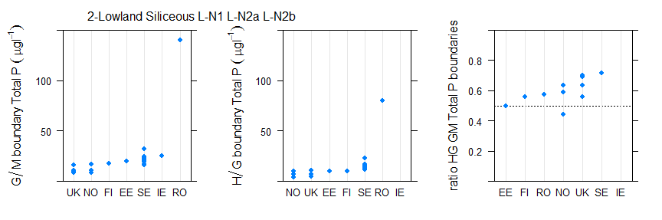
Figure 6.1-52 Range of a) good/moderate, b) high/good, c) ratio of good/moderate to high/good total phosphorus boundary values for broad type 2, lowland siliceous lake types by country.
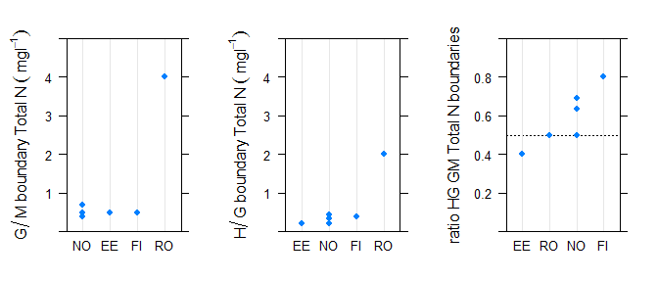
Figure 6.1-53 Range of a) good/moderate, b) high/good, c) ratio of good/moderate to high/good total nitrogen boundary values for broad type 2, lowland siliceous lake types by country.

Type 3 Lowland stratified, calcareous/mixed

Broad Type | Country | National type code | Description of type | IC Type
3 | BE (Fl) | Awe | Groot, diep, eutroof, alkalisch meer | L-CB1
3 | BE (Fl) | Awom | Groot, diep, oligotroof tot mesotroof, alkalisch meer | L-CB1
3 | BG | L14 | Large lowland reservoirs with medium depth in ER 12 (usually <120m variable; mixed/silicious/calcareous; >10 km2, large; max. depth <50m profundal lacks or slightly developed; mesotrophic ; salinity < 0.5‰)
3 | BG | L15 | Large lowland reservoirs with medium depth in ER 7 (usually <200m variable; mixed/silicious/calcareous; >10 km2, large; max. depth <50m profundal lacks or slightly developed; mesotrophic ; salinity < 0.5‰)
3 | BG | L16 | Small and medium-size lowland reservoirs/ artificial lakes in ER 12 (<120m;mixed/silicious/calcareous;1-10 km2, mediumor 0.5 -1 km2 small; max. depth <50m variable; mesotrophic ; salinity < 0.5‰)
3 | BG | L17 | Small and medium-size lowland reservoirs/ artificial lakes in ER 12 (<200m;mixed/silicious/calcareous;1-10 km2, mediumor 0.5 -1 km2 small; max. depth <50m variable; mesotrophic ; salinity < 0.5‰)
3 | DE | 10 | geschichteter Tieflandsee mit relativ großem Einzugsgebiet
3 | DE | 10 | geschichteter Tieflandsee mit relativ großem Einzugsgebiet | L-CB1, L-CB2
3 | DE | 13 | geschichteter Tieflandsee mit relativ kleinem Einzugsgebiet
3 | DE | 13 | geschichteter Tieflandsee mit relativ kleinem Einzugsgebiet | L-CB1, L-CB2
3 | DK | 10 | high alkalinity, clear, fresh, deep | L-CB1
3 | EE | 1 | lowland, < 10 km2; extra calcareous( over 240 HCO3- mg/L), ground water connected
3 | EE | 3 | lowland, < 10 km2; medium alkalinity 80-240 HCO3- mg/L, stratified, mean depth 3-15m | L-CB1
3 | EE | 6 | lowland, 100-300 km2; medium alkalinity 80-240 HCO3- mg/L, not stratified, mean depth 3-5 m (Võrtsjärv)
3 | EE | 7 | lowland, over 1000 km2; medium alkalinity 80-240 HCO3- mg/L, not stratified, mean depth 3-5 m
3 | FR | A16 | Plan d’eau peu profond, obtenu par creusement, en lit majeur d’un cours d’eau, en relation avec la nappe, forme de type L, sans thermocline
3 | FR | A6a | Retenue de basse altitude, peu profonde, non calcaire | L-CB1 L-CB1
3 | FR | A6b | Retenue de basse altitude, profonde, non calcaire | L-CB1
3 | FR | A7a | Retenue de basse altitude, peu profonde, calcaire | L-CB2
3 | FR | A7b | Retenue de basse altitude, profonde, calcaire
3 | HU | 13L | Calcarous-small size-shallow-not overgrown-perennial | L-EC1
3 | HU | 14L | Calcarous-small size-medium depth-not overgrown-perennial | L-EC1
3 | HU | 15L | Calcarous-medium size-shallow-not overgrown-perennial
3 | HU | 16L | Calcareous-large size-medium depth- not overgrown-perennial
3 | IE | 11 | Altitude m<200, Alkalinity meq l-1 >2, Mean depth m>4, Area km2<0.5 | L-CB1
3 | IE | 12 | Altitude m<200, Alkalinity meq l-1 >2, Mean depth m>4, Area km2>0.5 | L-CB1
3 | IE | 7 | Altitude m<200, Alkalinity meq l-1 0.4 - 2, Mean depth m>4, Area km2<0.5
3 | IE | 8 | Altitude m<200, Alkalinity meq l-1 0.4 -2, Mean depth m>4, Area km2>0.5
3 | IT | ITAL-5 | Shallow subalpine lakes/reservoirs | L-AL4
3 | IT | ITAL-6 | Deep subalpine (0-800) lakes/reservoirs | L-AL3

3 | LT | LWT2 | Medium depth lakes (average depth 3-9 m) | L-CB1
3 | LT | LWT3 | Deep lakes (average depth more than 9m) | L-CB1
3 | LV | L5 | Lowland, size > 50 ha, shallow (2-9 m), hardwater (> 165 mkS/cm), oligohumic (< 80 Pt-Co). | L-CB1
3 | LV | L7 | Lowland, size > 50 ha, shallow (2-9 m), soft water (< 165 mkS/cm), oligohumic (< 80 Pt-Co). | L-CB3
3 | LV | L9 | Lowland, size > 50 ha, deep (> 9 m), hardwater (> 165 mkS/cm), oligohumic (< 80 Pt-Co). | L-CB1
3 | NL | M12 | Kleine Ondiepe zwak gebufferde plassen (vennen) | L-CB3
3 | NL | M20 | Matig grote diepe gebufferde meren | L-CB1
3 | NL | M21 | Grote diepe gebufferde meren | L-CB1
3 | PL | 2a | Western Europe Unit (Ni? ?rodkowopolski), stratified, Ca>25 mgCa/l, Schindler's ratio <2 | L-CB1, L-CB2
3 | PL | 3a | Western Europe Unit (Ni? ?rodkowopolski), stratified, Ca>25 mgCa/l, Schindler's ratio >2 | L-CB1, L-CB2
3 | PL | 6a | Eastern Europe Unit (Niziny Wschodnioba?tycko-Bia?oruskie), stratified, Ca>25 mgCa/l, Schindler's ratio >2 | L-CB1
3 | RO | ROLN02 | Lac natural in zona de campie, adancime foarte mica, siliciu, suprafata medie
3 | RO | ROLN11 | Lac natural in zona de campie, adancime mica, calcar, suprafata medie
3 | RO | ROLN14T | Lac natural in zona de campie, adancime foarte mica si mica, siliciu si calcar, terapeutic
3 | SE | S3DSNY | Dep>4m Alk>1meqL Col<50mgPtL Area<10km2 S3, Coast of Norrland below marine limit (the highest level the sea reached after the ice age)
3 | SE | S4DLNY | Dep>4m Alk>1meqL Col<50mgPtL Area>10km2 S4, Southeast Sweden below 200 masl
3 | SE | S4DSNY | Dep>4m Alk>1meqL Col<50mgPtL Area<10km2 S4, Southeast Sweden below 200 masl
3 | SE | S5DLNY | Dep>4m Alk>1meqL Col<50mgPtL Area>10km2 S5, South Sweden below 200 masl
3 | SE | S5DSNY | Dep>4m Alk>1meqL Col<50mgPtL Area<10km2 S5, South Sweden below 200 masl
3 | UK | HAS | high alkalinity shallow | L-CB1

Table 6.1-31 National & intercalibration types for countries reporting Broad Type 3 Lowland, stratified, calcareous/mixed lakes.

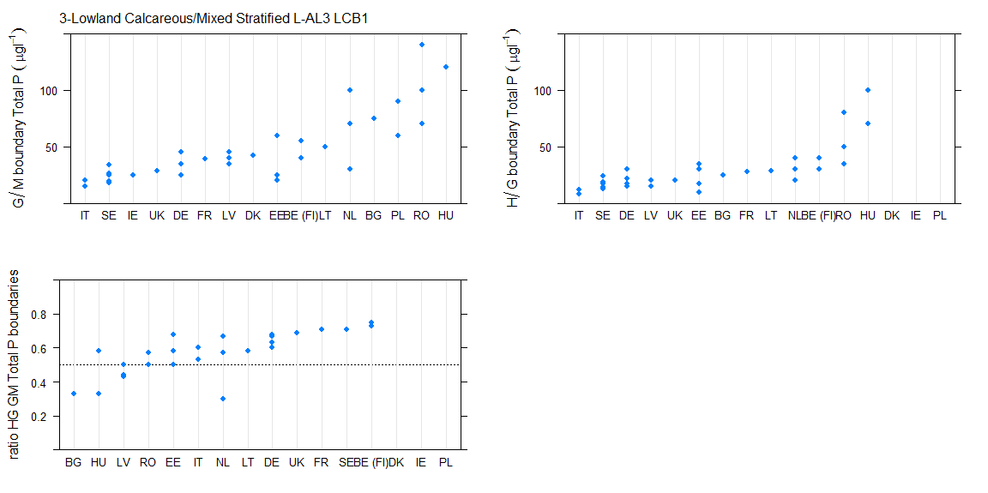
Figure 6.1-54 Range of a) good/moderate, b) high/good, c) ratio of good/moderate to high/good total phosphorus boundary values for broad type 3, lowland stratified calcareous/mixed lake types by country (values for DE include both median and 75th percentile standards).
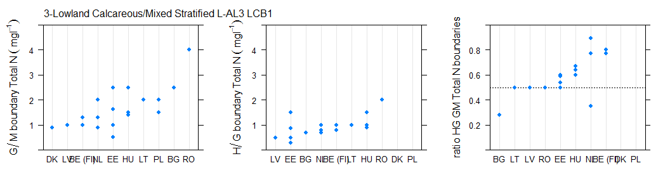
Figure 6.1-55 Range of a) good/moderate, b) high/good, c) ratio of good/moderate to high/good total nitrogen boundary values for broad type 3, lowland stratified calcareous/mixed lake types by country.
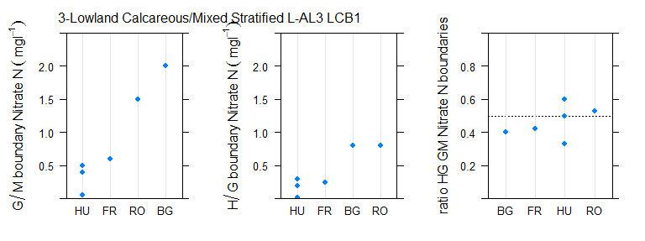
Figure 6.1-56 Range of a) good/moderate, b) high/good, c) ratio of good/moderate to high/good nitrate nitrogen boundary values for broad type 3, lowland stratified calcareous/mixed lake types by country.

Type 4 Lowland, calcareous/mixed very shallow lakes

Broad Type | Country | National type code | Description of type | IC Type
4 | AT | A1 | Lakes of the Pannonian Plain-Specual type Neusiedlersee | other
4 | BE (Fl) | Ai | Ionenrijk, alkalisch meer | L-CB2
4 | BE (Fl) | Ami | Matig ionenrijk, alkalisch meer | L-CB2
4 | BG | L4 | Lowland or semi-mountain natural lakes & swamps in ER 12 (variable, semi-mountain and lowlandzones; mixed/silicious/calcareus; <0.5 km2 dominated <5km2(rarely,reservoirs); max. depth <15m; mezotrophic; salinity < 0.5‰)
4 | DK | 11 | high alkalinity, clear, brackish, shallow
4 | DK | 13 | high alkalinity, colored, fresh, shallow
4 | DK | 9 | high alkalinity, clear, fresh, shallow | L-CB2
4 | EE | 2 | lowland, < 10 km2; medium alkalinity 80-240 HCO3- mg/L, not stratified mean depth below 3m | L-CB2
4 | FR | A13a | Plan d'eau vidangé à intervalle régulier | L-CB2
4 | FR | A13b | Plan d'eau généralement non vidangé mais à gestion hydraulique contrôlée | L-CB2
4 | FR | A16 | Plan d'eau peu profond, obtenu par creusement, en lit majeur d'un cours d'eay, en relation avec la nappe, forme de type L, sand thermocline | L-CB2
4 | FR | A6a | Retenue de basse altitude, peu profonde, non calcaire | L-CB1 L-CB2
4 | FR | A7a | Retenue de basse altitude, peu profonde, calcaire | L-CB2
4 | HU | 10L | Calcarous-small size-shallow-overgrown -intermittant
4 | HU | 12L | Calcarous-small size-shallow-overgrown-perennial | L-EC1
4 | IE | 10 | Altitude m<200, Alkalinity meq l-1 >2, Mean depth m<4, Area km2>0.5 | L-CB2
4 | IE | 5 | Altitude m<200, Alkalinity meq l-1 0.4 - 2, Mean depth m<4, Area km2<0.5
4 | IE | 6 | Altitude m<200, Alkalinity meq l-1 0.4 - 2, Mean depth m<4, Area km2>0.5
4 | IE | 9 | Altitude m<200, Alkalinity meq l-1 >2, Mean depth m<4, Area km2<0.5 | L-CB2
4 | IT | ITAL-4 | Unstratified subalpine lakes/reservoirs
4 | LT | LWT1 | Shallow lakes (average depth less than 3m) | L-CB2
4 | LV | L1 | Lowland, size > 50 ha, very shallow (< 2 m), hardwater (> 165 mkS/cm), oligohumic (< 80 Pt-Co). | L-CB2
4 | LV | L2 | Lowland, size > 50 ha, very shallow (< 2 m), hardwater (> 165 mkS/cm), polyhumic (> 80 Pt-Co). | L-CB2
4 | NL | M14 | Ondiepe gebufferde plassen | L-CB2
4 | NL | M23 | Grote ondiepe kalkrijke plassen | L-CB2
4 | PL | 3b | Western Europe Unit (Ni? ?rodkowopolski),polymictic, Ca>25 mgCa/l, Schindler's ratio >2 | L-CB1, L-CB2
4 | RO | ROLN04 | Lac natural in zona de campie, adancime foarte mica, calcar, suprafata medie
4 | RO | ROLN05 | Lac natural in zona de campie, adancime foarte mica, calcar, suprafata mare
4 | RO | ROLN06 | Lac natural in zona de campie, adancime foarte mica, calcar, suprafata foarte mare

4 | SE | S3SSNY | Dep<4m Alk>1meqL Col<50mgPtL Area<10km2 S3, Coast of Norrland below marine limit (the highest level the sea reached after the ice age)
4 | SE | S4SLNY | Dep<4m Alk>1meqL Col<50mgPtL Area>10km2 S4, Southeast Sweden below 200 masl
4 | SE | S4SLYY | Dep<4m Alk>1meqL Col>50mgPtL Area>10km2 S4, Southeast Sweden below 200 masl
4 | SE | S4SSNY | Dep<4m Alk>1meqL Col<50mgPtL Area<10km2 S4, Southeast Sweden below 200 masl
4 | SE | S4SSYY | Dep<4m Alk>1meqL Col>50mgPtL Area<10km2 S4, Southeast Sweden below 200 masl
4 | SE | S5SLNY | Dep<4m Alk>1meqL Col<50mgPtL Area>10km2 S5, South Sweden below 200 masl
4 | SE | S5SSNY | Dep<4m Alk>1meqL Col<50mgPtL Area<10km2 S5, South Sweden below 200 masl
4 | SE | S5SSYY | Dep<4m Alk>1meqL Col>50mgPtL Area<10km2 S5, South Sweden below 200 masl
4 | SE | S6SLYY | Dep<4m Alk>1meqL Col>50mgPtL Area>10km2 S6, Southwest Sweden below 200 masl
4 | SE | S6SSYY | Dep<4m Alk>1meqL Col>50mgPtL Area<10km2 S6, Southwest Sweden below 200 masl
4 | UK | HAVS | high alkalinity very shallow | L-CB2

Table 6.1-32 National & intercalibration types for countries reporting Broad Type 4 Lowland, calcareous/mixed, very shallow (unstratified) lakes.

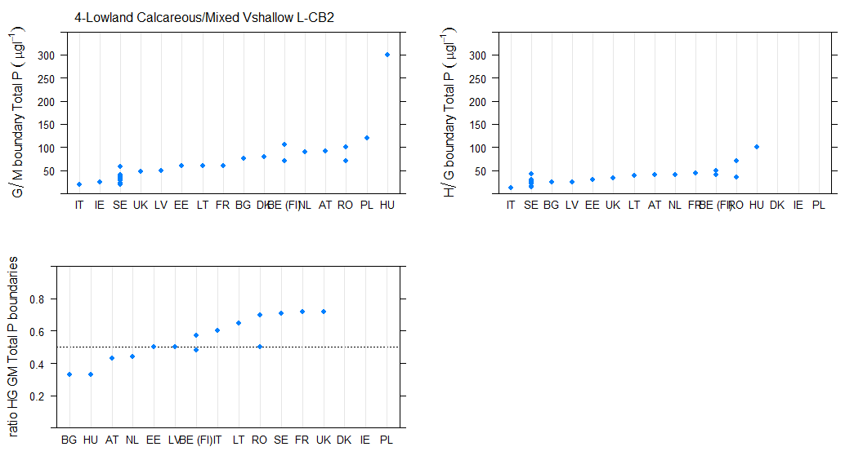
Figure 6.1-57 Range of a) good/moderate, b) high/good, c) ratio of good/moderate to high/good total phosphorus boundary values for broad type 4, lowland, calcareous/mixed, very shallow (un-stratified) lakes.
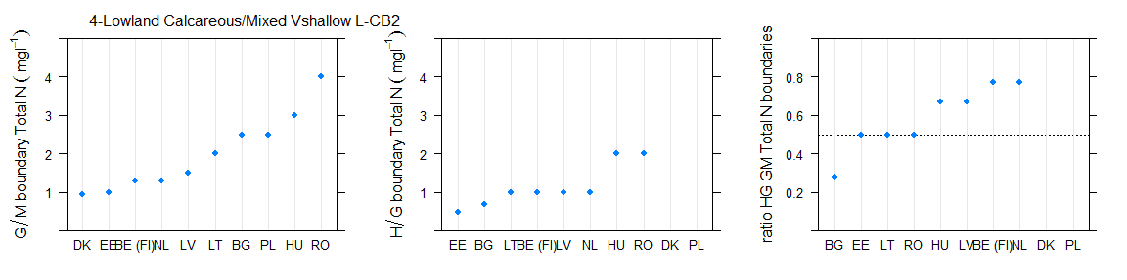
Figure 6.1-58 Range of a) good/moderate, b) high/good, c) ratio of good/moderate to high/good total nitrogen boundary values for broad type 4, lowland, calcareous/mixed, very shallow (un-stratified) lakes.
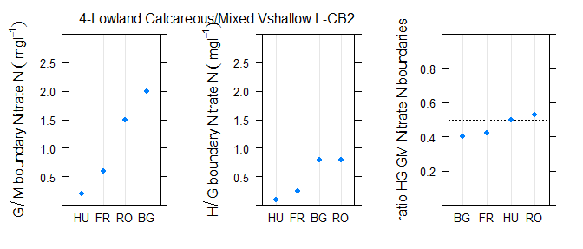
Figure 6.1-59 Range of a) good/moderate, b) high/good, c) ratio of good/moderate to high/good nitrate nitrogen boundary values for broad type 3, lowland stratified calcareous/mixed lake types by country.

Type 5 Lowland, organic and siliceous

Broad Type | Country | National type code | Description of type | IC Type
5 | FI | Kh | Medium-size (surface area 5- 40 km2), humic (colour 30-90 mg/l Pt), mean depth ?3 m | L-N3a
5 | FI | Ph | Small (surface area < 5 km2), humic (colour 30-90 mg/l Pt), mean depth ?3 m | L-N3a
5 | FR | N11 | Lac de basse altitude en façade méditerranéenne
5 | LV | L4 | Lowland, size > 50 ha, very shallow (< 2 m), soft water (< 165 mkS/cm), polyhumic (> 80 Pt-Co).
5 | LV | L8 | Lowland, size > 50 ha, shallow (2-9 m), soft water (< 165 mkS/cm), polyhumic (> 80 Pt-Co). | L-CB3
5 | NO | 3 | lowland, shallow (stratified, mean depth 3-15 m), low alkalinity (<0,2 mekv/l), humic (colour 30-90 mg Pt/l) | L-N3a
5 | NO | 7 | lowland, shallow (stratified, mean depth 3-15 m), low alkalinity (<0,2 mekv/l), humic (colour 30-90 mg Pt/l) | L-N3a
5 | NO | 9 | lowland, shallow (stratified, mean depth 3-15 m), moderate alkalinity (0,2-1,0 mekv/l), humic (colour 30-90 mg Pt/l) | L-N8a
5 | SE | S3DLYN | Dep>4m Alk<1meqL Col>50mgPtL Area>10km2 S3, Coast of Norrland below marine limit (the highest level the sea reached after the ice age)
5 | SE | S3DSYN | Dep>4m Alk<1meqL Col>50mgPtL Area<10km2 S3, Coast of Norrland below marine limit (the highest level the sea reached after the ice age)
5 | SE | S3SLYN | Dep<4m Alk<1meqL Col>50mgPtL Area>10km2 S3, Coast of Norrland below marine limit (the highest level the sea reached after the ice age)
5 | SE | S3SSYN | Dep<4m Alk<1meqL Col>50mgPtL Area<10km2 S3, Coast of Norrland below marine limit (the highest level the sea reached after the ice age)
5 | SE | S4DLYN | Dep>4m Alk<1meqL Col>50mgPtL Area>10km2 S4, Southeast Sweden below 200 masl
5 | SE | S4DSYN | Dep>4m Alk<1meqL Col>50mgPtL Area<10km2 S4, Southeast Sweden below 200 masl
5 | SE | S4SSYN | Dep<4m Alk<1meqL Col>50mgPtL Area<10km2 S4, Southeast Sweden below 200 masl
5 | SE | S5DLYN | Dep>4m Alk<1meqL Col>50mgPtL Area>10km2 S5, South Sweden below 200 masl
5 | SE | S5DSYN | Dep>4m Alk<1meqL Col>50mgPtL Area<10km2 S5, South Sweden below 200 masl
5 | SE | S5SLYN | Dep<4m Alk<1meqL Col>50mgPtL Area>10km2 S5, South Sweden below 200 masl
5 | SE | S5SSYN | Dep<4m Alk<1meqL Col>50mgPtL Area<10km2 S5, South Sweden below 200 masl
5 | SE | S6DLYN | Dep>4m Alk<1meqL Col>50mgPtL Area>10km2 S6, Southwest Sweden below 200 masl
5 | SE | S6DSYN | Dep>4m Alk<1meqL Col>50mgPtL Area<10km2 S6, Southwest Sweden below 200 masl
5 | SE | S6SLYN | Dep<4m Alk<1meqL Col>50mgPtL Area>10km2 S6, Southwest Sweden below 200 masl
5 | SE | S6SSYN | Dep<4m Alk<1meqL Col>50mgPtL Area<10km2 S6, Southwest Sweden below 200 masl

Table 6.1-33 National & intercalibration types for countries reporting Broad Type 5, lowland, organic siliceous lakes.
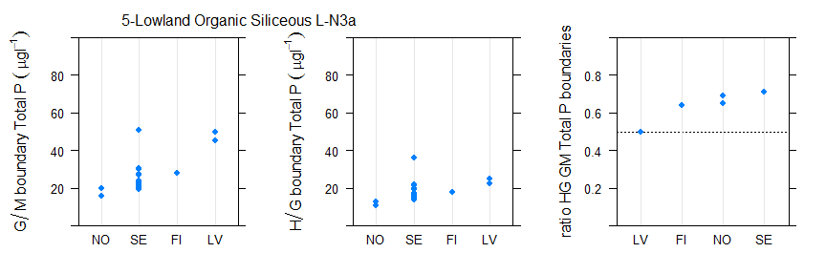
Figure 6.1-60 Range of a) good/moderate, b) high/good, c) ratio of good/moderate to high/good total phosphorus boundary values for broad type 5, lowland, organic siliceous lakes.
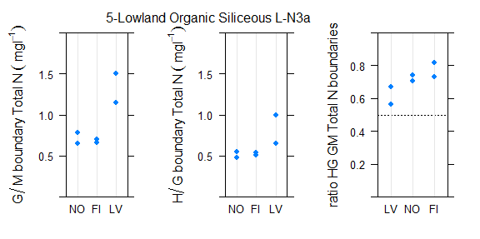
Figure 6.1-61 Range of a) good/moderate, b) high/good, c) ratio of good/moderate to high/good total nitrogen boundary values for broad type 5, lowland, organic siliceous lakes.

Type 6 Lowland, organic, calcareous/mixed

Broad Type | Country | National type code | Description of type | IC Type
6 | EE | 4 | lowland, < 10 km2; low alkalinity < 80 HCO3- mg/L, brown water, not stratified, mean depth <3m
6 | HU | 1L | Organic-small size-shallow-overgrown-intermittent
6 | HU | 2L | Organic-small size-shallow-overgrown-perennial | L-EC1
6 | HU | 3L | Organic-small size-shallow-not overgrown-perennial | L-EC1
6 | LV | L6 | Lowland, size > 50 ha, shallow (2-9 m), hardwater (> 165 mkS/cm), polyhumic (> 80 Pt-Co). | L-CB1
6 | NL | M27 | Matig grote ondiepe laagveenplassen | L-CB2
6 | RO | ROLN07 | Lac natural in zona de campie, adancime foarte mica, turba, suprafata mica
6 | RO | ROLN08 | Lac natural in zona de campie, adancime foarte mica, turba, suprafata medie
6 | RO | ROLN09 | Lac natural in zona de campie, adancime foarte mica, turba, suprafata mare
6 | RO | ROLN13 | Lac natural in zona de campie, adancime mica, turba, suprafata medie
6 | SE | S4DLYY | Dep>4m Alk>1meqL Col>50mgPtL Area>10km2 S4, Southeast Sweden below 200 masl
6 | SE | S4DSYY | Dep>4m Alk>1meqL Col>50mgPtL Area<10km2 S4, Southeast Sweden below 200 masl
6 | SE | S6DSYY | Dep>4m Alk>1meqL Col>50mgPtL Area<10km2 S6, Southwest Sweden below 200 masl

Table 6.1-34 National & intercalibration types for countries reporting Broad Type 6, lowland, organic calcareous/mixed lakes.

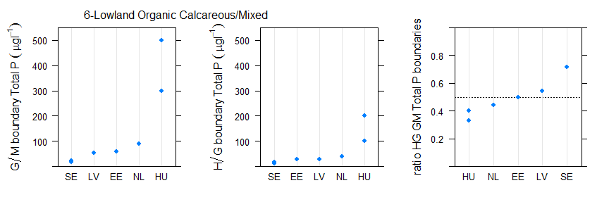
Figure 6.1-62 Range of a) good/moderate, b) high/good, c) ratio of good/moderate to high/good total phosphorus boundary values for broad Broad Type 6, lowland, organic calcareous/mixed lakes.
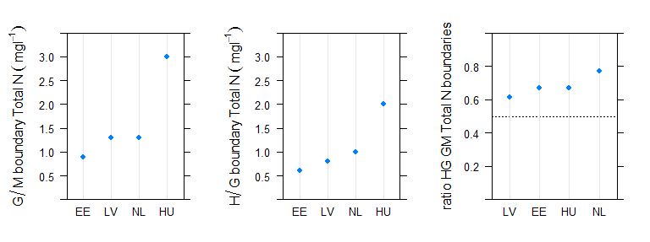
Figure 6.1-63 Range of a) good/moderate, b) high/good, c) ratio of good/moderate to high/good total nitrogen boundary values for broad Broad Type 6, lowland, organic calcareous/mixed lakes.

Type 7 Mid-altitude, siliceous lakes
Broad Type | Country | National type code | Description of type | IC Type
7 | AT | D3 | Large Lakes of the Central Alps 600-600m | L-AL3
7 | DE | 8 | geschichteter, calciumarmer Mittelgebirgssee mit relativ großem Einzugsgebiet
7 | DE | 9 | geschichteter, calciumarmer Mittelgebirgssee mit relativ kleinem Einzugsgebiet
7 | FR | A13a | Plan d'eau vidangé à intervalle régulier | L-CB2
7 | FR | A4 | Retenue de moyenne montagne, non calcaire, peu profonde
7 | FR | A5 | Retenue de moyenne montagne, non calcaire, profonde
7 | FR | A6a | Retenue de basse altitude, peu profonde, non calcaire | L-CB1  L-CB2
7 | FR | A6b | Retenue de basse altitude, profonde, non calcaire (L-CB1)
7 | IE | 13 | Altitude m>200
7 | IT | ITAL-8 | Deep silceous Alpine (800-2000m) lakes/reservoirs | L-AL4
7 | IT | ITAL-10 | Deep silceous Alpine (800-2000m) lakes/reservoirs | L-AL3
7 | NO | 12 | mid-altitude (200-800 masl), shallow or deep (stratified, mean depth > 3 m), low alkalinity (<0,2 mekv/l), clear (colour <30 mg Pt/l) | L-N5
7 | NO | 13 | mid-altitude (200-800 masl), shallow or deep (stratified, mean depth > 3 m), low alkalinity (<0,2 mekv/l), clear (colour <30 mg Pt/l) | L-N5
7 | NO | 15 | mid-altitude (200-800 masl), shallow or deep (stratified, mean depth > 3 m), low alkalinity (<0,2 mekv/l), clear (colour <30 mg Pt/l) | L-N5
7 | NO | 16 | mid-altitude (200-800 masl), shallow or deep (stratified, mean depth > 3 m), low alkalinity (<0,2 mekv/l), clear (colour <30 mg Pt/l) | L-N5
7 | PT | B-L-M/MI/S/PP | Lagoas Pouco Profundas
7 | PT | B-L-M/MI-MP/S/P | Lagoas Profundas
7 | RO | ROLN15 | Lac natural in zona de deal si podis, adancime foarte mica, siliciu, suprafata foarte mica
7 | RO | ROLN16 | Lac natural in zona de deal si podis, adancime mica, siliciu, suprafata foarte mica
7 | SE | S2DLNN | Dep>4m Alk<1meqL Col<50mgPtL Area>10km2 S2, Inlands of Norrland below tree line
7 | SE | S2DSNN | Dep>4m Alk<1meqL Col<50mgPtL Area<10km2 S2, Inlands of Norrland below tree line
7 | SE | S2SSNN | Dep<4m Alk<1meqL Col<50mgPtL Area<10km2 S2, Inlands of Norrland below tree line
7 | SE | S7DLNN | Dep>4m Alk<1meqL Col<50mgPtL Area>10km2 S7, Highlands of South Sweden above 200 masl
7 | SE | S7DSNN | Dep>4m Alk<1meqL Col<50mgPtL Area<10km2 S7, Highlands of South Sweden above 200 masl
7 | SE | S7SSNN | Dep<4m Alk<1meqL Col<50mgPtL Area<10km2 S7, Highlands of South Sweden above 200 masl

Table 6.1-35 National & intercalibration types for countries reporting Broad Type 7, Mid-altitude, siliceous lakes
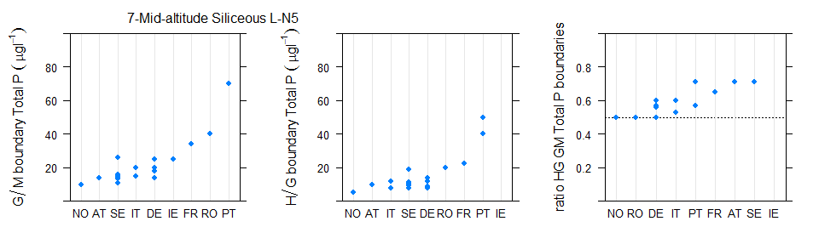
Figure 6.1-64 Range of a) good/moderate, b) high/good, c) ratio of good/moderate to high/good total phosphorus boundary values for Broad Type Type 7 Mid-altitude, siliceous lakes (values for DE include both median and 75th percentile metrics)
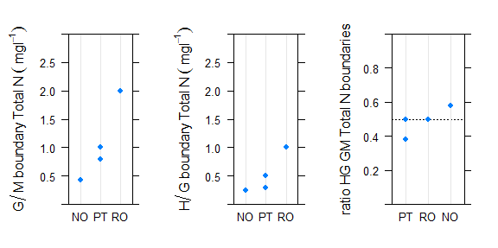
Figure 6.1-65 Range of a) good/moderate, b) high/good, c) ratio of good/moderate to high/good total phosphorus boundary values for Broad Type Type 7 Mid-altitude, siliceous lakes
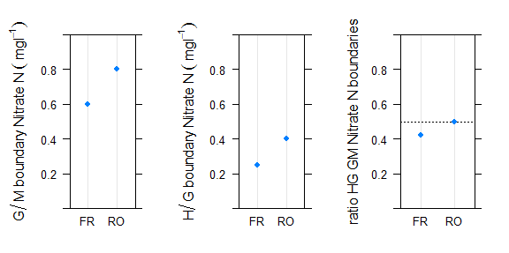
Figure 6.1-66 Range of a) good/moderate, b) high/good, c) ratio of good/moderate to high/good nitrate phosphorus boundary values for Broad Type Type 7 Mid-altitude, siliceous lakes

Type 8 Mid-altitude, calcareous/mixed

Broad Type | Country | National type code | Description of type | IC Type
8 | AT | B2 | Large Alpine foothill lakes | L-AL4
8 | AT | C1a | Large Carinthian lakes < 600m, Zavg > 15m | L-AL3
8 | AT | C1b | Large Carinthian lakes < 600m, Zavg < 15m | L-AL4
8 | AT | D1 | Large, deep lakes of the Northern Limestone Alps 400-600m | L-AL3
8 | AT | D2a+b | Large, shallow to moderately deep lakes of the Limestone Alpine Foothills 600-800 m | L-AL3
8 | BG | L12 | Small and medium-size semi-mountain reservoirs/ artificial lakes in ER 12 (>150 (200) m up to mountain zone variable; mixed/silicious/calcareous; 1-10 km2, medium or 0.5 -1 km2 small; max. depth <80m; usually oligotrophic to mesotrophic ; salinity < 0.5‰
8 | BG | L13 | Small and medium-size semi-mountain reservoirs/ artificial lakes in ER 7 (150 (350)-600 (800)m variable; mixed/silicious/calcareous; 1-10 km2, medium or 0.5 -1 km2 small; max. depth <80m; usually oligotrophic to mesotrophic ; salinity < 0.5‰)
8 | DE | 2 | geschichteter Alpenvorlandsee mit relativ großem Einzugsgebiet | L-AL4
8 | DE | 3 | geschichteter Alpenvorlandsee mit relativ kleinem Einzugsgebiet | L-AL4
8 | DE | 5 | geschichteter, calciumreicher Mittelgebirgssee mit relativ großem Einzugsgebiet
8 | DE | 6 | polymiktischer, calciumreicher Mittelgebirgssee
8 | DE | 7 | geschichteter, calciumreicher Mittelgebirgssee mit relativ kleinem Einzugsgebiet
8 | FR | A13a | Plan d’eau vidangé à intervalle régulier | L-CB2
8 | FR | A13b | Plan d'eau généralement non vidangé mais à gestion hydraulique contrôlée | L-CB2
8 | FR | A2 | Retenue de moyenne montagne, calcaire, peu profonde | L-AL4
8 | FR | A3 | Retenue de moyenne montagne, calcaire, profunde | L-AL3  L-AL4
8 | FR | A5 | Retenue de moyenne montagne, non calcaire, profonde | L-M5/7
8 | FR | A6b | Retenue de basse altitude, profonde, non calcaire | L-CB1
8 | FR | A7a | Retenue de basse altitude, peu profonde, calcaire | L-CB1
8 | FR | A7b | Retenue de basse altitude, profonde, calcaire | L-CB1  L-CB3
8 | FR | N3 | Lac de moyenne montagne, calcaire, peu profond | L-AL4
8 | FR | N4 | Lac de moyenne montagne, calcaire, profond, à zone littorale | L-AL3  L-AL4
8 | HR | HR-J_1A | Mountain,oligotrophic, deep, small lakes; carbonate bed
8 | HR | HR-J_1B | Mountain, oligotrophic-mesotrophic, deep, small lakes; carbonate bed
8 | IT | ITAL-7 | Shallow calcareous Alpine (800-2000 m) lakes/reservoirs | L-AL4
8 | IT | ITAL-9 | Deep calcareous Alpine (800-2000) lakes/reservoirs | L-AL3
8 | SE | S2DSNY | Dep>4m Alk>1meqL Col<50mgPtL Area<10km2 S2, Inlands of Norrland below tree line
8 | SE | S2SSNY | Dep<4m Alk>1meqL Col<50mgPtL Area<10km2 S2, Inlands of Norrland below tree line
8 | Sl | A1 | Dep>15m Limestone Area 1-10km2 mid altituded 200-800m >1yr Retention Alps | L-AL3
8 | Sl | A2 | Dep>15m Limestone Area 1-10km2 mid altituded 200-800m <1yr Retention Alps | L-AL3

Table 6.1-36 National & intercalibration types for countries reporting Broad Type 8, mid-altitude, calcareous/mixed
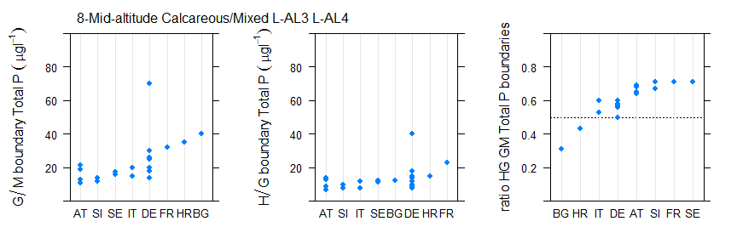
Figure 6.1-67 Range of a) good/moderate, b) high/good, c) ratio of good/moderate to high/good total phosphorus boundary values for broad type 8, mid-altitude, calcareous/mixed (values for DE include median and 75th percentiles).
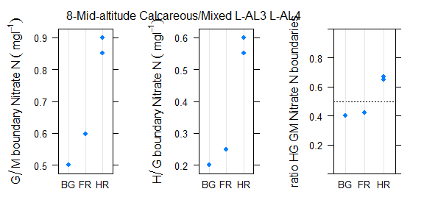
Figure 6.1-68 Range of a) good/moderate, b) high/good, c) ratio of good/moderate to high/good nitrate nitrogen boundary values for broad type 8, mid-altitude, calcareous/mixed.

Type 9, Mid-altitude, organic & siliceous lakes

Broad Type | Country | National type code | Description of type | IC Type
9 | NO | 14 | mid-altitude (200-800 masl) or highland (>800 masl), shallow or deep (stratified, mean depth > 3 m), low alkalinity (<0,2 mekv/l), humic (colour 30-90 mg Pt/l) | L-N6a
9 | NO | 17 | mid-altitude (200-800 masl) or highland (>800 masl), shallow or deep (stratified, mean depth > 3 m), low alkalinity (<0,2 mekv/l), humic (colour 30-90 mg Pt/l) | L-N6a
9 | SE | S2DLYN | Dep>4m Alk<1meqL Col>50mgPtL Area>10km2 S2, Inlands of Norrland below tree line
9 | SE | S2DSYN | Dep>4m Alk<1meqL Col>50mgPtL Area<10km2 S2, Inlands of Norrland below tree line
9 | SE | S2SSYN | Dep<4m Alk<1meqL Col>50mgPtL Area<10km2 S2, Inlands of Norrland below tree line
9 | SE | S7DLYN | Dep>4m Alk<1meqL Col>50mgPtL Area>10km2 S7, Highlands of South Sweden above 200 masl
9 | SE | S7DSYN | Dep>4m Alk<1meqL Col>50mgPtL Area<10km2 S7, Highlands of South Sweden above 200 masl
9 | SE | S7SSYN | Dep<4m Alk<1meqL Col>50mgPtL Area<10km2 S7, Highlands of South Sweden above 200 masl

Table 6.1-37 National & intercalibration types for countries reporting Broad Type 9 mid-altitude, organic and siliceous lakes.
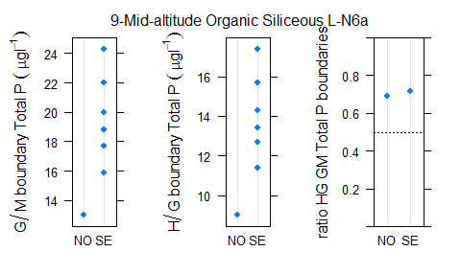
Figure 6.1-69 Range of a) good/moderate, b) high/good, c) ratio of good/moderate to high/good nitrate nitrogen boundary values for broad type 9 mid-altitude, organic and siliceous lakes.

Type 10, Mid-altitude, organic & calcareous/mixed lakes
Only one country reporting this lake type

Type 11, Highland, siliceous (all Europe) lakes.

Broad Type | Country | National type code | Description of type | IC Type
11 | BG | L1 | High mountain glacial lakes (ER12/ER7; altitude >2000 m; silicious/mixed; very smal <0.15 km2; max. depth <50 m, ultra-oligotrophic; salinity < 0.5‰)
11 | BG | L2 | Mountain lakes in ER12 (mountainous zone - variable; mixed/silicious/calcareus; very smal <0.1 km2; max. depth <15m, <80m reservoirs; oligotrophic; salinity < 0.5‰)
11 | BG | L3 | Mountain lakes in ER7 (>(600) 800 m variable ; organic(peat)/mixed/silicious/calcareus; very smal <0.1 km2(naturallakes), <5km2 for HMWB; max. depth <6m lakes, <80mreservoirs; oligotrophic; salinity < 0.5‰)
11 | FR | A1 | Retenue de haute montagne
11 | FR | N11 | Lac de basse altitude en façade méditerranéenne
11 | FR | N2 | Lac de haute montagne à berges dénudées
11 | FR | N5 | Lac de moyenne montagne, non calcaire, peu profond
11 | FR | N7 | Lac de moyenne montagne, non calcaire, profond et sans zone littorale importante
11 | IT | ITAL-2 | Siliceous high mountain lakes and reservoirs subtype <15m depth
11 | IT | ITAL-2 | Siliceous high mountain lakes and reservoirs subtype >15m depth
11 | NO | 20 | highland (> 800 masl), shallow or deep (stratified, mean depth > 3 m), low alkalinity (<0,2 mekv/l), clear (colour <30 mg Pt/l) | L-N7
11 | NO | 21 | highland (> 800 masl), shallow or deep (stratified, mean depth > 3 m), low alkalinity (<0,2 mekv/l), clear (colour <30 mg Pt/l) | L-N7
11 | NO | 22 | mid-altitude (200-800 masl) or highland (>800 masl), shallow or deep (stratified, mean depth > 3 m), low alkalinity (<0,2 mekv/l), humic (colour 30-90 mg Pt/l) | L-N6a
11 | NO | 23 | highland (> 800 masl), shallow or deep (stratified, mean depth > 3 m), low alkalinity (<0,2 mekv/l), clear (colour <30 mg Pt/l) | L-N7
11 | NO | 24 | highland (> 800 masl), shallow or deep (stratified, mean depth > 3 m), low alkalinity (<0,2 mekv/l), clear (colour <30 mg Pt/l) | L-N7
11 | NO | 25 | mid-altitude (200-800 masl) or highland (>800 masl), shallow or deep (stratified, mean depth > 3 m), low alkalinity (<0,2 mekv/l), humic (colour 30-90 mg Pt/l) | L-N6a
11 | RO | ROLN17 | Lac natural in zona montana, adancime mica, siliciu, suprafata foarte mica
11 | RO | ROLN18 | Lac natural in zona montana, adancime foarte mica, siliciu, suprafata foarte mica
11 | SE | S1DSNN | Dep>4m Alk<1meqL Col<50mgPtL Area>10km2 S4, Southeast Sweden above treeline

Table 6.1-38 National & intercalibration types for countries reporting Broad Type 11, highland, siliceous (all Europe)

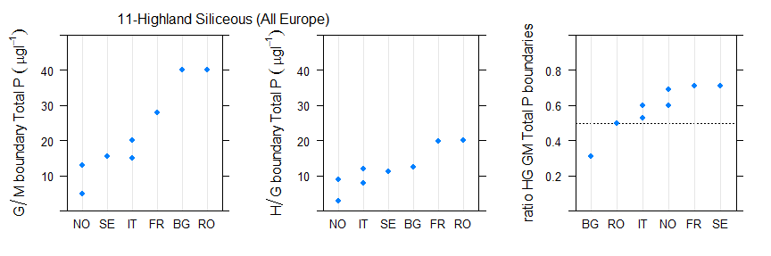
Figure 6.1-70 Range of a) good/moderate, b) high/good, c) ratio of good/moderate to high/good total phosphorus boundary values for broad type11, highland, siliceous (all Europe)

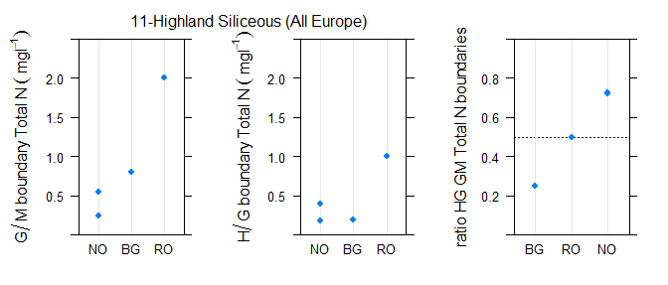
Figure 6.1-71 Range of a) good/moderate, b) high/good, c) ratio of good/moderate to high/good total nitrogen boundary values for broad type11, highland, siliceous (all Europe)
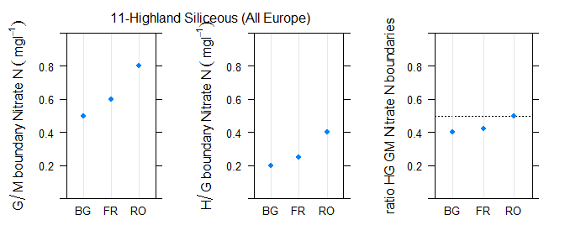
Figure 6.1-72 Range of a) good/moderate, b) high/good, c) ratio of good/moderate to high/good nitrate nitrogen boundary values for broad type11, highland, siliceous (all Europe)

Type 12 Highland, calcareous/mixed (all Europe)

Broad Type | Country | National type code | Description of type | IC Type
12 | AT | E1 | Large, deep mountain lakes of the Limestone Alps 800-1200 m | L-AL3
12 | IT | ITAL-1 | Calcareous high mountain lakes and reservoirs subtype <15m depth
12 | IT | ITAL-1 | Calcareous high mountain lakes and reservoirs subtype >15m depth

Table 6.1-39 National & intercalibration types for countries reporting Broad Type 12, highland, calcareous/mixed (all Europe)
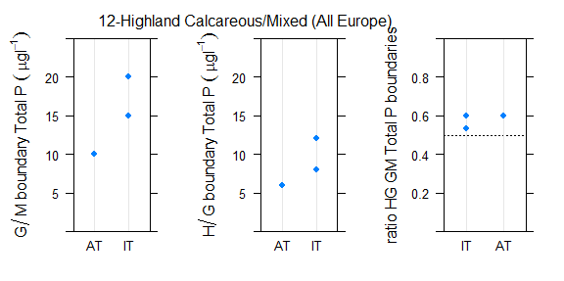
Figure 6.1-73 Range of a) good/moderate, b) high/good, c) ratio of good/moderate to high/good boundary values for broad type12, highland, calcareous/mixed (all Europe)

Type 13 Mediterranean, small-large, siliceous (including reservoirs)

Broad Type | Country | National type code | Description of type | IC Type
13 | IT | ITME-3 | Shallow, siliceous, Mediterranean lakes/reservoirs
13 | IT | ITME-5 | Deep, siliceous, Mediterranean lakes/reservoirs | L-M8
13 | PT | L_N | Norte | L-M5/7
13 | PT | L_S | Sul | L-M5/7

Table 6.1-40 National & intercalibration types for countries reporting Broad Type 13 Mediterranean, small-large, siliceous (including reservoirs)
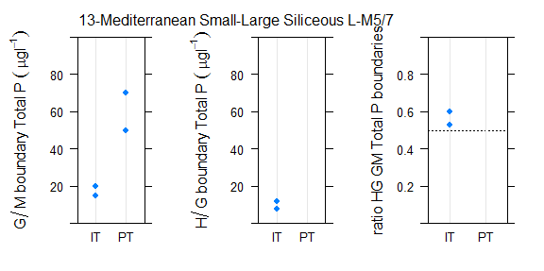
Figure 6.1-74 Range of a) good/moderate, b) high/good, c) ratio of good/moderate to high/good total phosphorus boundary values for broad type 13 Mediterranean, small-large, siliceous (including reservoirs)

Type 14, Mediterranean, small-large, calcareous/mixed (including reservoirs)

Broad Type | Country | National type code | Description of type | IC Type
14 | CY | L4 | connected deep reservoir (>5m mean depth) | L-M8
14 | FR | A3 | Retenue de moyenne montagne, calcaire, profonde | L-AL3 L-AL4  L-M8
14 | FR | A12 | Retenue méditerranéenne de basse altitude sur socle cristallin, profonde
14 | FR | A8 | Retenue à marnage très important voire fréquent
14 | FR | N11 | Lac de basse altitude en façade méditerranéenne
14 | HR | HR-J_2 | Lowland, deep, medium lakes; cryptodepression, carbonate bed
14 | HR | HR-J_3 | Lowland, medium deep, small lakes; cryptodepression, carbonate bed
14 | HR | HR-J_4 | Lowland, shallow, big lakes; cryptodepression, carbonate bed
14 | HR | HR-J_5 | Lowland, medium deep, medium lakes; carbonate bed
14 | IT | ITME-1 | Unstratified Mediterranean lakes/reservoirs
14 | IT | ITME-2 | Shallow, calcareous, Mediterranean lakes/reservoirs
14 | IT | ITME-4 | Deep, calcareous, Mediterranean lakes/reservoirs | L-M8
14 | IT | ITME-6 | Shallow volcanic lakes
14 | IT | ITME-6 | Shallow volcanic lakes

Table 6.1-41 National & intercalibration types for countries reporting Broad Type 14, Mediterranean, small-large, calcareous/mixed (including reservoirs)

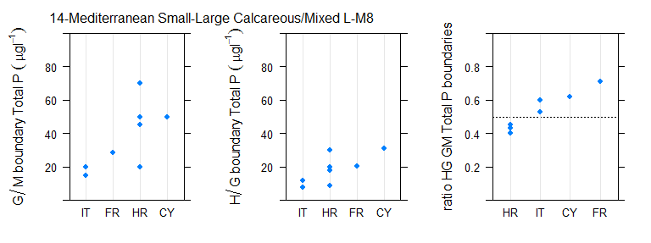
Figure 6.1-75 Range of a) good/moderate, b) high/good, c) ratio of good/moderate to high/good total phosphorus boundary values for broad type 14, Mediterranean, small-large, calcareous/mixed (including reservoirs)
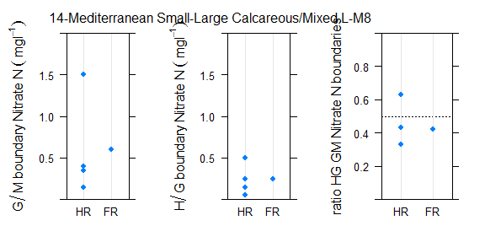
Figure 6.1-76 Range of a) good/moderate, b) high/good, c) ratio of good/moderate to high/good nitrate nitrogen boundary values for broad type 14, Mediterranean, small-large, calcareous/mixed (including reservoirs)

Type 15
Only one country, France, reported this type

Detailed comparison of river boundaries

River boundaries by intercalibration type and country
Comparisons of all intercalibration types with four or more countries contributing to the type are set out in the following section

R-A2 Small-medium, high altitude, siliceous rivers, boulders

Broad Type | Country | National type code | Description of type | IC Type
10 | FR | GM5/2 | Grand ou Moyen cours d'eau du Jura/Pré-Alpes du Nord et exogène des Alpes internes | R-A2
14 | AT | 2_MZB1,25_PHBot | Bioregion: Unglaciated Central Alps (2); Macroinvertebrate- saprobic reference condition: SI 1,25; Phytobenthos-trophic reference condition: oligotrophic (ot) | R-A2
14 | AT | 2_MZB1,5_PHBot | Bioregion: Unglaciated Central Alps (2); Macroinvertebrate- saprobic reference condition: SI 1,5; Phytobenthos-trophic reference condition: oligotrophic (ot) | R-A2
14 | AT | 3_MZB1,5_PHBmt | Bioregion: Ridges and Foothills of the Central Alps (3); Macroinvertebrate- saprobic reference condition: SI 1,5; Phytobenthos-trophic reference condition: mesotrophic (mt) | R-A2
14 | AT | 3_MZB1,5_PHBom | Bioregion: Ridges and Foothills of the Central Alps (3); Macroinvertebrate- saprobic reference condition: SI 1,5; Phytobenthos-trophic reference condition: oligo-mesotrophic (om) | R-A2
 | ES | 120 | Ríos de serranías béticas húmedas | R-A2
14 | FR | MP2 | Moyen ou Petit cours d'eau des Alpes internes | R-A2
14 | FR | P14/1 | Petit cours d'eau des Coteaux aquitains et exogène des Pyrénées | R-A2
16 | FR | G1 | Grand cours d'eau des Pyrénées | R-A2
16 | FR | G2 | Grand cours d'eau des Alpes internes | R-A2
16 | FR | GM7/2 | Grand ou Moyen cours d'eau des Pré-Alpes du Sud et exogène des Alpes internes | R-A2
16 | FR | GM5/2 | Grand ou Moyen cours d'eau du Jura/Pré-Alpes du Nord et exogène des Alpes internes | R-A2
16 | FR | M1 | Moyen cours d'eau des Pyrénées | R-A2
16 | FR | P1 | Petit cours d'eau des Pyrénées | R-A2
16 | FR | TP1 | Très Petit cours d'eau des Pyrénées | R-A2
16 | FR | TP2 | Très petit cours d'eau des Alpes internes | R-A2
16 | IT | IT01GH1N |  | R-A2
16 | IT | IT01GH2N |  | R-A2
16 | IT | IT01SS1N |  | R-A2
16 | IT | IT01SS2N |  | R-A2
16 | IT | IT04SS2N |  | R-A2
14 | IT | IT03GH1N |  | R-A2
9 | IT | IT03GH6N |  | R-A2
9 | IT | IT03SS1N |  | R-A2
9 | IT | IT03SS2N |  | R-A2
8 | IT | IT03SS3N |  | R-A2

Table 6.2-42 National & broad types for Alpine GIG countries reporting river intercalibration type R-A2

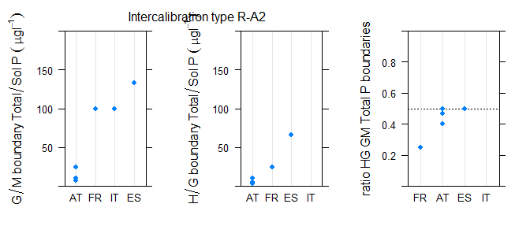
Figure 6.2-77 Range of a)good/moderate, b)high/good, c)ratio of good/moderate to high/good phosphorus boundary values for intercalibration type R-A2
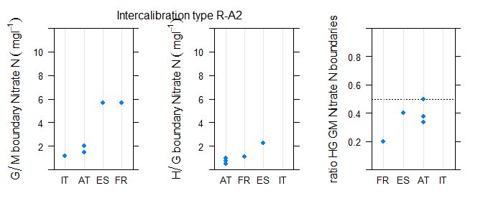
Figure 6.2-78 Range of a)good/moderate, b)high/good, c)ratio of good/moderate to high/good nitrate nitrogen boundary values for intercalibration type R-A2

R-C1 Small, lowland, siliceous rivers dominated by sand

Broad Type | Country | National type code | Description of type | IC Type
3 | FR | P13 | Petit cours d'eau des Landes | R-C1
3 | FR | P18/4 | Petit cours d'eau d'Alsace et exogène des Vosges | R-C1
3 | FR | P20 | Petit cours d'eau des Dépôts argilo-sableux | R-C1
3 | FR | TP13 | Très Petit cours d'eau des Landes | R-C1
3 | FR | TP20 | Très Petit cours d'eau des Dépôts argilo-sableux | R-C1
3 | NL | R14 | Snelstromende middenloop/benedenloop op zand | R-C1
3 | NL | R17 | Snelstromende bovenloop op kalkhoudende bodem | R-C1
3 | NL | R18 | Snelstromende middenloop/benedenloop op kalkhoudende bodem | R-C1
3 | PL | 17 | Potok nizinny piaszczysty | R-C1
3 | PL | 18 | Potok nizinny żwirowy | R-C1
3 | PL | 26 | Cieki w dolinach wielkich rzek nizinnych | R-C1
5 | BE (W) | RIV_20 |  | R-C1
5 | LT | RWT1 | Small rivers (area less than 100 km2) | R-C1
5 | NL | R4 | Permanente langzaam stromende bovenloop op zand | R-C1
5 | NL | R5 | Langzaam stromende middenloop/benedenloop op zand | R-C1
5 | UK | 2 | Lowland Calcareous Small | R-C1

Table 6.2-43 National & broad types for Central Baltic GIG countries reporting river intercalibration type R-C1
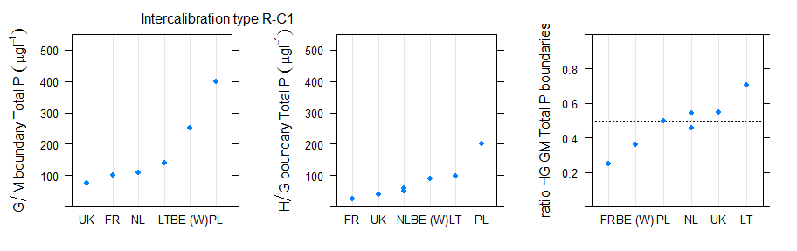
Figure 6.2-79 Range of a)good/moderate, b)high/good, c)ratio of good/moderate to high/good phosphorus boundary values for intercalibration type R-C1
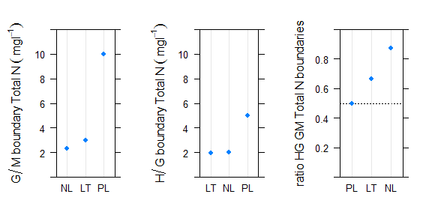
Figure 6.2-80 Range of a)good/moderate, b)high/good, c)ratio of good/moderate to high/good total nitrogen boundary values for intercalibration type R-C1
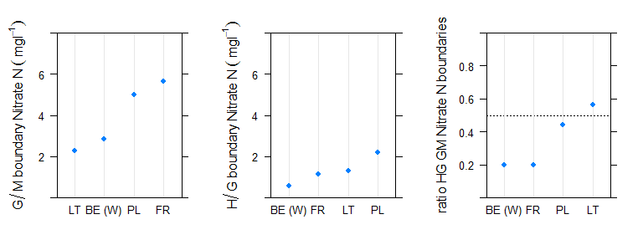
Figure 6.2-81 Range of a)good/moderate, b)high/good, c)ratio of good/moderate to high/good nitrate nitrogen boundary values for intercalibration type R-C1

R-C3 Small, mid-altitude, siliceous rivers with rock
Broad Type | Country | National type code | Description of type | IC Type
8 | BE (W) | RIV_06 |  | R-C3
8 | BE (W) | RIV_07 |  | R-C3
8 | FR | P21 | Petit cours d'eau du Massif central Nord | R-C3
8 | FR | P3 | Petit cours d'eau du Massif central Sud | R-C3
8 | UK | 13 | Mid-altitude Siliceous Medium | R-C3
9 | AT | 11_MZB1,75_PHBmt | Bioregion: Bavarian-Austrian Alpine Foothills (11); Macroinvertebrate- saprobic reference condition: SI 1,75; Phytobenthos-trophic reference condition: mesotrophic (mt) | R-C3
9 | AT | 11_MZB1,75_PHBom | Bioregion: Bavarian-Austrian Alpine Foothills (11); Macroinvertebrate- saprobic reference condition: SI 1,75; Phytobenthos-trophic reference condition: oligo-mesotrophic (om) | R-C3
9 | AT | 12_MZB1,5_PHBme1 | Bioregion: Granite and Gneiss Region of the Bohemian Massif (12); Macroinvertebrate- saprobic reference condition:SI 1,5; Phytobenthos-trophic reference condition: lower half meso-eutrophic (me1) | R-C3
9 | AT | 12_MZB1,5_PHBmt | Bioregion: Granite and Gneiss Region of the Bohemian Massif (12); Macroinvertebrate- saprobic reference condition:SI 1,5; Phytobenthos-trophic reference condition: mesotrophic (mt) | R-C3
9 | AT | 12_MZB1,75_PHBme2 | Bioregion: Granite and Gneiss Region of the Bohemian Massif (12); Macroinvertebrate- saprobic reference condition: SI 1,75; Phytobenthos-trophic reference condition: meso-eutrophic overall (me2) | R-C3
9 | BE (W) | RIV_04 |  | R-C3
9 | BE (W) | RIV_05 |  | R-C3
 | ES | 121 | Ríos cántabro-atlánticos silíceos | R-C3
 | ES | 125 | Ríos de montaña húmeda silícea | R-C3
9 | FR | M21 | Moyen cours d'eau du Massif central Nord | R-C3
9 | FR | M22 |  | R-C3
9 | FR | M3 | Moyen cours d'eau du Massif central Sud | R-C3
9 | FR | M4 | Moyen cours d'eau des Vosges | R-C3
9 | FR | P11/3-21 | Petit cours d'eau des Causses aquitains et exogène du Massif central Sud ou du Massif central Nord | R-C3
9 | FR | P17/3-21 | Petit cours d'eau des Dépressions sédimentaires et exogène du Massif central Sud ou du Massif central Nord | R-C3
9 | FR | P22 | Petit cours d'eau des Ardennes | R-C3
9 | FR | P4 | Petit cours d'eau des Vosges | R-C3
9 | FR | TP21 | Très Petit cours d'eau du Massif central Nord | R-C3
9 | FR | TP22 | Très Petit cours d'eau des Ardennes | R-C3
9 | FR | TP4 | Très Petit cours d'eau des Vosges | R-C3
9 | LU | 1 | small high-altitude streams in the Oesling | R-C3
9 | LU | 2 | small mid-altitude streams in the Oesling | R-C3
9 | PL | 4 | Potok wyżynny krzemianowy z substratem gruboziarnistym - zachodni | R-C3
9 | PL | 5 | Potok wyżynny krzemianowy z substratem drobnoziarnistym- zachodni | R-C3
9 | UK | 10 | Mid-altitude Siliceous Small | R-C3
12 | BE (W) | RIV_24 |  | R-C3
14 | FR | TP3 | Très Petit cours d'eau du Massif central Sud | R-C3

Table 6.2-44 National & broad types for Central Baltic GIG countries reporting river intercalibration type R-C3
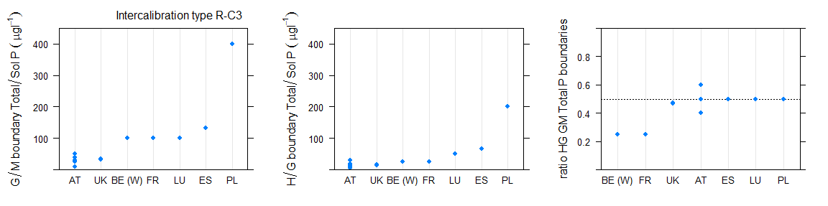
Figure 6.2-82 Range of a)good/moderate, b)high/good, c)ratio of good/moderate to high/good phosphorus boundary values for intercalibration type R-C3

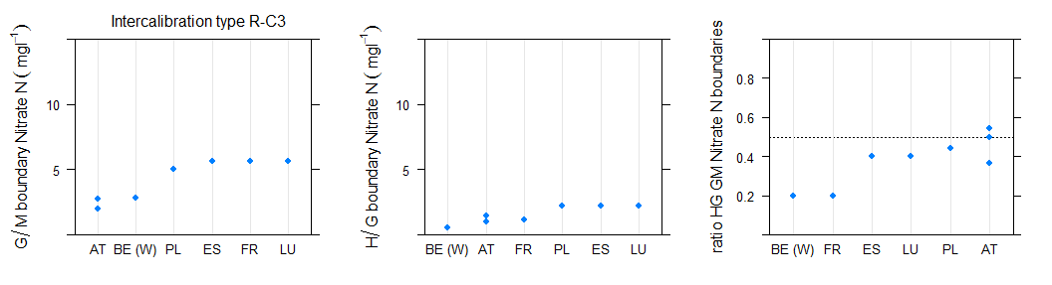
Figure 6.2-83 Range of a)good/moderate, b)high/good, c)ratio of good/moderate to high/good nitrate nitrogen boundary values for intercalibration type R-C3

R-C4 Medium, lowland mixed rivers with sand/gravel

Broad Type | Country | National type code | Description of type | IC Type
2 | BE (Fl) | Rg | Grote rivier | R-C4
2 | BE (Fl) | Rk | Kleine rivier | R-C4
3 | BE (Fl) | Bg | Grote beek | R-C4
3 | BE (Fl) | BgK | Grote beek Kempen | R-C4
4 | BE (W) | RIV_21 |  | R-C4
4 | BE (W) | RIV_22 |  | R-C4
4 | CZ | X-1-1-2 | <200m,Crystalinicum, volcanic rock,Strahler 4-6 (smaller rivers) | R-C4
4 | CZ_3rd | X-1-1-2 | <200m,Crystalinicum, volcanic rock,Strahler 4-6 (smaller rivers) | R-C4
4 | EE | 2A | Catchment 100-1000 km2, COD-Mn 90% 25 and over mgO/L | R-C4
4 | EE | 2B | Catchment 100-1000 km2, COD-Mn 90% below 25 mgO/L | R-C4
 | ES | 131 | Pequeños ejes cántabro-atlánticos silíceos | R-C4
4 | FR | M10 | Moyen cours d'eau des Côtes calcaires Est | R-C4
4 | FR | M10/4 | Moyen cours d'eau des Côtes calcaires Est et exogène des Vosges | R-C4
4 | FR | M11/3-21 | Moyen cours d'eau des Causses aquitains et exogène du Massif central Sud ou du Massif central Nord | R-C4
4 | FR | M12-A | Moyen cours d'eau Armoricain dans les HER de niveau 2 n°58 ou n°117 | R-C4
4 | FR | M12-B | Moyen cours d'eau Armoricain dans les HER de niveau 2 n°55, n°59 ou n°118 | R-C4
4 | FR | M13 | Moyen cours d'eau des Landes | R-C4
4 | FR | M14/3-11 | Moyen cours d'eau des Coteaux aquitains et exogène du Massif central Sud et/ou des Causses aquitains | R-C4
4 | FR | M14/3-8 | Moyen cours d'eau des Coteaux aquitains et exogène du Massif central Sud et/ou des Cévennes | R-C4
4 | FR | M15-17/3-21 | Moyen cours d'eau de la Plaine de Saône ou des Dépressions sédimentaires et exogène du Massif central Sud ou du Massif central Nord | R-C4
4 | FR | M18/4 | Moyen cours d'eau d'Alsace et exogène des Vosges | R-C4
4 | FR | M20 |  | R-C4
4 | FR | M9 | Moyen cours d'eau des Tables calcaires | R-C4
4 | FR | M9-10/21 | Moyen cours d'eau des Tables calcaires ou des Côtes calcaires Est et exogène du Massif central Nord | R-C4
4 | FR | M9-A | Moyen cours d'eau des Tables calcaires dans l'HER de niveau 2 n°57 | R-C4
4 | FR | MP15 | Moyen ou Petit cours d'eau de Plaine de Saône | R-C4
4 | FR | MP15/5 | Moyen ou Petit cours d'eau de Plaine de Saône et exogène du Jura/Pré-Alpes du Nord | R-C4
4 | FR | MP18 | Moyen ou Petit cours d'eau d'Alsace | R-C4
4 | LT | RWT2 | Medium slow flowing rivers (area 100-1000 km2, slope less than 0,7 m/km) | R-C4
4 | LT | RWT3 | Medium fast flowing rivers (area 100-1000 km2, slope more than 0,7 m/km) | R-C4
4 | LU | 5 | mid-sized and mid-altitude streams in the Gutland | R-C4
4 | LV | R3 | Lowland (< 300 m a.s.l.), carbonatic bedrock, medium size (100-1000km2), fast-flowing (slope > 1 m/km). | R-C4
4 | LV | R4 | Lowland (< 300 m a.s.l.), carbonatic bedrock, medium size (100-1000km2), slow-running (slope < 1 m/km). | R-C4

4 | NL | R13 | Snelstromende bovenloop op zand | R-C4
4 | NL | R15 | Snelstromend riviertje op kiezelhoudende bodem | R-C4
4 | PL | 19 | Rzeka nizinna piaszczysto- gliniasta
4 | PL | 20 | Rzeka nizinna żwirowa
4 | UK | 5 | Lowland Calcareous Medium | R-C4
5 | EE | 1A | Catchment 10-100 km2, COD-Mn 90% 25 and more mgO/L | R-C4
5 | IE | 31 | Calcareous, low slope | R-C4
5 | IE | 32 | Calcareous, medium slope | R-C4
5 | NL | R6 | Langzaam stromend riviertje op zand/klei | R-C4
8 | LU | 3 | mid-sized and mid-altitude streams in the Oesling | R-C4
10 | BE (W) | RIV_03 |  | R-C4
10 | BE (W) | RIV_11 |  | R-C4
10 | BE (W) | RIV_15 |  | R-C4
10 | BE (W) | RIV_16 |  | R-C4
10 | UK | 14 | Mid-altitude Calcareous Medium | R-C4
13 | PL | 24 | Małe i średnie rzeki na obszarach będących pod wpływem procesów torfotwórczych | R-C4

Table 6.2-45 National & broad types for Central Baltic GIG countries reporting river intercalibration type R-C4
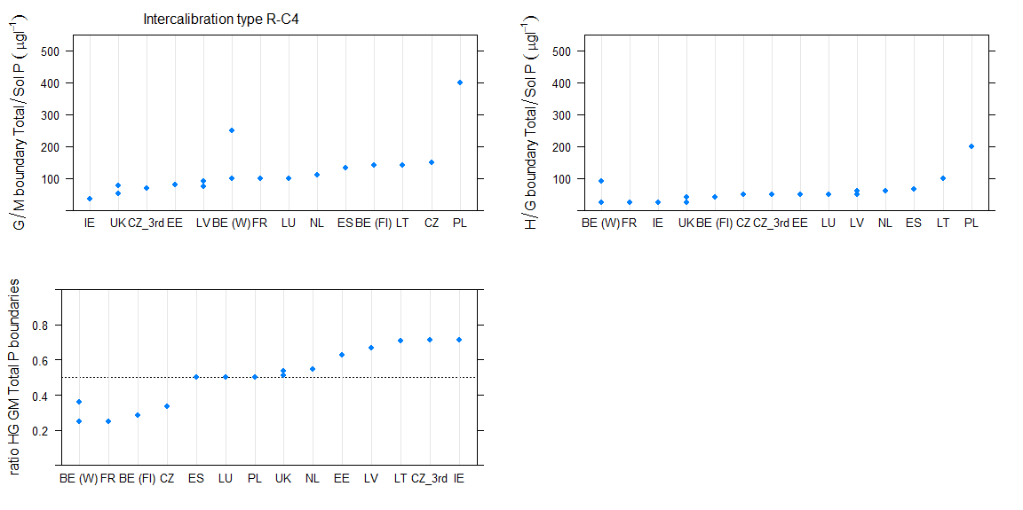
Figure 6.2-84 Range of a)good/moderate, b)high/good, c)ratio of good/moderate to high/good phosphorus boundary values for intercalibration type R-C4

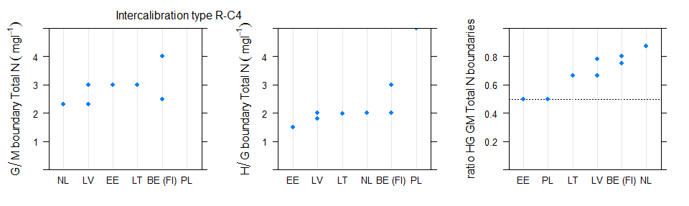
Figure 6.2-85 Range of a)good/moderate, b)high/good, c)ratio of good/moderate to high/good total nitrogen boundary values for intercalibration type R-C4
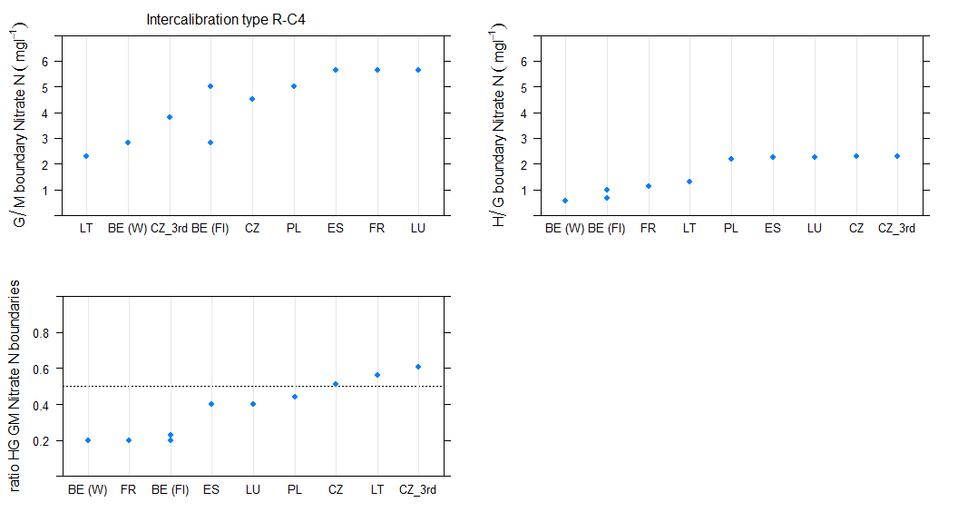
Figure 6.2-86 Range of a)good/moderate, b)high/good, c)ratio of good/moderate to high/good nitrate nitrogen boundary values for intercalibration type R-C4

R-C5 Large, lowland, mixed rivers

Broad Type | Country | National type code | Description of type | IC Type
1 | BE (W) | RIV_19 |  | R-C5
1 | FR | TG22/10 | Très Grand cours d'eau des Ardennes et exogène des Côtes calcaires Est | R-C5
1 | NL | R7 | Langzaam stromende rivier/nevengeul op zand/klei | R-C5
2 | FR | G12 | Grand cours d'eau Armoricain | R-C5
2 | FR | G18/4 | Grand cours d'eau d'Alsace et exogène des Vosges | R-C5
2 | FR | GM20 | Grand ou Moyen cours d'eau des Dépôts argilo-sableux | R-C5
4 | BE (W) | RIV_23 |  | R-C5
4 | CZ | X-1-1-3 | <200m,Crystalinicum, volcanic rock,Strahler 7-9 (rivers) | R-C5
4 | CZ_3rd | X-1-1-3 | <200m,Crystalinicum, volcanic rock,Strahler 7-9 (rivers) | R-C5
4 | EE | 3A | Catchment 1000-10000 km2, COD-Mn 90% 25 and over mgO/L | R-C5
4 | EE | 3B | Catchment 1000-10000 km2, COD-Mn 90% below 25 mgO/L | R-C5
4 | FR | G9 | Grand cours d'eau des Tables calcaires | R-C5
4 | FR | G9-10/21 | Grand cours d'eau des Tables calcaires ou des Côtes calcaires Est et exogène du Massif central Nord | R-C5
4 | FR | GM14 | Grand ou Moyen cours d'eau des Coteaux aquitains | R-C5
4 | FR | GM20/9 | Grand ou Moyen cours d'eau des Dépôts argilo-sableux et exogène des Tables calcaires | R-C5
4 | LT | RWT4 | Large slow flowing rivers (area more than 1000 km2, slope less than 0,3 m/km) | R-C5
4 | LT | RWT5 | Large fast flowing rivers (area more than 1000 km2, slope more than 0,3 m/km) | R-C5
4 | LU | 6 | large lowland streams | R-C5
4 | LV | R5 | Lowland (< 300 m a.s.l.), carbonatic bedrock, large (> 1000 km2), fast-flowing (slope > 1 m/km). | R-C5
4 | LV | R6 | Lowland (< 300 m a.s.l.), carbonatic bedrock, large (> 1000 km2), slow-running (slope < 1 m/km). | R-C5
4 | NL | R12 | Langzaam stromende middenloop/benedenloop op veenbodem | R-C5
4 | NL | R16 | Snelstromende rivier/nevengeul op zandbodem of grind | R-C5
4 | NL | R8 | Zoet getijdenwater (uitlopers rivier) op zand/klei | R-C5
4 | PL | 19 | Rzeka nizinna piaszczysto- gliniasta | R-C5
4 | PL | 20 | Rzeka nizinna żwirowa | R-C5
4 | PL | 25 | Cieki łączące jeziora | R-C5
5 | IE | 31 | Calcareous, low slope | R-C5
5 | IE | 32 | Calcareous, medium slope | R-C5
8 | BE (W) | RIV_08 |  | R-C5
8 | FR | G17/3-21 | Grand cours d'eau des Dépressions sédimentaires et exogène du Massif central Sud ou du Massif central Nord | R-C5
10 | BE (W) | RIV_12 |  | R-C5
10 | BE (W) | RIV_17 |  | R-C5
10 | BE (W) | RIV_18 |  | R-C5

10 | FR | G10 | Grand cours d'eau des Côtes calcaires Est | R-C5
 | ES | 128 | Ejes fluviales principales cántabro-atlánticos silíceos | R-C5
 | LV | R6 | Lowland (< 300 m a.s.l.), carbonatic bedrock, large (> 1000 km2), slow-running (slope < 1 m/km). | R-C5

Table 6.2-46 National & broad types for Central Baltic GIG countries reporting river intercalibration type R-C5
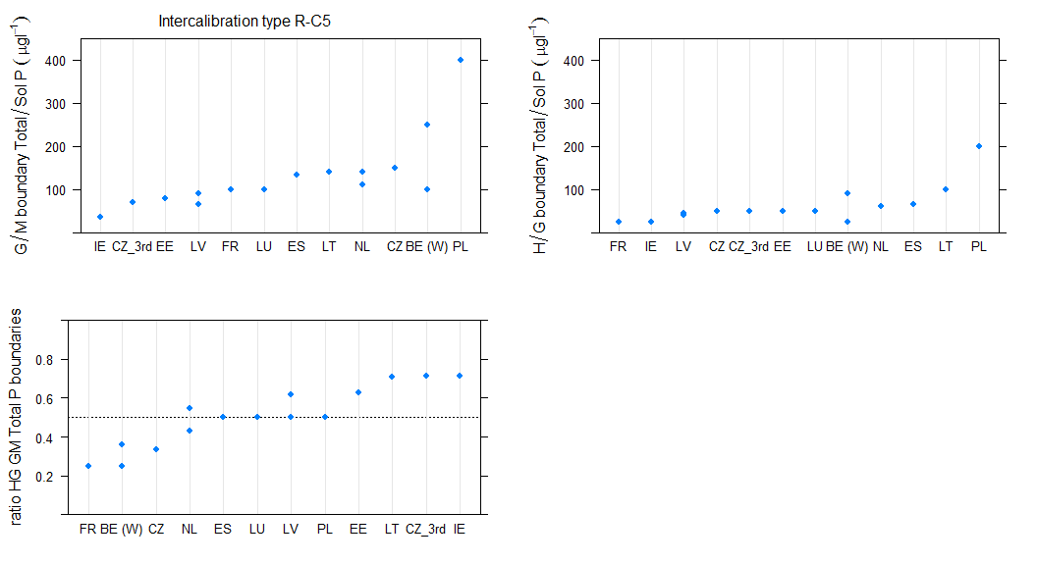
Figure 6.2-87 Range of a)good/moderate, b)high/good, c)ratio of good/moderate to high/good phosphorus boundary values for intercalibration type R-C5
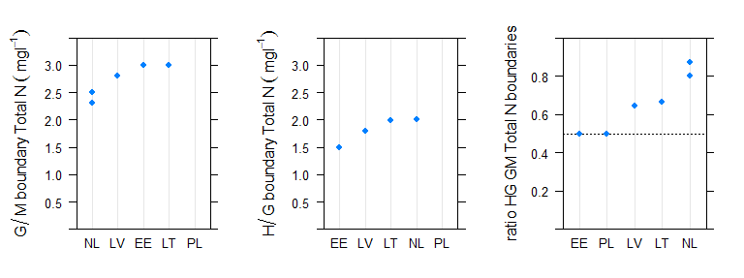
Figure 6.2-88 Range of a)good/moderate, b)high/good, c)ratio of good/moderate to high/good total nitrogen boundary values for intercalibration type R-C5
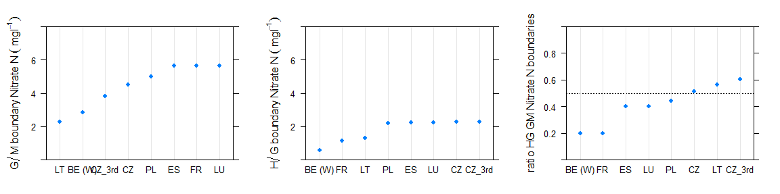
Figure 6.2-89 Range of a)good/moderate, b)high/good, c)ratio of good/moderate to high/good nitrate nitrogen boundary values for intercalibration type R-C5

R-C6 Small, lowland, calcareous rivers with gravel

Broad Type | Country | National type code | Description of type | IC Type
4 | EE | 2A | Catchment 100-1000 km2, COD-Mn 90% 25 and over mgO/L | R-C6
4 | EE | 2B | Catchment 100-1000 km2, COD-Mn 90% below 25 mgO/L | R-C6
4 | FR | P9 | Petit cours d'eau des Tables calcaires | R-C6
4 | LT | RWT2 | Medium slow flowing rivers (area 100-1000 km2, slope less than 0,7 m/km) | R-C6
4 | LT | RWT3 | Medium fast flowing rivers (area 100-1000 km2, slope more than 0,7 m/km) | R-C6
5 | EE | 1A | Catchment 10-100 km2, COD-Mn 90% 25 and more mgO/L | R-C6
5 | EE | 1B | Catchment 10-100 km2, COD-Mn 90% below 25 mgO/L | R-C6
5 | FR | P9-A | Petit cours d'eau des Tables calcaires dans l'HER de niveau 2 n°57 | R-C6
5 | FR | TP15 | Très Petit cours d'eau de Plaine de Saône | R-C6
5 | FR | TP17 | Très Petit cours d'eau des Dépressions sédimentaires | R-C6
5 | FR | TP18 | Très Petit cours d'eau d'Alsace | R-C6
5 | FR | TP9 | Très Petit cours d'eau des Tables calcaires | R-C6
5 | IE | 31 | Calcareous, low slope | R-C6
5 | IE | 32 | Calcareous, medium slope | R-C6
5 | IE | 33 | Calcareous, high slope | R-C6
5 | IE | 34 | Calcareous, very high slope | R-C6
5 | LT | RWT1 | Small rivers (area less than 100 km2) | R-C6
5 | LU | 4 | small mid-altitude streams in the Gutland | R-C6
5 | LV | R1 | Lowland (< 300 m a.s.l.), carbonatic bedrock, small (< 100 km2), fast-flowing (> 1 m/km). | R-C6
5 | LV | R2 | Lowland (< 300 m a.s.l.), carbonatic bedrock, small (< 100 km2), slow-running (< 1 m/km). | R-C6
11 | BE (W) | RIV_01 |  | R-C6
11 | BE (W) | RIV_02 |  | R-C6
11 | BE (W) | RIV_09 |  | R-C6
11 | BE (W) | RIV_10 |  | R-C6
11 | BE (W) | RIV_13 |  | R-C6
11 | BE (W) | RIV_14 |  | R-C6

Table 6.2-47 National & broad types for Central Baltic GIG countries reporting river intercalibration type R-C6
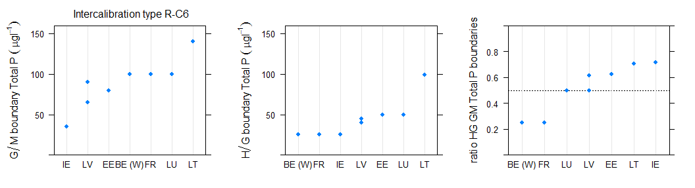
Figure 6.2-90 Range of a)good/moderate, b)high/good, c)ratio of good/moderate to high/good phosphorus boundary values for intercalibration type R-C6

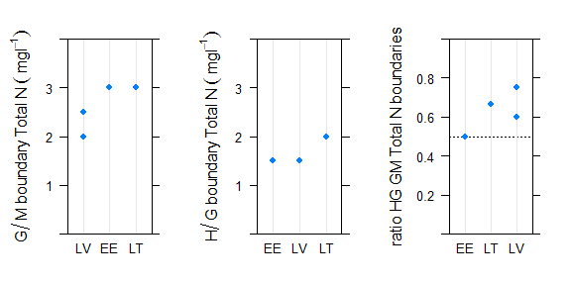
Figure 6.2-91 Range of a)good/moderate, b)high/good, c)ratio of good/moderate to high/good total nitrogen boundary values for intercalibration type R-C6

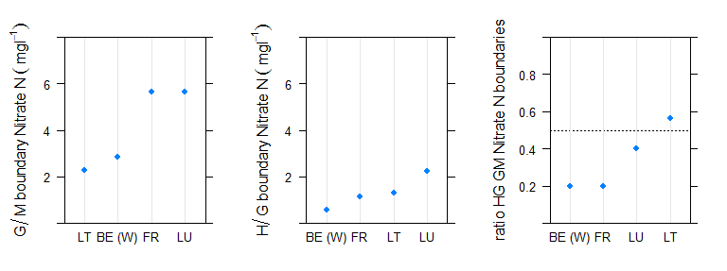
Figure 6.2-92 Range of a)good/moderate, b)high/good, c)ratio of good/moderate to high/good nitrate nitrogen boundary values for intercalibration type R-C6

R-E1 Carpathians: small-medium, mid-altitude, siliceous rivers with gravel & boulders

Broad Type | Country | National type code | Description of type | IC Type
14 | BG | R2 | Mountainous rivers (Uplands) in ER12 (mountain zone- sometimes get down; mixed/siliceous/calcareous;size <100 km2, smal rivers; boulders and cobles) | R-E1a
9 | BG | R4 | Semi mountain rivers (gravel rivers) in ER12 (semi-mountain zone - big variation; mixed/siliceous/calcareous;size <1300 km2,small and medium (rarely large) ; gravels) | R-E1b
11 | CZ | X-2-2-1 | 200-500m,Sandstone, holocene,Strahler 1-3 (brooks) | R-E1b
11 | CZ | X-3-1-1 | 500-800m,Crystalinicum, volcanic rock,Strahler 1-3 (brooks) | R-E1a
11 | CZ_3rd | X-2-2-1 | 200-500m,Sandstone, holocene,Strahler 1-3 (brooks) | R-E1b
11 | CZ_3rd | X-3-1-1 | 500-800m,Crystalinicum, volcanic rock,Strahler 1-3 (brooks) | R-E1a
11 | HU | 2R | Mountainous – calcerous – coarse – small catchment | R-E1b
11 | HU | 3R | Mountainous – calcareous – coarse – medium catchment | R-E1b
9 | HU | 1R | Mountainous - siliceous – coarse – small catchment | R-E1b
11 | RO | RO01 | Curs de apa situat in zona montana, piemontana sau de podisuri inalte | R-E1a
11 | RO | RO04 | Curs de apa situat in zona de dealuri sau de podisuri | R-E1b
10 | SK | K2S | Stredne veľké toky v nadmorskej výške 200 - 500 m v Karpatoch | R-E1b
10 | SK | K3S | Stredne veľké toky v nadmorskej výške 500 - 800 m v Karpatoch | R-E1a
11 | SK | K2M | Malé toky v nadmorskej výške 200 - 500 m v Karpatoch | R-E1b
15 | SK | K3M | Malé toky v nadmorskej výške 500 - 800 m v Karpatoch | R-E1a

Table 6.2-48 National & broad types for Eastern Continental GIG countries reporting river intercalibration type R-E1
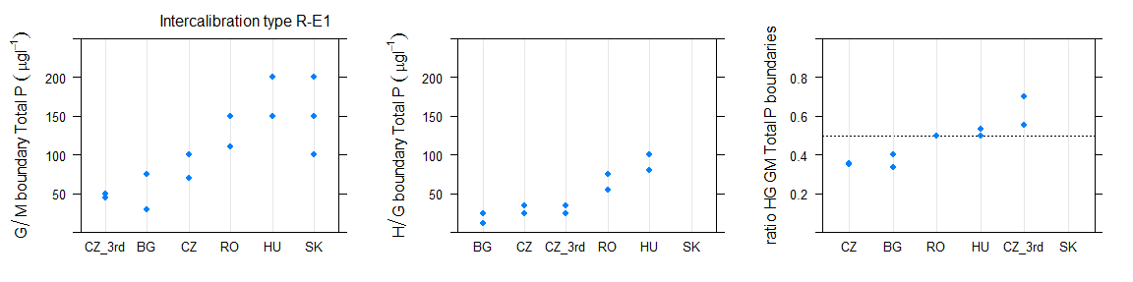
Figure 6.2-93 Range of a)good/moderate, b)high/good, c)ratio of good/moderate to high/good phosphorus boundary values for intercalibration type R-E1

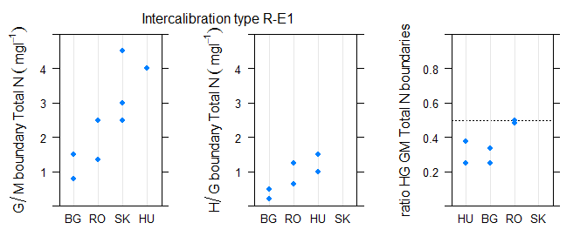
Figure 6.2-94 Range of a)good/moderate, b)high/good, c)ratio of good/moderate to high/good total nitrogen boundary values for intercalibration type R-E1
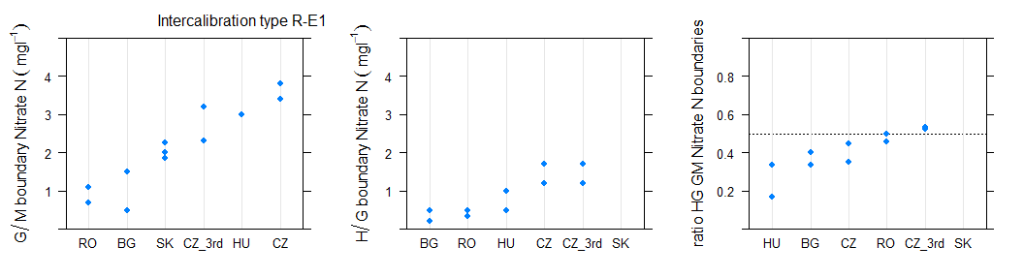
Figure 6.2-95 Range of a)good/moderate, b)high/good, c)ratio of good/moderate to high/good nitrate nitrogen boundary values for intercalibration type R-E1

R-E2 Plains: medium, lowland mixed rivers with sand & silt

Broad Type | Country | National type code | Description of type | IC Type
4 | BG | R8 | Medium and small Danube rivers (ER12-1;altitude <100m; calcareous/mixed/siliceous;size variable; sand, silt, clay, loess) | R-E2
4 | CZ | X-1-2-2 | <200m,Sandstone, holocene,Strahler 4-6 (smaller rivers) | R-E2
4 | CZ_3rd | X-1-2-2 | <200m,Sandstone, holocene,Strahler 4-6 (smaller rivers) | R-E2
4 | HU | 12R | Plain – calcareous – coarse – medium catchment | R-E2
4 | HU | 18R | Plain – calcareous – medium/fine – medium catchment | R-E2
4 | HU | 22R | Plain – organic – medium catchment | R-E2
4 | SK | P1S | Stredne veľké toky v nadmorskej výške do 200 m v Panónskej panve | R-E2
5 | HU | 17R | Plain – calcareous – medium/fine – medium catchment with little slope | R-E2
5 | RO | RO06 | Curs de apa situat in zona de campie | R-E2

Table 6.2-49 National & broad types for Eastern Continental GIG countries reporting river intercalibration type R-E2
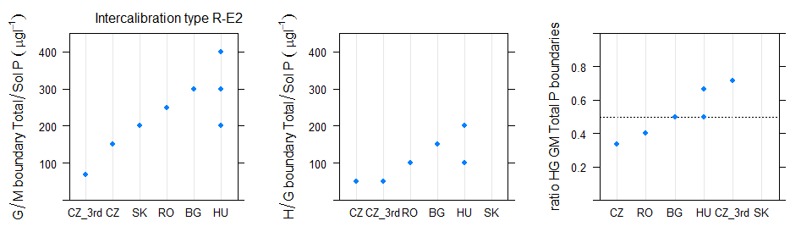
Figure 6.2-96 Range of a)good/moderate, b)high/good, c)ratio of good/moderate to high/good phosphorus boundary values for intercalibration type R-E2
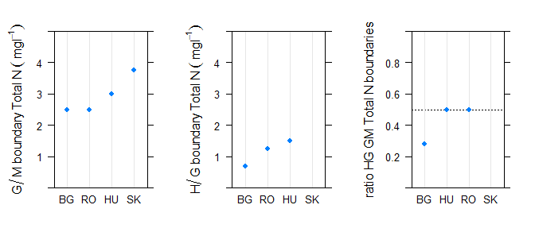
Figure 6.2-97 Range of a)good/moderate, b)high/good, c)ratio of good/moderate to high/good total nitrogen boundary values for intercalibration type R-E2
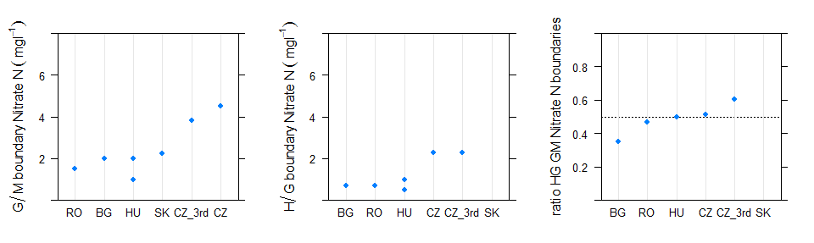
Figure 6.2-98 Range of a)good/moderate, b)high/good, c)ratio of good/moderate to high/good nitrate nitrogen boundary values for intercalibration type R-E2

R-E3 Plains: large/very large, lowland mixed rivers with sand, silt & gravel

Broad Type | Country | National type code | Description of type | IC Type
1 | HU | 14R | Plain – calcareous – coarse – very large catchment | R-E3
1 | HU | 20R | Plain – calcareous – medium/fine – very large catchment | R-E3
1 | HU | 7R | Hilly – calcareous – coarse – very large catchment | R-E3
4 | BG | R7 | Large Danube tributaries (ER12-1;altitude <80m; mixed;size >2500 km2, large; sand, silt, clay, loess) | R-E3
4 | CZ | X-1-2-3 | <200m,Sandstone, holocene,Strahler 7-9 (rivers) | R-E3
4 | CZ_3rd | X-1-2-3 | <200m,Sandstone, holocene,Strahler 7-9 (rivers) | R-E3
4 | HU | 13R | Plain – calcareous – coarse – large catchment | R-E3
4 | HU | 19R | Plain – calcareous – medium/fine – large catchment | R-E3
4 | SK | B1(P1V) | Veľké toky v povodí Bodrogu v nadmorskej výške do 200 m v Panónskej panve | R-E3
4 | SK | I1(P1V) | Dolná časť toku Ipeľ v nadmorskej výške do 200 m v Panónskej panve | R-E3
4 | SK | M1(P1V) | Morava v nadmorskej výške do 200 m v Panónskej panve | R-E3
4 | SK | R2(P1V) | Dolná časť toku Hron v nadmorskej výške do 200 m v Panónskej panve | R-E3
4 | SK | V3(P1V) | Veľké toky dolnej časti povodia Váhu v nadmorskej výške do 200 m v Panónskej panve | R-E3
10 | HU | 10R | Hilly – calcareous – medium/fine – large catchment | R-E3
10 | HU | 6R | Hilly – calcareous – coarse – large catchment | R-E3

Table 6.2-50 National & broad types for Eastern Continental GIG countries reporting river intercalibration type R-E3
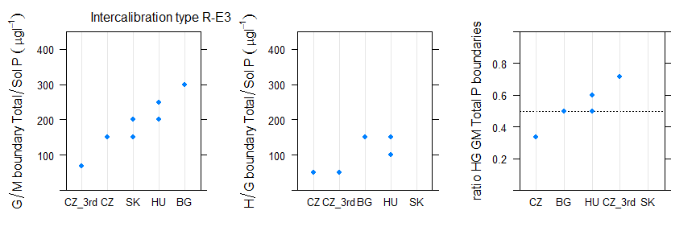
Figure 6.2-99 Range of a)good/moderate, b)high/good, c)ratio of good/moderate to high/good phosphorus boundary values for intercalibration type R-E3
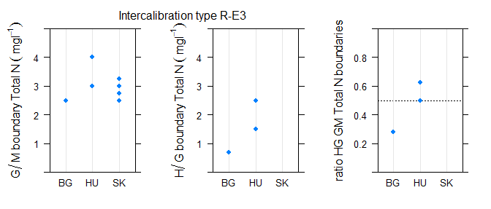
Figure 6.2-100 Range of a)good/moderate, b)high/good, c)ratio of good/moderate to high/good total nitrogen boundary values for intercalibration type R-E3
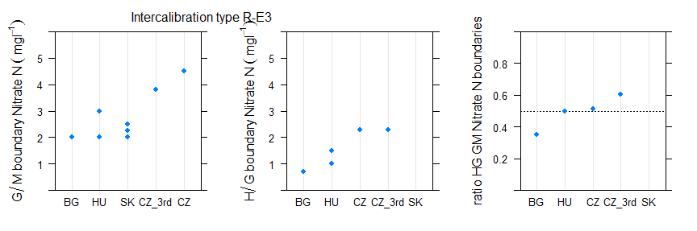
Figure 6.2-101 Range of a)good/moderate, b)high/good, c)ratio of good/moderate to high/good nitrate nitrogen boundary values for intercalibration type R-E3

R-E4 Plains: medium.mid-altitude, mixed rivers with sand & gravel

Broad Type | Country | National type code | Description of type | ICType
 | CZ_3rd | X-2-1-2 | 200-500m,Crystalinicum, volcanic rock,Strahler 4-6 (smaller rivers) | R-E4
 | CZ_3rd | X-2-2-2 | 200-500m,Sandstone, holocene,Strahler 4-6 (smaller rivers) | R-E4
9 | BG | R4 | "Semi mountain rivers (gravel rivers) in ER12
10 | AT | 13__MZB1,75_PHBme2 | Bioregion: Eastern Lowlands and Uplands of the Hungarian Plain (13); Macroinvertebrate- saprobic reference condition: SI 1,75; Phytobenthos-trophic reference condition: meso-eutrophic overall (me2) | R-E4
10 | CZ | X-2-1-2 | 200-500m,Crystalinicum, volcanic rock,Strahler 4-6 (smaller rivers) | R-E4
10 | CZ | X-2-2-2 | 200-500m,Sandstone, holocene,Strahler 4-6 (smaller rivers) | R-E4
10 | HU | 5R | Hilly – calcareous – coarse – medium catchment | R-E4
10 | HU | 9R | Hilly – calcareous – medium/fine – medium catchment | R-E4
11 | SK | P2M | Malé toky v nadmorskej výške 200 - 500 m v Panónskej panve | R-E4
11 | RO | RO04 | Curs de apa situat in zona de dealuri sau de podisuri | R-E4

Table 6.2-51 National & broad types for Eastern Continental GIG countries reporting river intercalibration type R-E4
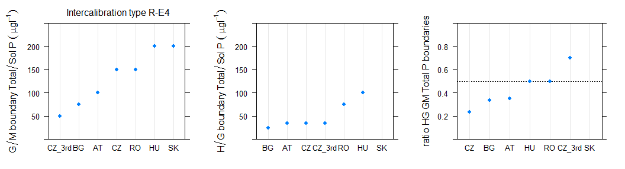
Figure 6.2-102 Range of a)good/moderate, b)high/good, c)ratio of good/moderate to high/good phosphorus boundary values for intercalibration type R-E4
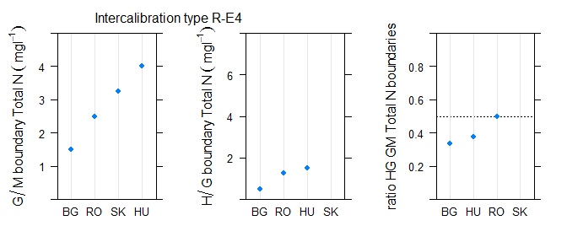
Figure 6.2-103 Range of a)good/moderate, b)high/good, c)ratio of good/moderate to high/good total nitrogen boundary values for intercalibration type R-E4
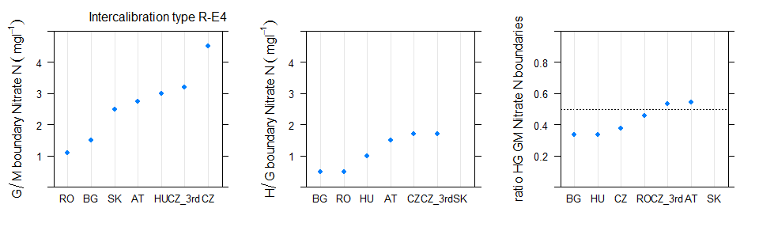
Figure 6.2-104 Range of a)good/moderate, b)high/good, c)ratio of good/moderate to high/good nitrate nitrogen boundary values for intercalibration type R-E4

R-M1 Small, mid-altitude Mediterranean mixed rivers, highly seasonal flow regime

Broad Type | Country | National type code | Description of type | ICType
 | ES | 101 | Ríos de llanuras silíceas del Tajo y Guadia | R-M1
 | ES | 108 | Ríos de baja montaña mediterránea silícea | R-M1
 | ES | 109 | Ríos mineralizados de baja montaña mediterránea | R-M1
 | ES | 111 | Ríos de montaña mediterránea silícea | R-M1
 | ES | 112 | Ríos de montaña mediterránea calcárea | R-M1
 | ES | 113 | Ríos mediterráneos muy mineralizados | R-M1
14 | FR | PTP8-A | Petit ou Très Petit cours d'eau des Cévennes dans l'HER de niveau 2 n°70 | R-M1
19 | FR | PTP16-A | Petit ou Très Petit cours d'eau de Corse dans l'HER de niveau 2 n°22 | R-M1
19 | FR | PTP8 | Petit ou Très Petit cours d'eau des Cévennes | R-M1
3 | FR | PTP16-B | Petit ou Très Petit cours d'eau de Corse dans l'HER de niveau 2 n°88 | R-M1
11 | IT | IT10SS1N |  | R-M1
11 | IT | IT10SS2N |  | R-M1
18 | IT | IT13AS3N |  | R-M1
19 | IT | IT09SS2T |  | R-M1
19 | IT | IT10SS2T |  | R-M1
19 | IT | IT11SS2N |  | R-M1
19 | IT | IT11SS2T |  | R-M1
19 | IT | IT13SR2T |  | R-M1
19 | IT | IT14SS2T |  | R-M1
19 | IT | IT19SR1N |  | R-M1
19 | IT | IT19SR2N |  | R-M1
19 | IT | IT19SS1N |  | R-M1
19 | IT | IT19SS2N |  | R-M1
19 | IT | IT21SS2T |  | R-M1
 | PT | R_M | Rios Montanhosos do Norte | R-M1
 | PT | R_N4 | Rios de Transição Norte-Sul | R-M1
 | PT | R_S2 | Rios Montanhosos do Sul | R-M1
17 | PT | R_L | Rios do Litoral Centro | R-M1
17 | PT | R_S3 | Depósitos Sedimentares do Tejo e Sado | R-M1
19 | PT | R_N1P | Rios do Norte de Pequena Dimensão | R-M1
19 | PT | R_N3 | Rios do Alto Douro de Pequena Dimensão | R-M1

Table 6.2-52 National & broad types for Mediterranean GIG countries reporting river intercalibration type R-M1
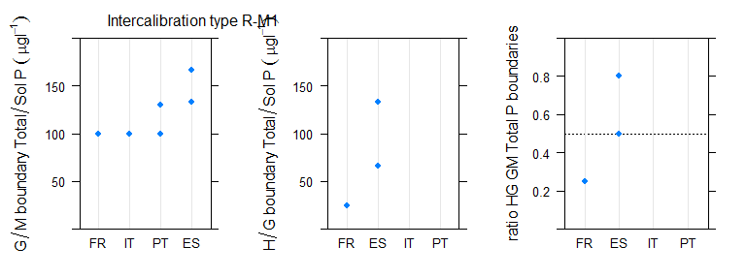
Figure 6.2-105 Range of a)good/moderate, b)high/good, c)ratio of good/moderate to high/good phosphorus boundary values for intercalibration type R-M1
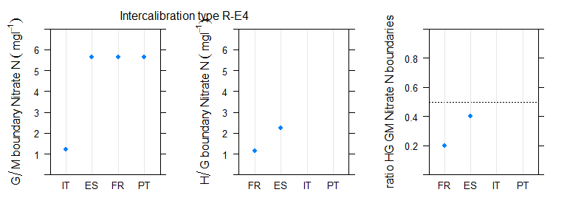
Figure 6.2-106 Range of a)good/moderate, b)high/good, c)ratio of good/moderate to high/good nitrate nitrogen boundary values for intercalibration type R-M1

R-M2 Medium, Mediterranean mixed streams, highly seasonal flow regime

Broad Type | Country | National type code | Description of type | ICType
 | ES | 102 | Ríos de la depresión del Guadalquivir | R-M2
 | ES | 106 | Ríos silíceos del piedemonte de Sierra More | R-M2
 | ES | 107 | Ríos mineralizados mediterráneos de baja altitud | R-M2
 | ES | 109 | Ríos mineralizados de baja montaña mediterránea | R-M2
 | ES | 111 | Ríos de montaña mediterránea silícea | R-M2
 | ES | 112 | Ríos de montaña mediterránea calcárea | R-M2
 | ES | 114 | Ejes mediterráneos de baja altitud | R-M2
 | ES | 116 | Ejes mediterráneos continentales mineralizados | R-M2
2 | FR | M16-B | Moyen cours d'eau de Corse dans l'HER de niveau 2 n°88 | R-M2
8 | FR | M16-A | Moyen cours d'eau de Corse dans l'HER de niveau 2 n°22 | R-M2
8 | FR | M8-A | Moyen cours d'eau des Cévennes dans l'HER de niveau 2 n°70 | R-M2
17 | IT | IT06SS4D |  | R-M2
17 | IT | IT06SS4F |  | R-M2
 | PT | R_N1G | Rios do Norte de Média-Grande Dimensão | R-M2
 | PT | R_N2 | Rios do Alto Douro de Média-Grande Dimensão | R-M2
 | PT | R_N4 | Rios de Transição Norte-Sul | R-M2
 | PT | R_S2 | Rios Montanhosos do Sul | R-M2
17 | PT | R_L | Rios do Litoral Centro | R-M2
17 | PT | R_S1G | Rios do Sul de Média-Grande Dimensão | R-M2
17 | PT | R_S3 | Depósitos Sedimentares do Tejo e Sado | R-M2

Table 6.2-53 National & broad types for Mediterranean GIG countries reporting river intercalibration type R-M2

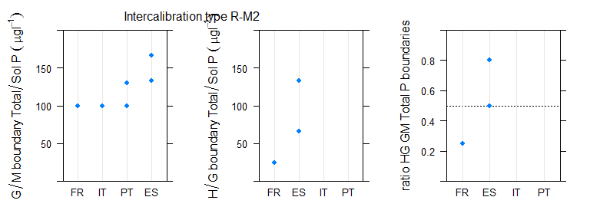
Figure 6.2-107 Range of a)good/moderate, b)high/good, c)ratio of good/moderate to high/good phosphorus boundary values for intercalibration type R-M2
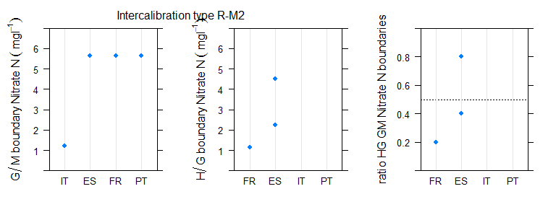
Figure 6.2-108 Range of a)good/moderate, b)high/good, c)ratio of good/moderate to high/good nitrate nitrogen boundary values for intercalibration type R-M2

R-M4 Small/medium Mediterranean mountain streams

Broad Type | Country | National type code | Description of type | ICType
15 | CY | R2 | large rain volume with continuous flow | R-M4
 | ES | 111 | Ríos de montaña mediterránea silícea | R-M4
 | ES | 112 | Ríos de montaña mediterránea calcárea | R-M4
 | ES | 117 | Grandes ejes en ambiente mediterráneo | R-M4
 | ES | 126 | Ríos de montaña húmeda calcárea | R-M4
 | ES | 127 | Ríos de alta montaña | R-M4
15 | FR | MP6 | Moyen ou Petit cours d'eau de Méditerranée | R-M4
15 | FR | TP7 | Très Petit cours d'eau des Pré-Alpes du Sud | R-M4
18 | FR | GMP7 | Grand ou Moyen ou Petit cours d'eau des Pré-Alpes du Sud | R-M4
19 | FR | TP6 | Très Petit cours d'eau de Méditerranée | R-M4
17 | IT | IT06SS3T |  | R-M4
18 | IT | IT10SS3N |  | R-M4
18 | IT | IT19SS3N |  | R-M4
18 | IT | IT21SS3T |  | R-M4

Table 6.2-54 National & broad types for Mediterranean GIG countries reporting river intercalibration type R-M4

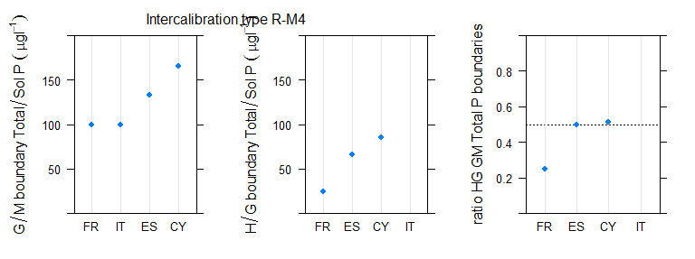
Figure 6.2-109 Range of a)good/moderate, b)high/good, c)ratio of good/moderate to high/good boundary values for intercalibration type R-M4
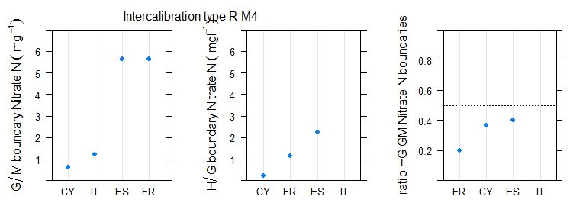
Figure 6.2-110 Range of a)good/moderate, b)high/good, c)ratio of good/moderate to high/good nitrate nitrogen boundary values for intercalibration type R-M4

R-M5 Mediterranean temporary streams

Broad Type | Country | National type code | Description of type | ICType
20 | CY | R1 | small rain volume with non-continuous flow | R-M5
20 | CY | R3 | large rain volume with non-continuous flow | R-M5
 | ES | 105 | Ríos manchegos | R-M5
 | ES | 106 | Ríos silíceos del piedemonte de Sierra More | R-M5
 | ES | 108 | Ríos de baja montaña mediterránea silícea | R-M5
 | ES | 109 | Ríos mineralizados de baja montaña mediterránea | R-M5
 | ES | 110 | Ríos mediterráneos con influencia cárstica | R-M5
 | ES | 111 | Ríos de montaña mediterránea silícea | R-M5
 | ES | 112 | Ríos de montaña mediterránea calcárea | R-M5
 | ES | 118 | Ríos costeros mediterráneos | R-M5
20 | IT | IT06IN7D |  | R-M5
20 | IT | IT06IN7N |  | R-M5
20 | IT | IT10EF7N |  | R-M5
20 | IT | IT10IN7N |  | R-M5
20 | IT | IT11EF7N |  | R-M5
20 | IT | IT11IN7N |  | R-M5
20 | IT | IT11IN7T |  | R-M5
20 | IT | IT12IN7N |  | R-M5
20 | IT | IT19EF7N |  | R-M5
20 | IT | IT19IN7N |  | R-M5
20 | IT | IT19IN8N |  | R-M5
20 | IT | IT20IN7N |  | R-M5
20 | IT | IT21EF7T |  | R-M5
20 | IT | IT21IN7T |  | R-M5
 | PT | R_N4 | Rios de Transição Norte-Sul | R-M5
 | PT | R_S2 | Rios Montanhosos do Sul | R-M5
17 | PT | R_L | Rios do Litoral Centro | R-M5
17 | PT | R_S1G | Rios do Sul de Média-Grande Dimensão | R-M5
17 | PT | R_S3 | Depósitos Sedimentares do Tejo e Sado | R-M5
20 | PT | R_S1P | Rios do Sul de Pequena Dimensão | R-M5
20 | PT | R_S4 | Calcários do Algarve | R-M5

Table 6.2-55 National & broad types for Mediterranean GIG countries reporting river intercalibration type R-M5

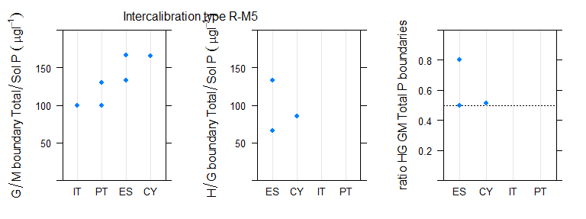
Figure 6.2-111 Range of a)good/moderate, b)high/good, c)ratio of good/moderate to high/good phosphorus boundary values for intercalibration type R-M5
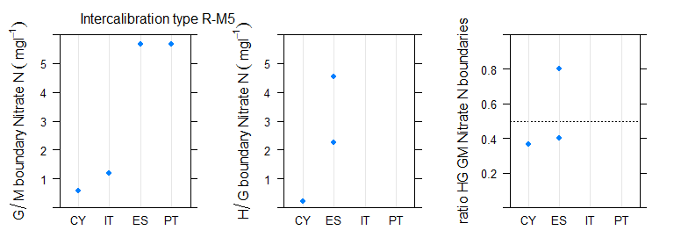
Figure 6.2-112 Range of a)good/moderate, b)high/good, c)ratio of good/moderate to high/good nitrate nitrogen boundary values for intercalibration type R-M5

River phosphorus and nitrogen boundaries by broad type and country
Note that tables only show types where a good moderate boundary was reported

Type 1, Very large rivers, all Europe

Broad Type | Country | National type code | Description of type | IC Type
1 | BE (Fl) | Rzg | Zeer grote rivier | R-L
1 | BE (W) | RIV_19 |  | R-C5
1 | DE | 10 | Kiesgeprägte Ströme | not allocated
1 | DE | 20 | Sandgeprägte Ströme | not allocated
1 | EE | 4B | Catchment over 10 000 km2, COD-Mn 90% below 25 mgO/L | R-L
1 | FI | ESk | Catchment area > 10000 km2 of which peat land <25%,na tural water colour <90 mg/l Pt | not allocated
1 | FI | ESt | Catchment area > 10000 km2 of which peat land >25%, natural water colour >90 mg/l Pt | not allocated
1 | FR | TG22/10 | Très Grand cours d'eau des Ardennes et exogène des Côtes calcaires Est | R-C5
1 | HR | HR-R_5A | Lowland very large rivers - source in Diric ecoregion | not allocated
1 | HR | HR-R_5B | Lowland very large rivers, siliceous and calcareous bed -lower course of Mura river and medium course of Drava and Sava river | not allocated
1 | HR | HR-R_5C | Lowland very large rivers, siliceous bed - lower course of Drava and Sava river | not allocated
1 | HR | HR-R_5D | Lowland very large rivers, siliceous bed - Danube river | not allocated
1 | HU | 14R | Plain – calcareous – coarse – very large catchment | R-E3
1 | HU | 20R | Plain – calcareous – medium/fine – very large catchment | R-E3
1 | HU | 23R | Du above Gönyű | R-E6a
1 | HU | 24R | Du between Gönyű and Baja | R-E6a
1 | HU | 25R | Du below Baja | R-E6b
1 | HU | 7R | Hilly – calcareous – coarse – very large catchment | R-E3
1 | NL | R7 | Langzaam stromende rivier/nevengeul op zand/klei | R-C5
1 | PL | 21 | Wielka rzeka nizinna | not allocated
1 | RO | RO15 | Delta Dunarii | not allocated
1 | SK | D1(P1V) | Dunaj v úseku Devín - Klížská Nemá v nadmorskej výške do 200 m v Panónskej panve | R-L
1 | SK | D2(P1V) | Dunaj v úseku Klížská Nemá - št. hranica s HU v nadmorskej výške do 200 m v Panónskej panve | R-L

Table 6.2-56 National & intercalibration types for countries reporting Broad Type 1, very large rivers all Europe

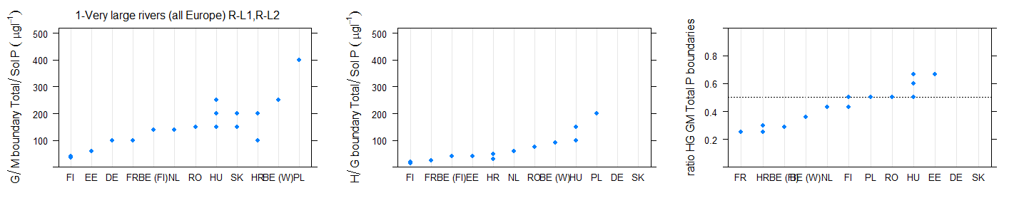
Figure 6.2-113 Range of a) good/moderate, b)high/good, c) ratio of good/moderate to high/good national phosphorus boundary values for rivers in broad type 1, very large rivers all Europe. (90th percentile values halved)
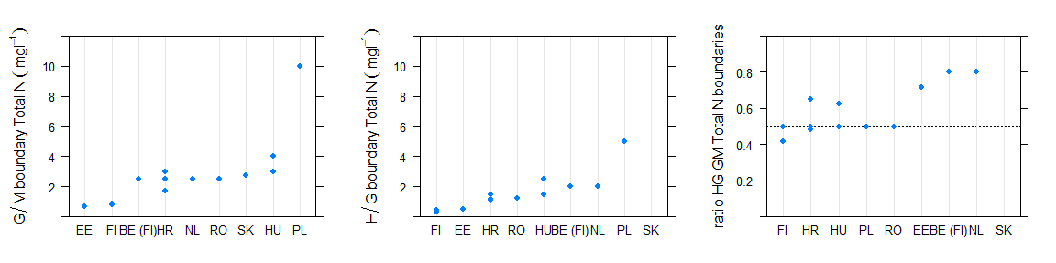
Figure 6.2-114 Range of a) good/moderate, b)high/good, c) ratio of good/moderate to high/good national total nitrogen boundary values for rivers in broad type 1, very large rivers all Europe.
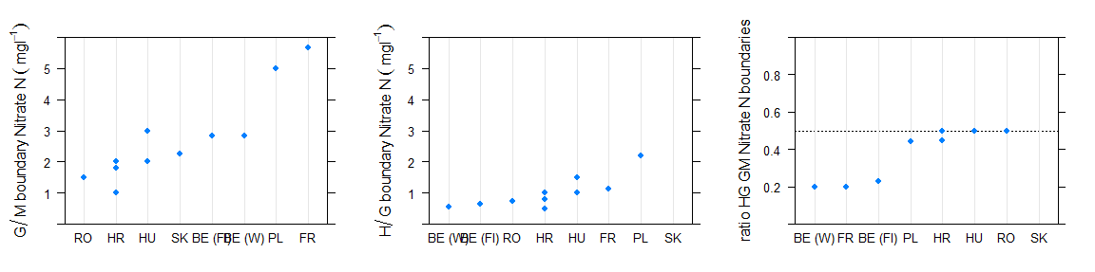
Figure 6.2-115 Range of a) good/moderate, b)high/good, c) ratio of good/moderate to high/good national nitrate nitrogen boundary values for rivers in broad type 1, very large rivers all Europe.

Type 2 Lowland, siliceous, medium-large rivers

Broad Type | Country | National type code | Description of type | IC Type
2 | BE (Fl) | Rg | Grote rivier | R-C4
2 | BE (Fl) | Rk | Kleine rivier | R-C4
2 | BG | R12 | Large floodplain rivers (ER7;altitude <150 (200) m variable; mixed/siliceous;size >7000 km2, large and very large; sand)
2 | FI | Kk | Catchment area 100-1000 km2 of which peat land <25%, natural water colour <90 mg/l Pt | R-N4
2 | FR | G12 | Grand cours d'eau Armoricain | R-C5
2 | FR | G18/4 | Grand cours d'eau d'Alsace et exogène des Vosges | R-C5
2 | FR | GM20 | Grand ou Moyen cours d'eau des Dépôts argilo-sableux | R-C5
2 | FR | M16-B | Moyen cours d'eau de Corse dans l'HER de niveau 2 n°88 | R-M2
2 | FR | P12-A | Petit cours d'eau Armoricain dans les HER de niveau 2 n°58 ou n°117 | R-C2
2 | FR | P12-B | Petit cours d'eau Armoricain dans les HER de niveau 2 n°55, n°59 ou n°118 | R-C2
2 | SE | V3LNN | lowland silic >100km2 S3, Coast of Norrland
2 | SE | V4LNN | lowland silic >100km2 S4, Southeast Sweden
2 | SE | V5LNN | lowland silic >100km2 S5, South Sweden
2 | SE | V6LNN | lowland silic >100km2 S6, Southwest Sweden
2 | UK | 4 | Lowland Siliceous Medium
2 | UK | 7 | Lowland Siliceous Large

Table 6.2-57 National & intercalibration types for countries reporting Broad Type 2, lowland, siliceous, medium large rivers

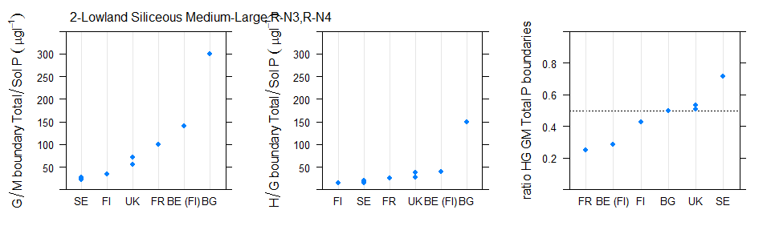
Figure 6.2-116 Range of a) good/moderate, b)high/good, c) ratio of good/moderate to high/good national phosphorus boundary values for rivers in broad type 2, lowland, siliceous, medium large rivers (90th percentile values halved)
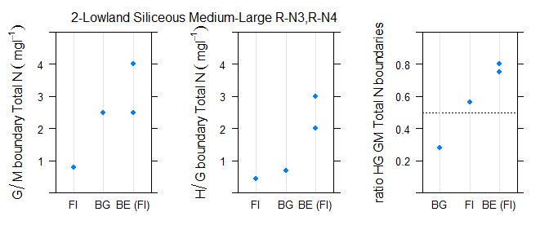
Figure 6.2-117 Range of a) good/moderate, b)high/good, c) ratio of good/moderate to high/good national total nitrogen boundary values for rivers in broad type 2, lowland, siliceous, medium large rivers
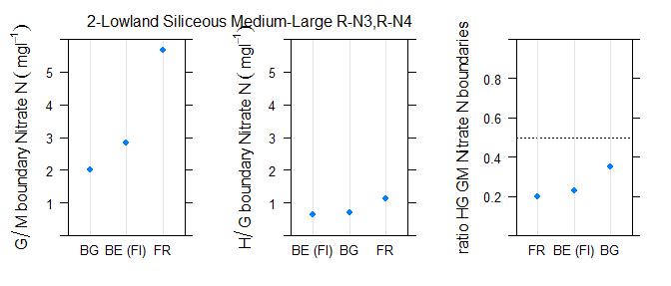
Figure 6.2-118 Range of a) good/moderate, b)high/good, c) ratio of good/moderate to high/good national nitrate nitrogen boundary values for rivers in broad type 2, lowland, siliceous, medium large rivers

Type 3 Lowland, siliceous, very small-small rivers

Broad Type | Country | National type code | Description of type | IC Type
3 | BE (Fl) | Bg | Grote beek | R-C4
3 | BE (Fl) | BgK | Grote beek Kempen | R-C4
3 | DE | 19 | Kleine Niederungsfließgewässer in Fluss- und Stromtälern | not allocated
3 | FI | Pk | Catchment area < 100 km2 of which peat land <25%, natural water colour <90 mg/l Pt | R-N1
3 | FR | P13 | Petit cours d'eau des Landes | R-C1
3 | FR | P18/4 | Petit cours d'eau d'Alsace et exogène des Vosges | R-C1
3 | FR | P20 | Petit cours d'eau des Dépôts argilo-sableux | R-C1
3 | FR | PTP16-B | Petit ou Très Petit cours d'eau de Corse dans l'HER de niveau 2 n°88 | R-M1
3 | FR | TP12-A | Très Petit cours d'eau Armoricain dans les HER de niveau 2 n°58 ou n°117 | R-C2
3 | FR | TP12-B | Très Petit cours d'eau Armoricain dans les HER de niveau 2 n°55, n°59 ou n°118 | R-C2
3 | FR | TP13 | Très Petit cours d'eau des Landes | R-C1
3 | FR | TP20 | Très Petit cours d'eau des Dépôts argilo-sableux | R-C1
3 | HR | HR-R_3A | Lowland small alluvial rivers with gravel-cobble substrate | not allocated
3 | IE | 11 | Siliceous, low slope | R-N3
3 | IE | 12 | Siliceous, medium slope | R-N3
3 | IE | 13 | Siliceous, high slope | R-N3
3 | IE | 14 | Siliceous, very high slope | R-N3
3 | NL | R14 | Snelstromende middenloop/benedenloop op zand | R-C1
3 | NL | R17 | Snelstromende bovenloop op kalkhoudende bodem | R-C1
3 | NL | R18 | Snelstromende middenloop/benedenloop op kalkhoudende bodem | R-C1
3 | NO | 1 | lowland, low alkalinity (<0,2 mekv/l), clear (colour <30 mg Pt/l) | R-N2a
3 | NO | 2 | lowland, low alkalinity (<0,2 mekv/l), clear (colour <30 mg Pt/l) | R-N2a
3 | NO | 5 | lowland, low alkalinity (<0,2 mekv/l), clear (colour <30 mg Pt/l) | R-N2a
3 | NO | 7 | lowland, moderate alkalinity (0,2-1,0 mekv/l), clear (colour <30 mg Pt/l) | R-N1
3 | PL | 17 | Potok nizinny piaszczysty | R-C1
3 | PL | 18 | Potok nizinny żwirowy | R-C1
3 | PL | 26 | Cieki w dolinach wielkich rzek nizinnych | R-C1
3 | SE | V3SNN | lowland silic <100km2 S3, Coast of Norrland | not allocated
3 | SE | V4SNN | lowland silic <100km2 S4, Southeast Sweden | not allocated
3 | SE | V5SNN | lowland silic <100km2 S5, South Sweden | not allocated
3 | SE | V6SNN | lowland silic <100km2 S6, Southwest Sweden | not allocated
3 | UK | 1 | Lowland Siliceous Small | not allocated
3 | UK | 37 | Lowland Siliceous extra-small | not allocated

Table 6.2-58 National & intercalibration types for countries reporting Broad Type3, lowland, siliceous, very small-small rivers
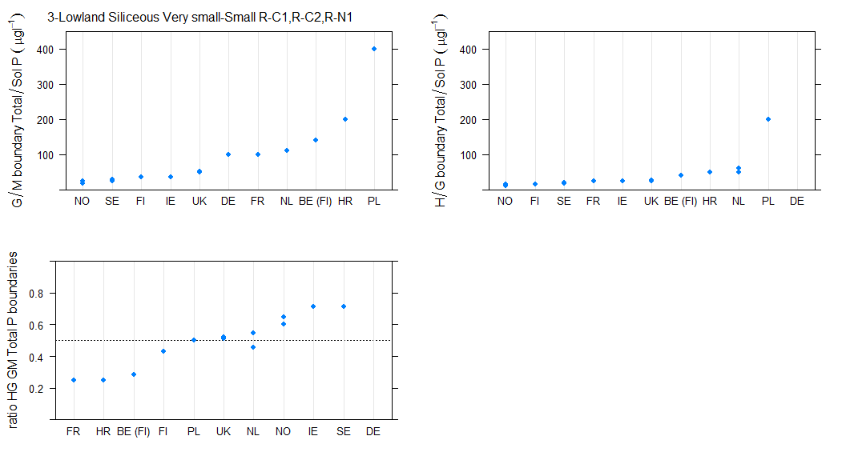
Figure 6.2-119 Range of a) good/moderate, b)high/good, c) ratio of good/moderate to high/good national phosphorus boundary values for rivers in broad type 3, lowland, siliceous, very small-small rivers (90th percentile values halved)
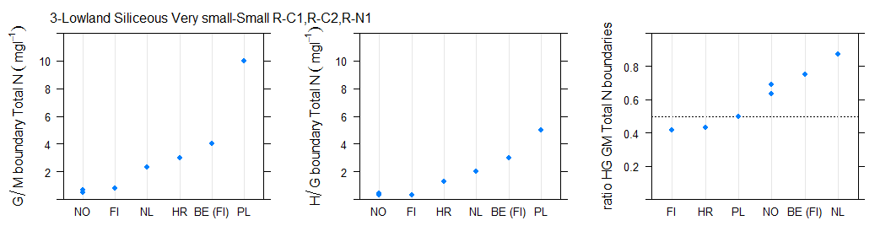
Figure 6.2-120 Range of a) good/moderate, b)high/good, c) ratio of good/moderate to high/good national total nitrogen boundary values for rivers in broad type 3, lowland, siliceous, very small-small rivers

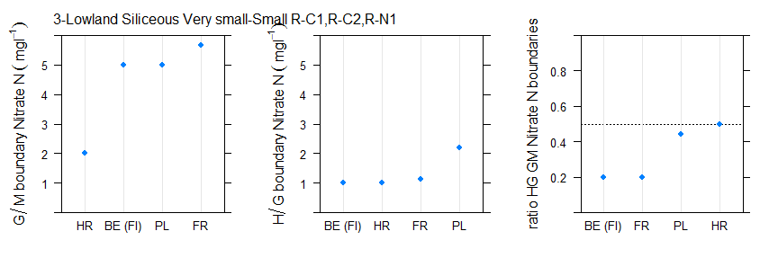
Figure 6.2-121 Range of a) good/moderate, b)high/good, c) ratio of good/moderate to high/good national nitrate nitrogen boundary values for rivers in broad type 3, lowland, siliceous, very small-small rivers

Type 4 Lowland, calcareous/mixed, medium-large rivers
Broad Type | Country | National type code | Description of type | IC Type
4 | BE (W) | RIV_21 |  | R-C4
4 | BE (W) | RIV_22 |  | R-C4
4 | BE (W) | RIV_23 |  | R-C5
4 | BG | R10 | Large Black Sea rivers (ER12-2;altitude <80m; mixed/siliceous;size >2500 km2, large; sand, silt, clay) | not allocated
4 | BG | R11 | Small and medium Black Sea rivers (ER12-2;altitude <70m, variable; mixed/siliceous;size <900 km2, small and medium; sand, silt, clay) | not allocated
4 | BG | R13 | Small and medium floodplain rivers (ER 7;altitude <150 (350) m variable; mixed/siliceous;size <1300 km2, medium and small; sand, silt) | not allocated
4 | BG | R7 | Large Danube tributaries (ER12-1;altitude <80m; mixed;size >2500 km2, large; sand, silt, clay, loess) | R-E3
4 | BG | R8 | Medium and small Danube rivers (ER12-1;altitude <100m; calcareous/mixed/siliceous;size variable; sand, silt, clay, loess) | R-E2
4 | CZ | X-1-1-2 | <200m,Crystalinicum, volcanic rock,Strahler 4-6 (smaller rivers) | R-C4
4 | CZ | X-1-1-3 | <200m,Crystalinicum, volcanic rock,Strahler 7-9 (rivers) | R-C5
4 | CZ | X-1-2-2 | <200m,Sandstone, holocene,Strahler 4-6 (smaller rivers) | R-E2
4 | CZ | X-1-2-3 | <200m,Sandstone, holocene,Strahler 7-9 (rivers) | R-E3
4 | CZ_3rd | X-1-1-2 | <200m,Crystalinicum, volcanic rock,Strahler 4-6 (smaller rivers) | R-C4
4 | CZ_3rd | X-1-1-3 | <200m,Crystalinicum, volcanic rock,Strahler 7-9 (rivers) | R-C5
4 | CZ_3rd | X-1-2-2 | <200m,Sandstone, holocene,Strahler 4-6 (smaller rivers) | R-E2
4 | CZ_3rd | X-1-2-3 | <200m,Sandstone, holocene,Strahler 7-9 (rivers) | R-E3
4 | DE | 15 | Sand- und lehmgeprägte Tieflandflüsse | not allocated
4 | DE | 15_g | "Große sand- und lehmgeprägte Tieflandflüsse
" | not allocated
4 | DE | 17 | Kiesgeprägte Tieflandflüsse | not allocated
4 | EE | 2A | Catchment 100-1000 km2, COD-Mn 90% 25 and over mgO/L | R-C4
4 | EE | 2A | Catchment 100-1000 km2, COD-Mn 90% 25 and over mgO/L | R-C6
4 | EE | 2B | Catchment 100-1000 km2, COD-Mn 90% below 25 mgO/L | R-C4
4 | EE | 2B | Catchment 100-1000 km2, COD-Mn 90% below 25 mgO/L | R-C6
4 | EE | 3A | Catchment 1000-10000 km2, COD-Mn 90% 25 and over mgO/L | R-C5
4 | EE | 3B | Catchment 1000-10000 km2, COD-Mn 90% below 25 mgO/L | R-C5
4 | FR | G9 | Grand cours d'eau des Tables calcaires | R-C5
4 | FR | G9-10/21 | Grand cours d'eau des Tables calcaires ou des Côtes calcaires Est et exogène du Massif central Nord | R-C5
4 | FR | GM14 | Grand ou Moyen cours d'eau des Coteaux aquitains | R-C5
4 | FR | GM20/9 | Grand ou Moyen cours d'eau des Dépôts argilo-sableux et exogène des Tables calcaires | R-C5

4 | FR | M10 | Moyen cours d'eau des Côtes calcaires Est | R-C4
4 | FR | M10/4 | Moyen cours d'eau des Côtes calcaires Est et exogène des Vosges | R-C4
4 | FR | M11/3-21 | Moyen cours d'eau des Causses aquitains et exogène du Massif central Sud ou du Massif central Nord | R-C4
4 | FR | M12-A | Moyen cours d'eau Armoricain dans les HER de niveau 2 n°58 ou n°117 | R-C4
4 | FR | M12-B | Moyen cours d'eau Armoricain dans les HER de niveau 2 n°55, n°59 ou n°118 | R-C4
4 | FR | M13 | Moyen cours d'eau des Landes | R-C4
4 | FR | M14/3-11 | Moyen cours d'eau des Coteaux aquitains et exogène du Massif central Sud et/ou des Causses aquitains | R-C4
4 | FR | M14/3-8 | Moyen cours d'eau des Coteaux aquitains et exogène du Massif central Sud et/ou des Cévennes | R-C4
4 | FR | M15-17/3-21 | Moyen cours d'eau de la Plaine de Saône ou des Dépressions sédimentaires et exogène du Massif central Sud ou du Massif central Nord | R-C4
4 | FR | M18/4 | Moyen cours d'eau d'Alsace et exogène des Vosges | R-C4
4 | FR | M20 |  | R-C4
4 | FR | M9 | Moyen cours d'eau des Tables calcaires | R-C4
4 | FR | M9-10/21 | Moyen cours d'eau des Tables calcaires ou des Côtes calcaires Est et exogène du Massif central Nord | R-C4
4 | FR | M9-A | Moyen cours d'eau des Tables calcaires dans l'HER de niveau 2 n°57 | R-C4
4 | FR | MP15 | Moyen ou Petit cours d'eau de Plaine de Saône | R-C4
4 | FR | MP15/5 | Moyen ou Petit cours d'eau de Plaine de Saône et exogène du Jura/Pré-Alpes du Nord | R-C4
4 | FR | MP18 | Moyen ou Petit cours d'eau d'Alsace | R-C4
4 | FR | P9 | Petit cours d'eau des Tables calcaires | R-C6
4 | HR | HR-R_4 | Lowland medium and large rivers | not allocated
4 | HR | HR-R_8 | Lowland medium and large rivers in Diric ecoregion | not allocated
4 | HU | 12R | Plain – calcareous – coarse – medium catchment | R-E2
4 | HU | 13R | Plain – calcareous – coarse – large catchment | R-E3
4 | HU | 18R | Plain – calcareous – medium/fine – medium catchment | R-E2
4 | HU | 19R | Plain – calcareous – medium/fine – large catchment | R-E3
4 | HU | 22R | Plain – organic – medium catchment | R-E2
4 | IT | IT06SS3F |  | not allocated
4 | LT | RWT2 | Medium slow flowing rivers (area 100-1000 km2, slope less than 0,7 m/km) | R-C4
4 | LT | RWT2 | Medium slow flowing rivers (area 100-1000 km2, slope less than 0,7 m/km) | R-C6
4 | LT | RWT3 | Medium fast flowing rivers (area 100-1000 km2, slope more than 0,7 m/km) | R-C4
4 | LT | RWT3 | Medium fast flowing rivers (area 100-1000 km2, slope more than 0,7 m/km) | R-C6
4 | LT | RWT4 | Large slow flowing rivers (area more than 1000 km2, slope less than 0,3 m/km) | R-C5
4 | LT | RWT5 | Large fast flowing rivers (area more than 1000 km2, slope more than 0,3 m/km) | R-C5
4 | LU | 5 | mid-sized and mid-altitude streams in the Gutland | R-C4
4 | LU | 6 | large lowland streams | R-C5
4 | LV | R3 | Lowland (< 300 m a.s.l.), carbonatic bedrock, medium size (100-1000km2), fast-flowing (slope > 1 m/km). | R-C4
4 | LV | R4 | Lowland (< 300 m a.s.l.), carbonatic bedrock, medium size (100-1000km2), slow-running (slope < 1 m/km). | R-C4
4 | LV | R5 | Lowland (< 300 m a.s.l.), carbonatic bedrock, large (> 1000 km2), fast-flowing (slope > 1 m/km). | R-C5
4 | LV | R6 | Lowland (< 300 m a.s.l.), carbonatic bedrock, large (> 1000 km2), slow-running (slope < 1 m/km). | R-C5
4 | LV | R6 | Lowland (< 300 m a.s.l.), carbonatic bedrock, large (> 1000 km2), slow-running (slope < 1 m/km). | R-L
4 | NL | R12 | Langzaam stromende middenloop/benedenloop op veenbodem | R-C5
4 | NL | R13 | Snelstromende bovenloop op zand | R-C4
4 | NL | R15 | Snelstromend riviertje op kiezelhoudende bodem | R-C4
4 | NL | R16 | Snelstromende rivier/nevengeul op zandbodem of grind | R-C5
4 | NL | R8 | Zoet getijdenwater (uitlopers rivier) op zand/klei | R-C5
4 | PL | 19 | Rzeka nizinna piaszczysto- gliniasta | R-C4
4 | PL | 19 | Rzeka nizinna piaszczysto- gliniasta | R-C5
4 | PL | 20 | Rzeka nizinna żwirowa | R-C4
4 | PL | 20 | Rzeka nizinna żwirowa | R-C5
4 | PL | 25 | Cieki łączące jeziora | R-C5
4 | RO | RO07 | Sector de curs de apa situat in zona de campie -ecoregiunea 11 | not allocated
4 | RO | RO08 | Sector de curs de apa situat in zona de campie -ecoregiunea 12 | not allocated
4 | RO | RO08* | Sector de curs de apa situat in zona de campie (fara fauna piscicola in conditii naturale) - ecoregiunea 12 | not allocated
4 | RO | RO10 | Sector de curs de apa situat in zona de campie - F>3000 km2 - ecoregiunea 11 | not allocated
4 | RO | RO11 | Sector de curs de apa cu zone umede situat in zona de campie -F>3000 km2 - ecoregiunea 11 | not allocated
4 | RO | RO11* | Sector de curs de apa cu zone umede situat in zona de campie -F>5000 km2 - ecoregiunea 12,16 | not allocated
4 | SE | V4LNY | lowland calc >100km2 S4, Southeast Sweden | not allocated
4 | SE | V5LNY | lowland calc >100km2 S5, South Sweden | not allocated
4 | SE | V6LNY | lowland calc >100km2 S6, Southwest Sweden | not allocated
4 | SK | B1(P1V) | Veľké toky v povodí Bodrogu v nadmorskej výške do 200 m v Panónskej panve | R-E3
4 | SK | I1(P1V) | Dolná časť toku Ipeľ v nadmorskej výške do 200 m v Panónskej panve | R-E3
4 | SK | M1(P1V) | Morava v nadmorskej výške do 200 m v Panónskej panve | R-E3
4 | SK | P1S | Stredne veľké toky v nadmorskej výške do 200 m v Panónskej panve | R-E2
4 | SK | R2(P1V) | Dolná časť toku Hron v nadmorskej výške do 200 m v Panónskej panve | R-E3
4 | SK | V3(P1V) | Veľké toky dolnej časti povodia Váhu v nadmorskej výške do 200 m v Panónskej panve | R-E3
4 | UK | 5 | Lowland Calcareous Medium | R-C4
4 | UK | 8 | Lowland Calcareous Large | not allocated

Table 6.2-59 National & intercalibration types for countries reporting Broad Type 4, lowland, calcareous/mixed, medium-large rivers
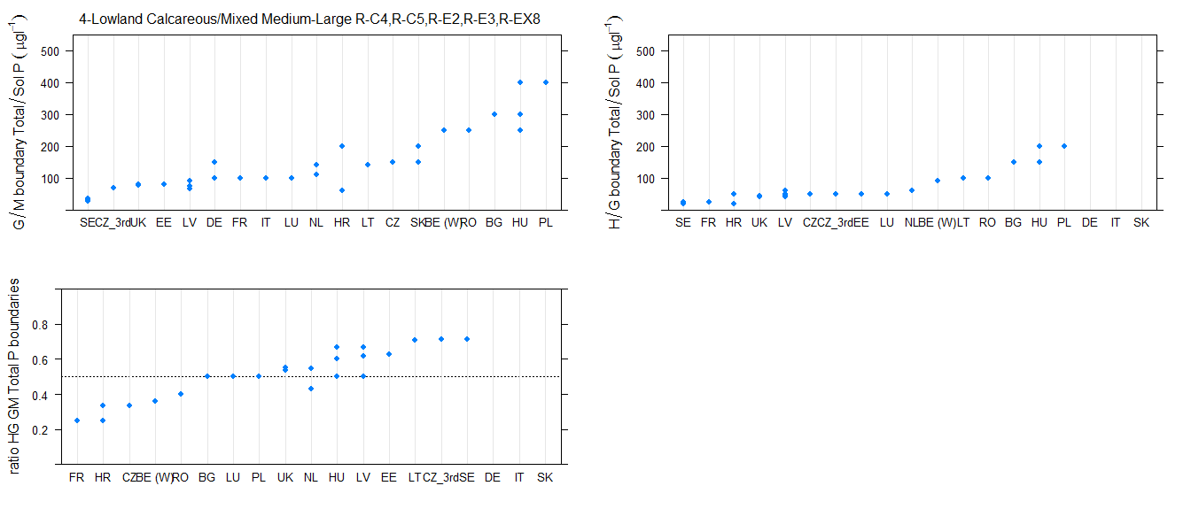
Figure 6.2-122 Range of a) good/moderate, b)high/good, c) ratio of good/moderate to high/good national phosphorus boundary values for rivers in broad type 4, lowland, calcareous/mixed, medium-large rivers (90th percentile values halved)
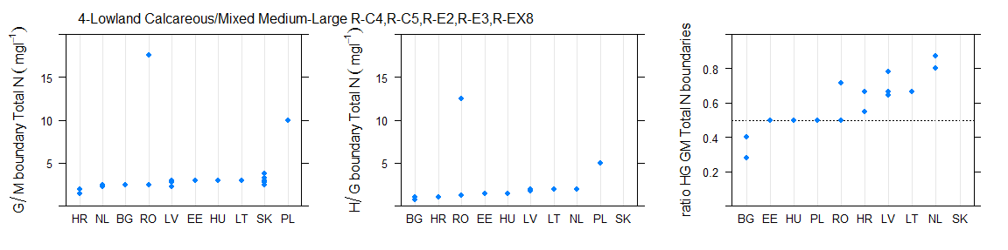
Figure 6.2-123 Range of a) good/moderate, b)high/good, c) ratio of good/moderate to high/good national total nitrogen boundary values for rivers in broad type 4, lowland, calcareous/mixed, medium-large rivers

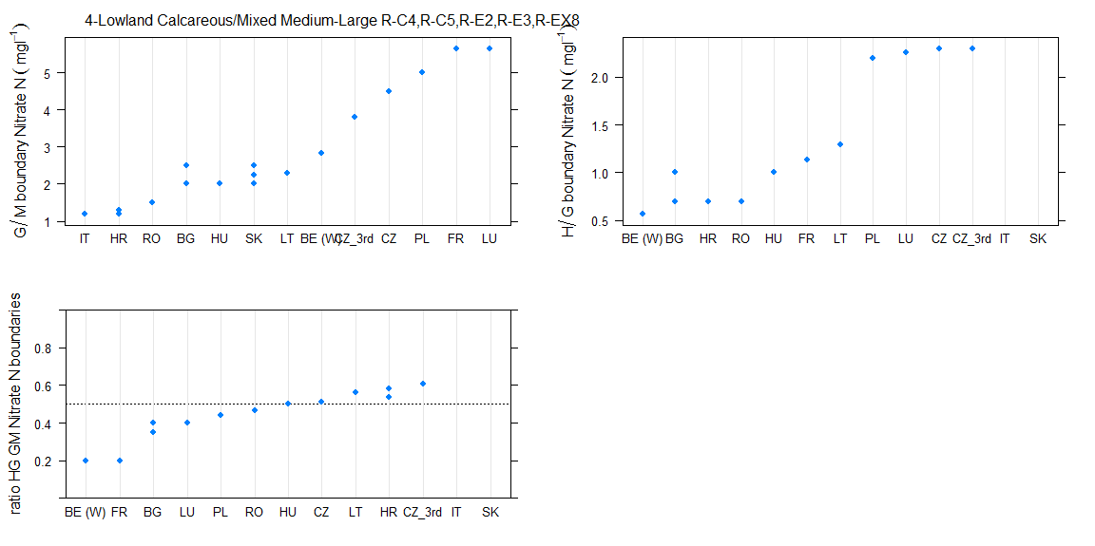
Figure 6.2-124 Range of a) good/moderate, b)high/good, c) ratio of good/moderate to high/good national nitrate nitrogen boundary values for rivers in broad type 4, lowland, calcareous/mixed, medium-large rivers

Type 5 Lowland, calcareous/mixed, very small-small rivers

Broad Type | Country | National type code | Description of type | IC Type
5 | BE (W) | RIV_20 |  | R-C1
5 | CZ | X-1-1-1 | <200m,Crystalinicum, volcanic rock,Strahler 1-3 (brooks) | not allocated
5 | CZ | X-1-2-1 | <200m,Sandstone, holocene,Strahler 1-3 (brooks) | not allocated
5 | CZ_3rd | X-1-1-1 | <200m,Crystalinicum, volcanic rock,Strahler 1-3 (brooks) | not allocated
5 | CZ_3rd | X-1-2-1 | <200m,Sandstone, holocene,Strahler 1-3 (brooks) | not allocated
5 | DE | 14 | Sandgeprägte Tieflandbäche | not allocated
5 | DE | 16 | Kiesgeprägte Tieflandbäche | not allocated
5 | DE | 18 | Lösslehmgeprägte Tieflandbäche | not allocated
5 | DE | 19 | Kleine Niederungsfließgewässer in Fluss- und Stromtälern | not allocated
5 | EE | 1A | Catchment 10-100 km2, COD-Mn 90% 25 and more mgO/L | R-C4
5 | EE | 1A | Catchment 10-100 km2, COD-Mn 90% 25 and more mgO/L | R-C6
5 | EE | 1B | Catchment 10-100 km2, COD-Mn 90% below 25 mgO/L | R-C6
5 | FR | P9-A | Petit cours d'eau des Tables calcaires dans l'HER de niveau 2 n°57 | R-C6
5 | FR | TP15 | Très Petit cours d'eau de Plaine de Saône | R-C6
5 | FR | TP17 | Très Petit cours d'eau des Dépressions sédimentaires | R-C6
5 | FR | TP18 | Très Petit cours d'eau d'Alsace | R-C6
5 | FR | TP9 | Très Petit cours d'eau des Tables calcaires | R-C6
5 | HR | HR-R_2A | Lowland small rivers with clay-sand substrate | not allocated
5 | HR | HR-R_2B | Lowland small rivers with gravel-cobble substrate | not allocated
5 | HU | 11R | Plain – calcareous – coarse – small catchment | R-EX5
5 | HU | 15R | Plain – calcareous – medium/fine – small catchment | R-EX5
5 | HU | 16R | Plain – calcareous – medium/fine – small catchment with little slope | R-EX5
5 | HU | 17R | Plain – calcareous – medium/fine – medium catchment with little slope | R-E2
5 | HU | 21R | Plain – organic – small catchment | R-EX5
5 | IE | 21 | Mixed geology, low slope | R-N1
5 | IE | 22 | Mixed geology, medium slope | R-N1
5 | IE | 23 | Mixed geology, high slope | R-N1
5 | IE | 24 | Mixed geology, very high slope | R-N1
5 | IE | 31 | Calcareous, low slope | R-C4
5 | IE | 31 | Calcareous, low slope | R-C5
5 | IE | 31 | Calcareous, low slope | R-C6
5 | IE | 32 | Calcareous, medium slope | R-C4
5 | IE | 32 | Calcareous, medium slope | R-C5

5 | IE | 32 | Calcareous, medium slope | R-C6
5 | IE | 33 | Calcareous, high slope | R-C6
5 | IE | 34 | Calcareous, very high slope | R-C6
5 | IT | IT06AS2T |  | not allocated
5 | IT | IT06AS6T |  | not allocated
5 | IT | IT06SR6T |  | not allocated
5 | IT | IT06SS1T |  | not allocated
5 | LT | RWT1 | Small rivers (area less than 100 km2) | R-C1
5 | LT | RWT1 | Small rivers (area less than 100 km2) | R-C6
5 | LU | 4 | small mid-altitude streams in the Gutland | R-C6
5 | LV | R1 | Lowland (< 300 m a.s.l.), carbonatic bedrock, small (< 100 km2), fast-flowing (> 1 m/km). | R-C6
5 | LV | R2 | Lowland (< 300 m a.s.l.), carbonatic bedrock, small (< 100 km2), slow-running (< 1 m/km). | R-C6
5 | NL | R4 | Permanente langzaam stromende bovenloop op zand | R-C1
5 | NL | R5 | Langzaam stromende middenloop/benedenloop op zand | R-C1
5 | NL | R6 | Langzaam stromend riviertje op zand/klei | R-C4
5 | NO | 9 | lowland, moderate alkalinity (0,2-1,0 mekv/l), clear (colour <30 mg Pt/l) | R-N1
5 | PL | 16 | Potok nizinny lessowo-gliniasty | not allocated
5 | RO | RO06 | Curs de apa situat in zona de campie | R-E2
5 | RO | RO06 | Curs de apa situat in zona de campie | R-EX5
5 | RO | RO06* | Curs de apa situat in zona de campie (fara fauna piscicola in conditii naturale) | not allocated
5 | SE | V3SNY | lowland calc <100km2 S3, Coast of Norrland | not allocated
5 | SE | V4SNY | lowland calc <100km2 S4, Southeast Sweden | not allocated
5 | SE | V5SNY | lowland calc <100km2 S5, South Sweden | not allocated
5 | SE | V6SNY | lowland calc <100km2 S6, Southwest Sweden | not allocated
5 | SK | P1M | Malé toky v nadmorskej výške do 200 m v Panónskej panve | R-EX5
5 | UK | 2 | Lowland Calcareous Small | R-C1
5 | UK | 40 | Lowland Calcareous extra-small | not allocated

Table 6.2-60 National & intercalibration types for countries reporting Broad Type 5, lowland, calcareous/mixed, very small-small rivers
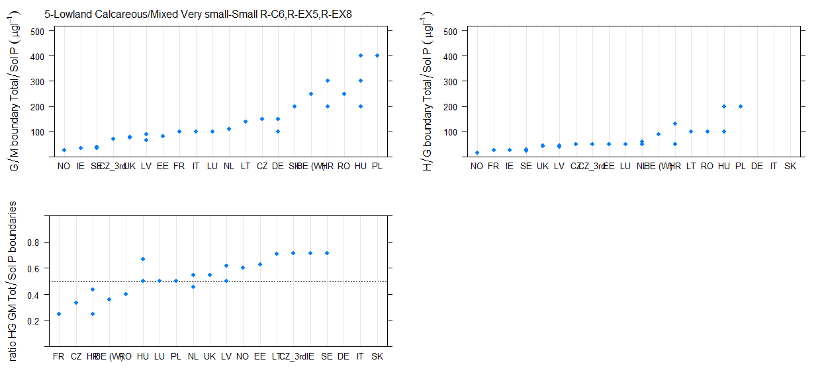
Figure 6.2-125 Range of a) good/moderate, b)high/good, c) ratio of good/moderate to high/good national phosphorus boundary values for rivers in broad type 5, lowland, calcareous/mixed, very small-small rivers (90th percentile values halved)

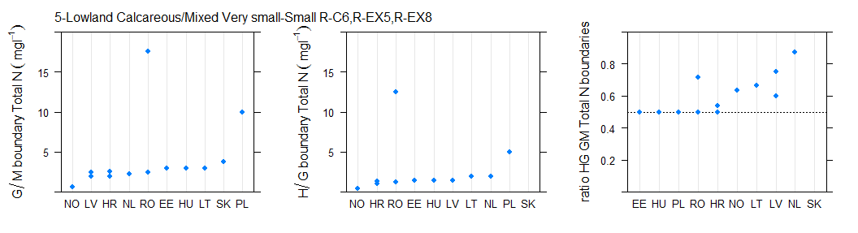
Figure 6.2-126 Range of a) good/moderate, b)high/good, c) ratio of good/moderate to high/good national total nitrogen boundary values for rivers in broad type 5, lowland, calcareous/mixed, very small-small rivers
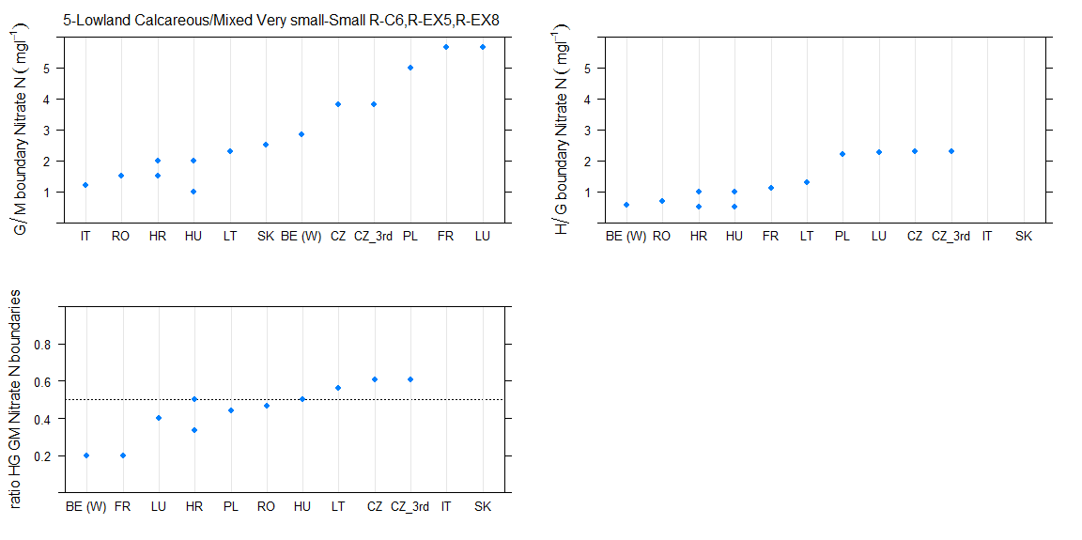

Figure 6.2-127 Range of a) good/moderate, b)high/good, c) ratio of good/moderate to high/good nitrate nitrogen boundary values for rivers in broad type 5, lowland, calcareous/mixed, very small-small rivers

Type 6 Lowland, organic & siliceous rivers

Broad Type | Country | National type code | Description of type | IC Type
6 | DE | 11 | Organisch geprägte Bäche
6 | DE | 12 | Organisch geprägte Flüsse
6 | FI | Kt | Catchment area 100-1000 km2 of which peat land >25%, natural water colour >90 mg/l Pt | R-N3
6 | FI | Pt | Catchment area < 100 km2 of which peat land >25%, natural water colour >90 mg/l Pt | R-N3
6 | NO | 3 | lowland, low alkalinity (<0,2 mekv/l), humic (colour 30-90 mg Pt/l) | R-N3a
6 | NO | 6 | lowland, low alkalinity (<0,2 mekv/l), humic (colour 30-90 mg Pt/l) | R-N3a
6 | NO | 8 | lowland, moderate alkalinity (0,2-1,0 mekv/l), humic (colour 30-90 mg Pt/l)
6 | PL | 23 | Potoki i strumienie na obszarach będących pod wpływem procesów torfotwórczych
6 | SE | V3LYN | lowland silicorganic >100km2 S3, Coast of Norrland
6 | SE | V3SYN | lowland silicorganic <100km2 S3, Coast of Norrland
6 | SE | V4LYN | lowland silicorganic >100km2 S4, Southeast Sweden
6 | SE | V4SYN | lowland silicorganic <100km2 S4, Southeast Sweden
6 | SE | V5LYN | lowland silicorganic >100km2 S5, South Sweden
6 | SE | V5SYN | lowland silicorganic <100km2 S5, South Sweden
6 | SE | V6LYN | lowland silicorganic >100km2 S6, Southwest Sweden
6 | SE | V6SYN | lowland silicorganic <100km2 S6, Southwest Sweden
6 | UK | 3 | Lowland Organic Small
6 | UK | 6 | Lowland Organic Medium
6 | UK | 9 | Lowland Organic Large

Table 6.2-61 National & intercalibration types for countries reporting Broad Type 6, lowland, organic & siliceous rivers

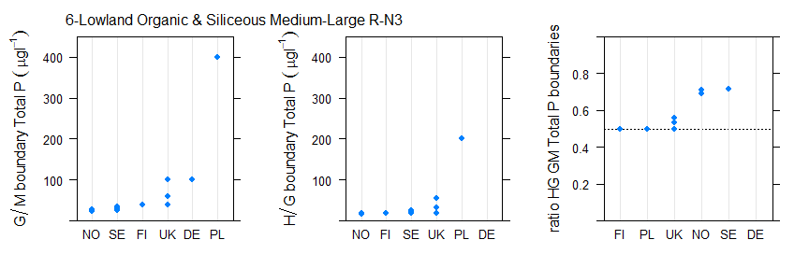
Figure 6.2-128 Range of a) good/moderate, b)high/good, c) ratio of good/moderate to high/good national phosphorus boundary values for rivers in broad type 6, lowland, organic & siliceous rivers
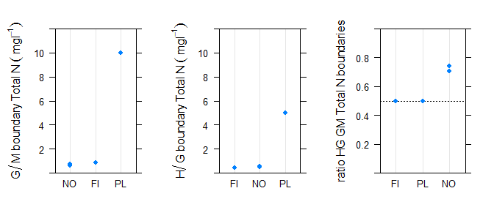
Figure 6.2-129 Range of a) good/moderate, b)high/good, c) ratio of good/moderate to high/good national total nitrogen boundary values for rivers in broad type 6, lowland, organic & siliceous rivers

Type 7 Lowland, organic and calcareous/mixed rivers

Broad Type | Country | National type code | Description of type | IC Type
7 | DE | 11 | Organisch geprägte Bäche
7 | DE | 12 | Organisch geprägte Flüsse
7 | NO | 10 | lowland, moderate alkalinity (0,2-1,0 mekv/l), humic (colour 30-90 mg Pt/l)
7 | NO | 11 | lowland, turbid (susp solids > 10 mg/l)
7 | SE | V3SYY | lowland calcorganic <100km2 S3, Coast of Norrland
7 | SE | V4LYY | lowland calcorganic >100km2 S4, Southeast Sweden
7 | SE | V4SYY | lowland calcorganic <100km2 S4, Southeast Sweden
7 | SE | V5LYY | lowland calcorganic >100km2 S5, South Sweden
7 | SE | V5SYY | lowland calcorganic <100km2 S5, South Sweden
7 | SE | V6LYY | lowland calcorganic >100km2 S6, Southwest Sweden
7 | SE | V6SYY | lowland calcorganic <100km2 S6, Southwest Sweden

Table 6.2-62 National & intercalibration types for countries reporting Broad Type 7 lowland, organic and calcareous/mixed rivers
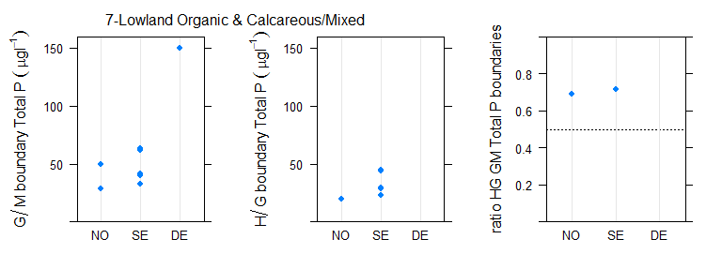
Figure 6.2-130 Range of a) good/moderate, b)high/good, c) ratio of good/moderate to high/good national phosphorus boundary values for rivers in broad type 7, lowland, organic & calcareous/mixed rivers.

Type 8 Mid-altitude, siliceous, medium-large rivers

Broad Type | Country | National type code | Description of type | IC Type
8 | BE (W) | RIV_06 |  | R-C3
8 | BE (W) | RIV_07 |  | R-C3
8 | BE (W) | RIV_08 |  | R-C5
8 | BG | R5 | Semi mountain rivers (gravel rivers) in ER7 (semi-mountain zone - big variation; mixed/siliceous/calcareous;size <1300 km2,small and medium (rarely large) ; gravels) | not allocated
8 | DE | 9 | Silikatische, fein- bis grobmaterialreiche Mittelgebirgsflüsse | not allocated
8 | FR | G17/3-21 | Grand cours d'eau des Dépressions sédimentaires et exogène du Massif central Sud ou du Massif central Nord | R-C5
8 | FR | GM8 | Grand ou Moyen cours d'eau des Cévennes | R-M3
8 | FR | M16-A | Moyen cours d'eau de Corse dans l'HER de niveau 2 n°22 | R-M2
8 | FR | M8-A | Moyen cours d'eau des Cévennes dans l'HER de niveau 2 n°70 | R-M2
8 | FR | P21 | Petit cours d'eau du Massif central Nord | R-C3
8 | FR | P3 | Petit cours d'eau du Massif central Sud | R-C3
8 | IT | IT03SS3N |  | R-A1
8 | IT | IT03SS3N |  | R-A2
8 | LU | 3 | mid-sized and mid-altitude streams in the Oesling | R-C4
8 | PL | 8 | Mała rzeka wyżynna krzemianowa - zachodnia | not allocated
8 | SE | V2LNN | mid alt silic >100km2 S2, Inlands of Norrland | not allocated
8 | SE | V7LNN | mid alt silic >100km2 S7, Highlands of South Sweden | not allocated
8 | UK | 13 | Mid-altitude Siliceous Medium | R-C3
8 | UK | 16 | Mid-altitude Siliceous Large | not allocated

Table 6.2-63 National & intercalibration types for countries reporting Broad Type 8, mid-altitude, siliceous, medium large rivers

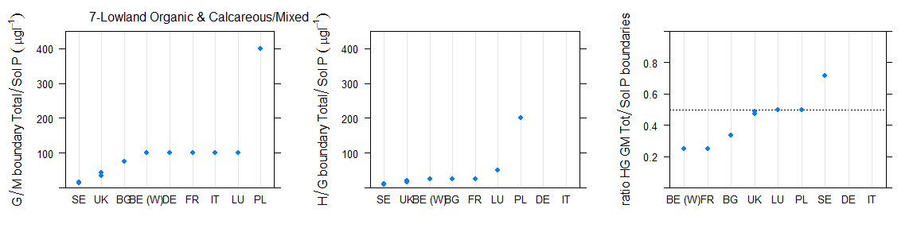
Figure 6.2-131 Range of a) good/moderate, b)high/good, c) ratio of good/moderate to high/good national phosphorus boundary values for rivers in broad type 8, mid-altitude, siliceous, medium large rivers (90th percentile values halved)
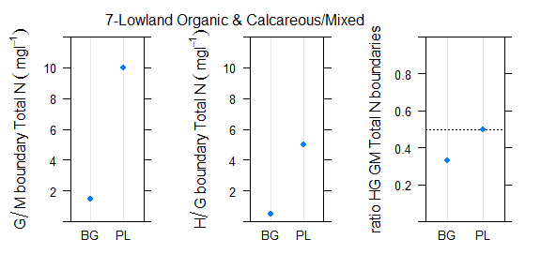
Figure 6.2-132 Range of a) good/moderate, b)high/good, c) ratio of good/moderate to high/good national total nitrogen boundary values for rivers in broad type 8, mid-altitude, siliceous, medium large rivers
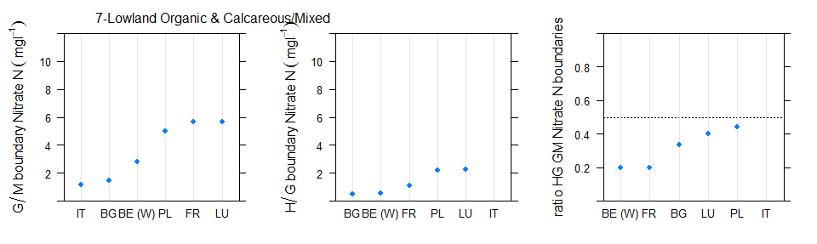
Figure 6.2-133 Range of a) good/moderate, b)high/good, c) ratio of good/moderate to high/good national nitrate nitrogen boundary values for rivers in broad type 8, mid-altitude, siliceous, medium large rivers

Type 9 Mid-altitude, siliceous, very small-small rivers

Broad Type | Country | National type code | Description of type | IC Type
9 | BE (W) | RIV_05 |  | R-C3
9 | BG | R4 | Semi mountain rivers (gravel rivers) in ER12 (semi-mountain zone - big variation; mixed/siliceous/calcareous;size <1300 km2,small and medium (rarely large) ; gravels) | R-E1b
9 | BG | R4 | Semi mountain rivers (gravel rivers) in ER12 (semi-mountain zone - big variation; mixed/siliceous/calcareous;size <1300 km2,small and medium (rarely large) ; gravels) | R-E4
9 | DE | 5 | Grobmaterialreiche, silikatische Mittelgebirgsbäche | not allocated
9 | DE | 5.1 | Feinmaterialreiche, silikatische Mittelgebirgsbäche | not allocated
9 | FR | M21 | Moyen cours d'eau du Massif central Nord | R-C3
9 | FR | M22 |  | R-C3
9 | FR | M3 | Moyen cours d'eau du Massif central Sud | R-C3
9 | FR | M4 | Moyen cours d'eau des Vosges | R-C3
9 | FR | P11/3-21 | Petit cours d'eau des Causses aquitains et exogène du Massif central Sud ou du Massif central Nord | R-C3
9 | FR | P17/3-21 | Petit cours d'eau des Dépressions sédimentaires et exogène du Massif central Sud ou du Massif central Nord | R-C3
9 | FR | P22 | Petit cours d'eau des Ardennes | R-C3
9 | FR | P4 | Petit cours d'eau des Vosges | R-C3
9 | FR | TP21 | Très Petit cours d'eau du Massif central Nord | R-C3
9 | FR | TP22 | Très Petit cours d'eau des Ardennes | R-C3
9 | FR | TP4 | Très Petit cours d'eau des Vosges | R-C3
9 | HU | 1R | Mountainous - siliceous – coarse – small catchment | R-E1b
9 | IT | IT03GH6N |  | R-A1
9 | IT | IT03GH6N |  | R-A2
9 | IT | IT03SR6N |  | not allocated
9 | IT | IT03SS1N |  | R-A1
9 | IT | IT03SS1N |  | R-A2
9 | IT | IT03SS2N |  | R-A1
9 | IT | IT03SS2N |  | R-A2
9 | LU | 1 | small high-altitude streams in the Oesling | R-C3
9 | LU | 2 | small mid-altitude streams in the Oesling | R-C3
9 | NO | 12 | mid-altitude (200-800 masl), low alkalinity (<0,2 mekv/l), clear (colour <30 mg Pt/l) | R-N5a
9 | NO | 13 | mid-altitude (200-800 masl), low alkalinity (<0,2 mekv/l), clear (colour <30 mg Pt/l) | R-N5a
9 | NO | 15 | mid-altitude (200-800 masl), low alkalinity (<0,2 mekv/l), clear (colour <30 mg Pt/l) | R-N5a
9 | NO | 16 | mid-altitude (200-800 masl), low alkalinity (<0,2 mekv/l), clear (colour <30 mg Pt/l) | R-N5a

9 | PL | 12 | Potok fliszowy | not allocated
9 | PL | 4 | Potok wyżynny krzemianowy z substratem gruboziarnistym - zachodni | R-C3
9 | PL | 5 | Potok wyżynny krzemianowy z substratem drobnoziarnistym- zachodni | R-C3
9 | SE | V2SNN | mid alt silic <100km2 S2, Inlands of Norrland | not allocated
9 | SE | V7SNN | mid alt silic <100km2 S7, Highlands of South Sweden | not allocated
9 | UK | 10 | Mid-altitude Siliceous Small | R-C3

Table 6.2-64 National & intercalibration types for countries reporting Broad Type 9, mid-altitude, siliceous, very small-small rivers

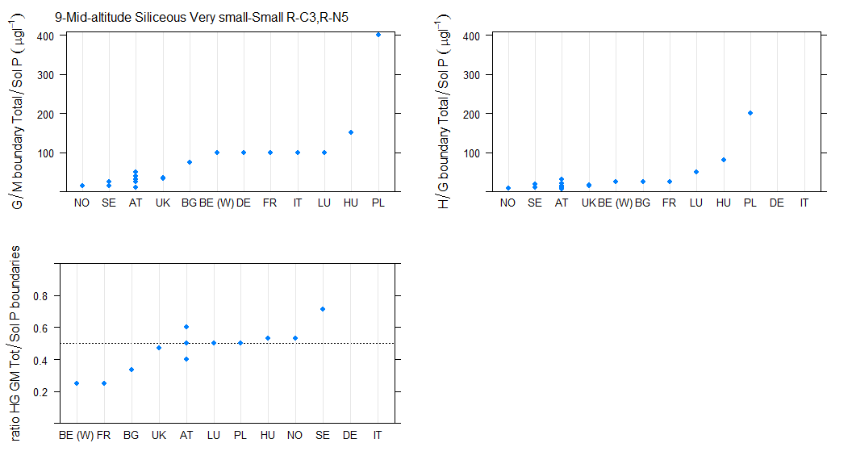
Figure 6.2-134 Range of a) good/moderate, b)high/good, c) ratio of good/moderate to high/good national phosphorus boundary values for rivers in broad type 9, mid-altitude, siliceous, very small-small rivers (90th percentile values halved)
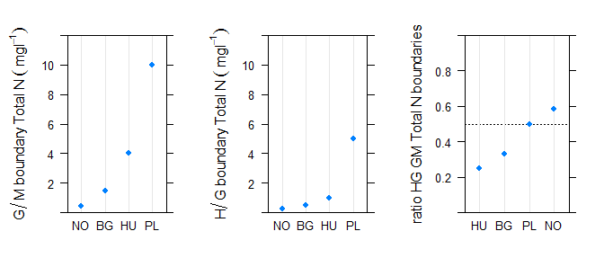
Figure 6.2-135 Range of a) good/moderate, b)high/good, c) ratio of good/moderate to high/good national total nitrogen boundary values for rivers in broad type 9, mid-altitude, siliceous, very small-small rivers
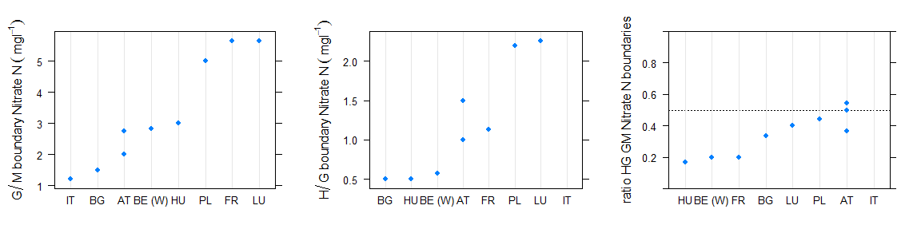
Figure 6.2-136 Range of a) good/moderate, b)high/good, c) ratio of good/moderate to high/good national nitrate nitrogen boundary values for rivers in broad type 9, mid-altitude, siliceous, very small-small rivers

Type 10 Mid-altitude, calcareous/mixed, medium-large rivers

Broad Type | Country | National type code | Description of type | IC Type
10 | AT | 13__MZB1,75_PHBme2 | Bioregion: Eastern Lowlands and Uplands of the Hungarian Plain (13); Macroinvertebrate- saprobic reference condition: SI 1,75; Phytobenthos-trophic reference condition: meso-eutrophic overall (me2) | R-E4
10 | BE (W) | RIV_03 |  | R-C4
10 | BE (W) | RIV_11 |  | R-C4
10 | BE (W) | RIV_12 |  | R-C5
10 | BE (W) | RIV_15 |  | R-C4
10 | BE (W) | RIV_16 |  | R-C4
10 | BE (W) | RIV_17 |  | R-C5
10 | BE (W) | RIV_18 |  | R-C5
10 | CZ | X-2-1-2 | 200-500m,Crystalinicum, volcanic rock,Strahler 4-6 (smaller rivers) | R-E4
10 | CZ | X-2-1-3 | 200-500m,Crystalinicum, volcanic rock,Strahler 7-9 (rivers) | not allocated
10 | CZ | X-2-2-2 | 200-500m,Sandstone, holocene,Strahler 4-6 (smaller rivers) | not allocated
10 | CZ | X-2-2-2 | 200-500m,Sandstone, holocene,Strahler 4-6 (smaller rivers) | R-E4
10 | CZ | X-2-2-3 | 200-500m,Sandstone, holocene,Strahler 7-9 (rivers) | R-EX4
10 | CZ | X-3-1-3 | 500-800m,Crystalinicum, volcanic rock,Strahler 7-9 (rivers) | not allocated
10 | CZ_3rd | X-2-1-2 | 200-500m,Crystalinicum, volcanic rock,Strahler 4-6 (smaller rivers) | R-E4
10 | CZ_3rd | X-2-1-3 | 200-500m,Crystalinicum, volcanic rock,Strahler 7-9 (rivers) | not allocated
10 | CZ_3rd | X-2-2-2 | 200-500m,Sandstone, holocene,Strahler 4-6 (smaller rivers) | R-E4
10 | CZ_3rd | X-2-2-3 | 200-500m,Sandstone, holocene,Strahler 7-9 (rivers) | R-EX4
10 | CZ_3rd | X-3-1-3 | 500-800m,Crystalinicum, volcanic rock,Strahler 7-9 (rivers) | not allocated
10 | DE | 3.2 | Kleine Flüsse der Jungmoräne des Alpenvorlandes | not allocated
10 | DE | 4 | Große Flüsse des Alpenvorlandes | not allocated
10 | DE | 9.1 | Karbotische, fein- bis grobmaterialreiche Mittelgebirgsflüsse | not allocated
10 | DE | 9.1_K | Karbotische, fein- bis grobmaterialreiche Mittelgebirgsflüsse (Keuper) | not allocated
10 | DE | 9.2 | Große Flüsse des Mittelgebirges | not allocated

10 | FR | G10 | Grand cours d'eau des Côtes calcaires Est | R-C5
10 | FR | GM5/2 | Grand ou Moyen cours d'eau du Jura/Pré-Alpes du Nord et exogène des Alpes internes | R-A2
10 | HR | HR-R_10B | Mountainous medium temporary rivers | not allocated
10 | HR | HR-R_7 | Mountain and foothill midium and large rivers | not allocated
10 | HR | HR-R_9 | Mountain and foothill midium rivers of karstic fields | not allocated
10 | HU | 10R | Hilly – calcareous – medium/fine – large catchment | R-E3
10 | HU | 5R | Hilly – calcareous – coarse – medium catchment | R-E4
10 | HU | 6R | Hilly – calcareous – coarse – large catchment | R-E3
10 | HU | 9R | Hilly – calcareous – medium/fine – medium catchment | R-E4
10 | PL | 9 | Mała rzeka wyżynna węglanowa | not allocated
10 | RO | RO02 | Sector de curs de apa situat in zona piemontana sau de podisuri inalte | not allocated
10 | RO | RO05 | Sector de curs de apa situat in zona de dealuri si de podisuri | R-EX4
10 | RO | RO05 | Sector de curs de apa situat in zona de dealuri si de podisuri | R-EX6
10 | SK | H1(K2V) | Stredná časť toku Hornád v nadmorskej výške 200 - 500 m v Karpatoch | R-EX4
10 | SK | H2(K2V) | Dolná časť toku Hornád v nadmorskej výške 200 - 500 m v Karpatoch | R-EX4
10 | SK | K2S | Stredne veľké toky v nadmorskej výške 200 - 500 m v Karpatoch | R-E1b
10 | SK | K3S | Stredne veľké toky v nadmorskej výške 500 - 800 m v Karpatoch | R-E1a
10 | SK | P1(K3V) | Stredná časť toku Poprad v nadmorskej výške 500 - 800 m v Karpatoch | not allocated
10 | SK | P2(K3V) | Dolná časť toku Poprad v nadmorskej výške 500 - 800 m v Karpatoch | not allocated
10 | SK | R1(K2V) | Stredná časť toku Hron v nadmorskej výške 200 - 500 m v Karpatoch | R-EX4
10 | SK | V1(K3V) | Veľké toky hornej časti povodia Váhu v nadmorskej výške 500 - 800 m v Karpatoch | not allocated
10 | UK | 14 | Mid-altitude Calcareous Medium | R-C4
10 | UK | 17 | Mid-altitude Calcareous Large | not allocated

Table 6.2-65 National & intercalibration types for countries reporting Broad Type 10, mid-altitude, calcareous/mixed, medium-large rivers (90th percentile values halved)

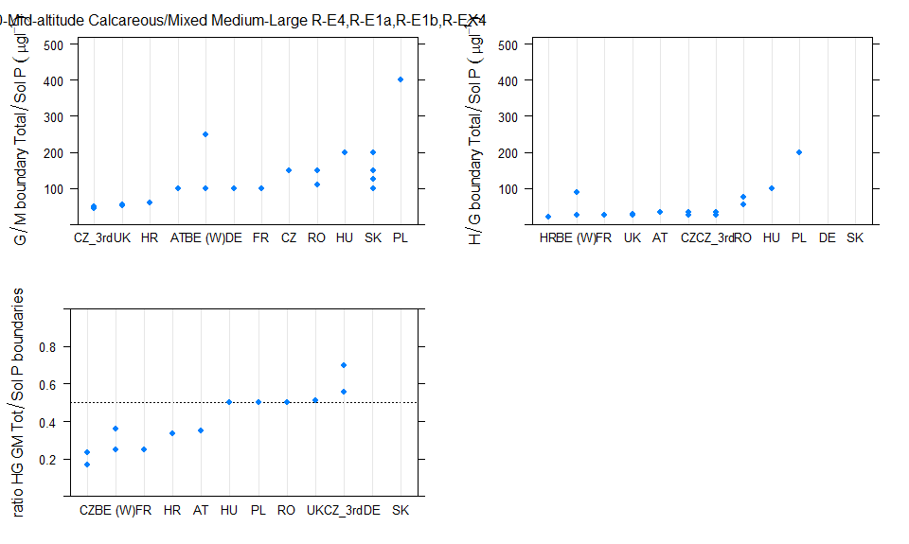
Figure 6.2-137 Range of a) good/moderate, b)high/good, c) ratio of good/moderate to high/good national phosphorus boundary values for rivers in broad type 10, mid-altitude, calcareous/mixed, medium-large rivers (90th percentile values halved)

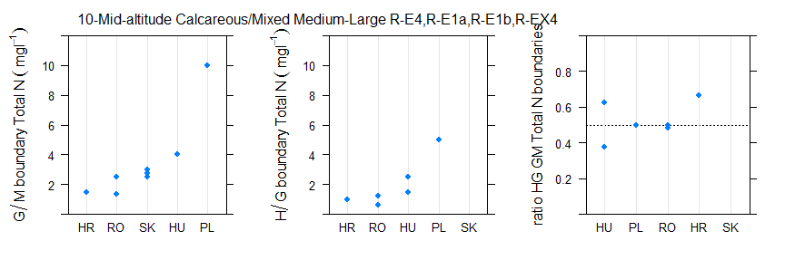
Figure 6.2-138 Range of a) good/moderate, b)high/good, c) ratio of good/moderate to high/good national total nitrogen boundary values for rivers in broad type 10, mid-altitude, calcareous/mixed, medium-large rivers

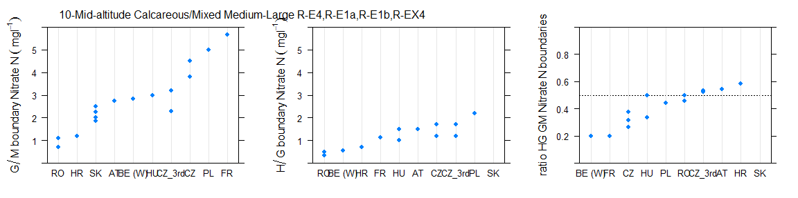
Figure 6.2-139 Range of a) good/moderate, b)high/good, c) ratio of good/moderate to high/good national nitrate nitrogen boundary values for rivers in broad type 10, mid-altitude, calcareous/mixed, medium-large rivers

Type 11 Mid-altitude, calcareous/mixed, very small-small rivers

Broad Type | Country | National type code | Description of type | IC Type
11 | BE (W) | RIV_01 |  | R-C6
11 | BE (W) | RIV_02 |  | R-C6
11 | BE (W) | RIV_09 |  | R-C6
11 | BE (W) | RIV_10 |  | R-C6
11 | BE (W) | RIV_13 |  | R-C6
11 | BE (W) | RIV_14 |  | R-C6
11 | CZ | X-2-1-1 | 200-500m,Crystalinicum, volcanic rock,Strahler 1-3 (brooks) | not allocated
11 | CZ | X-2-2-1 | 200-500m,Sandstone, holocene,Strahler 1-3 (brooks) | R-E1b
11 | CZ | X-3-1-1 | 500-800m,Crystalinicum, volcanic rock,Strahler 1-3 (brooks) | R-E1a
11 | CZ | X-3-1-2 | 500-800m,Crystalinicum, volcanic rock,Strahler 4-6 (smaller rivers) | not allocated
11 | CZ | X-3-2-1 | 500-800m,Sandstone, holocene,Strahler 1-3 (brooks) | not allocated
11 | CZ | X-3-2-2 | 500-800m,Sandstone, holocene,Strahler 4-6 (smaller rivers) | not allocated
11 | CZ_3rd | X-2-1-1 | 200-500m,Crystalinicum, volcanic rock,Strahler 1-3 (brooks) | not allocated
11 | CZ_3rd | X-2-2-1 | 200-500m,Sandstone, holocene,Strahler 1-3 (brooks) | R-E1b
11 | CZ_3rd | X-3-1-1 | 500-800m,Crystalinicum, volcanic rock,Strahler 1-3 (brooks) | R-E1a
11 | CZ_3rd | X-3-1-2 | 500-800m,Crystalinicum, volcanic rock,Strahler 4-6 (smaller rivers) | not allocated
11 | CZ_3rd | X-3-2-1 | 500-800m,Sandstone, holocene,Strahler 1-3 (brooks) | not allocated
11 | CZ_3rd | X-3-2-2 | 500-800m,Sandstone, holocene,Strahler 4-6 (smaller rivers) | not allocated
11 | DE | 3.1 | Bäche der Jungmoräne des Alpenvorlandes | not allocated
11 | DE | 6 | Feinmaterialreiche, karbotische Mittelgebirgsbäche | not allocated
11 | DE | 7 | Grobmaterialreiche, karbotische Mittelgebirgsbäche | not allocated
11 | HR | HR-R_1 | Mountain and foothill small and midium rivers | not allocated
11 | HR | HR-R_10A | Mountain and foothill small temporary rivers | not allocated
11 | HR | HR-R_6 | Mountain and foothill small rivers | not allocated
11 | HU | 2R | Mountainous – calcerous – coarse – small catchment | R-E1b
11 | HU | 3R | Mountainous – calcareous – coarse – medium catchment | R-E1b
11 | HU | 4R | Hilly – calcareous – coarse – small catchment | R-EX6
11 | HU | 8R | Hilly – calcareous – medium/fine – small catchment | R-EX5
11 | IT | IT02SR6N |  | not allocated
11 | IT | IT02SR6T |  | not allocated
11 | IT | IT02SS1N |  | R-A1
11 | IT | IT02SS1T |  | R-A1
11 | IT | IT02SS2N |  | R-A1
11 | IT | IT02SS2T |  | R-A1
11 | IT | IT06SS2T |  | not allocated
11 | IT | IT10SS1N |  | R-M1
11 | IT | IT10SS2N |  | R-M1

11 | PL | 6 | Potok wyżynny węglanowy z substratem drobnoziarnistym na lessach i lessopodobnych | not allocated
11 | PL | 7 | Potok wyżynny węglanowy z substratem gruboziarnistymi | not allocated
11 | RO | RO01 | Curs de apa situat in zona montana, piemontana sau de podisuri inalte | R-E1a
11 | RO | RO04 | Curs de apa situat in zona de dealuri sau de podisuri | R-E1b
11 | RO | RO04 | Curs de apa situat in zona de dealuri sau de podisuri | R-E4
11 | SK | K2M | Malé toky v nadmorskej výške 200 - 500 m v Karpatoch | R-E1b
11 | SK | P2M | Malé toky v nadmorskej výške 200 - 500 m v Panónskej panve | R-E4
11 | UK | 11 | Mid-altitude Calcareous Small | not allocated

Table 6.2-66 National & intercalibration types for countries reporting Broad Type 11, mid-altitude, calcareous/mixed, very small-small rivers (90th percentile values halved)

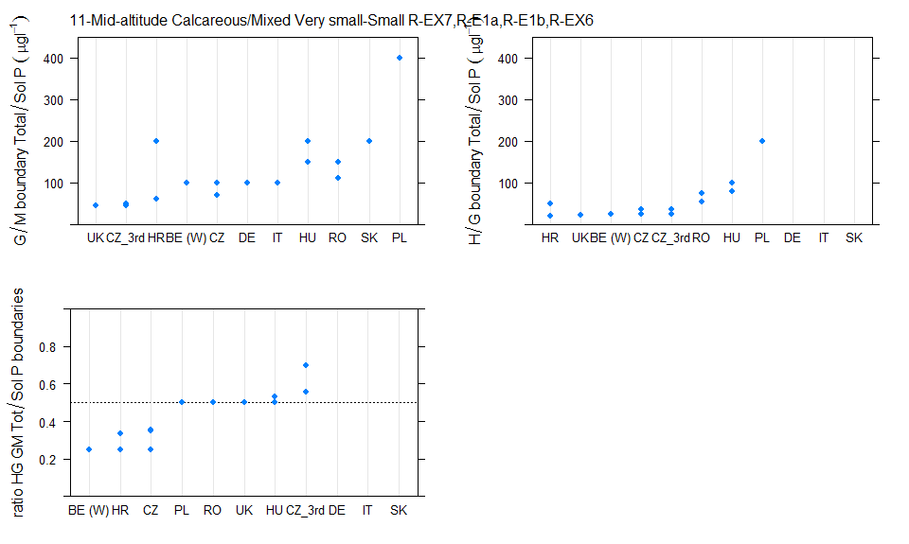
Figure 6.2-140 Range of a) good/moderate, b)high/good, c) ratio of good/moderate to high/good national phosphorus boundary values for rivers in broad type 11, mid-altitude, calcareous/mixed, very small-small rivers
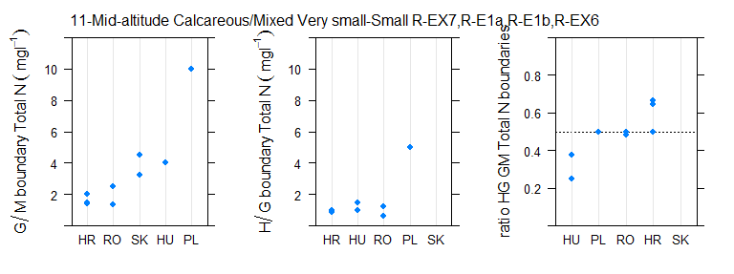
Figure 6.2-141 Range of a) good/moderate, b)high/good, c) ratio of good/moderate to high/good national total nitrogen boundary values for rivers in broad type 11, mid-altitude, calcareous/mixed, very small-small rivers
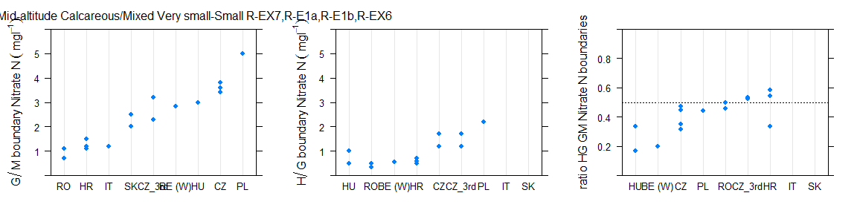
Figure 6.2-142 Range of a) good/moderate, b)high/good, c) ratio of good/moderate to high/good national nitrate nitrogen boundary values for rivers in broad type 11, mid-altitude, calcareous/mixed, very small-small rivers

Type 12 mid-altitude organic and siliceous

Broad Type | Country | National type code | Description of type | IC Type
12 | BE (W) | RIV_24 |  | R-C3
12 | NO | 14 | mid-altitude (200-800 masl) or highland (>800 masl), low alkalinity (<0,2 mekv/l), humic (colour 30-90 mg Pt/l) | R-N6a
12 | NO | 17 | mid-altitude (200-800 masl) or highland (>800 masl), low alkalinity (<0,2 mekv/l), humic (colour 30-90 mg Pt/l) | R-N6a
12 | SE | V2LYN | mid alt silicorganic >100km2 S2, Inlands of Norrland
12 | SE | V2SYN | mid alt silicorganic <100km2 S2, Inlands of Norrland
12 | SE | V7LYN | mid alt silicorganic >100km2 S7, Highlands of South Sweden
12 | SE | V7SYN | mid alt silicorganic <100km2 S7, Highlands of South Sweden

Table 6.2-67 National & intercalibration types for countries reporting Broad Type 12
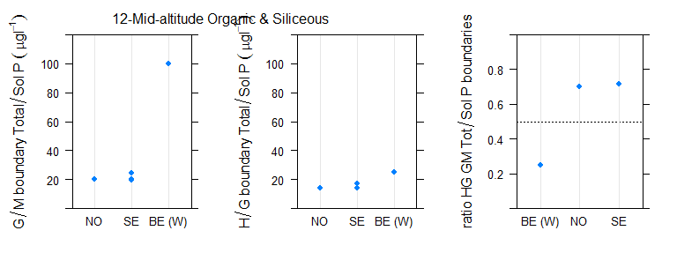
Figure 6.2-143 Range of a) good/moderate, b)high/good, c) ratio of good/moderate to high/good national phosphorus boundary values for rivers in broad type 12 mid-altitude organic and siliceous (90th percentile values halved)

Type 13 mid-altitude calcareous/mixed

Broad Type | Country | National type code | Description of type | IC Type
13 | PL | 24 | Małe i średnie rzeki na obszarach będących pod wpływem procesów torfotwórczych | R-C4/5
13 | SE | V7LYY | mid alt calcorganic >100km2 S7, Highlands of South Sweden
13 | SE | V7SYY | mid alt calcorganic <100km2 S7, Highlands of South Sweden

Table 6.2-68 National & intercalibration types for countries reporting Broad Type 13 mid-altitude calcareous/mixed
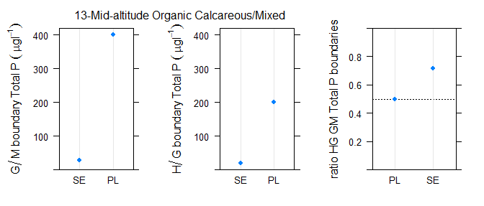
Figure 6.2-144 Range of a) good/moderate, b)high/good, c) ratio of good/moderate to high/good national phosphorus boundary values for rivers in broad type 13 mid-altitude calcareous/mixed

Type 14 Highland, siliceous, all Europe

Broad Type | Country | National type code | Description of type | IC Type
14 | AT | 2_MZB1,25_PHBot | Bioregion: Unglaciated Central Alps (2); Macroinvertebrate- saprobic reference condition: SI 1,25; Phytobenthos-trophic reference condition: oligotrophic (ot) | R-A2
14 | AT | 2_MZB1,5_PHBot | Bioregion: Unglaciated Central Alps (2); Macroinvertebrate- saprobic reference condition: SI 1,5; Phytobenthos-trophic reference condition: oligotrophic (ot) | R-A2
14 | AT | 3_MZB1,5_PHBmt | Bioregion: Ridges and Foothills of the Central Alps (3); Macroinvertebrate- saprobic reference condition: SI 1,5; Phytobenthos-trophic reference condition: mesotrophic (mt) | R-A2
14 | AT | 3_MZB1,5_PHBom | Bioregion: Ridges and Foothills of the Central Alps (3); Macroinvertebrate- saprobic reference condition: SI 1,5; Phytobenthos-trophic reference condition: oligo-mesotrophic (om) | R-A2
14 | BG | R2 | Mountainous rivers (Uplands) in ER12 (mountain zone- sometimes get down; mixed/siliceous/calcareous;size <100 km2, smal rivers; boulders and cobles) | R-E1a
14 | BG | R3 | Mountainous rivers (Uplands) in ER7 (>(600) 800 m, vary to some extent; mixed/siliceous/calcareous;size <100 km2, smal rivers; boulders and cobles) | not allocated
14 | FR | MP2 | Moyen ou Petit cours d'eau des Alpes internes | R-A2
14 | FR | P14/1 | Petit cours d'eau des Coteaux aquitains et exogène des Pyrénées | R-A2
14 | FR | PTP8-A | Petit ou Très Petit cours d'eau des Cévennes dans l'HER de niveau 2 n°70 | R-M1
14 | FR | TP3 | Très Petit cours d'eau du Massif central Sud | R-C3
14 | IT | IT03GH1N |  | R-A1
14 | IT | IT03GH1N |  | R-A2
14 | NO | 20 | highland (> 800 masl), low alkalinity (<0,2 mekv/l), clear (colour <30 mg Pt/l) | R-N7
14 | NO | 21 | highland (> 800 masl), low alkalinity (<0,2 mekv/l), clear (colour <30 mg Pt/l) | R-N7
14 | NO | 22 | mid-altitude (200-800 masl) or highland (>800 masl), low alkalinity (<0,2 mekv/l), humic (colour 30-90 mg Pt/l) | R-N6a
14 | NO | 23 | highland (> 800 masl), low alkalinity (<0,2 mekv/l), clear (colour <30 mg Pt/l) | R-N7
14 | NO | 24 | highland (> 800 masl), low alkalinity (<0,2 mekv/l), clear (colour <30 mg Pt/l) | R-N7
14 | NO | 25 | mid-altitude (200-800 masl) or highland (>800 masl), low alkalinity (<0,2 mekv/l), humic (colour 30-90 mg Pt/l) | R-N6a
14 | PL | 1 | Potok tatrzański krzemianowy | not allocated
14 | UK | 18 | High Siliceous Small | not allocated

Table 6.2-69 National & intercalibration types for countries reporting Broad Type 14, highland, siliceous, all Europe rivers

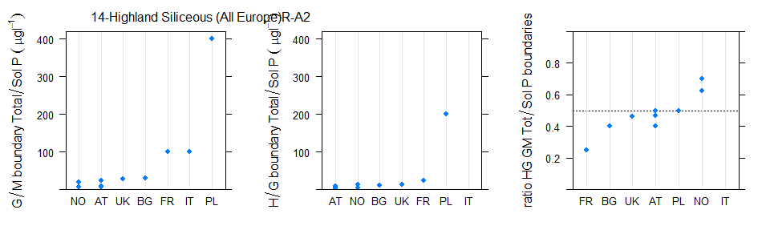
Figure 6.2-145 Range of a) good/moderate, b)high/good, c) ratio of good/moderate to high/good national phosphorus boundary values for rivers in broad type 14, highland, siliceous, all Europe rivers (90th percentile values halved)
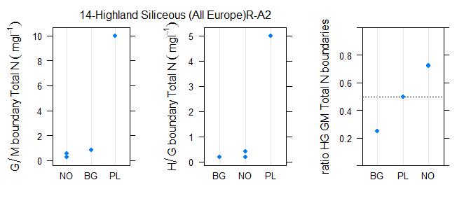
Figure 6.2-146 Range of a) good/moderate, b)high/good, c) ratio of good/moderate to high/good national total nitrogen boundary values for rivers in broad type 14, highland, siliceous, all Europe rivers
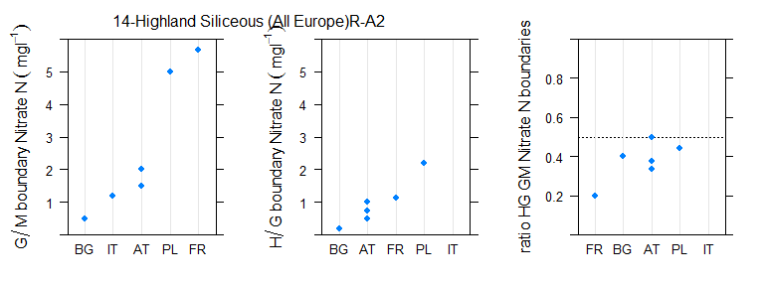
Figure 6.2-147 Range of a) good/moderate, b)high/good, c) ratio of good/moderate to high/good national nitrate nitrogen boundary values for rivers in broad type 14, highland, siliceous, all Europe rivers

Type 15 Highland, calcareous/mixed, all Europe

Broad Type | Country | National type code | Description of type | IC Type
15 | AT | 5_MZB1,5_PHBom | Bioregion: Limestone Alpine Foothills (5); Macroinvertebrate- saprobic reference condition: SI 1,5; Phytobenthos-trophic reference condition: oligo-mesotrophic (om) | R-A1
15 | AT | 5_MZB1,5_PHBot | Bioregion: Limestone Alpine Foothills (5); Macroinvertebrate- saprobic reference condition: SI 1,5; Phytobenthos-trophic reference condition: oligotrophic (ot) | R-A1
15 | BG | R1 | High mountain (Alpine) rivers (ER12/ER7; altitude > 1800 m vary to some extent; mixed/siliceous/calcareous;size <100 km2, streams; bedrock,rocks, boulders) | not allocated
15 | CY | R2 | large rain volume with continuous flow | R-M4
15 | CZ | X-4-1-1 | >800m,Crystalinicum, volcanic rock,Strahler 1-3 (brooks) | not allocated
15 | CZ | X-4-1-2 | >800m,Crystalinicum, volcanic rock,Strahler 4-6 (smaller rivers) | not allocated
15 | CZ | X-4-2-1 | >800m,Sandstone, holocene,Strahler 1-3 (brooks) | not allocated
15 | CZ | X-4-2-2 | >800m,Sandstone, holocene,Strahler 4-6 (smaller rivers) | not allocated
15 | CZ_3rd | X-4-1-1 | >800m,Crystalinicum, volcanic rock,Strahler 1-3 (brooks) | not allocated
15 | FR | M5 | Moyen cours d'eau du Jura/Pré-Alpes du Nord | R-A1
15 | FR | MP6 | Moyen ou Petit cours d'eau de Méditerranée | R-M4
15 | FR | P5 | Petit cours d'eau du Jura/Pré-Alpes du Nord | R-A1
15 | FR | TP5 | Très Petit cours d'eau du Jura/Pré-Alpes du Nord | R-A1
15 | FR | TP7 | Très Petit cours d'eau des Pré-Alpes du Sud | R-M4
15 | PL | 2 | Potok tatrzański węglanowy | not allocated
15 | SK | K3M | Malé toky v nadmorskej výške 500 - 800 m v Karpatoch | R-E1a
15 | SK | K4M | Malé toky v nadmorskej výške nad 800 m v Karpatoch | not allocated

Table 6.2-70 National & intercalibration types for countries reporting Broad Type15, highland, calcareous/mixed, all Europe rivers
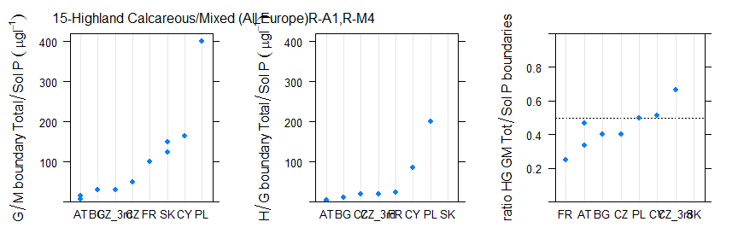
Figure 6.2-148 Range of a) good/moderate, b)high/good, c) ratio of good/moderate to high/good national phosphorus boundary values for rivers in broad type 15, highland, calcareous/mixed, all Europe rivers (90th percentile values halved)
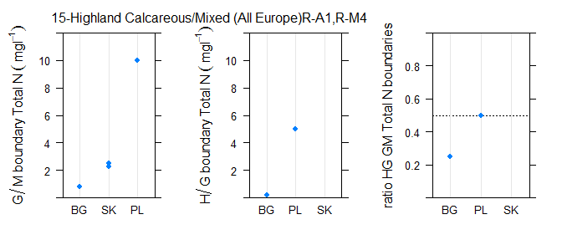
Figure 6.2-149 Range of a) good/moderate, b)high/good, c) ratio of good/moderate to high/good national total nitrogen boundary values for rivers in broad type 15, highland, calcareous/mixed, all Europe rivers
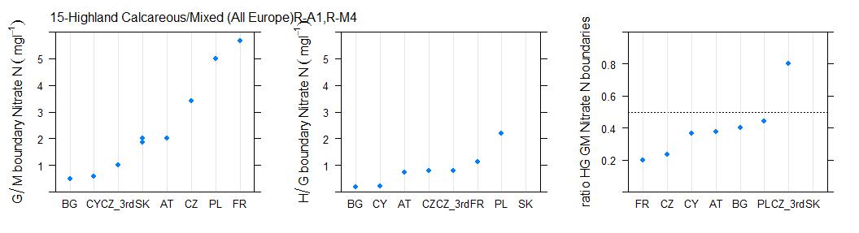
Figure 6.2-150 Range of a) good/moderate, b)high/good, c) ratio of good/moderate to high/good national nitrate nitrogen boundary values for rivers in broad type 15, highland, calcareous/mixed, all Europe rivers

Type l16 Glacial rivers all Europe

Broad Type | Country | National type code | Description of type | IC Type
16 | FR | G1 | Grand cours d'eau des Pyrénées | R-A2
16 | FR | G2 | Grand cours d'eau des Alpes internes | R-A2
16 | FR | GM7/2 | Grand ou Moyen cours d'eau des Pré-Alpes du Sud et exogène des Alpes internes | R-A2
16 | FR | M1 | Moyen cours d'eau des Pyrénées | R-A2
16 | FR | P1 | Petit cours d'eau des Pyrénées | R-A2
16 | FR | TP1 | Très Petit cours d'eau des Pyrénées | R-A2
16 | FR | TP2 | Très petit cours d'eau des Alpes internes | R-A2
16 | IT | IT01GH1N |  | R-A2
16 | IT | IT01GH2N |  | R-A2
16 | IT | IT01SS1N |  | R-A2
16 | IT | IT01SS2N |  | R-A2
16 | IT | IT04SS2N |  | R-A2

Table 6.2-71 National & intercalibration types for countries reporting Broad Type16
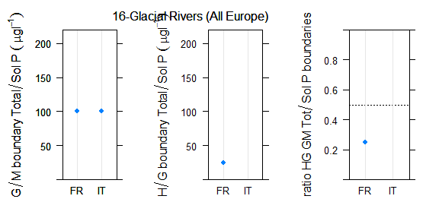
Figure 6.2-151 Range of a) good/moderate, b)high/good, c) ratio of good/moderate to high/good national phosphorus boundary values for rivers in broad type 16, glacial rivers, all Europe (90th percentile values halved)

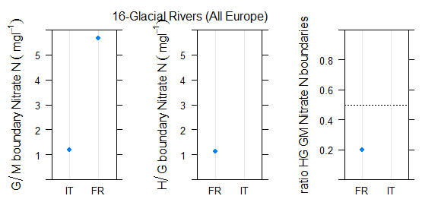
Figure 6.2-152 Range of a) good/moderate, b)high/good, c) ratio of good/moderate to high/good national nitrate nitrogen boundary values for rivers in broad type 16, glacial rivers, all Europe

Type 17 Mediterranean, lowland, medium-large, perennial rivers

Broad Type | Country | National type code | Description of type | IC Type
Broad_Type3 | Country | National type code | Descr | IC_Type
17 | FR | G16 | Grand cours d'eau de Corse | R-M3
17 | FR | G6 | Grand cours d'eau de Méditerranée | R-M3
17 | FR | GM6/1 | Grand ou Moyen cours d'eau de Méditerranée et exogène des Pyrénées | R-M3
17 | HR | HR-R_13 | Lowland medium and large rivers | not allocated
17 | HR | HR-R_13A | Lowland large rivers with the barrage pools | not allocated
17 | HR | HR-R_18 | Lowland medium rivers of Istria | not allocated
17 | IT | IT06SS3T |  | R-M4
17 | IT | IT06SS4D |  | R-M2
17 | IT | IT06SS4F |  | R-M2
17 | PT | R_L | Rios do Litoral Centro | R-M1
17 | PT | R_L | Rios do Litoral Centro | R-M2
17 | PT | R_L | Rios do Litoral Centro | R-M5
17 | PT | R_S1G | Rios do Sul de Média-Grande Dimensão | R-M2
17 | PT | R_S1G | Rios do Sul de Média-Grande Dimensão | R-M5
17 | PT | R_S3 | Depósitos Sedimentares do Tejo e Sado | R-M1
17 | PT | R_S3 | Depósitos Sedimentares do Tejo e Sado | R-M2

Table 6.2-72 National & intercalibration types for countries reporting Broad Type 17, Mediterranean, lowland, medium-large rivers

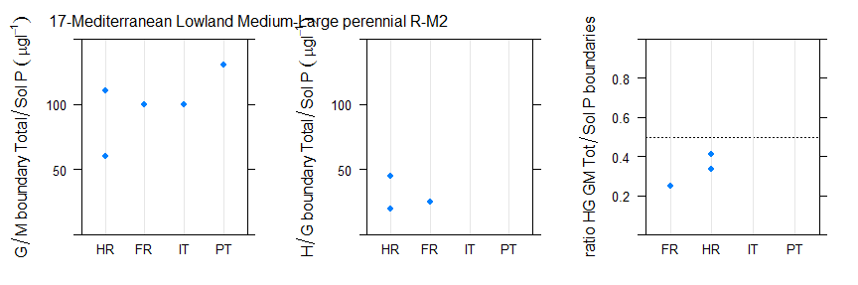
Figure 6.2-153 Range of a) good/moderate, b)high/good, c) ratio of good/moderate to high/good national phosphorus boundary values for rivers in broad type 17, Mediterranean, lowland, medium-large rivers (90th percentile values halved)
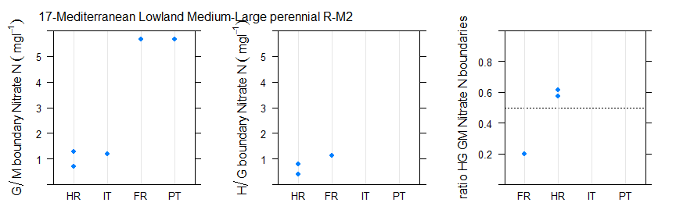
Figure 6.2-154 Range of a) good/moderate, b)high/good, c) ratio of good/moderate to high/good national nitrate nitrogen boundary values for rivers in broad type 17, Mediterranean, lowland, medium-large rivers

Type 18 Mediterranean, mid-altitude, medium/large, perennial rivers

Broad Type | Country | National type code | Description of type | IC Type
18 | FR | GM6/2-7 | Grand ou Moyen cours d'eau de Méditerranée et exogène des Pré-Alpes du Sud ou des Alpes internes | R-M3
18 | FR | GM6/8 | Grand ou Moyen cours d'eau de Méditerranée et exogène des Cévennes | R-M3
18 | FR | GMP7 | Grand ou Moyen ou Petit cours d'eau des Pré-Alpes du Sud | R-M4
18 | FR | TG6/1-8 | Très Grand cours d'eau de Méditerranée et exogène des Pyrénées ou des Cévennes | R-M3
18 | FR | TG6-7/2 | Très Grand cours d'eau en Méditerranée ou des Pré-Alpes du Sud et exogène des Alpes internes | R-M3
18 | HR | HR-R_12 | Foothill midium and large rivers
18 | IT | IT10SS3N |  | R-M4
18 | IT | IT13AS3N |  | R-M1
18 | IT | IT19SS3N |  | R-M4
18 | IT | IT21SS3T |  | R-M4

Table 6.2-73 National & intercalibration types for countries reporting Broad Type 18 Mediterranean, mid-altitude, medium-large, perennial rivers

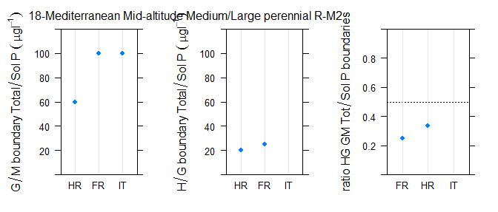
Figure 6.2-155 Range of a) good/moderate, b)high/good, c) ratio of good/moderate to high/good national phosphorus boundary values for rivers in broad type 18 mid-altitude medium large perennial rivers (90th percentile values halved)

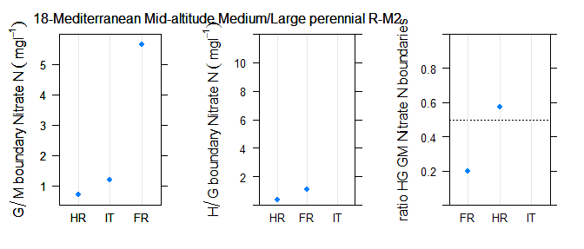
Figure 6.2-156 Range of a) good/moderate, b)high/good, c) ratio of good/moderate to high/good national nitrate boundary values for rivers in broad type 18 mid-altitude medium large perennial rivers,

Type 19 Mediterranean, very small-small, perennial rivers

Broad Type | Country | National type code | Description of type | IC Type
19 | FR | PTP16-A | Petit ou Très Petit cours d'eau de Corse dans l'HER de niveau 2 n°22 | R-M1
19 | FR | PTP8 | Petit ou Très Petit cours d'eau des Cévennes | R-M1
19 | FR | TP6 | Très Petit cours d'eau de Méditerranée | R-M4
19 | HR | HR-R_11 | Lowland and foothill small rivers | not allocated
19 | HR | HR-R_16B | Lowland small temporary rivers | not allocated
19 | HR | HR-R_17 | Lowland and foothill small rivers of Istria | not allocated
19 | HR | HR-R_19 | Temporary rivers of Istria | not allocated
19 | IT | IT09SS2T |  | R-M1
19 | IT | IT10SS2T |  | R-M1
19 | IT | IT11SS2N |  | R-M1
19 | IT | IT11SS2T |  | R-M1
19 | IT | IT13SR2T |  | R-M1
19 | IT | IT14SS2T |  | R-M1
19 | IT | IT19SR1N |  | R-M1
19 | IT | IT19SR2N |  | R-M1
19 | IT | IT19SS1N |  | R-M1
19 | IT | IT19SS2N |  | R-M1
19 | IT | IT21SS2T |  | R-M1
19 | PT | R_N1P | Rios do Norte de Pequena Dimensão | R-M1
19 | PT | R_N3 | Rios do Alto Douro de Pequena Dimensão | R-M1

Table 6.2-74 National & intercalibration types for countries reporting Broad Type 19, Mediterranean, very small perennial rivers
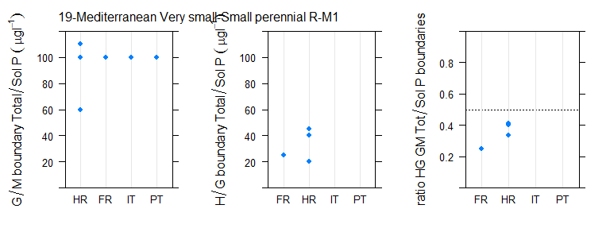
Figure 6.2-157 Range of a) good/moderate, b)high/good, c) ratio of good/moderate to high/good national phosphorus boundary values for rivers in broad type 19, Mediterranean, very small perennial rivers (90th percentile values halved)
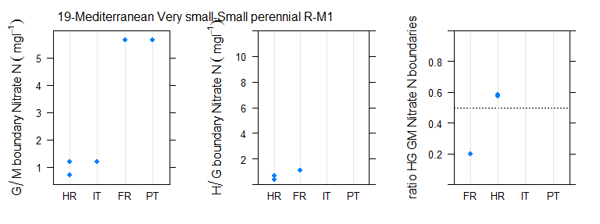
Figure 6.2-158 Range of a) good/moderate, b)high/good, c) ratio of good/moderate to high/good national nitrate nitrogen boundary values for rivers in broad type 19, Mediterranean, very small perennial rivers

Type 20 Mediterranean, temporary/intermittent streams

Broad Type | Country | National type code | Description of type | IC Type
20 | BG | R14 | Sub-Mediterranean rivers (temporary)(ER 7;altitude <500 (650) m variable; mixed/siliceous/calcareous;size <1100 km2, medium and small; substratum variable) | not allocated
20 | CY | R1 | small rain volume with non-continuous flow | R-M5
20 | CY | R3 | large rain volume with non-continuous flow | R-M5
20 | IT | IT02IN7N |  | R-A1
20 | IT | IT02IN7T |  | R-A1
20 | IT | IT06IN7D |  | R-M5
20 | IT | IT06IN7N |  | R-M5
20 | IT | IT10EF7N |  | R-M5
20 | IT | IT10IN7N |  | R-M5
20 | IT | IT11EF7N |  | R-M5
20 | IT | IT11IN7N |  | R-M5
20 | IT | IT11IN7T |  | R-M5
20 | IT | IT12IN7N |  | R-M5
20 | IT | IT19EF7N |  | R-M5
20 | IT | IT19IN7N |  | R-M5
20 | IT | IT19IN8N |  | R-M5
20 | IT | IT20IN7N |  | R-M5
20 | IT | IT21EF7T |  | R-M5
20 | IT | IT21IN7T |  | R-M5
20 | PT | R_S1P | Rios do Sul de Pequena Dimensão | R-M5
20 | PT | R_S4 | Calcários do Algarve | R-M5
20 | RO | RO17 | Curs de apa nepermanent situat in zona montana | not allocated
20 | RO | RO18 | Curs de apa nepermanent situat in zona piemontana sau de podisuri inalte | not allocated
20 | RO | RO19 | Curs de apa nepermanent situat in zona de dealuri si podisuri | not allocated
20 | RO | RO20 | Curs de apa nepermanent situat in zona de campie | not allocated

Table 6.2-75 National & intercalibration types for countries reporting Broad Type 20, Mediterranean, temporary/intermittent streams
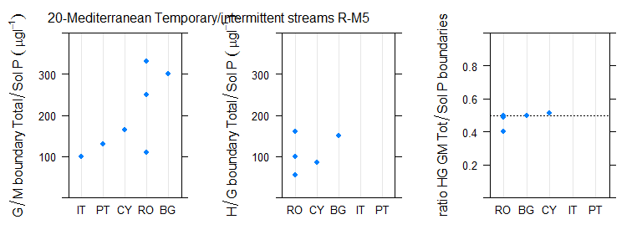
Figure 6.2-159 Range of a) good/moderate, b)high/good, c) ratio of good/moderate to high/good national phosphorus boundary values for rivers in broad type 20, Mediterranean, temporary/intermittent streams (90th percentile values halved)
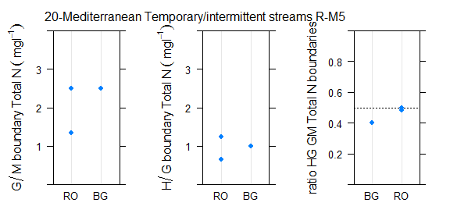
Figure 6.2-160 Range of a) good/moderate, b)high/good, c) ratio of good/moderate to high/good national total nitrogen boundary values for rivers in broad type 20, Mediterranean, temporary/intermittent streams
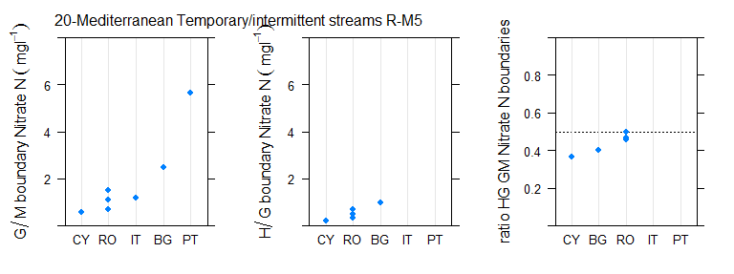
Figure 6.2-161 Range of a) good/moderate, b)high/good, c) ratio of good/moderate to high/good national nitrate nitrogen boundary values for rivers in broad type 20, Mediterranean, temporary/intermittent streams

Following comments from ES no matches to the Broad Typology were made for ES rivers or lakes and thus boundaries from ES do not contribute to comparisons using this typology.
As information only available in German

